Kuberetes Pods
1. Making an html&Dockerfile and building the image for nginx
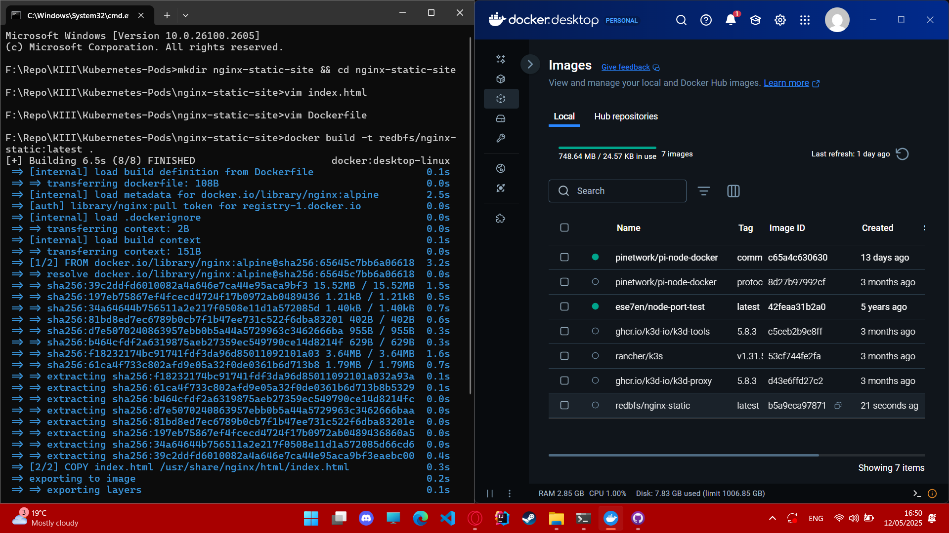

2.Pushing the image to docker hub
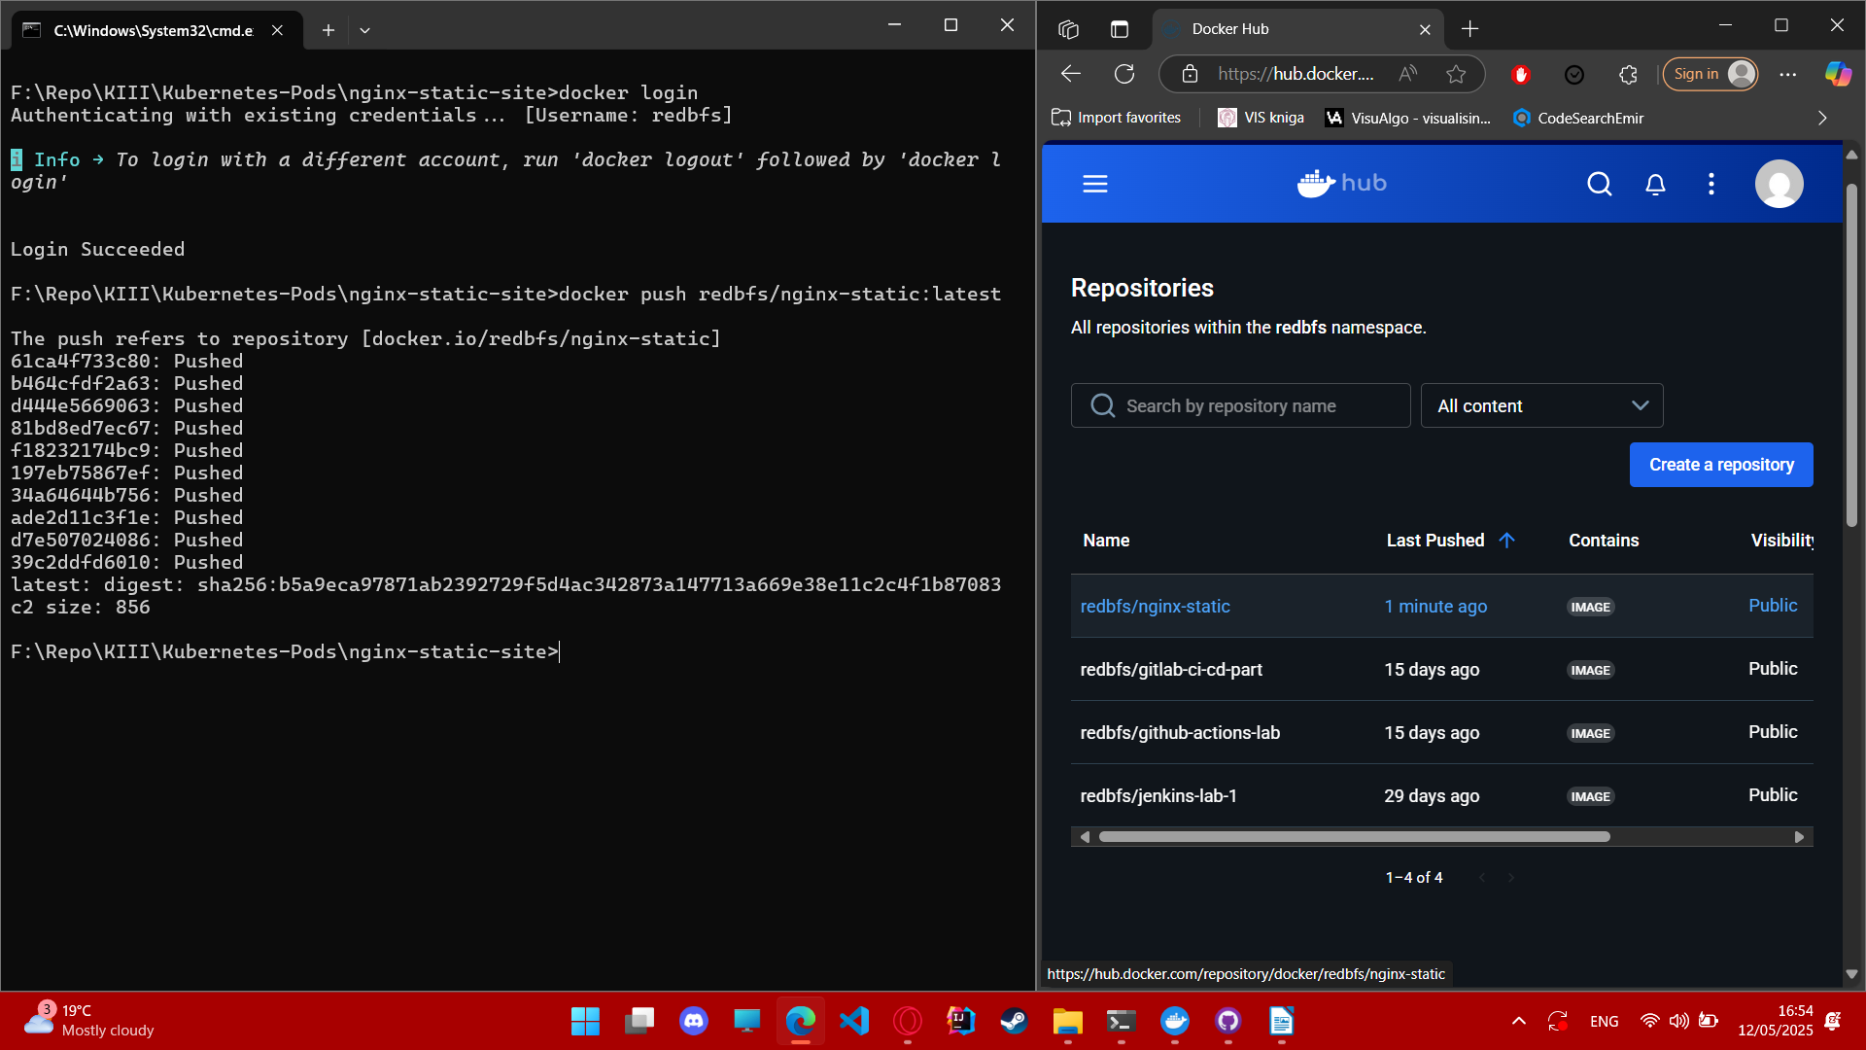

3.Writing the manifest
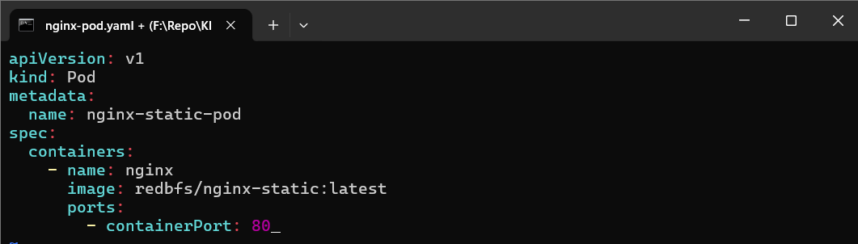

4.Created the cluster and applied the manifest
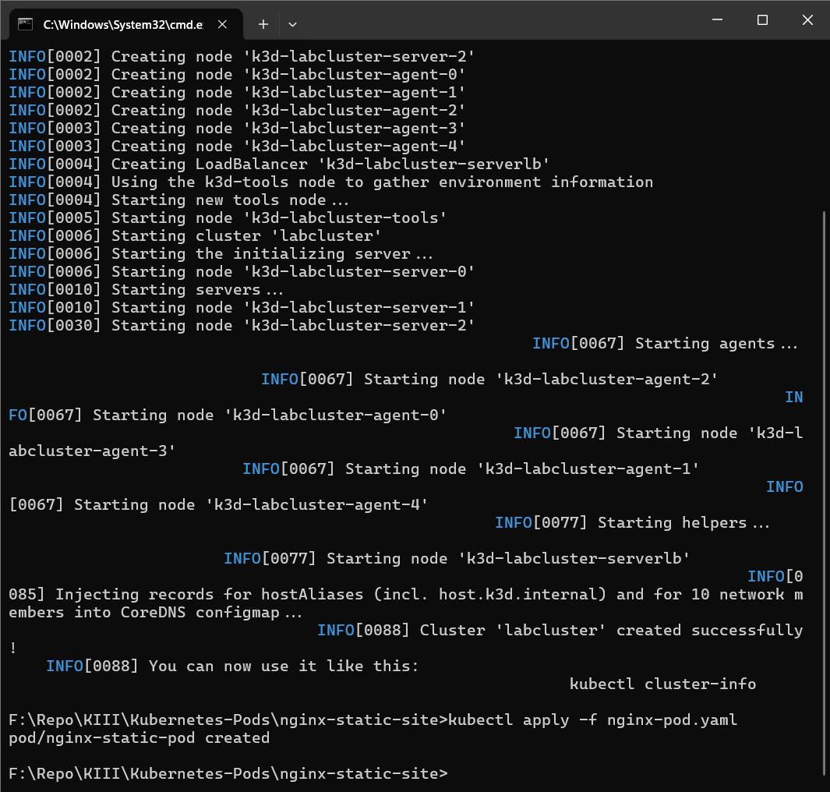

5.The Pod is running
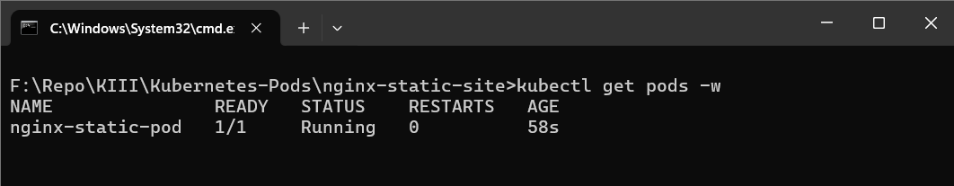

6. Watching the event in node k3d-labcluster-server-0→ kubectl describe node k3d-labcluster-server-0
