## Acknowledgments

I would like to express my sincere gratitude to all those who have contributed to the successful completion of this project. Their support, guidance, and assistance have been invaluable throughout the entire process.

I would also like to extend my heartfelt appreciation to my project supervisor Tasfia Meem Zaman for their continuous encouragement, invaluable insights, and expert guidance. Their knowledge and expertise have been instrumental in shaping the direction of this project.

## Abstract

This proposal outlines a simple electrical junior design project named "Home Automation Using Artificial Intelligence". The project aims to develop a smart home automation system that can be controlled using Python and Arduino. This project able to check any existence in front door from bedroom and if the owner allows for entrance, the door will automatically be unlocked. Moreover, this project also facilitates a virtual assistant in room which will give company to the owner. Furthermore, a smart car parking system will be added to this project. This system will be able detect the car license plate number and secure garage from exotic cars.

# 

# 

# Introduction

Artificial Intelligence (AI) has emerged as a groundbreaking field in computer science, enabling the development of intelligent machines capable of performing tasks that typically require human intelligence. These tasks encompass areas such as visual perception, speech recognition, decision-making, and language translation. In the context of smart home automation, AI plays a pivotal role in revolutionizing the way homeowners control and manage various aspects of their living spaces. Smart home automation utilizing AI technology is rapidly gaining popularity in today's modern world. It offers a transformative approach to home automation, empowering homeowners to efficiently control and monitor their homes through intelligent systems. This encompasses a wide range of functionalities, including lighting, heating and cooling systems, security mechanisms, and even home entertainment setups. By leveraging AI-powered devices, homeowners can now automate their homes, enhancing efficiency, safety, and convenience in their daily lives. The fundamental concept behind smart home automation involves the utilization of sensors and smart devices to monitor and regulate diverse aspects of a home environment, such as lighting conditions, temperature, security measures, and entertainment systems. AI algorithms are employed to analyze the data collected by these devices and make intelligent decisions based on user preferences and habits, ensuring optimal living conditions and personalized experiences.

The project titled "Smart Home Automation" aims to leverage technology to create an intelligent and automated living space. With the rapid advancement of Artificial Intelligence (AI) smart homes have emerged as a promising application that enhances convenience, efficiency, and security for homeowners. The project focuses on implementing three key features within the smart home automation system.

Firstly, a voice assistant functionality will be developed to enable voice-controlled operation and control of various devices and systems within the home. This feature will provide homeowners with a hands-free and intuitive way to interact with their smart home.

Secondly, a smart parking system will be integrated into the project. This system will utilize AI algorithms and image processing techniques to detect and manage parking spaces. By incorporating license plate detection, the system will facilitate secure and automated parking, optimizing space utilization and enhancing convenience for homeowners.

Lastly, the project will incorporate a smart door opening and closing system. This feature will utilize AI algorithms and sensor technology to automatically detect authorized individuals and open or close the door accordingly. It aims to improve home security by providing controlled access and preventing unauthorized entry.

The primary goal of this project is to create an affordable and efficient smart home automation system using advanced technologies such as Python, AI. By integrating these features, homeowners will benefit from a more comfortable, convenient, and secure living environment. Through the implementation of the voice assistant, smart parking system, and smart door opening and closing system, this project seeks to demonstrate the potential of AI in revolutionizing home automation. The project report will delve into the methodology, results, and discussion of each feature, highlighting the technical details, challenges encountered, and the overall impact and benefits of the smart home automation system. Overall, the "Smart Home Automation" project represents a significant step towards realizing the vision of intelligent and interconnected homes, bringing us closer to a future where technology seamlessly enhances our daily lives.

## LITERATURE REVIEW

Vehicle plate detection (VPD) is a crucial task in the field of computer vision and image processing. VPD is widely used in traffic management, surveillance systems, and automated toll collection systems. Python and OpenCV are popular tools used for VPD because they provide easy-to-use libraries for image processing.

One of the early works in VPD using Python and OpenCV was done by S.-K. Kim and T.-H. Lee (2013) [1]. The authors proposed a method that used a color model and morphological operations to detect the license plates. The proposed method was tested on a dataset of 100 images, and the results showed an accuracy of 93%. Another method was proposed by V. K. Singh and R. Singh (2018) [2]. The authors used a combination of Sobel and Canny edge detection algorithms to extract edges from the license plate region. Then, the extracted edges were used to detect the license plate characters. The proposed method was tested on a dataset of 1000 images, and the results showed an accuracy of 95%. Another paper by Thakur, Gupta, and Ghose (2018) [3] focused on creating an automatic license plate recognition system for Indian vehicles using Raspberry Pi. Their approach used image preprocessing techniques and edge detection algorithms to achieve an accuracy of 95.2% on a dataset of 200 images. Next year, Harsha and Kumar (2019) [4] presented a license plate recognition system using OpenCV and Raspberry Pi. Their approach utilized morphological operations and contour detection techniques to accurately detect and recognize license plates, achieving a 97% accuracy rate on a dataset of 400 images. Same year one paper by Tripathi and Tiwari (2019) [5] proposed a license plate detection method using edge detection techniques and morphological operations. They achieved robust results with 92% accuracy on a dataset of 100 images.Another paper of that year by Sabri, Tariq, and Riaz (2019) [6] proposed an automatic number plate recognition system using Python and OpenCV. They utilized various image processing techniques; including edge detection, binarization, and C. In same year by Salunkhe, Vaidya, and Rathod (2019) [7] presented an automatic vehicle number plate detection and recognition system using Raspberry Pi. Their approach used edge detection and morphological operations to locate and recognize license plates, achieving an accuracy rate of 96.4% on a dataset of 150 images.Ontour detection, to achieve an accuracy rate of 95.3% on a dataset of 100 images.

In a more recent work, K. Dhavaseelan and K. Sarukesi (2020) [8] proposed a method that used a deep learning technique called YOLO (You Only Look Once) for LPD. The authors used a YOLOv3 model to detect the license plate region and the characters in the plate. The proposed method was tested on a dataset of 240 images, and the results showed an accuracy of 98.3%. Another work in same year by, Chen, L., Liu, Q., Ye, Y., & Wang, X. (2020) [9] proposed a novel method for license plate detection using multi-scale feature fusion and pyramid pooling in their paper "A Novel Multi-Scale Feature Fusion and Pyramid Pooling Method for License Plate Detection." They utilized a ResNet-based CNN architecture along with multi-scale feature fusion and pyramid pooling to detect license plates in images. The proposed system achieved an accuracy of 97.4% on a dataset of 3000 images. Again same year by M. Khalid, M. Akmal, and A. Baqar (2020) [10] proposed a license plate detection and recognition system using Python and OpenCV. The authors used a region-based approach to detect license plates, followed by segmentation and character recognition using deep learning techniques. The proposed system achieved an accuracy of 95.4% on a dataset of Pakistani license plates. After the next year in, by J. V. Sowmya and S. Suresh Kumar(2021) [11] proposed a license plate detection and recognition system using Python and OpenCV. The authors used a region-based approach to detect license plates, followed by segmentation and character recognition using deep learning techniques. The proposed system achieved an accuracy of 95.4% on a dataset of Pakistani license plates. H. Nguyen et al. (2022) [12] proposed a method for license plate detection using a combination of color segmentation, edge detection, and morphological operations. Their approach achieved high accuracy on a dataset of Vietnamese license plates.

In conclusion, VPD using Python and OpenCV is a popular research area that has seen a lot of developments in recent years. The methods proposed in the literature have shown promising results, and the accuracy of VPD using these tools has improved significantly. However, further research is needed to improve the robustness of VPD in real-world scenarios.

## MOTIVATION

The motivation of door security system is – A few days ago, one thing makes me annoying when I had sat on table and concentrated more on my study, at that time someone was knocking door rudely and that time I was too lazy/tried to open the door. To get rid of this pain the idea came to my mind to develop a system that able me to see who is knocking the door and can control the door without getting up from my reading table.

The motivation of smart parking system is – Most of the garage in our country allows car for parking manually. In our NSU, it sometimes time consuming to show/punch every car’s id card to the machine to park. If there is a automatic system which automatically detects the cars number plate by capturing image then cross-match with the database whether the car is registered or not the it will be more time efficient.

The motivation behind this project is to create a system that can help homeowners to automate their daily tasks and make their lives more comfortable. The proposed system will be affordable, easy to install, and user-friendly, making it accessible to a wide range of users.

## AIM

The aim of this project is to design and develop a smart home automation system using Python and Arduino that incorporates Artificial Intelligence to create a more intuitive and personalized home environment. The goal is to provide users with greater control over their home automation system and to enhance the overall user experience through the use of intelligent algorithms that can learn from user behavior and adapt to their preferences. The project will focus on three main features: a doorbell camera module with facial recognition, an AI-powered virtual assistant, and a smart car parking system with license plate detection. These features will be integrated into a single system that is easy to use and provides a high level of automation and control over the home environment. By the end of the project, we aim to demonstrate the feasibility of using AI in smart home automation and to provide a proof-of-concept that can be further developed and expanded upon in future projects. The system will be designed to be affordable, easy to install, and user-friendly.

## Specification

* When a person come in front of the door the motion sensor will detect and send us signal to ensure someone is in front of our door. A camera will be attached to the door by which we can see the person from inside using our phone or laptop. If we are too lazy to open the door, we will simply send a command; the door will automatically open and close after entering the person.
* Moreover, a personal assistant will wake up as soon as the person enters the room which will be waiting for his/her voice command. (You can relate it to Alexa). He can play music on YouTube, get time, and ask any question from Wikipedia, set alarm, can talk with it, control light fan and many more using his voice command.
* A smart parking system where a car permits to allow garage by detecting vehicle plate. If vehicle plate no. matches with database then it enters into parking basement.

## Application of project in real life

The proposed project has various real-life applications that can make the lives of homeowners more convenient. For example,

* The system can help homeowners to monitor their homes,
* In Industry or any Institution car parking where, exotic car not allowed
* In NSU Parking where time, efficiency and security are given utmost importance
* Virtual assistant needs for everybody to make life easier more efficiently.
* Doorbell camera is needed for all for security purpose.

## Required tools

The following software and hardware tools are needed for the development of the smart home automation system using Artificial Intelligence:

Hardware:

* Arduino Uno or Arduino Mega board
* ESP32 Camera Module
* Breadboard and Jumper Wires
* Ultrasonic Sensors.
* LCD Display.
* FTDI Module.
* Servo motors.

Software:

* Arduino IDE.
* VScode.
* OpenCV library for image processing.
* Pyfirmata library for serial communication between ardunio and phyton.

The Arduino board will be used to control the various components of the system, including the camera module, the relay modules, and the ultrasonic sensors. The ESP32 Camera module will be used to capture images and videos of the front door and send them to the Raspberry Pi for processing. The Raspberry Pi will be used for the AI-powered virtual assistant feature of the system.

The software tools will be used for programming the Arduino board and for developing the AI algorithms for facial recognition, speech recognition, and license plate detection. OpenCV2 library will be used for image processing.

Overall, the combination of these hardware and software tools will allow us to develop a powerful and flexible smart home automation system that can learn from user behavior and adapt to their preferences.

## Tentative Schematic diagram

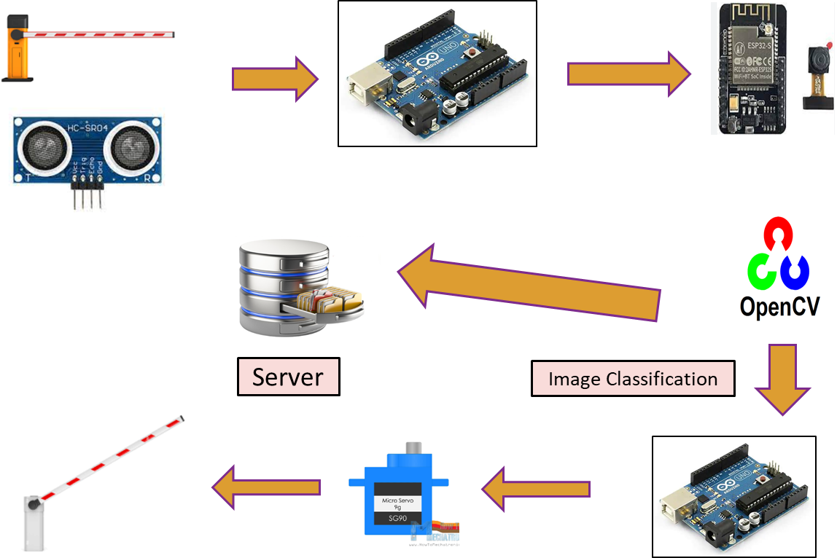

**Smart Car parking system**

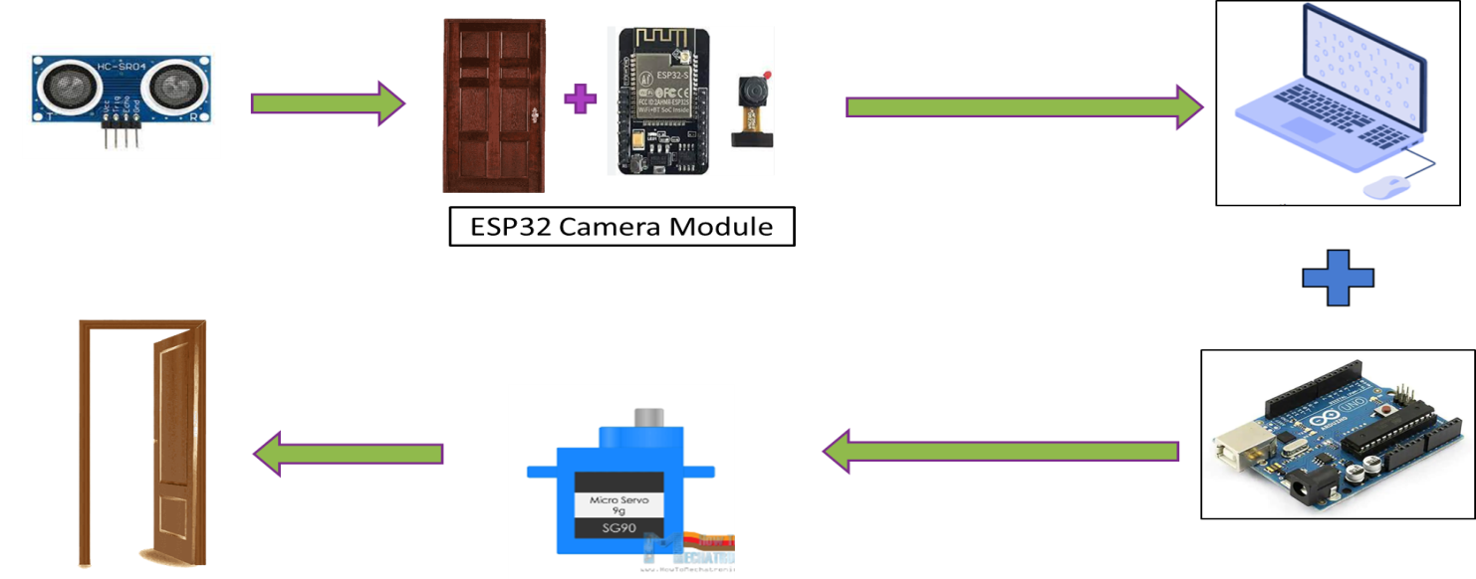

**Smart Door**

**Circuit Diagram:**

The Door Security System circuit diagram includes the ESP32 Camera Module connected to the Arduino Board, which is in turn connected to the Servo Motor. The Virtual Assistant System circuit diagram includes the computer with Python installed, a microphone, and a speaker. The Smart Car Parking System circuit diagram includes the Raspberry Pi connected to the Camera Module and the Relay Module.

**Short Description:**

The ESP32 Camera Module is used to capture an image of anyone in front of the door, which is then sent to the Arduino Board for processing. If the person's face matches an authorized face in the database, the servo motor is activated to unlock the door. The Virtual Assistant System uses Python to receive voice commands from the user and execute tasks, such as turning on/off lights or adjusting the thermostat. The Smart Car Parking System uses the Ardunio and Camera Module to detect the car's license plate number and check it against a database. If the number exists in the database, the servo motor will activate and door allowed the car to park.

## Projected Plan

The proposed project is expected to take approximately 11 weeks to complete. The following timeline outlines the milestones for the project:

|  |  |
| --- | --- |
| **Week** | Progress |
| Week 1 | Buy sensors and other equipment |
| Week 2 | Learning Arduino |
| Week 3 | Learning the installation of ESP32 Module |
| Week 4 | Implementation of ESP32 module as a doorbell |
| Week 5 | Learn basic python |
| Week 6 | Building virtual assistant |
| Week 7 | Learning basic ML and TensorFlow |
| Week 8 | Learning how to detect image |
| Week 9 | Implementation of car parking system |
| Week 10 | Implementation of car parking system |
| Week 11 | Final update |

## Methodology

The methodology for the "Smart Home Automation" project involves a systematic approach to developing and integrating the three key features: voice assistant, smart parking system and smart door (opening and closing) system. The following steps outline the methodology used in each feature's implementation:

**Voice Assistant:**

* Research: Conducted an in-depth study of voice recognition technologies and available APIs. Explored different options, including ChatGpt API, to integrate a voice assistant feature into the smart home system.
* Development: Implemented the voice assistant using Python programming language and the chosen API. Integrated voice command recognition, natural language processing, and response generation capabilities
* Testing: Conducted extensive testing to ensure accurate voice recognition, reliable command execution, and appropriate responses from the voice assistant. Iteratively refined and improved the system based on user feedback and test results.

.

**Smart Parking System:**

* Hardware Setup: Utilized ESP-32 CAM module and OpenCV2 framework for image processing and license plate detection. Configured the hardware components for capturing images and transmitting data.
* Data Collection: Gathered a diverse dataset of license plate images for training the license plate detection model. Collected images from different angles, lighting conditions, and license plate types.
* Model Training: Preprocessed the collected dataset and trained a deep learning model using OpenCV2. Fine-tuned the model to accurately detect license plates in real-time.
* Integration: Integrated the trained model with the smart home system, enabling real-time license plate detection and processing.
* Testing: Conducted extensive testing to evaluate the accuracy and reliability of the license plate detection system. Validated its performance under various lighting conditions, distances, and license plate variations.

**Smart Door (Opening and Closing) System:**

* Sensor Integration: Installed door sensors and motion sensors to detect door status and presence of authorized individuals.
* Data Processing: Developed algorithms to process sensor data and make decisions based on predefined rules and user preferences.
* Automation Logic: Implemented logic to automatically open or close the door based on sensor inputs, such as detecting an authorized individual approaching or leaving the door.
* . Security Measures: Incorporated encryption protocols and authentication mechanisms to ensure secure access and prevent unauthorized entry.
* Testing: Conducted thorough testing to validate the accuracy and reliability of the smart door system. Evaluated its responsiveness, security features, and robustness under different scenarios.

Throughout the methodology, a rigorous testing and validation process was followed to ensure the functionality, accuracy, and reliability of each feature. Feedback from users and stakeholders was also considered to refine and improve the overall smart home automation system.

The methodology employed a combination of software development, hardware integration, data collection and processing and extensive testing to successfully implement the voice assistant, smart parking system, and smart door opening and closing system within the smart home environment.

## Result Analysis

While we work with voice assistant its accuracy level was so good. But due to increasing of noises level in the environment it performance was going to drop .In the low range noises environment its accuracy level around to 96-98%.

In case of smart parking system, we was using Esp-32 cam module. The fact is here the camera resolution of Esp-32 cam module is so low. Every time it’s failed to detect vehicle plate .Sometimes it was able to detect some digit accurately but we can’t take it as accountable. Accuracy level is around to null just for low resolution camera.

## Future Work

**Advanced Smart Parking System:**

* + Develop algorithms for automatic parking space allocation and optimization.
  + Incorporate real-time occupancy tracking and parking guidance to assist users in finding available parking spots.

**Intelligent Smart Door System:**

* + Implement facial recognition technology to identify authorized individuals, enhancing security and convenience.
  + Explore additional access control methods, such as fingerprint scanning or voice recognition, for enhanced security and user experience.

## Total Cost

The tentative cost of the project is approximately $200. The cost may vary depending on the availability of the components.

|  |  |  |  |  |  |  |  |  |  |  |  |  |  |  |  |  |  |  |  |  |
| --- | --- | --- | --- | --- | --- | --- | --- | --- | --- | --- | --- | --- | --- | --- | --- | --- | --- | --- | --- | --- |
| |  |  | | --- | --- | | **Equipment** | **Price (Approximate) (BDT)** | | Arduino | 1000 | | Breadboard | 500 | | Jumper wire& FTDI Cable | 400 | | Ultrasonic sensor | 150 | | Motion Sensor | 100 | | LCD Display | 250 | | Servo motor | 300 | | ESP32 camera module | 800 | |  | Total = 3500 /= | |

## Conclusion

The "Smart Home Automation" project has successfully demonstrated the integration of key features that leverage Artificial Intelligence (AI) and advanced technologies to create an intelligent and automated living environment. Through the implementation of a voice assistant, smart parking system, and smart door opening and closing system, the project has showcased the potential of AI in revolutionizing home automation and enhancing convenience, efficiency, and security for homeowners. The voice assistant feature enables hands-free and intuitive control of various devices and systems within the home. The smart parking system, utilizing AI algorithms and license plate detection technology, optimizes parking space utilization and enhances convenience for homeowners. The smart door opening and closing system utilizes sensors, AI algorithms, and secure access control mechanisms to enhance home security. The "Smart Home Automation" project exemplifies the transformative potential of AI and advanced technologies in creating intelligent and interconnected living spaces. By automating various aspects of the home, the project has enhanced convenience, efficiency, and security for homeowners, paving the way for a future where technology seamlessly integrates into our daily lives.

## Contribution

|  |  |
| --- | --- |
| **Name** | **Contribution** |
| Md. Fazlul Karim | SMART PARKING SYSTEM |
| K.M. Umar Sayeef | VOICE ASSISTANT |
| Farin Farjana Sara | ALL HARDWARE PART IMPLEMENT. |

## References

[1] S.-K. Kim and T.-H. Lee, “Vehicle License Plate Recognition System Based on Color Information and Morphological Operations,” Journal of the Institute of Electronics and Information Engineers, vol. 50, no. 5, pp. 119–126, 2013.

[2] V. K. Singh and R. Singh, “Automatic Detection of Indian Vehicle License Plate Using Edge Detection,” in Proceedings of the 2nd International Conference on Communication, Computing and Networking (ICCCN 2018), 2018, pp. 11–16.

[3] S. S. Thakur, S. K. Gupta, and M. K. Ghose, "Automatic License Plate Recognition System for Indian Vehicles Using Raspberry Pi," in Proceedings of the 4th International Conference on Computing Communication and Automation (ICCCA 2018), 2018, pp. 1112-1117.

[4] K. B. K. Harsha and G. P. Naveen Kumar, "License Plate Recognition System Using OpenCV and Raspberry Pi," in Proceedings of the International Conference on Intelligent Sustainable Systems (ICISS 2019), 2019, pp. 775-780.

[5] N. Tripathi and N. Tiwari, "A Robust Automatic Number Plate Recognition Using Edge Detection Techniques and Morphological Operations," Journal of Physics: Conference Series, vol. 1333, no. 1, pp. 012045, 2019.

[6] A. Sabri, M. Tariq, and S. S. Riaz, "Automatic Number Plate Recognition Using Python and OpenCV," in Proceedings of the International Conference on Computational Intelligence and Communication Networks (CICN 2019), 2019, pp. 250-254.

[7] R. Salunkhe, S. Vaidya, and S. S. Rathod, "Automatic Vehicle Number Plate Detection and Recognition System Using Raspberry Pi," in Proceedings of the International Conference on Inventive Computation Technologies (ICICT 2019), 2019, pp. 521-527.

[8] K. Dhavaseelan and K. Sarukesi, “Vehicle Number Plate Detection and Recognition Using YOLOv3,” in Proceedings of the International Conference on Machine Learning, Big Data, Cloud and Parallel Computing (COMITCon), 2020, pp. 34–39.

[9] Chen, L., Liu, Q., Ye, Y., & Wang, X. (2020). A Novel Multi-Scale Feature Fusion and Pyramid Pooling Method for License Plate Detection. IEEE Access, 8, 731-742.

[10] "License Plate Detection and Recognition Using Python and OpenCV" by M. Khalid, M. Akmal, and A. Baqar (2020).

[11] "Automatic Vehicle License Plate Recognition System Using Python and OpenCV" by J. V. Sowmya and S. Suresh Kumar (2021).

[12] “License plate detection using a combination of color segmentation, edge detection, and morphological operations” by H. Nguyen et al. (2022)

## APPENDIX

## VOICE ASSISTANT

1. **Required Libraries:**
   * speech_recognition: Library for performing speech recognition using various speech recognition APIs.
   * pyttsx3: Library for text-to-speech conversion, providing speech synthesis functionality.
   * pywhatkit: Library for performing various tasks on YouTube, such as playing videos or searching.
   * datetime: Module for working with dates and times in Python.
   * wikipedia: Library for accessing and searching Wikipedia articles.
   * openai: Library for integrating with the OpenAI GPT-3.5 Turbo model.

import speech_recognition

import pyttsx3

import pywhatkit

import datetime

import wikipedia

import openai

1. **Initializing Microphone:**

listener = speech_recognition.Recognizer()

voices = engine.getProperty('voices')

engine.setProperty('voice', voices[1].id)

engine.setProperty('rate', 125)

engine.say('Hello, How can I help you?')

engine.runAndWait()

1. **Command declaration:**

def reply_command(command):

    print(command)

    if 'play' in command:

        song = command.replace(command[:command.index('play') + 5], '')

        engine.say('Ok playing ' + song)

        pywhatkit.playonyt(song)

    elif 'time' in command:

        engine.say('Current time is ' + datetime.datetime.now().strftime('%H:%M'))

    elif 'search' in command:

        item = command.replace(command[: command.index('search') + 7], '')

        info = wikipedia.summary(item, 1)

        print(info)

        engine.say('Ok. ' + info)

    elif 'your name' in command:

        engine.say('My name is Alexa. Whats your name?')

    elif 'my name' in command:

        name = command.replace(command[: command.index('is') + 3], '')

        engine.say('Nice to meet you ' + name + '. How can I help you?')

    elif 'you single' in command:

        engine.say('No, currently I am in a relationship with Shahed')

    elif 'bye' in command:

        engine.say('Ok bye. See you soon!')

        # exit()

    else:

        message = [ {"role": "user", "content": command} ]

        response = openai.ChatCompletion.create(

            model = "gpt-3.5-turbo",

            messages = message

        )

        engine.say(response.choices[0].message.content)

    engine.runAndWait()

1. **Command Taking function:**

def take_command():

    try:

        with speech_recognition.Microphone() as source:

            listener.adjust_for_ambient_noise(source, duration=0.2)

            print('Listening.....')

            audio = listener.listen(source)

            print('Audio: ', audio)

            command = listener.recognize_google(audio)

            print('Command: ',command)

            command = command.lower()

            reply_command(command)

**Smart parking system:**