**Correlating thrust and throttle percentage:**

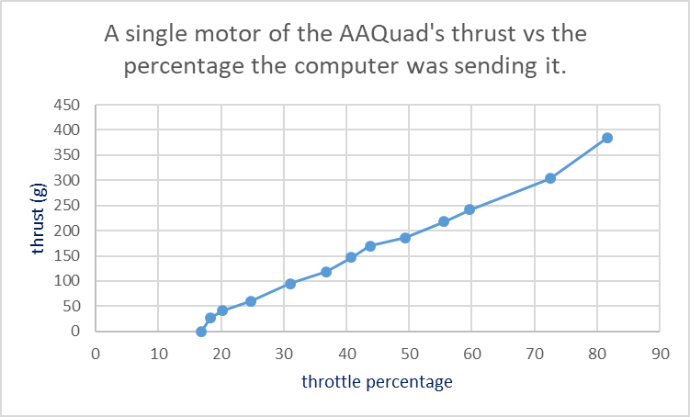In my test, I found that the curve that fits the results is the following:

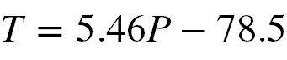

With a correlation coefficient of 0.997.

Where T is the thrust in g and P is the throttle percentage sent by the computer.

I also found that below 16.9% the motor did not start to spin and above 82 %, the results were incredibly inconsistent. The operating Range of my flight computer should therefore be between these 2 values.

**Finding the moment of force**:

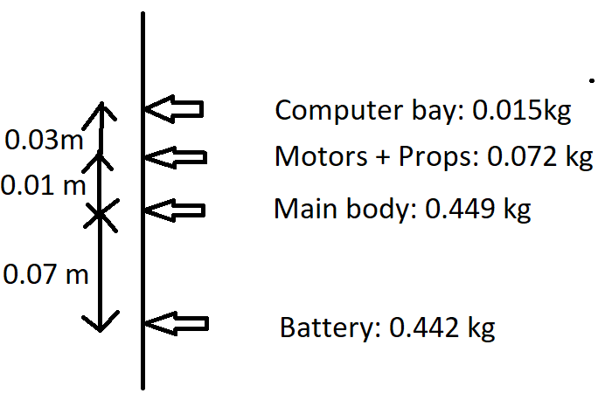

Vertical weight distribution of the AAQuad is show by this Image.

From it, It can be deduced that the CoG of the AAQuad is 0.0304 m below it’s center, or roughly 5.5 cm below it’s center of thrust.

The moment of force of a single motor is given by the following formula:

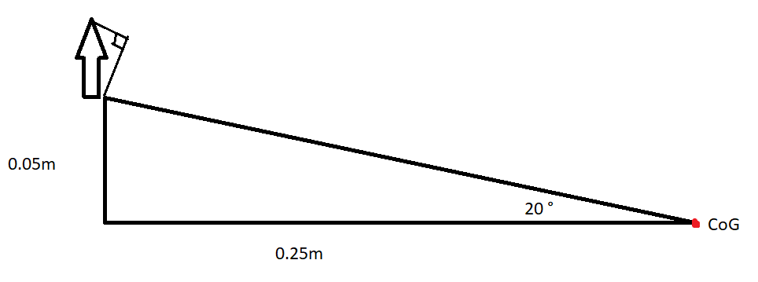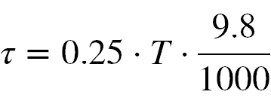

Where tau is the moment of force and T is the thrust in grams.

Combining this with the results of the thrust tests, we arrive at the following formula:

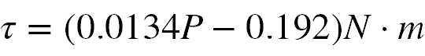

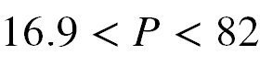

Where tau is the moment of force and P is the throttle percentage sent by the AAQuad flight computer.

It should be noted that in the case where more than 1 motor is running, it is the difference of percentages between both motors in the same plane that replace P. Therefore, in the case where both motors receive a throttle percentage of more than 16.9%, we may use the following formula to determine the total moment of force:

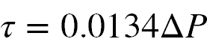

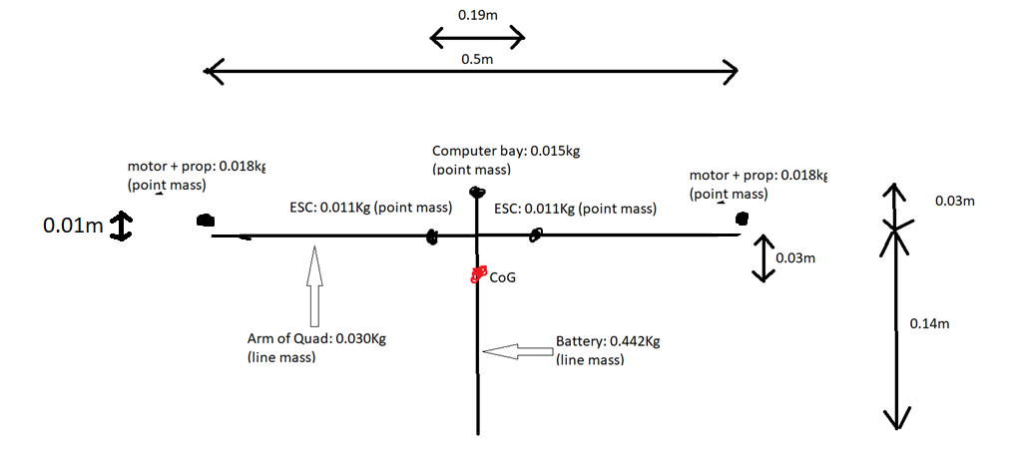

**Finding the Moment of Inertia:**

To find the moment of Inertia, I’ll slice the Quad as so:

This is the view of one the planes of the Quad. It must be remembered, however that there is another arm and set of 2 motors, looking and weighing the same as the one in view, expect going on and out of the paper.

Calculations of the moments of inertia: (note that parallel axis theorem was used)

Battery:

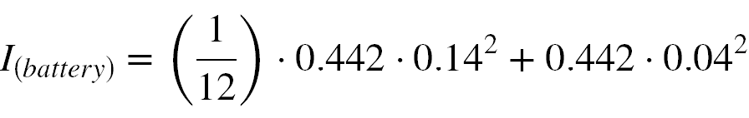

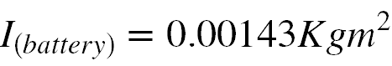

Computer bay:

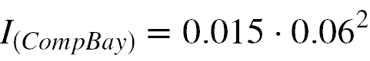



Motors (in the viewable plane of the above figure):

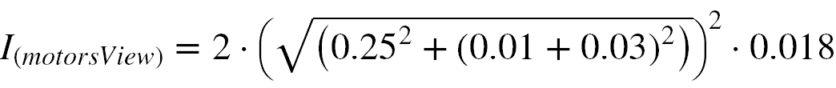

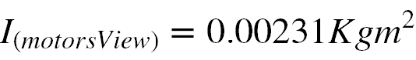

Motors (in the perpendicular plane):

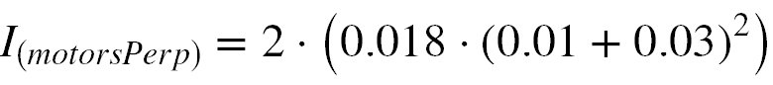

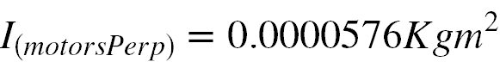

Esc’s (in the viewable plane):

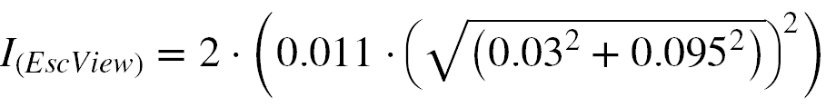

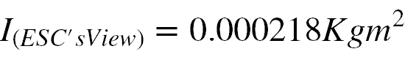

Esc’s (in the perpendicular plane):

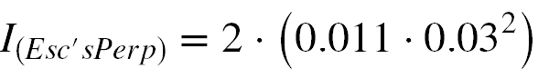

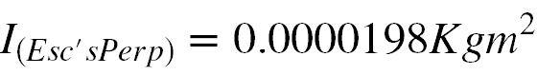

AAQuad arm (in the viewable plane):

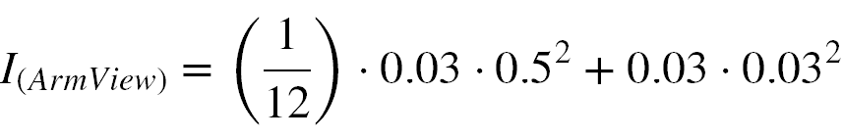

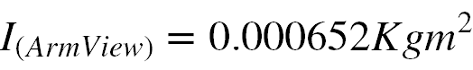

AAQuad arm (in the perpendicular plane):

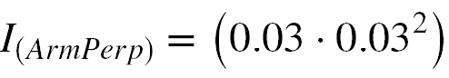

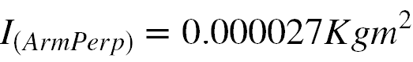

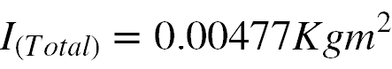

**Conclusions:**

In combining both formulas, we can achieve a formula that describes the angular acceleration of the AAQuad as a function of the throttle percentage as sent by the motors. It is the following:

