*** R Programming Language ***

INDEX PAGE

|  |  |  |
| --- | --- | --- |
| **S.NO** | **Questions** | **Page No.** |
| 01. | Write a program print “Hello world” to the screen. | 2 |
| 02. | Write a program that asks the user for a number n and prints the sum of the 1 to n. | 3 |
| 03. | Write a program that prints a multiplication table for numbers up to 12. | 4 |
| 04. | Write a function that returns the largest element in a list. | 5 |
| 05. | Write a function that computers the running total of a list. | 6 |
| 06. | Write a function that tests whether a string is Palindrome. | 7 |
| 07. | Implement the following sorting algorithms: Selection sort, Insertion sort, Bubble sort. | 8-10 |
| 08. | Implement linear search. | 11 |
| 09. | Implement binary search. | 12 |
| 10. | Implement matrices addition, subtraction and Multiplication. | 13-14 |

01.=> Print “Hello World” to the Screen.

> Here a simple R Program that prints “Hello, World”:

Syntax=> print(“Hello, World”)

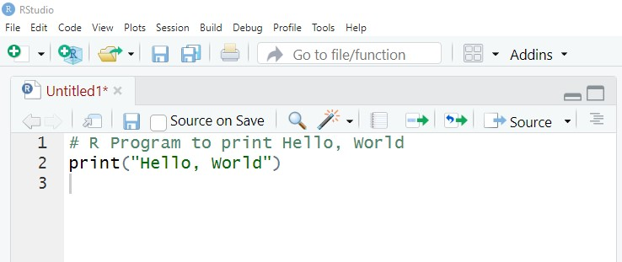 Code >

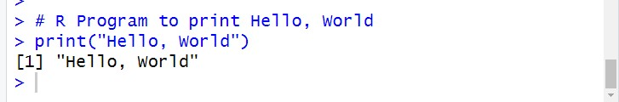 Output >

02. > Write a program that asks the user for a number n and prints the sum of the 1 to n.

>that prompts the user for a number n and prints the sumb of integers from 1 to n;

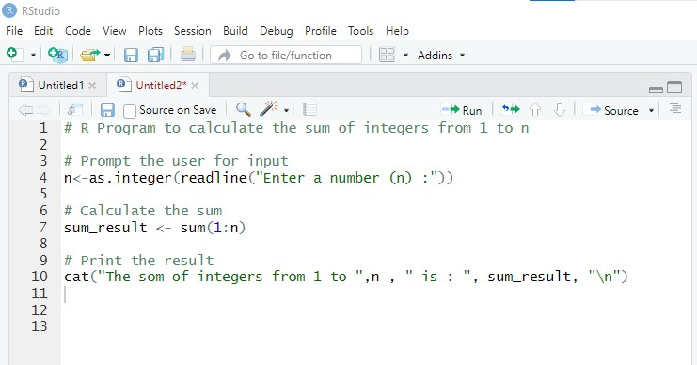 Code >

Output >

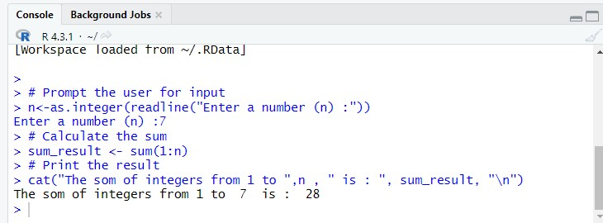

03. > Write a program that prints a multiplication table for numbers up to 12.

Code >

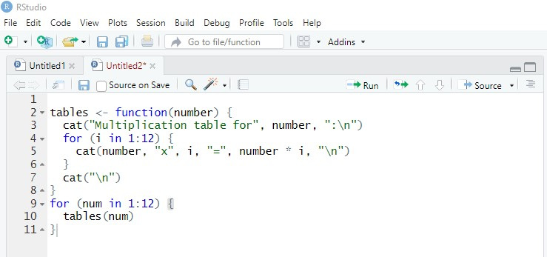

Output >

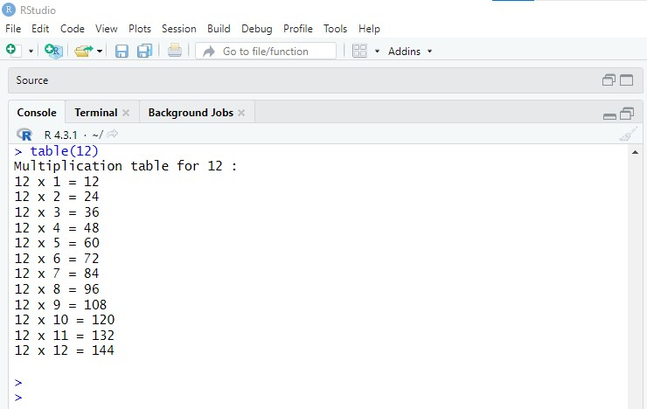

04. > Write a function that returns the largest element in a list.

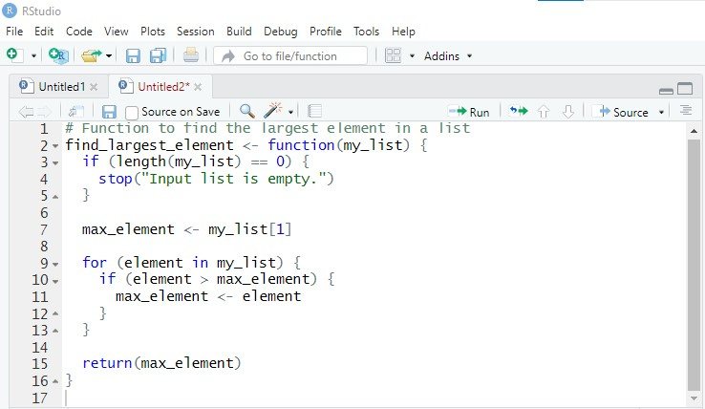 Code >

Output >

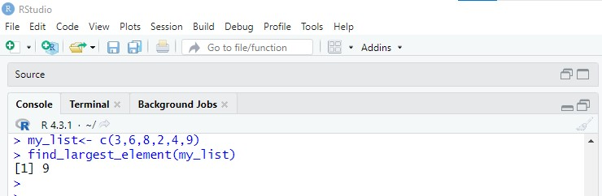

O5. > Write a function that computers the running total of a list.

Code >

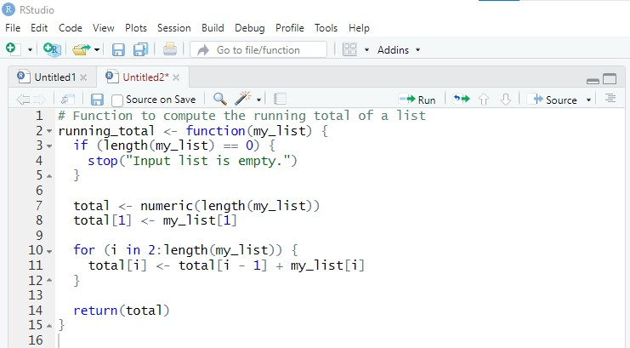

Output >

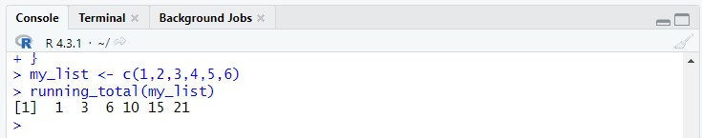

06. > Write a function that tests whether a string is Palindrome.

Code >

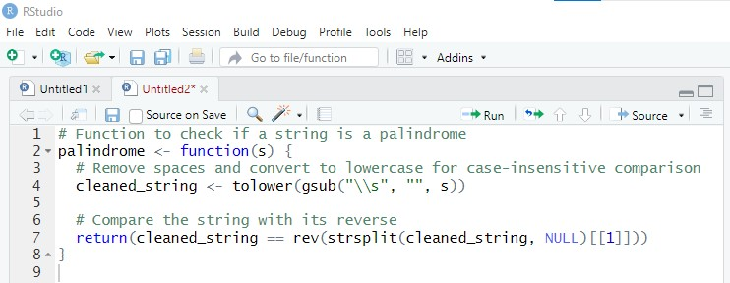

Output >

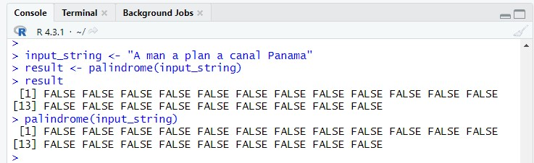

07. > Implement the following sorting algorithms: Selection sort, Insertion sort, Bubble sort.

Code > Selection Sort

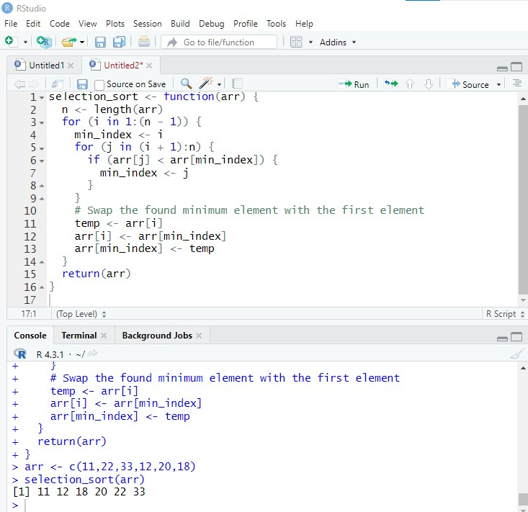

Code > Insertion Sort

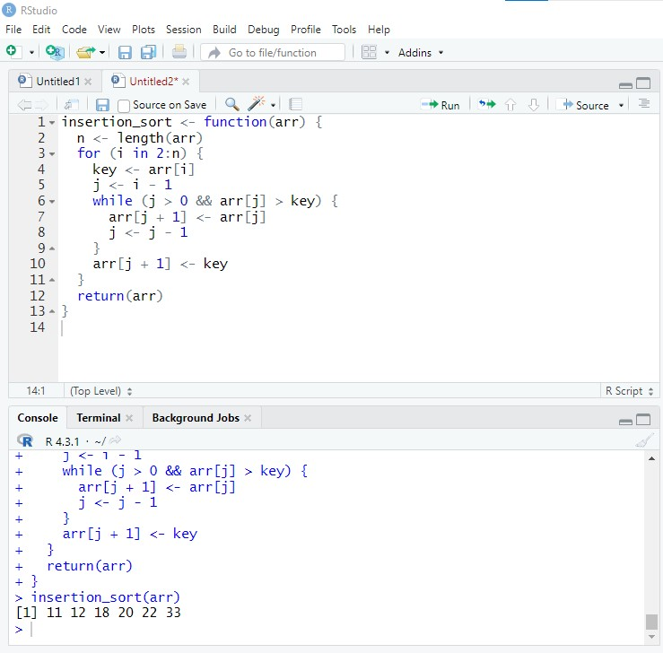

Code > Bubble Sort

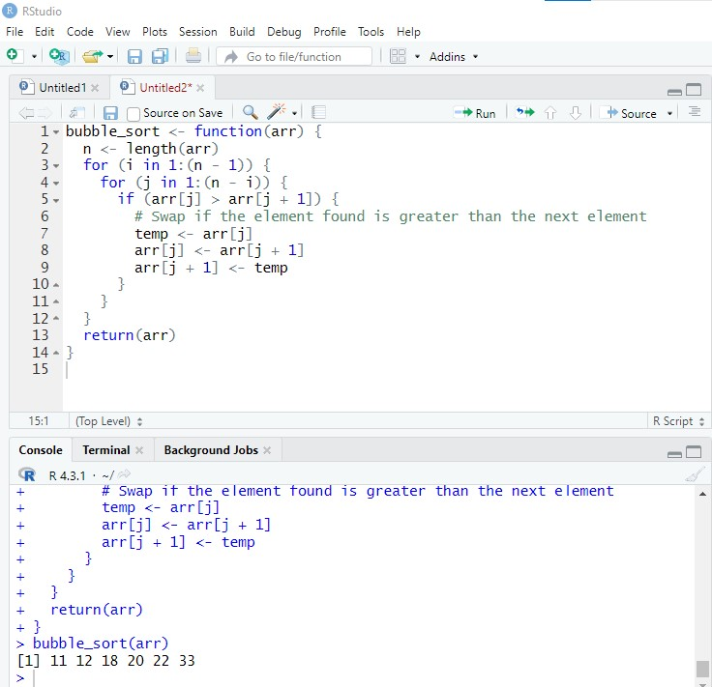

08. > Implement linear search.

Code >

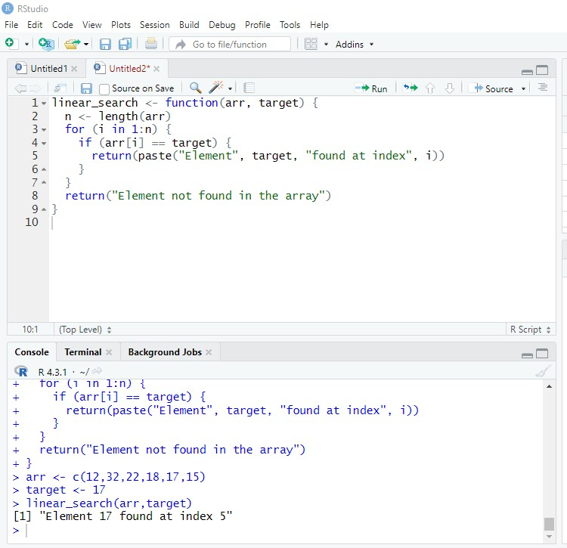

09. > Implement binary search.

Code >

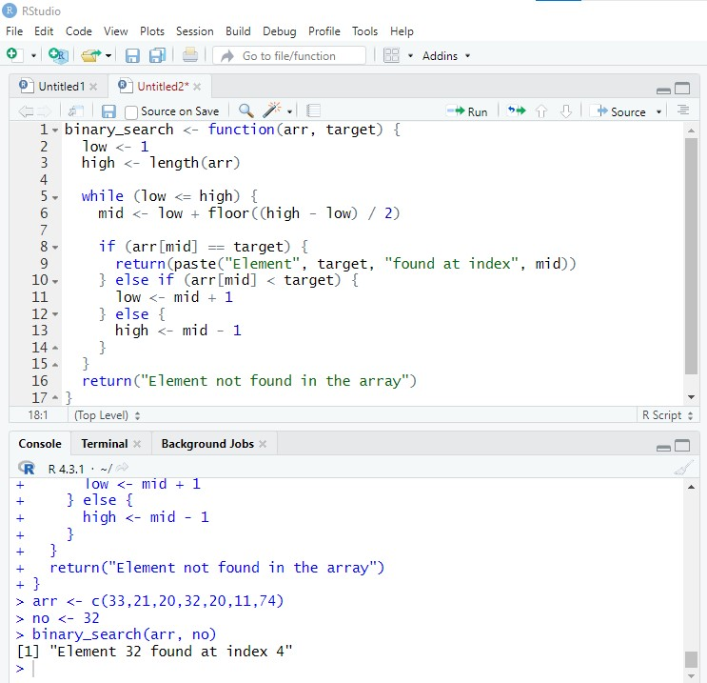

1. > Implement matrices addition, subtraction and Multiplication.

Code > Addition matrices

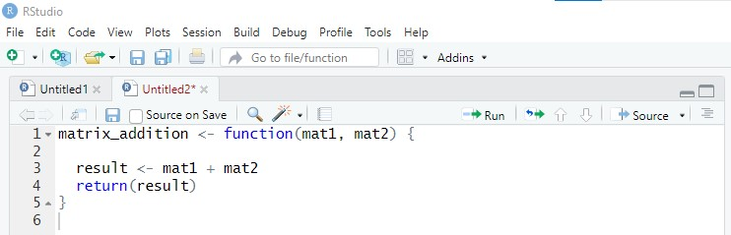

Output >

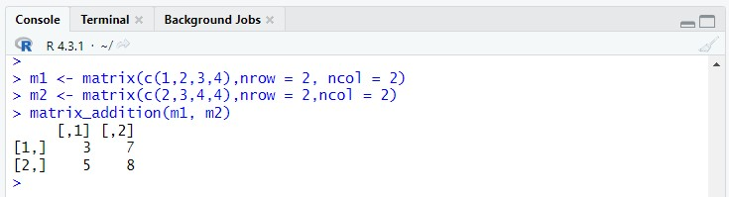

Code > Matrix Subtraction

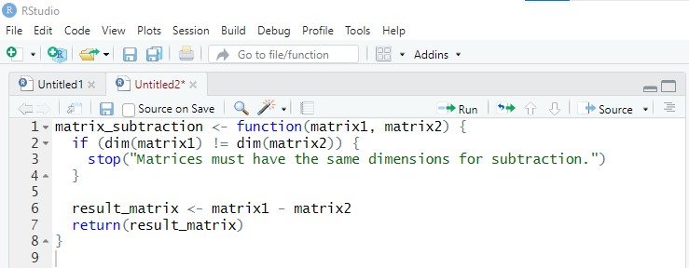

Code > Matrix Multiplication

