**Padel Rules: Quick overview of official padel regulations**

Whether you have heard of this sport or not. It does not really matter. With this post we will introduce you the padel rules in an accessible way, making sure you understand the game fast and easy. **We profoundly believe padel has the potential to become your favorite new sport.**Are you ready? Let´s start the game.

**WHAT PADEL RULES SHOULD I KNOW IN MY FIRST APPROACH TO IT?**

**NUMBER OF PLAYERS:**

**Padel is a team sport** in which we play with a partner to face another couple. That means we need 4 athletes to play it.

**DYNAMICS OF THE GAME:**

**1.**[**Padel imports**](https://allforpadel.com/blog/en/what-is-padel/)**the scoring system of tennis**. Matches are played to the best of 3 sets. The games follow the score of 15, 30, 40, Advantages and / or Equals. Since 2020, the use of golden point at 40-40 has been implemented in the professional circuit.

**2**. **As in tennis, we change side courts in the odd games**. Thus, we will change sides with 1-0, 2-1, 3-2, 4-3, 5-4...

**3**. The ball can be hit indistinctly by any player in any zone of the court.

**4**. **In padel, for the ball to be considered good it must touch the ground before hitting the walls or fences.** The only exception is with the serve, when we serve, the ball can only hit the wall after the bounce, never the fence. During the course of a point the ball may hit the walls and fences. The player may hit the ball with or without a bounce depending on the situation of the point.

**SERVE´S RULES**

**5.** How to perform a correct padel serve?  This is one of the most important rules of padel. The serve is considered good if the ball bounces inside the corresponding cross-quadrant . **As in tennis, the serve must be crossed, that is to say, the player serving from the right half of his court must direct the serve towards the square to his left in the opponent's court**. Unlike tennis, the ball is not thrown over the head to serve. In padel, the player must bounce the ball and can't hit it above the waist. **The serve can go to any area of the opponent's square but can never hit the side fence after the bounce.** On each service we have two opportunities to put the ball in play, that means if we missed our first service on the net or the ball bounces out, we still have another chance.

**6.** And when I serve, the ball touches the net and goes to the other side of the court? When the ball touches the net after the serve and goes to the other side of the court, there are several situations:

* If after touching the net, the ball does not bounce in the corresponding square it will always be bad.
* If after touching the net, the ball bounces in the corresponding square these situations can happen:

1. The ball bounces once and does not touch the side fence> It is considered null and the player has the right to repeat that service.
2. The ball bounces twice and touches the side fence> It is considered null  and the player has the right to repeat that service.
3. The ball bounces once and touches the side fence> It is considered bad and the player is not entitled to repeat that service

**MORE RULES**

**7**. Hitting the ball twice in the same shot is not allowed.

**8**. You are not allowed to play without adjusting the safety rope of the racket. Get used to it as your partner safety is very important.

**9**. If the opponent hits the ball hard, the ball bounces and goes out of the court, the point is considered won by the player who hit it. However, we always have the chance hit it from outside to the opponents side before the second bounce.

**10.** When the ball bounces, touches the wall or fence and returns to the opponent's court, the point is considered won by the player who hit it although we have the option to "safe" the point and hit the ball again even when it has crossed the net line into the opponent size of the court. This is a really flashy thing to do but is not easy, be careful, especially for begginers.

**11.** If we touch the net with the racket, clothes or any part of my body while playing any point, the point is won by my opponent. Now you know all you need to start enjoy this wonderful sport. But do you know the best way to learn anything? Trying it by yourself!. **IT´S TIME TO PLAY PADEL.**

<https://allforpadel.com/en/blog/padel-rules-quick-overview-of-official-padel-regulations-n231#:~:text=Unlike%20tennis%2C%20the%20ball%20is,side%20fence%20after%20the%20bounce>.

# What is the history of padel?

01/08/22 • 3 MINUTE READ

What is the history of padel?

**From Mexico to Britain via Argentina and Spain – the evolution of padel explained.**

## Who invented padel?

Mexican businessman Enrique Corcuera set up the first-ever padel court at his holiday home in Acapulco in 1969 – but the roots of the sport go back further than that.

During the 19th century, passengers on British cruise ships played a similar game with tennis rackets and in the 1910s ‘platform tennis’ became popular in Washington and New York, with paddles replacing traditional tennis rackets.

Over the next decade, changes were made to the courts, adding wooden floors and high surrounding fences to avoid losing the ball in the winter snow.

But it wasn’t until the 1960s when Mexican Enrique Corcuera set up the first recognised court on land he owned in Acapulco. The main difference being that he surrounded his court with walls and a metallic fence of up to four metres on all sides, designed to prevent the ball from escaping onto his neighbour’s land.

He called the sport Paddle Corcuera – and the rest is history.



## When did padel become an international sport?

Spanish enterpenuer Alfonso de Hohenlohe, a friend of Enrique’s, was the main driving force behind making padel an international sport.

While visiting Mexico in 1974, Hohenlohe enjoyed this new game so much that he decided to import it to Spain’s Costa del Sol, where he built the country’s first two padel courts at the Marbella Club.

The introduction of the courts marked the beginning of the game’s popularity among the members of this exclusive club, including the tennis player Manolo Santana, who won four Grand Slam titles.

Soon, tournaments were being organised along the Costa del Sol as more and more clubs built their own courts.

In 1975 an Argentine millionaire, Julio Menditenguia, discovered padel in Marbella and decided to take the sport to his country – where it became hugely popular.

Today there are more than two million officially licensed padel players in Argentina, a country that boasts more than 10,000 padel courts.

Padel is also wildly popular in Spain today as well. The European country has more than 20,000 padel courts, with an estimated six million active players. Behind football, it’s the country’s second-most-popular sport.

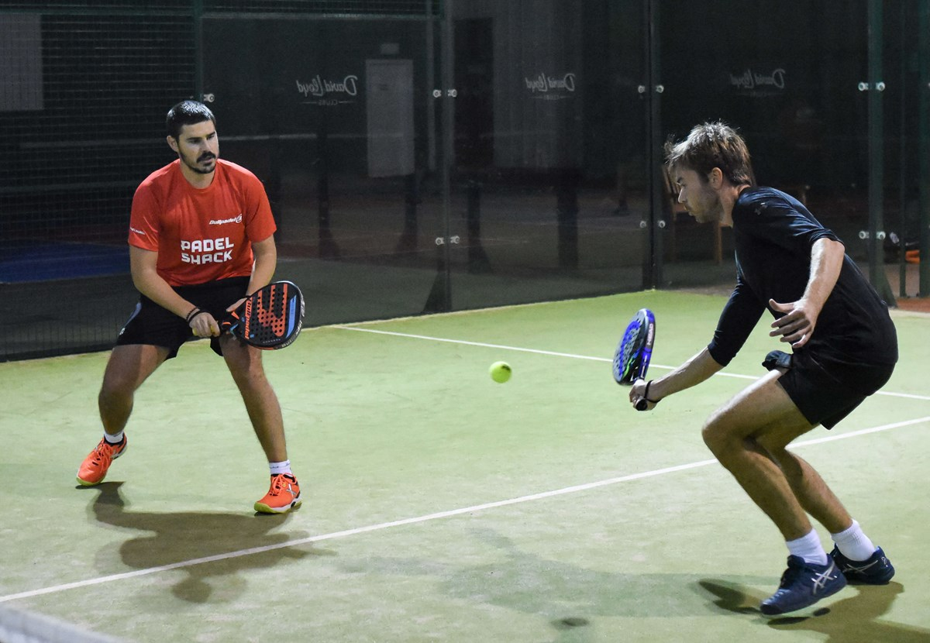

## When did padel become a professional sport?

In 1991 the International Paddle Federation was formed and in 1992 the first world championships were held in the dual cities of Madrid and Seville.

In 1993, the Sports Council of Spain recognised paddle as a sport, and changed its spelling to padel for pronunciation purposes in the Spanish language.

In 2005 the first professional world tour, Padel Pro Tour, was created. In 2013 this was renamed as the World Padel Tour – a circuit that still runs today with events held across the world.

## When was padel first played in Britain?

In 1992 the British Paddle Association was formed by a group of passionate British expats seeking to compete in the 1992 World Paddle Championships.

Since then the sport has steadily grown throughout Britain.

In 2019 the LTA announced it will integrate British Padel into the organisation’s day-to-day operations.

As of November 2020 there are around 6,000 active padel players across the UK. There are also currently 82 padel courts in Britain at 45 clubs – a number that is set to grow substantially over the coming years.

In November 2020 the LTA was confirmed as the national governing body for Padel and as part of its Padel Development Plan it is looking to have 400 padel courts in place across the United Kingdom by 2023.

<https://www.lta.org.uk/news/what-is-the-history-of-padel/>

VIDEOS

Men's BEST POINTS 2022 | World Padel Tour

<https://www.youtube.com/watch?v=Yrd3Px1uyTI>

How to play padel?

<https://www.youtube.com/watch?v=NX-68fxhL_4>

Padel Rules You NEED To Know

<https://www.youtube.com/watch?v=SPNVzkJSErs>

The 3 MOST COMMON Padel Tactics ERRORS

<https://www.youtube.com/watch?v=vdm5E3ZUUys>

Improve Your Padel In 24 HOURS!

<https://www.youtube.com/watch?v=nn0BZ2zB1nw>

10 🚹 Best Points - Mid Season | World Padel Tour

<https://www.youtube.com/watch?v=g9gRE5EVHFg>

10 🚺 Best Points - Mid Season | World Padel Tour

<https://www.youtube.com/watch?v=NM7FHxSRSms>