

[Document title]

[Document subtitle]



[Date]

[Company name]

[Company address]

Contents

**1.** **INTRODUCTION** 2

**1.1** **Problem Statement** 2

**2.** **System Analysis** 3

**2.1** **Unified Modeling Language** 3

**2.2** **Data Flow Description** 4

**2.3** **Data Flow in Depth** 5

2.4 E-R Diagram 5

# **INTRODUCTION**

In the times of Covid-19, for academic progress of students e-learning is the most essential system. The main goal to design this web application is to create a virtual platform for students as well as teachers for the continuous learning of students rather than stopping in the times of pandemic. Our system aims to the major 3 users of university they are administration, faculty employees and students. Other than these 3 components most important component that plays vital role is internet to provide the domain.

The aim to develop interface for learning system for students which might create a bridge between students and teachers in such times where both have to work at home. This work is very determined to provide user friendly system design for students who are very enthusiastic in acquainting the knowledge at any class level.

Considering these times as an opportunity to move the digital infrastructure of the university and make it more sharing based e learning system. Helping the future aspirants of the university is the main motive of this project also an easy interaction module for students with each other. Such interaction might result into many more innovative efforts which can bring university on the top list of the geographical area.

Under this platform there are some features which will be provided are: Students can easily interact with faculties any time over this platform and solve their doubts. Study materials can be accessed any time during the academic year. Faculties can connect with each student personally for their development and better studies. Encourages students to participate in activities. Improvement of skills at personal as well as technical level for students. Easy availability of reference books, test papers, etc., from the network.

## **Problem Statement**

* Objectives

The goal is to provide ease in access to exam papers. Our online platform will enrich students with education in order to get in touch with other friends and sharing innovative ideas. All the materials will be available in the form of e-data so that it can be easily accessed and environment is also saved by saving papers. The development of discussion forums to encourage students and participate in different ideas and doubt solving too.

Some successful stories that are expected to get as an outcome to each student by this portal or system are:

* Ease in understanding the materials by getting in touch with other colleagues.
* Fear of exams or tests will surpass as question banks and many sample papers will be available in the content section provided by students or teachers.
* A large number of students will gather on one platform and community will be formed irrespective of streams and that might help each other in any forms.
* All study materials will be in public for all students so it might be benefitted to everyone to gain knowledge.

# **System Analysis**

Our designed e-notes system supports web application mainly targeted for different training programs and knowledge sharing irrespective of discipline with a feature of accessing anytime, anywhere based on individual authorization system through unique user ID and Password.

The system is planned to deliver out of the box outcome than the existing learning systems. Some out of the box ideas are idea sharing, individual training report cards. Any course can be used at user’s pace of learning with content accessing system.

This idea is a initiative to train the students with high efficiency in a group of an organization. The whole system is managed with the software developed by using SQL and php that enhances users and admin to access tests, reports and content editing. It will be widely used in extensive manner at universities and rural colleges too.

## **Unified Modeling Language**

The UML is used for the object-oriented modeling which is universal notation for object-oriented architecture and design basically used for software applications. It expresses the high level of model of the system. It is also known as UML Model. For the purpose of object modeling the UML is used as a specific language. In this system the notation in the form of graphs is given for a model which is abstract and it is called as the UML Model. The main use of UML in the specifying, constructing, documentation and in the visualizing of the artifacts which are there in the intensive system of the software. It is used for writing the conceptual things including the system functions and the business process. It is also applicable to the database schemas , software components which are reusable and also for programming language statement .The method of UML is independent of the process . It has no connection with the SDLC process. The main work of UML is for the constructing, specifying, documenting and for the visualization. It is not a process but is a standard and cannot be taken as a method. The main work is the modeling and the software defining. It is not only related to the modelling software. It can be applied for the modeling of engineering systems, modeling of processes of business and also for the organizational structure representation. It can serve as the thing which will give impetus to the development of MDE, MDA and the MDD. It is used to solve the problem related to the architecture and the design of the systems which are complex.

## **Data Flow Description**

Our E-notes platform view at the zero level DFD. From this we can get the total information about the students, activity log and the assignment and also the test and the levels. The list of High-Level Entities and process stream of E-notes Platform:

* Student Management
* Activity Log Management
* Assignment Management
* Specialties Management
* Tests Management

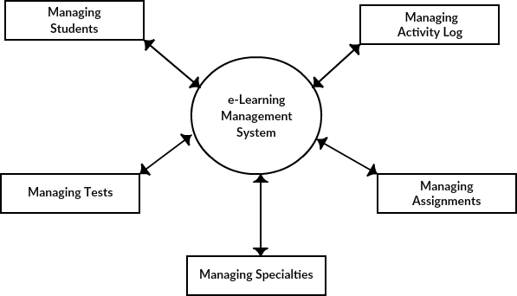

Figure 0-level DFD: E-notes

## **Data Flow in Depth**

* 1st Level of DFD explains about the main functionalities they are:
  + Data Processing and report Generation
  + Assignment records analysis and its report card generation for academic year
  + 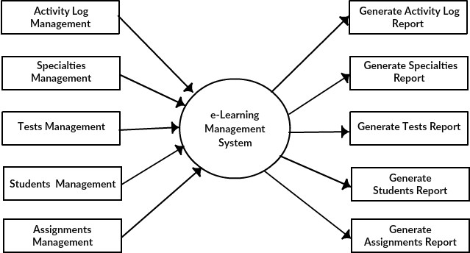Overall survey for new functionalities and data analysis for its implementation

Figure 1st-level: E-notes

* 2nd level data flow diagram brings us more enhanced view of the system functionalities that are opened up is related to information sharing of different test, students and assignment with the logs of all activity.
* Low Level functionalities of E-notes from the administration end:
  + Get, Put, Post, Delete of any notes, assignments, test, etc.,
  + Login approval for students as well as teachers.
  + Report generation of students
  + Search operations to manage the filters applied by respective users.

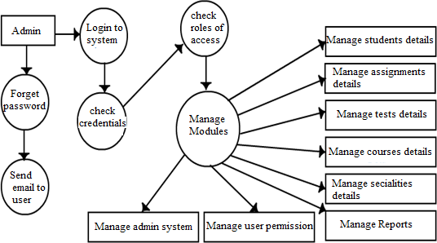

Figure 3 2nd level: E-Notes

## E-R Diagram

The entity of the E-notes learning platform can be known from the ER diagram. From this we can come to know the relation between the specialties, assignments, and the tests and the students. It also establishes the relation between the structural data set. The main entity are the specialties, assignment and the students.

Herewith, below is the table which could help with the database

|  |  |
| --- | --- |
| Student entity | **st_Id**, st_Id, st_name, st_contact, st_mail, st_pswd, st_uname, st_add, st_lvl |
| Course entity | Cs_id, cs_name, cs_desc |
| Specialties entity | sp_id, sp_name, sp_desc |
| Test entity | tst_id, tst_desc, tst_file, **cs_id**, tst_name |
| Assignment entity | ass_id, ass_name, ass_file, ass_desc, **cs_id, st_id** |

