

E-Notes: an enhanced system

[Document subtitle]



[Date]

[Company name]

[Company address]

Contents

**1.****INTRODUCTION** 3

**1.1****Problem Statement** 3

**2.****System Analysis** 4

**2.1****Unified Modeling Language** 4

**2.2****Data Flow Description** 5

**2.3****Data Flow in Depth** 6

2.4 E-R Diagram 7

**3.****Functional Requirements** 10

**3.1 Hardware Requirement:** 13

**3.2 Software Requirements** 13

**4.****REFERENCES** 14

**APPENDIX** 15

**Data definition :** 15

**Table Population:** 17

# **INTRODUCTION**

In the times of Covid-19, for academic progress of students learning is the most essential system. The main goal to design this web application is to create a virtual platform for students as well as teachers for the continuous learning of students rather than stopping in the times of pandemic. Our system aims to the major 3 users of university they are administration, faculty employees and students. Other than these 3 components most important component that plays vital role is internet to provide the domain.

The aim to develop interface for learning system for students which might create a bridge between students and teachers in such times where both have to work at home. This work is very determined to provide user friendly system design for students who are very enthusiastic in acquainting the knowledge at any class level and deliver it within the respective time frame.

Considering these times as an opportunity to move the digital infrastructure of the university and make it more sharing based E-note system. Helping the future aspirants of the university is the main motive of this project also an easy interaction module for students with each other. Such interaction might result into many more innovative efforts which can bring university on the top list of the geographical area.

Under this platform there are some features which will be provided are: Students can easily interact with faculties any time over this platform and solve their doubts. Study materials can be accessed any time during the academic year. Faculties can connect with each student personally for their development and better studies. Encourages students to participate in activities. Improvement of skills at personal as well as technical level for students. Easy availability of reference books, test papers, etc., from the network.

## **Problem Statement**

* Objectives

The goal is to provide ease in access to exam papers. Our online platform will enrich students with education in order to get in touch with other friends and sharing innovative ideas. All the materials will be available in the form of e-Notes so that it can be easily accessed and environment is also saved by saving papers. The development of discussion forums to encourage students and participate in different ideas and doubt solving too.

Some successful stories that are expected to get as an outcome to each student by this portal or system are:

* Ease in understanding the materials by getting in touch with other colleagues.
* Fear of exams or tests will surpass as question banks and many sample papers will be available in the content section provided by students or teachers.
* A large number of students will gather on one platform and community will be formed irrespective of streams and that might help each other in any forms.
* All study materials will be in public for all students so it might be benefitted to everyone to gain knowledge.
* All materials can be filtered out based on dates as all the material can be sorted in calendar form.

# **System Analysis**

Our designed e-notes system supports web application mainly targeted for different training programs and knowledge sharing irrespective of discipline with a feature of accessing anytime, anywhere based on individual authorization system through unique user ID and Password.

The system is planned to deliver out of the box outcome than the existing learning systems. Some out of the box ideas are idea sharing, individual training report cards. Any course can be used at user’s pace of learning materials with content accessing system.

This idea is a initiative to train the students with high efficiency in a group of an organization. The whole system is managed with the software developed by using SQL and php that enhances users and admin to access Materials, reports and content editing. It will be widely used in extensive manner at universities and rural colleges too.

## **Unified Modeling Language**

The UML is used for the object-oriented modeling which is universal notation for object-oriented architecture and design basically used for software applications. It expresses the high level of model of the system. It is also known as UML Model. For the purpose of object modeling the UML is used as a specific language. In this system the notation in the form of graphs is given for a model which is abstract and it is called as the UML Model. The main use of UML in the specifying, constructing, documentation and in the visualizing of the artifacts which are there in the intensive system of the software. It is used for writing the conceptual things including the system functions and the business process. It is also applicable to the database schemas , software components which are reusable and also for programming language statement .The method of UML is independent of the process . It has no connection with the SDLC process. The main work of UML is for the constructing, specifying, documenting and for the visualization. It is not a process but is a standard and cannot be taken as a method. The main work is the modeling and the software defining. It is not only related to the modelling software. It can be applied for the modeling of engineering systems, modeling of processes of business and also for the organizational structure representation. It can serve as the thing which will give impetus to the development of MDE, MDA and the MDD. It is used to solve the problem related to the architecture and the design of the systems which are complex.

## **Data Flow Description**

Our E-notes platform view at the zero level DFD. From this we can get the total information about the students, activity log and the assignment and also the test and the levels. The list of High-Level Entities and process stream of E-notes Platform:

* Student Management
* Activity Log Management
* Assignment Management
* Specialties Management
* Material Management

Managing Activity Log

Managing Students

Managing Specialties

Managing Notes Bar

Managing Material

Figure 1 0-level DFD: E-notes

## **Data Flow in Depth**

* 1st Level of DFD explains about the main functionalities they are:
  + Data Processing and report Generation
  + Assignment records analysis and its report card generation for respective calendar events.
  + Overall survey for new functionalities and data analysis for its implementation
* 2nd level data flow diagram brings us more enhanced view of the system functionalities that are opened up is related to information sharing of different test, students and assignment with the logs of all activity.
* Low Level functionalities of E-notes from the administration end:
  + Get, Put, Post, Delete of any notes, assignments, test, etc.,
  + Login approval for students as well as teachers.
  + Report generation of students
  + Student material sorting reports based on respective dates on the bar.
  + Search operations to manage the filters applied by respective users.

Generate Tests Reports

Generate Activity Log Report

Activity Log Management

Assignment Management

Generate Students Report

Generate Tests Reports

Student Management

Notes Management

Specialities Management

Figure 2 1st-level: E-notes

Admin

Manage Student Information

Manage Assignment Details

Manage Notes Information

Manage Calendar events

Manage specialities details

Manage permissions

Manage Admin system

Figure 3 2nd level: E-Notes

## **E-R Diagram**

The entity of the E-notes learning platform can be known from the ER diagram. From this we can come to know the relation between the specialties, assignments, and the tests and the students. It also establishes the relation between the structural data set. The main entity are the specialties, assignment and the students.

Herewith, below is the table which could help with the database

|  |  |
| --- | --- |
| Student entity | st_Id, st_Id, st_name, st_contact, st_mail, st_pswd, st_uname, st_add, st_lvl |
| Calendar entity | Cal_dt, cal_name, cal_desc |
| Specialties entity | sp_id, sp_name, sp_desc |
| Test entity | tst_id, tst_desc, tst_file, cal_dt, tst_name |
| Assignment entity | ass_id, ass_name, ass_file, ass_desc, cal_dt, st_id |

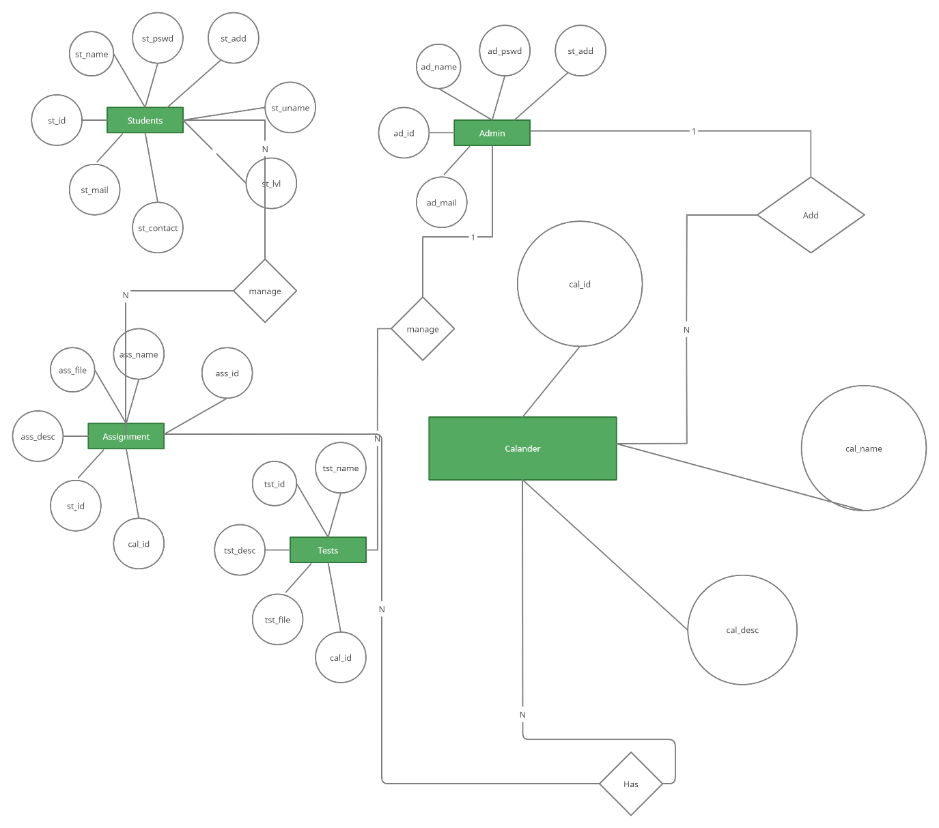

Figure 4 E-R Diagram : E-notes

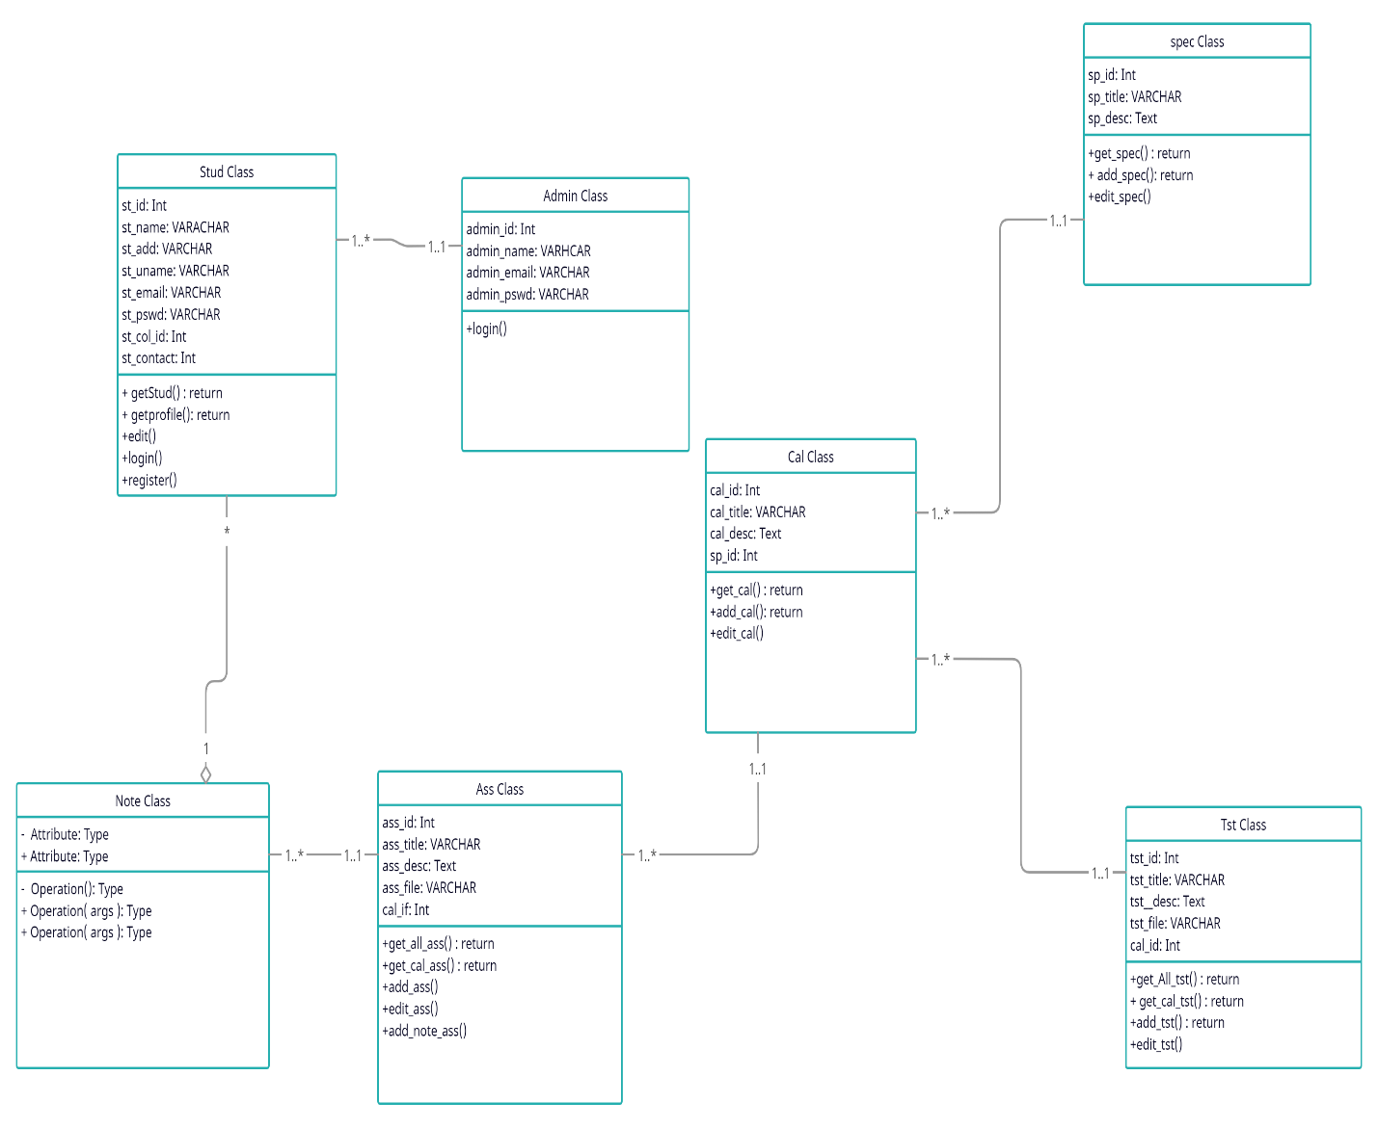

Figure 5 Class Diagram: E-notes

# **Functional Requirements**

For correct system we have to make a software system which can do the analysis. The main objective is in doing the analysis in a specific manner. The functional requirement are given as below

|  |  |
| --- | --- |
| **Functional Requirement** | |
| **Administrator** | |
| FR 1 | Password and username creation |
| FR 2 | Student account management |
| FR 3 | Upgradation of the login ability. |
| FR 4 | Completion and the log out process. |
| FR 5 | For editing , delete and creation of Materials . |
| FR 6 | Test creation, editing and delete. |
| FR 7 | Assignment creation, editing and the delete. |
| FR 8 | Specialties of creation, edition, delete. . |
| **Student** | |
| FR 1 | Test downloading ability |
| FR 2 | Assignments and Notes viewing. |
| FR 3 | Assignment and its solution. . |
| FR 4 | Data registration. |
| FR 5 | Profile updating and login. |
| FR 6 | Completion and final logout |

.

There is certain requirement which are nonfunctional. They include the convenience, availability

usability, consistency, reliability and the security. The section of designing of the database involve the following points such as the Admin, specialties, students, calendar, assignments, test.

* **Admin**

The profile of the admin is there in the stored by the admin table . All the details of all the admin will be given in this table .

**Table 3.1 Admin**

|  |  |  |  |  |  |
| --- | --- | --- | --- | --- | --- |
| Field Name | Data Type | Length | Key | A_T | Default value |
| ad_id | Int | 12 | Primary key | √ | None |
| ad_email | VARCHAR | 160 |  |  | None |
| ad_pswd | VARCHAR | 110 |  |  |  |
| ad_name | VARCHAR | 60 |  |  |  |
|  |  |  |  |  |  |

* **Specialties**

The specialty data are obtained from the table of the specialty . The data can be seen from the table below:

**Table 3.2 Specialties**

|  |  |  |  |  |  |
| --- | --- | --- | --- | --- | --- |
| Field Name | Data Type | Length | Key | A_T | Default Value |
| sp_id | INT | 12 | Primary Key | √ | None |
| sp_title | VARCHAR | 30 |  |  | None |

* **Student**

The profile of the student can be seen from the student table, The details of the signed up students is given from the table

**Table 3.3 Student**

|  |  |  |  |  |  |
| --- | --- | --- | --- | --- | --- |
| Field Name | Data Type | Length | Key | A_T | Default value |
| st_id | Int | 12 | Primary Key | √ | None |
| st_uname | VARCHAR | 30 |  |  | None |
| st_pswd | VARCHAR | 30 |  |  | None |
| _email of Student | VARCHAR | 60 |  |  | None |
| Name of Student | VARCHAR | 60 |  |  | None |
| _collage_id of Student | Int | 20 |  |  | None |
| Address of students | VARCHAR | 60 |  |  | None |
| Level of students | VARCHAR | 12 |  |  | None |
| Mobile of students | VARCHAR | 12 |  |  | None |

* **Calendar**

The information related to the material can be obtained from the table related to the calendar date events and alerts.

**Table 3.4 Courses**

|  |  |  |  |  |  |
| --- | --- | --- | --- | --- | --- |
| Field Name | Data Type | Length | Key | A_T | Default Value |
| cal_dt | Date(dd/mm/yyyy) | 12 | Primary Key | √ | None |
| cal_title | VARCHAR | 30 |  |  | None |
| cal_desc | TEXT |  |  |  | None |

##### **Assignment**

##### From this we can get the information of the e-Notes stored by the students using this platform

**Table 3.5 Assignments**

|  |  |  |  |  |  |
| --- | --- | --- | --- | --- | --- |
| Field Name | Data Type | Length | Key | A_T | Default Value |
| ass_id | INT | 12 | Primary Key | √ | None |
| ass_title | VARCHAR | 30 |  |  | None |
| ass_desc | TEXT |  |  |  | None |
| ass_file | VARCHAR | 60 |  |  | None |
| ass_id | Int | 12 | Foreign key |  | None |

* **Tests**

The data related to the test from all the courses can be given in the table.

**Table 3.6 Tests**

|  |  |  |  |  |  |
| --- | --- | --- | --- | --- | --- |
| Field Name | Data Type | Length | Key | A_T | Default Value |
| tst_id | INT | 12 | Primary Key | √ | None |
| tst_title | VARCHAR | 30 |  |  | None |
| tst_desc | TEXT |  |  |  | None |
| tst_file | VARCHAR | 60 |  |  | None |
| tst_cal | Int | 12 | Foreign key |  | None |

## **3.1 Hardware Requirement:**

|  |  |
| --- | --- |
| Space of the disk | 160MB free (min) + extra for storage of the material.  . 5GB is the minimum requirement |
| Backups | As as above to keep the backups of the site . |
| Memory | 256MB (min), 1GB and even more can be needed . For every 10-20 users in the e-note platform there is aRAM of 1 GB . The server process the memory at the same time and does not imply that the people are logged in . |

## **3.2 Software Requirements**

The last comes the application associated with the application form. It involves the training, installing, testing, programming and so on. The ownership is transferred from the project group to the customer performing.

* XAMPP

XAMPP is a completely free, easy-to-install Apache division containing MySQL, PHP, and Perl. XAMPP can be used for testing of the work without the use of internet and can also be applicable for the web pages on the web. It helps in the protection of the package. They provide the tools required for the admins, programmers and the web developers. The following are the tools included in it:

The most widely used software is the Apache It is prepared by the 0Indian software foundation. It contains many systems such as the Free BSD Apache, Novel, NetWare OS 10 , Microsoft Windows , Open VMS and so on. . Apache is open-source software.

* PHP

It is useful as a general purpose language . It can be combined with HTML It is applicable for the command line interface and can be used for the standalone graphic applications . The main features are it does not require any declaration about the variable . It gives the suitability for the cross-platform application. It is useful for preparing the problem notice.

# **REFERENCES**

1. Bhuiyan, T., Yousuf, K. B., Urmi, S. K., Nahar, A., & Ali, N. Y. (2013, August). Development of a Web-Based E-Learning System for Teaching Institution. In *3rd International Conference on Intelligent Computational Systems, Singapore*.
2. https://app.creately.com/diagram/XuK12BTjVnD/edit
3. Al-Hamdan, A. M. (2019). *E-Learning Platform (EduCare)* (Doctoral dissertation, Ministry of Higher Education).
4. KAMAGA, S., KOZONO, K., SUEMITSU, M., KIYAN, T., OHSHIMA, Y., & AKIYAMA, H. (2010). Development of Streaming Contents Generation System for Rapid e-Learning. In *Proceedings of the 18th International Conference on Computers in Education (ICCE2010)*.
5. Wiener, R. S., & Pinson, L. J. (1988). *An introduction to object-oriented programming and C++*. Addison-Wesley Longman Publishing Co., Inc..

# **APPENDIX**

## **Data definition :**

**Table Name: Student**

CREATE TABLE Student (

st_Id INT NOT NULL,

st_name CHAR(30) NOT NULL,

st_contact INT,

st_mail INT,

st_pswd CHAR(30) NOT NULL,

st_uname CHAR(30) NOT NULL,

st_add CHAR(100) NOT NULL,

st_lvl CHAR(30) NOT NULL,

PRIMARY KEY (st_Id));

**Table Name: Cal**

CREATE TABLE Cal(

cal_dt date NOT NULL,

cal_name CHAR(30) NOT NULL,

cal_desc CHAR(300) NOT NULL,

PRIMARY KEY (cal_dt));

**Table Name: Specialties**

CREATE TABLE Specialties(

sp_id INT NOT NULL,

sp_name CHAR(30) NOT NULL,

sp_desc CHAR(255) NOT NULL,

PRIMARY KEY (sp_id));

**Table Name: Test**

CREATE TABLE Test(

tst_id INT,

cal_dt date NOT NULL,

tst_file CHAR(255) NOT NULL,

tst_name CHAR(255) NOT NULL,

PRIMARY KEY (tst_id),

FOREIGN KEY (cal_dt) REFERENCES cal(cal_dt));

**Table Name: Assignment**

CREATE TABLE Assignment(

ass_id INT,

cal_dt date NOT NULL,

st_id INT NOT NULL,

ass_name CHAR(255) NOT NULL,

ass_file CHAR(255) NOT NULL,

ass_desc CHAR(255) NOT NULL,

PRIMARY KEY (ass_id),

FOREIGN KEY (st_id) REFERENCES Student(st_id),

FOREIGN KEY (cal_dt) REFERENCES cal(cal_dt));

## **Table Population:**

## 

**Table Name: Student**

INSERT INTO student (`st_Id`, `st_name`, `st_contact`, `st_mail`, `st_pswd`, `st_uname`, `st_add`, `st_lvl`) VALUES

(

'1',

'Rahmanmolla Molla',

'+96526777000',

'molla_rah@gmail.com',

'mollah1234',

'mollah_ranman',

'PO Box 13373 Farwaniya 81004,Kuwait',

'7'

);

**Table Name: Cal**

INSERT INTO `cal` (`cal_dt`, `cal_name`, `cal_desc`) VALUES

(

'12/05/2021',

'Cloud Computing',

'we are in demand from the biggest companies! Get certified today. Most value for money AWS training online. Get fantastic exclusive deals! Check offer now. Instructor-led Classes'

);

**Table Name: Specialties**

INSERT INTO `specialties` (`sp_id`, `sp_name`, `sp_desc`) VALUES

(

'201',

'Deep Learning',

'xDeep Learning is one of the most highly sought after skills in AI'

);

**Table Name: Test**

INSERT INTO `test` (`tst_id`, `cal_dt`, `tst_file`, `tst_name`) VALUES

(

'301',

'12/05/2021',

'MCQTest.docx',

'MCQ Test on Cloud Computing'

);

**Table Name: Assignment**

INSERT INTO `assignment` (`ass_id`, `cal_dt`, `st_id`, `ass_name`, `ass_file`, `ass_desc`) VALUES

('505',

'12/05/2021',

'1',

'Mid Term Assignment',

'midTermAss.docx',

'Mid Term Assignment for Learner , There are Two Assignments will creak for certificate '

);