***Design III – Final Design***

1. **Mechanical Configuration**

**Battery Module**

The battery module is assembled by taking six Sanyo 20700A cells, Adding an M12 Plastic Spacer and then finally the Cu101 conductor. A fuse wire (see electrical section) is welded in the hole between the battery and conductor. This wire acts as the last line of defence in the case of an overcurrent during charging or the first line in the case of a battery Short Circuit. Six of these cells are connected in parallel and they collectively make one battery module. There are 90 such modules in the entire battery pack (Making a total of 540 cells).

**Integrated Module Busbar**



The Module Busbar will be made of Cu101 grade Copper. It will run along the side of the cells (both +ve and -ve) and connect to them via fusible link wires. The top cylinder will be bent and inserted into the module cap where it will be connected in series with other modules and bolted down with an M10 Nut

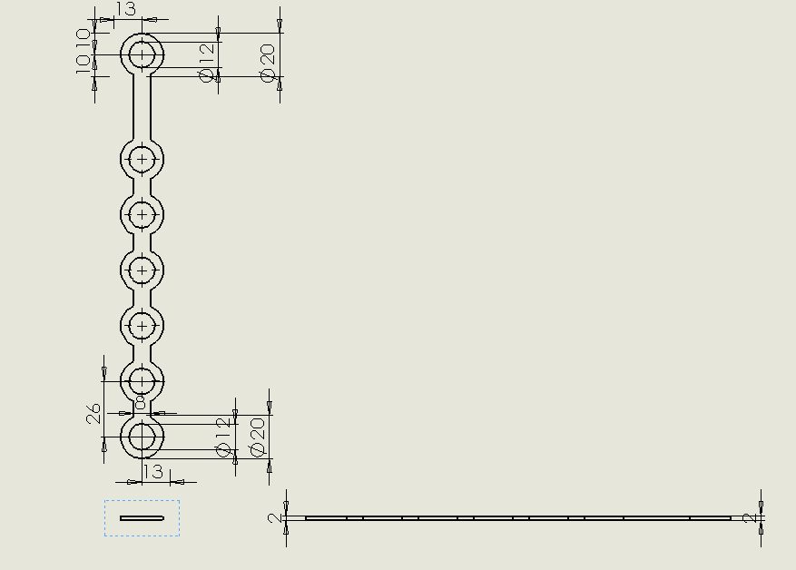

**Module Cap**

The Module Cap will be made of ABS Plastic. It has two circular holes at the top where an M10 bolt will be fastened to join the modules in series. There is a side cut to allow insertion of an M10 nut and finally, the rectangular holes at the sides will let the Conductor through from the Module Side Insert

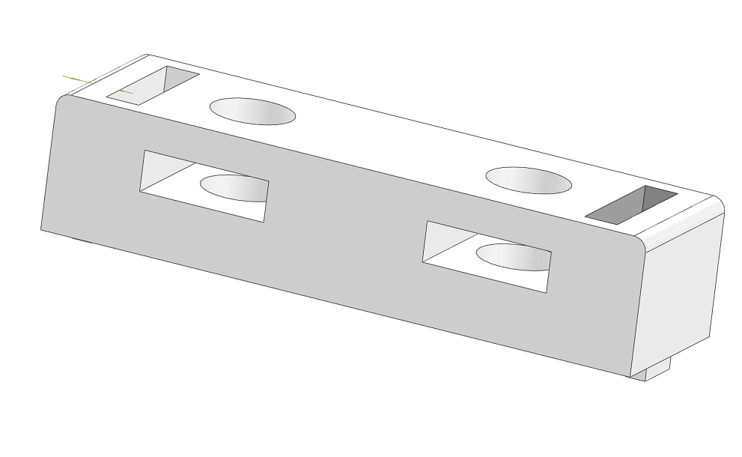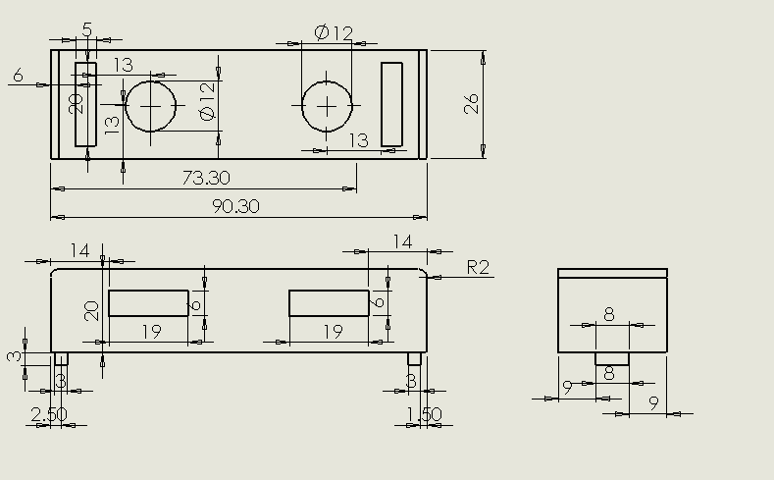

**Module Side Insert**

The Module Side insert (made with ABS) will accommodate the copper busbars. The circular spaces are 1mm larger than the busbar diameter to ensure a nice fit. ABS has a high tolerance of up to 110C so is adequate for our battery housing purposes.

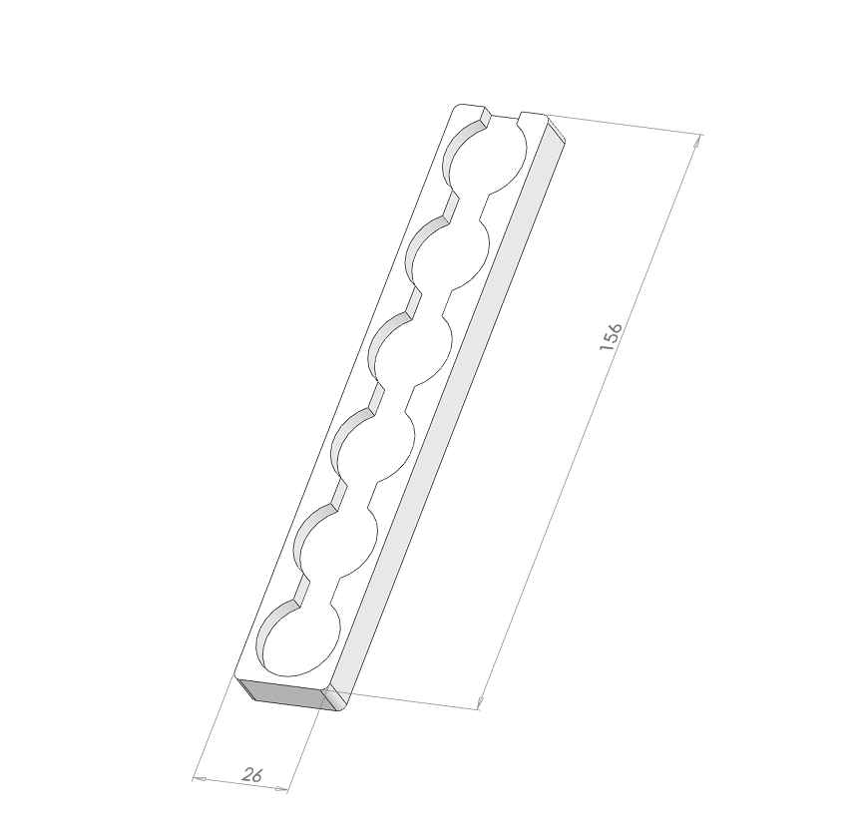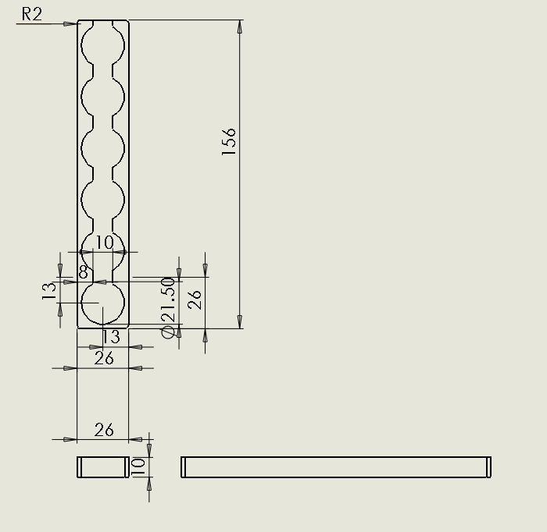

**Assembling Battery Module**

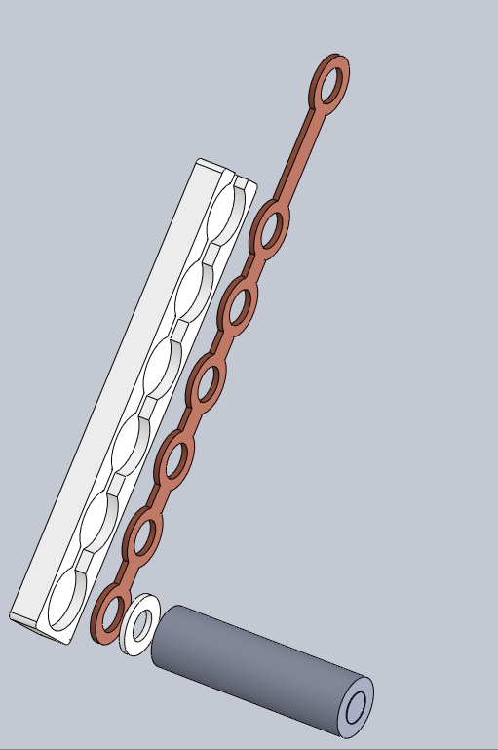 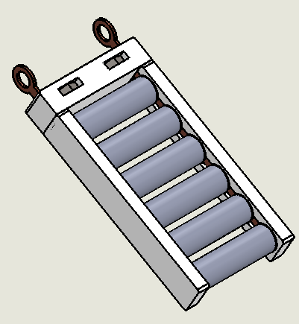

Left: Visualizing Module Assembly Steps

Right: Final Module Assembly (Note the M10 Nut inserted into the Module cap)

Each module is in effect an 18.6A (3.1A*6), 3.6Volt battery and 90 modules (18 per section *5sections) will be connected in series to give us a final pack voltage of 324V, I=18.6A (at 1C Discharge, 180A Max. Continuous discharge), P=6.026kW/4.338MJ.

**Section Calculations**

EV3.3.3 states that each section must be no greater than 120V, 6MJ.

Our section design here is 3.6V*18=64.8V /1.205kWh/ 4.336MJ which meets the requirements.

**Battery box assembly**

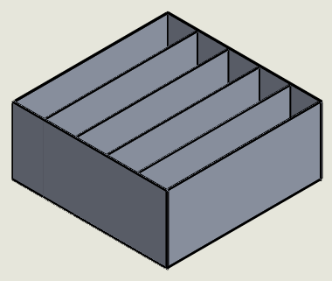

The battery box will be made of a 3.2mm thick, 464.2mm*468mm 6061-TS Aluminium plate as a base with four 2.3mm walls (and 200mm high) fastened with M8 bolts to divide the box into five sections and finally four 2.3mm thick external walls (205mm high) fastened with M8 bolts. The internal walls will then be covered with fire retardant formex and 18 modules inserted in each section. The PCB for each section will be inserted in the 32mm gap between the top of the modules and the top of the internal vertical wall.

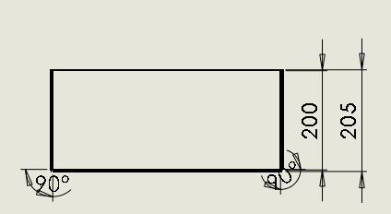 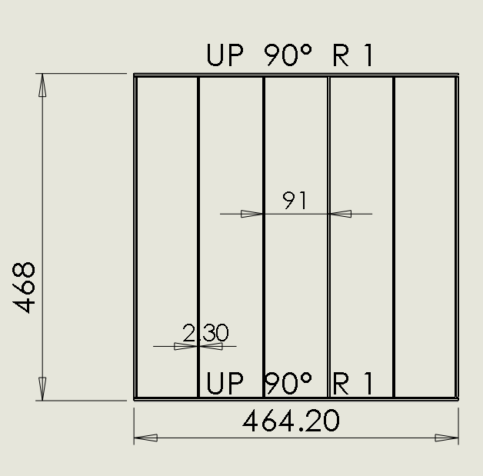

1. **Electrical Configuration**

**Battery Management System**

Temperature Acquisition Circuit

The temperature sensors will be placed at the end of each cell. The sensor selected is a Texas Instruments LMT-84 in a TO-92 Package. This will be inserted into the module PCB which then connects to a module multiplexer. This multiplexer selects one cell per module and sends the temperature value to the Analog to Digital Converter (ADC), once the temperature is converted and sent to the microcontroller, the microcontroller signals to the multiplexer to take the next cell temperature and this goes on until all six cells in a module are measured. Since there are 18 modules in each section, there will be three such ADCs per section. Each ADC is responsible for six modules. (see block diagrams below) The ADCs send the digital information of the cell temperatures to the Microcontroller using I2C communication. Instead of directly reading all 108 cells in a section (6 cells * 18 modules) which will require 108 analog pins or 18pcs of 8-channel ADCs, we are able to save space and cost by using a local multiplexer to switch temperatures.

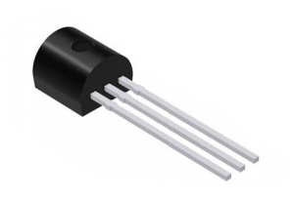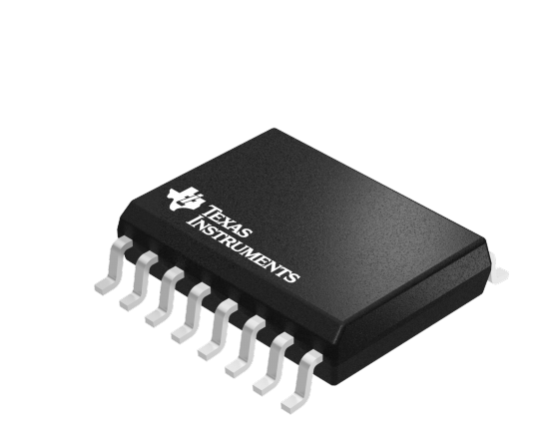

LMT84 Temperature Sensor and SN74LVxx MUX

The LMT84 is a precision CMOS temperature sensor which has a linear Voltage to temperature behaviour making it superior to NTC sensors (which have nonlinear behaviour and are very much affected by self-heating). It operates between 1.5V to 5V (VDD­)

The TI SN74LV4051A-Q1 is an Automotive rated 8 Channel CMOS multiplexer that has one output. The switching is done by the microcontroller and all 90 modules will have their local MUX unit which will all be connected by the same four GPIO pins from the µC. It comes in a compact 8.89*10.63*2.65mm SOIC package and will be inserted in a PCB just above the modules in the battery box. 2V < VDD <5.5V

The TI ADS7828-Q1 is an Automotive rated 12-bit, 8 Channel Analog to Digital Converter (ADC) with an I2C communications port and a 50kHz Sampling rate. It comes in a TSSOP 6.4*5mm package. 2.7V < VDD <5V

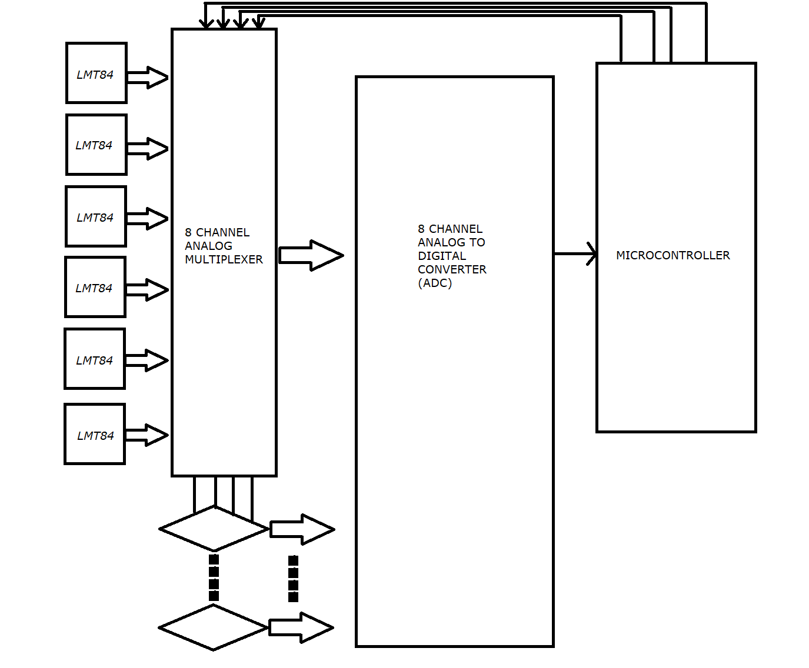

Temperature Acquisition Block Diagram (Thick arrows indicate Analog Paths; thin arrows indicate Digital Paths)

Battery Protection

A Renesas ISL92403 IC will be used for battery monitoring, protection and voltage balancing. It has a capacity of 3-8 cells but since our modules are in parallel, each monitor IC will handle 6 modules (i.e. 36 cells) and there will be three per section. It is a semi-autonomous unit that can do all the protection tasks required without the help of a microcontroller(µC), it has I2C communications capability and this will be used by the µC sparingly. This design ensures the micromanagement is done locally and the µC will be for data logging, coulomb counting and last resort interference.

Fuse Wire Rating

We want our fuse wire to melt when current goes over 30A in five seconds

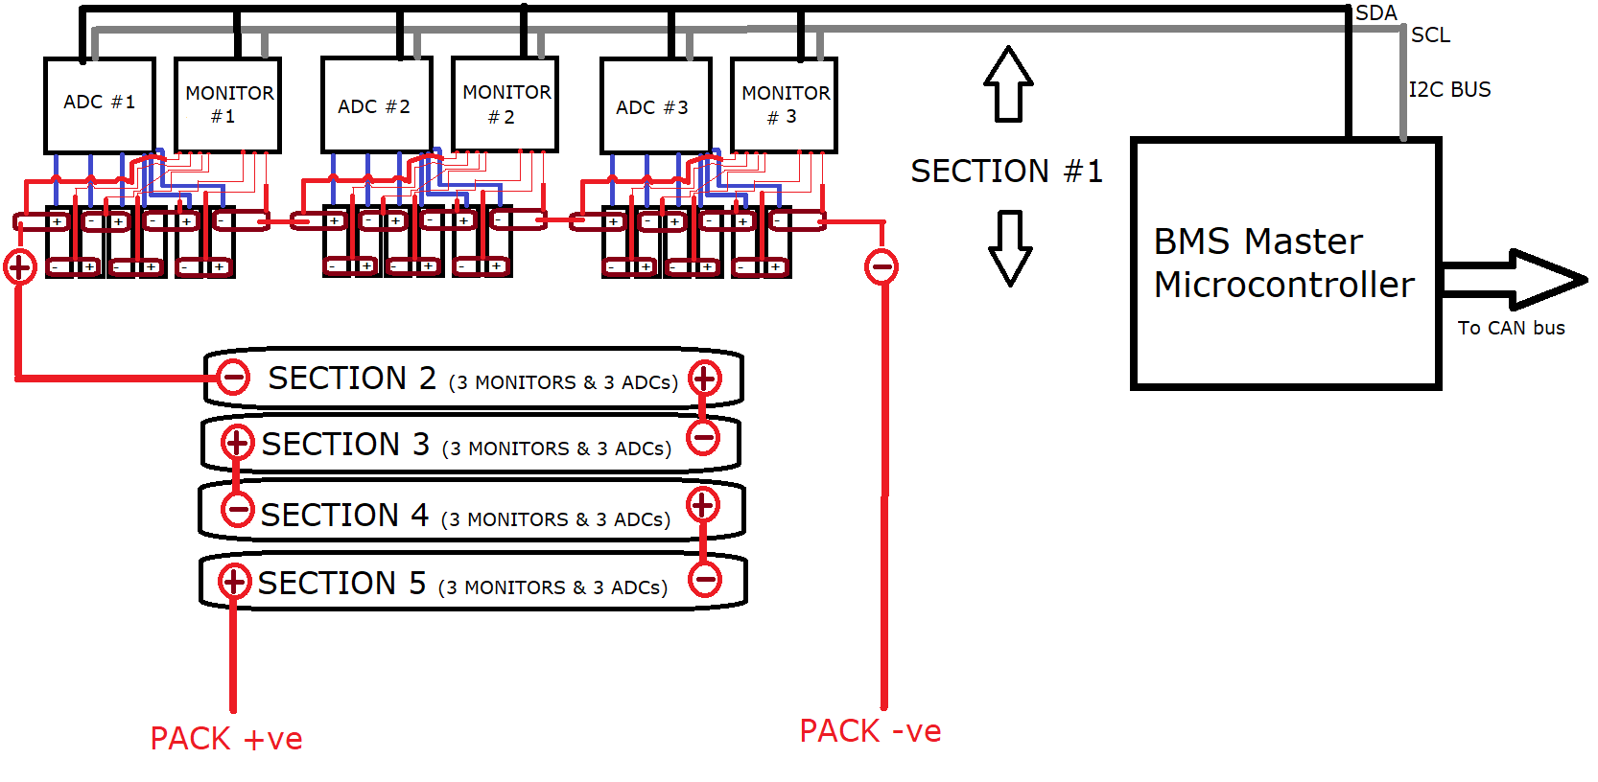

BMS block diagram – Thick red is high voltage, thin red is voltage sense, black and grey are the bidirectional communications channels on the I2C bus (one line for data, and one for the clock), Blue is the Temperature sense (explained above)

**Manufacture Plan**

3D printing can be used for the rapid prototyping and testing stage. However, because of the cost of 3D printing 90*2=180 side inserts, it is more economical to use injection moulding when the full pack is ready to be produced. The cost of the moulding tool and the will be cheaper than 3D printing all the Plastic parts and if we want to make a standby battery box (to implement the proposed fast change battery feature), the presence of the moulding tool makes it astronomically cheaper the second time around (this shall be explored further in the Cost Report)

The copper busbars will be CNC milled from 2mm thick rectangular Copper bars

Each module will require one PCB running along the side of the ABS side part (to acquire the temperature) and Each section will require one PCB running along the top where the six slave I2C Devices (ADCs and Monitors) will be mounted.

**Future work**

Testing of design

The circuit will have to be fully simulated and corrections made before the parts are purchased

Stress Testing of Battery Box

The battery box would have to be further analysed using FEA to make sure it can withstand stresses required (40g longitudinal and lateral Acceleration, and 20g vertical acceleration)

Full thermal characteristics to devise cooling system

The cooling systems cannot be devised just yet because the thermal characteristics of the cell are currently unknown. In the new year, a specimen of the cell will be acquired, and an equivalent circuit based on the cell’s thermal behaviour will be made. Then, it will be simulated over racing conditions and the temperature behaviour observed. It is at this point that a cooling system will be picked.

BMS software will have to be written to convert all internal I2C communications to CAN format so that the BMS can interact with the main vehicle ECU over a CAN bus.