**Electric Vehicle Subgroup**

**Final Report**

Ahmed Abid-Ali

Fe-eze Anyafulu

MEngElectrical Engineering Part 4

City, University of London

11 June 2018

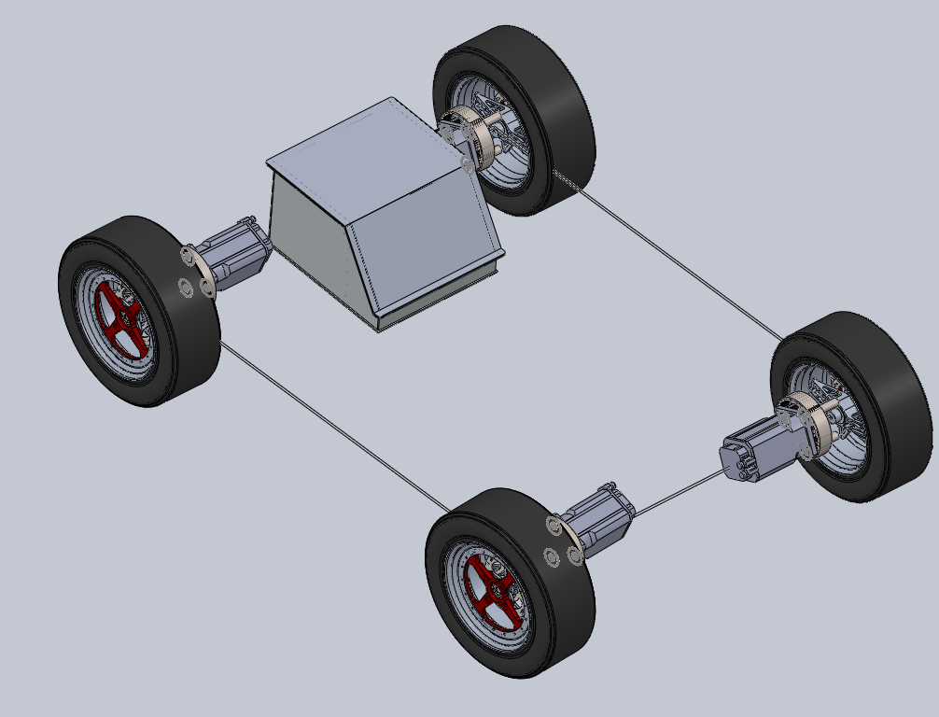

Contents

1 Introduction 2

2 Drivetrain 2

2.1 Introduction 2

2.2 Aims and objectives 2

2.2.1 Performance 2

2.3 Different conceptual designs 2

2.3.1 Analysing the forces acting on a four-wheel drive system 3

2.3.2 Maximum acceleration on a level road 4

2.3.3 Requested torque 4

2.4 Motor requirement calculations 5

2.5 Requested torque 6

2.6 Calculating maximum speed reached at 75 [m] 7

2.7 Motor specification 8

2.8 Choosing a motor 8

Torque/ Weight 8

3 Transmission system 8

4 Motor Controller 9

4.1 Front line task 9

5 Energy Storage and Protection 10

5.1 Introduction 10

5.3 AIMS AND OBJECTIVES 10

5.4 PERFORMANCE REQUIREMENTS 11

6 Conceptual Design 12

7 Final Design 15

8 Front line task 19

References 19

# 1 Introduction

Electric vehicles can achieve greater energy efficiency than internal combustion vehicles (90% vs ~30%) because the energy is supplied straight to the wheels with minimal losses whereas an IC engine loses a lot of energy to heat. better for environment

Electric vehicles are also able to achieve faster acceleration compared to their gasoline counterparts. It is for these reasons that we set out to design and build the core of an electric vehicle. While it was initially our goal to design the entire vehicle, the scope was reduced to focus on the core of the EV (the energy supply and drivetrain).

# Drivetrain

# 2.1 Introduction

Electric motors are responsible in converting the electrical energy stored in the battery into mechanical energy, which in turn, propels the car at the required speed. Since the Formula student competition consists of the static and dynamic event, one needs to ensure that the design of the drivetrain can provide the right performance for each event; The drivetrain consists of the electric motor. Therefore, the choice and design of the drivetrain will depend on different factors such as: weight, torque, speed, power to weight ratio, which will be analysed when deciding what drivetrain configuration to use.

# Aims and objectives

The aims and objectives in designing the drivetrain involves a high-performance system, low weight, and at the same time meet the regulations set. For the drivetrain, the total maximum power drawn by the electric motors from the battery cannot exceed 80 kW.

## Performance

A high pace must be achieved by the driver, or in other words a high performance must be delivered by the system to ensure the driver can accelerate fast. An electric motor must therefore be able to provide high enough torque in those situations.

# Different conceptual designs

Since the rules specify and limit the power drawn from the battery to be 80 kW, the next step is to analyse different drivetrain configurations which will provide the best performance in terms of acceleration and agility as well as high power to weight ratio. There are many different configuration systems that can be applied such as: front wheel drive, rear wheel drive or four-wheel drive. They all serve the same purpose of propelling the car. However, the type of configuration chosen will have a different effect on the acceleration, agility as well as the total weight of the car. By utilising the front wheel drive configuration or the rear wheel drive system, there are only 2 wheels being engaged in driving the car, whereas, the other two wheels are not contributing. On the other hand, the four-wheel drive system ensures that all wheels are contributing in driving the car and this has shown to provide higher acceleration even though more power is consumed [1].

The preferred weight distribution when designing the electric vehicle is 50:50 (front: rear). This is to distribute the power required for each motor more evenly and hence the efficiency will increase [2].

## Analysing the forces acting on a four-wheel drive system

To calculate the forces that are exerted on the vehicle by a 4 in wheel drive system, figure 1 was used to calculate the minimum requirements when choosing a motor.

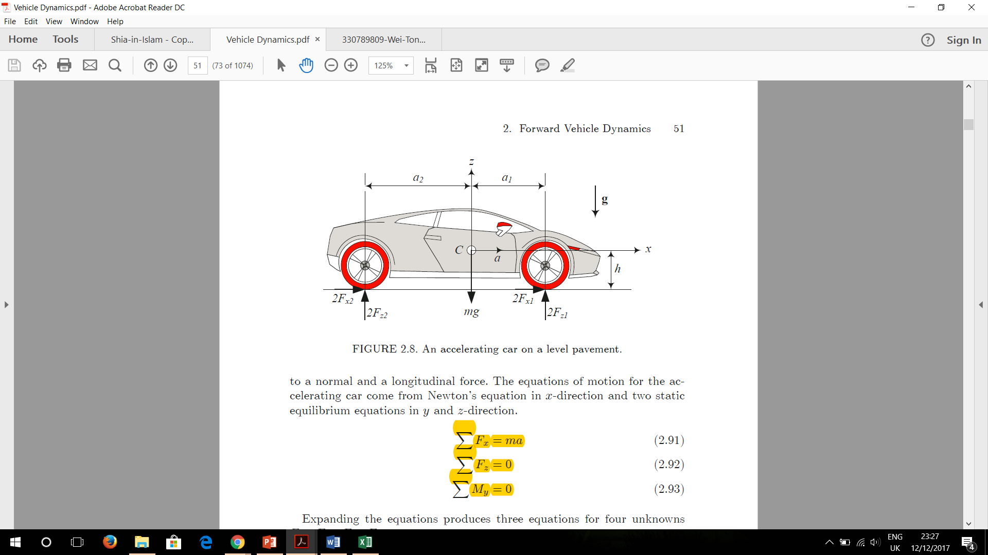

*Figure 1: Shows the forces that are exerted on the car for a 4 in wheel motor configuration system*

Using equations of motion for the accelerating car, Newton’s equation, in x-direction and two static equilibrium equations in y and z-direction.

(1.1) (1.2)

(1.3)

Expanding the equations produces three equations for four unknowns , , , .

(1.4)

(1.5)

(1.6)

To solve for the normal forces and , we would need to eliminate () between the equations 1.4 to 1.6.

(1.7)

(1.8)

The static parts of equation (1.7) and (1.8) are weight distribution for a stationary car and depend on the horizontal position of the mass centre. However, the dynamic parts indicate the weight distribution because of horizontal acceleration and depend on the vertical position of the mass centre.

## Maximum acceleration on a level road

The maximum acceleration of a car is proportional to the friction under its tires. We assume the friction coefficients at the front and rear tires are equal and all tires reach their maximum traction at the same time.

(1.9)

Newton’s equation (1.4) can now be written as

(1.10)

Substituting and from (1.7) and (1.8) results in

(1.11)

## Requested torque

To evaluate the longitudinal dynamic behaviour of the vehicle, the movement resistance forces such as the rolling resistance (), estimated by (2.1), and the aerodynamic drag, estimated by (2.2), need to be considered when calculating the torque required [2].

The rolling resistance () is related to the energy lost by the tire deformation and adhesion on contact area. It is the function of the vehicle weight (*W*) (N), multiplied by a dimensionless rolling resistance coefficient that expresses the effects of the interdependent physical properties of tire and ground as a function of the vehicle speed (*V*) (m/s)

(2.1)

The air resistance against the car passage is named the aerodynamic drag (). This resistance force is defined by the air density (*ρ*) (kg/), the vehicle frontal area (*A*) () and an empirical constant based on the vehicle geometry known as drag coefficient () as shown in the following equation:

(2.2)

The requested torque () is shown by (2.3) as a function of the vehicle acceleration () (), mass (*M*) (kg), the tire external radius (*r*) (m) and the wheels and tires inertia () () in which are also considered the in-wheel motors inertia

(2.3)

# Motor requirement calculations

**Assumptions**

* Mass with driver (*M*): 280 [kg]
* Wheelbase: 1.525 [m]
* Tyre rolling radius (*r*): 5” 0.127 [m]
* Coefficient of friction (*μ*): 1.2
* CoG height (*h*): 0.2 [m]
* Weight Distribution: 50:50
* Maximum power: 80 [kW]
* Inertia of tires and wheels (): [kg]
* Frontal area (*A*): 0.77 []
* Drag coefficient (): 0.69
* Air density (): 1.225 [kg/]

Using Equation (1.11) to work out the maximum acceleration.

The torque through the rear wheel can be calculated by using (1.8).

The torque through the front wheel can be calculated by using (1.7).

Total torque would then be:

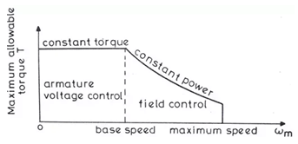 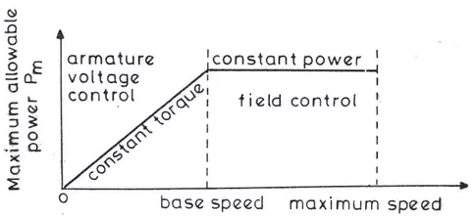

*(a) (b)*

*Figure 2: Shows the electric motor torque-speed curve. (a) Torque [Nm] against angular velocity [rad/s]. (b) Power [W] against angular velocity [rad/s]*

To calculate the speed when maximum power is achieved, the following equation for power was be used:

(3.1)

Since we know that the angular speed is related to the velocity and the tyre rolling radius, Equation (3.1) can be written as:

(3.2)

The above equation can then be further simplified as:

Substituting in the known values in the above equation results in:

Solving the above cubic expression results in the velocity of:

## Requested torque

Now that the speed for when the maximum power is achieved has been calculated we can finally calculate the requested torque when maximum power is achieved, equations (2.1), (2.2) and (2.3), by using the obtained value (24.27 [m/s]).

## Calculating maximum speed reached at 75 [m]

To specify the maximum speed required by the motor, the speed when the car accelerates to 75 [m] is calculated. This is done by using Figure 2 and calculating the work done, by calculating area under the graph, to reach 75 [m]. Firstly, the area when the motor has reached the maximum power is calculated, which is from 0 to base speed as shown on figure 2(a). The distance travelled before maximum power is reached:

* Initial speed: 0 m/s
* Final speed when max power reached: 22.8073 m/s
* Acceleration: 11.772

Therefore, work done during constant torque phase:

To work out the work done through the constant power phase the following equation was used:

where x represents the distance travelled (m), P represents the constant power (W). Using above equation:

The total work done is therefore:

The final speed reached when travelling 75m is then calculated by equating the total work done to the kinetic energy gained:

Converting it to rpm

## Motor specification

The motor specification required is shown on Table 1.

|  |  |  |  |  |
| --- | --- | --- | --- | --- |
| **Halt to max power** |  | **Rear** | **Front** | **Total** |
| **Torque (Nm)** | 146.42 | 76.31 | 445.47 |
| **RPM ()** | 1714.90 | 1714.90 |  |
| **Max power to 75 m** | **Torque (Nm)** | 122.11 | 63.64 | 371.50 |
| **RPM** | 2056.35 | 2056.35 |  |

*Table 1: The minimum motor specification required*

## Choosing a motor

Now that the calculations regarding the minimum torque as well as motor speed required when deciding on which motor to select has been done, a decision on which motor was made. There are many different types of motors available. However, the type of motor decided to use is a servomotor since they are designed to include an encoder which is used to calculate the speed of the motor. AMK is a company which sells servomotors and provide with a motor that meet our motor specification. More specifically AMK DD5-14-10 was chosen and its specification is illustrated on Table 1 which is a synchronous motor. Water cooling was chosen as the cooling type instead of air cooling since the aerodynamics of the car will not be affected as well as a simpler design. This will be at the cost of adding additional cost as well as weight of the total car.

|  |  |  |  |  |  |  |  |  |
| --- | --- | --- | --- | --- | --- | --- | --- | --- |
| Motor | Weight [kg] | Torque [Nm] | Power [kW] | Torque/ Weight | Size [] | Diameter [mm] | Moment of inertia [kg] | Speed [rpm] |
| AMK DD5-14-10 | 3.55 | 21 | 37 | 23.25 | 0.00075 | 24 | 2.74 | 20,000 |

*Table 1: Motor specification of single AMK DD5-14-10 motor*

# Transmission system

Since the torque provided by the AMK DD5-14-10 does not meet the minimum requirement, a transmission system will have to be implemented and used. A transmission system allows to alter the output torque in the expense of higher motor speed. There are many transmissions systems which could be used, but due to simplicity and high reliability, an epicyclic gear box was chosen. Due to the manufacturing of the epicyclic gearbox requiring to be very precise, it was decided to be bought. A 3:1 epicyclic gearbox ratio was chosen from HMK which meets the nominal requirements shown below on Table 2.

|  |  |  |  |  |
| --- | --- | --- | --- | --- |
| **Halt to max power** |  | **Rear** | **Front** | **Total** |
| **Torque (Nm)** | 48.81 | 25.44 | 148.49 |
| **RPM ()** | 5144.71 | 5144.71 |  |
| **Max power to 75 m** | **Torque (Nm)** | 40.70 | 21.21 | 123.83 |
| **RPM** | 6169.06 | 6169.06 |  |

*Table 2: Nominal requirements of the epicyclic gearbox.*

# Motor Controller

A drive is required to provide the required current and voltage which will control the torque and speed, respectively. Moreover, there are different types of motor controllers available for different purposes. For the car to be able to regenerate power during braking (regenerative braking), a motor controller which is able to control drives in 4-quadrant operation is therefore a necessity. This will ensure that when the driver wants to accelerate that the EMs behave as motors. On the other hand, when the driver is braking the EMs must behave as generators to transfer the mechanical energy into electrical energy. This has several advantages including: reducing the wear caused by braking pads since less force is required, energy will be restored into the battery which will increase the duration as well as the distance the car is able to travel. The motor controller is provided by AMK which supports 4 quadrant control, it is called the AMK KWS 26.

# 4.1 Front line task

As part of my front-line task, my responsibility was the fundraising of the EV. This means that certain tasks need to be carried out to recruit sponsors to purchase some parts. The completion of the BLC report was a huge part for my front-line task since it required to conduct a market research in the form of a questionnaire. This was done to get a better understanding of what was expected in terms of: the price that the customers were willing to pay, the target audience and finally, the features and performance requirements they were interested in.

# 5 Energy Storage and Protection

# 5.1 Introduction

The tractive system of the electric race car includes the battery, its container and the protection  
circuits and devices. The Ground Low Voltage System powers the rest of the vehicle and must be switched  
on before the tractive system.  
5.2 PART FUNCTIONS  
1. The Battery is the part of the tractive system that supplies energy to the motor. It can be  
considered the ‘fuel’ of the Electric Race car.  
2. The Battery container is a case made of metal designed to keep the battery  
(which has very high voltages) isolated from the rest of the vehicle. It prevents damage to the  
driver in the highly unlikely case of Electric shock or cell chemistry failure.  
3. The Battery Isolation relay is designed to prevent the by cutting off the entire tractive  
system from the powertrain in the event of over-voltage or high cell temperatures  
4. The Battery Management system (BMS) serves as the diagnostics hub of the entire tractive system and it monitors vital data on the Battery. It also informs the Battery Induction  
relay to shut off the tractive system in the case of an emergency  
5. The Grounded low voltage (GLV) system is as the on-board power supply for the parts of the car  
that are not part of the tractive system and is less than 60VDC  
6. Other protection devices include GLV master switch, Isolation Monitoring Device (IMD), Brake  
System Plausibility Device (BSPD), Three Shutdown buttons, Brake Over-travel switch, Inertia  
Switch, Tractive System measuring points (TSMP), Battery fuses and the  
Tractive System Master Switch.

5.3 AIMS AND OBJECTIVES  
The initial aims and objectives   
- To design a Battery that can provide enough energy for 22km of continuous driving,  
braking, turning and acceleration. This is estimated to be at least 5KWh (see calculations below)  
- To design the battery such that it can also provide very high bursts of energy over a short  
period of time in order to be able to compete in the acceleration event.  
- The battery must be as light as possible while delivering sufficient energy i.e. it should have  
high energy density  
- To design a Battery Container that can withstand the high g forces that it would be  
subjected to in racing conditions  
Number:  
- To design the case in such a way that it acts as the last line of defense in the case of severe failure  
- To design a case that seals properly in order to protect the battery from the elements  
- To design a Battery Management system (BMS) that is able to monitor the individual cells  
reliably and report the data back to the driver and the protective systems.  
- Reliability is very important in the BMS because failure of this system would be catastrophic as  
failure of subsequent systems would not be properly reported.  
- To design an Battery Isolation relay (AIR) that shuts off the entire tractive system when it  
receives critical temperature or voltage value from the cells

5.4 PERFORMANCE REQUIREMENTS   
• The tractive system must be isolated from the vehicle frame and insulated from the GLV circuit.  
• Vehicle frame should be properly grounded  
• Cells must be built into segments and stored in a Battery container and insulated from the container.  
• The AIR must be a normally open, non-mercury type with a rating higher than the main tractive system fuse. It must completely isolate the container when opened and be insulated from the rest of the battery  
• There must be three shutdown switches (One in the cockpit, and one on either side of the vehicle)  
• There must be two Master switches to shut down the tractive system and the GLV system  
manually  
5.5 OPERATIONAL REQUIREMENTS (see calculations for details)  
• Battery case should be able to withstand 40g of acceleration.  
• Battery should be able to deliver 5kWh of energy  
• Battery should be able to discharge at least 17C (17 times its rated discharge capacity) for a short period of time i.e. during sudden acceleration without failure  
• Inertia switch must trigger after an 8g impact on the chassis  
5.6 MANUFACTURING REQUIREMENTS  
• Battery container would be constructed of Steel or Aluminium  
• Battery container should be rated to IP65 to survive the rain test. Sealing methods are to be  
investigated to attain this rating  
• Fireproof material rated to UL94-V0 would be needed for insulation of AIR and fuse  
• There should be an Independent power supply for Container Voltage indicator  
5.7 CALCULATIONS - Battery Capacity and Power  
Endurance course is about 22km long, lasts about 0.35hours and will need at least 4.675KWh of energy to  
complete (from 2016 results). Since this is the longest event, we can therefore conclude that a battery  
with a 5kWh capacity will be sufficient for this event. Therefore, an average power of 4.675/0.35 = 13.2kW  
will be needed. The battery should be able to deliver 13.2kW and have a capacity of 5kWh.  
---  
The maximum power that can be used by the motor is 85kW. If we use the full power during  
the Acceleration event, we would need a cell capable of discharging at 85kW/5kWh=17C.

# 6 Conceptual Design

Regenerative braking power requirement – 63kW (see table below)  
Max motor power draw - 80kW

It was decided that it would be more beneficial to make the project as simple as possible i.e. use robust and well tested schemes that have been widely used before. It was for this reason that the regenerative braking system was de-emphasized  
Tabular comparison of the three cell choices

|  |  |  |  |  |  |
| --- | --- | --- | --- | --- | --- |
|  |  | [Turnigy_graphene-4000mAh (advertised)](https://hobbyking.com/en_us/graphene-4000mah-4s-45c-w-xt90.html) | Graphene realistic performance | LG HB2 18650 | Sanyo NCR20700A |
|  | Cells | 4 | 4 | 1 | 1 |
| Ah | Ah | 4 | 4 | 1.5 | 3.1 |
| V | Volts nom | 14.8 | 14.8 | 3.65 | 3.6 |
| A | Max Discharge Current | 180 | 116 | 30 | 30.07 |
|  | Discharge C rating | 45 | 29 | 20 | 9.7 |
|  | Charge C rating | 10 | 6 | 5.33 | 3 |
| kg | Mass | 0.484 | 0.484 | 0.044 | 0.06 |
| mm | Size | 144 | 144 | 65 | **70.3** |
| mm |  | 51 | 51 | 18 | 20.35 |
| mm |  | 34 | 34 | 18 | 20.35 |
|  | Cost | £41.90 | £41.90 | £2.25 | £3.60 |
|  |  |  |  |  |  |
|  | **Energy Derived** |  |  |  |  |
| W/kg | Power to mass | 122 | 122 | 124 | 186 |
| kg | Total battery wt | 40.9 | 40.9 | 40.2 | 26.9 |
|  | # Units for 5kWh | 84 | 84 | 913 | 448 |
|  | Car cost | £3,520 | £3,520 | £2,054 | £1,613 |
|  |  |  |  |  |  |
|  | **Power derived** |  |  |  |  |
| kW | Max power per cell | 2.66 | 1.72 | 0.11 | 0.11 |
|  | # cells for 80kW | 30 | 47 | 731 | 739 |
|  | Cost to meet power | £1,257 | £1,969 | £1,645 | £2,660 |
| kg | Mass | 14.5 | 22.7 | 32.2 | 44.3 |
|  |  |  |  |  |  |
|  | **Simple car derived** |  |  |  |  |
|  | # cells | 84 | 84 | 913 | 739 |
|  | Cost | £3,520 | £3,520 | £2,054 | £2,660 |
| kg | Mass | 40.9 | 40.9 | 40.2 | 44.3 |
| kW | Max regen power | 49.7 | 29.8 | 26.6 | 24.7 |
|  | Assumed regen efficiency | 75% | 75% | 75% | 75% |
| kW | Braking power available | 66.3 | 39.8 | 35.5 | 33.0 |
| m/s | Assumed average speed | 17.3 | 17.3 | 17.3 | 17.3 |
| kW | Assumed braking power required | 62 | 62 | 62 | 62 |
|  | Amount of electrical braking | 80.6% | 48.3% | 43.2% | 40.1% |
|  |  |  |  |  |  |
| kWh | Nominal(1C) capacity | 4.9728 | 4.9728 | 4.998675 | 8.24724 |

**Concept 1**Turnigy 4000mAh 4S 45C LiPo (Lithium Polymer) pack is a high capacity cell from Hobbyking. Although the specifications show a very high charge and very high discharge rating, there is evidence online that the cells might be overrated and do not actually perform at advertised specifications. The tests I saw for a different cell reached about 65% of the advertised rating before overheating (a model advertised as 65C performed at a maximum of 41C) so I cut down the advertised ratings in the second tab to better anticipate the real conditions of this cell. It was also given a bad reliability rating in the decision matrix because of this

**Concept 2**Sanyo 20700A is a high discharge cell made specifically for electric vehicles. Although it is quite a versatile cell, it was not chosen as it is quite difficult to find it for purchase. Another difficulty associated with it is one that is general to cylindrical cells. The structure makes it quite difficult to attach electrical leads to its terminal as it must be welded. The advantage of cylindrical over pouch  
cells is that the construction helps to keep the cell at an ideal pressure.

**Concept 3**The LG HB2 is a cheap 18650 cell. The 18650 has been tested in numerous automotive applications (e.g. Tesla Vehicles and other FSAE vehicles) but the drawbacks of the cylindrical cell remain. Connecting it in a 91s10p configuration we get a total rating of 332V,15A (with a maximum burst of up to 300A) which is sufficient for our chosen motor.

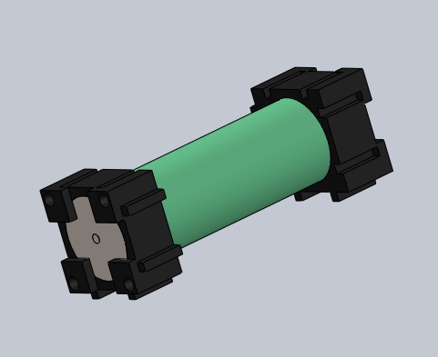

Figure 3: LG 18650 cell

**Decision Matrix**

|  |  |  |  |
| --- | --- | --- | --- |
|  | Concept 1 | Concept 2 | Concept 3 |
| Cost | 7 | 9 | 10 |
| Reliability | 5 | 9 | 8 |
| Weight | 9 | 9 | 8 |
| Ease of Setup | 10 | 7 | 7 |
|  | 31 | 34 | 33 |

From the decision matrix, we can see that the Concept 2 best fulfils our requirements as it is the  
lightest cell while being the second cheapest. The only drawback would be in the setup of the cell as  
it would be more difficult to assemble it because of the soldering required. This is considered an  
acceptable trade-off for the cost and weight.  
**Buy vs Make Analysis**It would not be practical to make the battery cells, so the best option is to buy.

# 7 Final Design

The design was altered considerably from the initial proposal. Though concept 2 was initally chosen, the parts required were not readily available so the next best concept (3) was chosen and the design altered.

**Battery Module**The battery module is assembled by taking eight LG HB2 18650 cells, adding an 18650-plastic spacer and then finally the Cu101 conductor. The module pcb is then screwed in to one side of the module. Eight of these cells are connected in parallel and they collectively make one battery module. There are  
120 such modules in the entire battery pack (Making a total of 960 cells).

Each module is in effect a 12A (1.5A*8), 3.6Volt battery and 120 modules (15  
per section *8sections) will be connected in series to give us a final pack voltage  
of 432V, I=12A (at 1C Discharge, 240A Max. Continuous discharge),  
P=5.18kW/18.65MJ.

**Section Calculations**EV3.3.3 states that each section must be no greater than 120V, 6MJ.  
Our section design here is 3.6V*15=54V /648Wh/ 2.332MJ which meets  
the requirements.

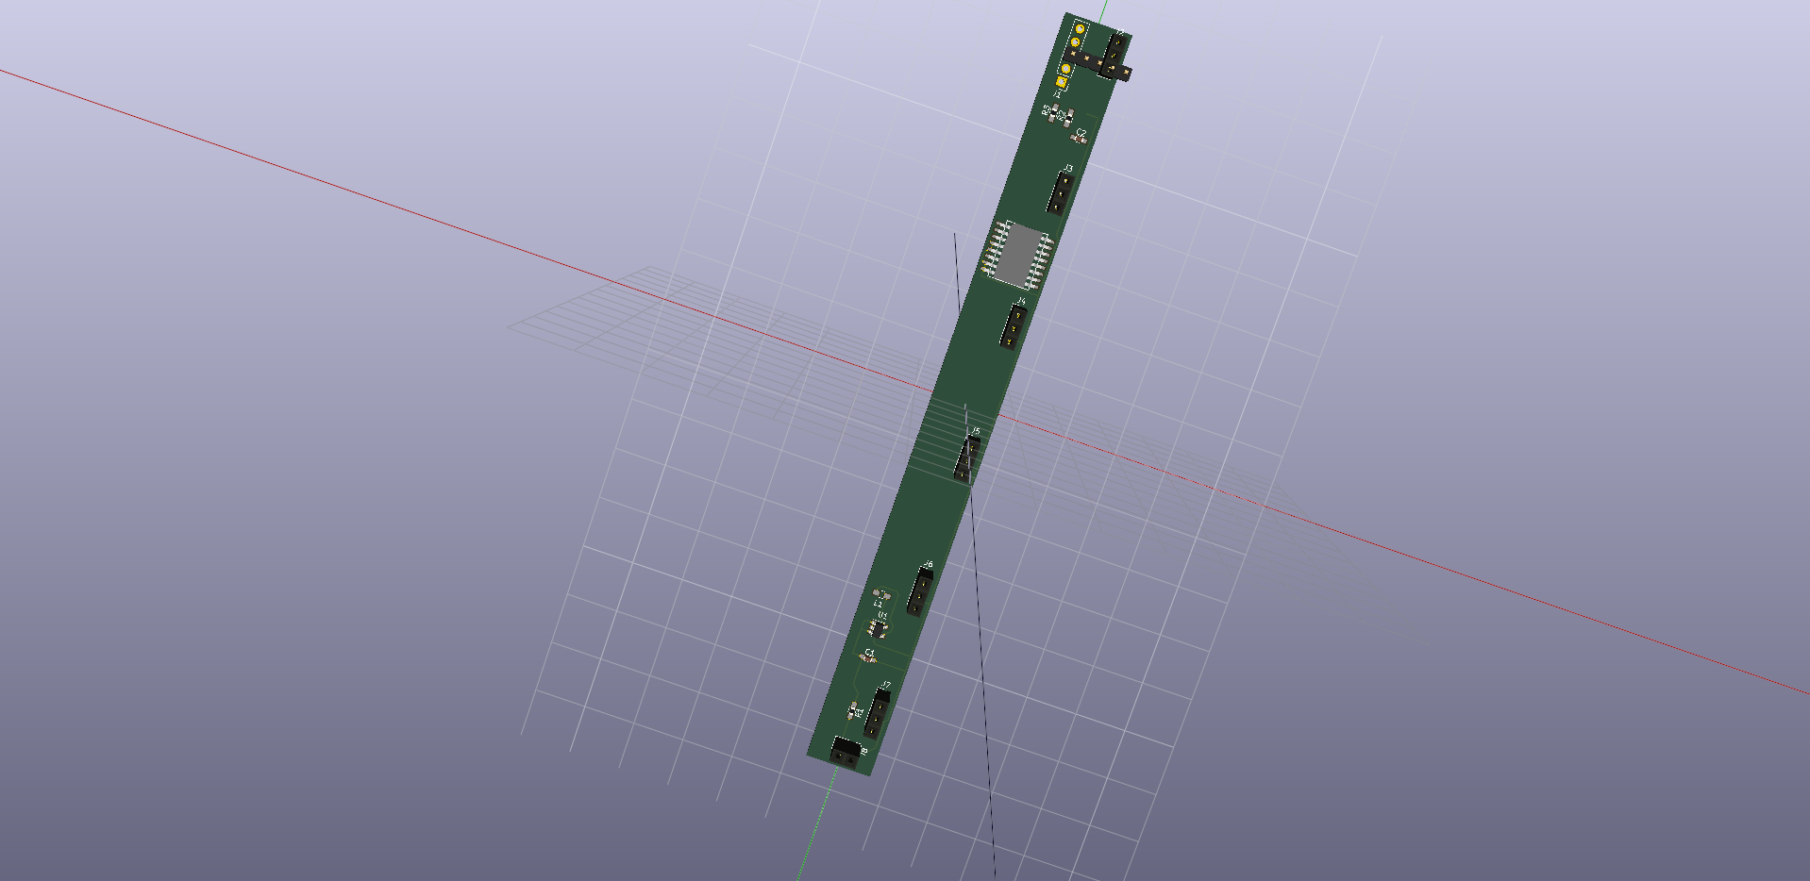 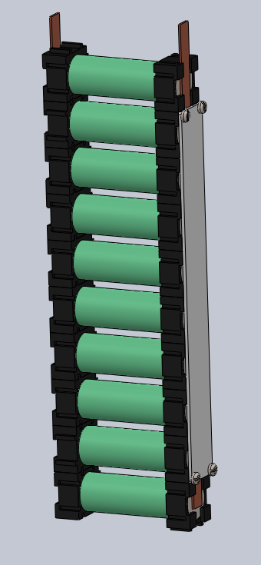

1. (b)

Figure 4(a) 3d render of pcb for battery modules (the design requires 90 of these);

(b)Assembled module with battery, plastic sleeve, conductor and pcb

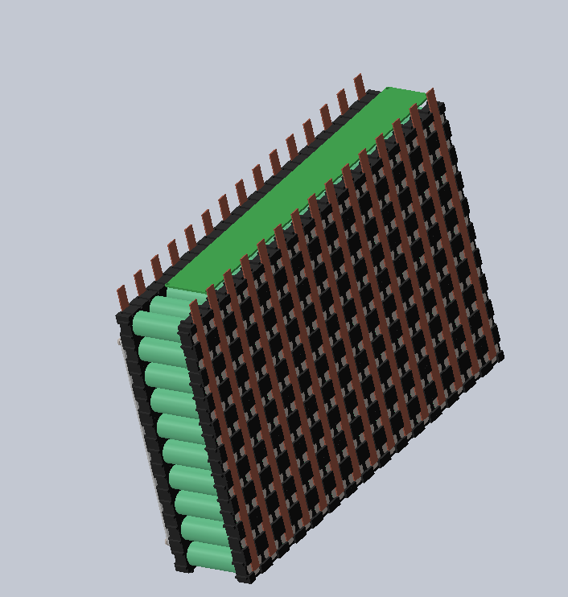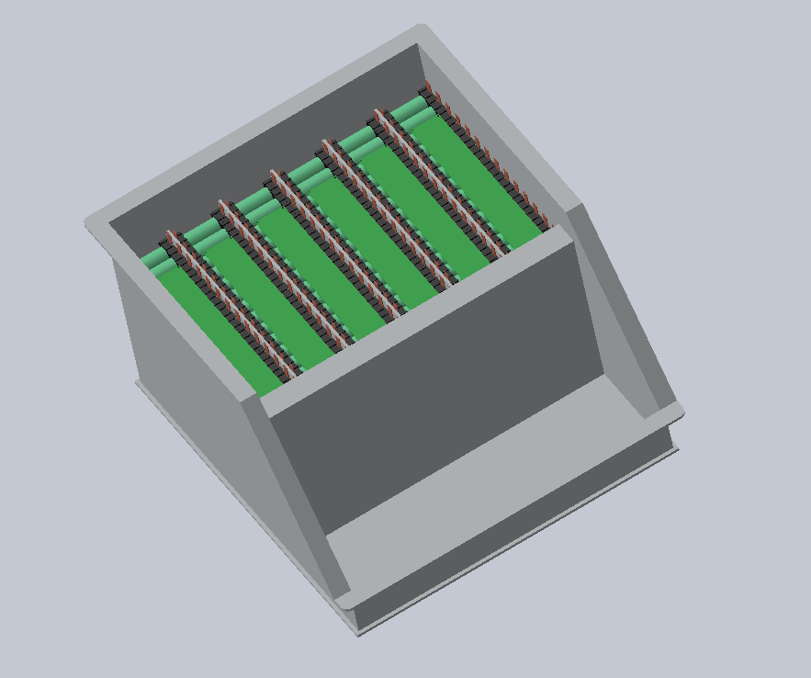

Fig5(a)Assembled Section (b) Sections assembled in Battery Box

**Battery box assembly**  
The battery box will be made of a 4mm thick, 505*458mm Aluminium plate as a  
base with four walls (and 300mm high) and a sloping front to facilitate easy maintenance. Internal sections fastened with M8 bolts will divide the box into eight sections and finally four 2.3mm thick external walls (280mm high) fastened with M8 bolts. The internal walls will then be covered with fire retardant formex and 15 modules inserted in each section. The PCB for each section will be inserted in the 32mm gap between the top of the modules and the top of the internal vertical wall. Finally, the top cover will be sealed with gaskets in order to fulfil the rain test requirement.

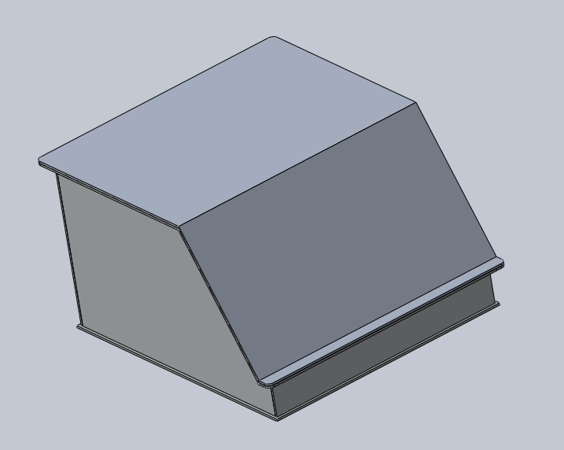

Figure 6: Battery Box

**Battery Management System  
Temperature Acquisition Circuit**The temperature sensors will be placed at the end of each cell. The sensor  
selected is a Texas Instruments LMT-84 in a TO-92 Package. This will be inserted  
into the module PCB which then connects to a module multiplexer. This  
multiplexer selects one cell per module and sends the temperature value to the  
Analog to Digital Converter (ADC), once the temperature is converted and sent  
to the microcontroller, the microcontroller signals to the multiplexer to take the  
next cell temperature and this goes on until all six cells in a module are  
measured. Since there are 18 modules in each section, there will be three such  
ADCs per section. Each ADC is responsible for six modules. The ADCs send the digital information of the cell temperatures to the  
Microcontroller using I2C communication. Instead of directly reading all 108 cells  
in a section (6 cells * 18 modules) which will require 108 analog pins or 18pcs of  
8-channel ADCs, we are able to save space and cost by using a local multiplexer  
to switch temperatures.  
  
The LMT84 is a precision CMOS temperature sensor which has a linear Voltage to  
temperature behaviour making it superior to NTC sensors (which have nonlinear  
behaviour and are very much affected by self-heating). It operates between  
1.5V to 5V (VDD)  
The TI SN74LV4051A-Q1 is an Automotive rated 8 Channel CMOS multiplexer  
that has one output. The switching is done by the microcontroller and all 90  
modules will have their local MUX unit which will all be connected by the same  
four GPIO pins from the µC. It comes in a compact 8.89*10.63*2.65mm SOIC  
package and will be inserted in a PCB just above the modules in the battery box.  
2V < VDD <5.5V  
The TI ADS7828-Q1 is an Automotive rated 12-bit, 8 Channel Analog to Digital  
Converter (ADC) with an I2C communications port and a 50kHz Sampling rate.  
It comes in a TSSOP 6.4*5mm package. 2.7V < VDD <5V  
  
**Battery Protection**A battery management system composed of TI parts (listed in the BOM submission) monitors each 15-cell section, each section pcb (shown below) can work autonomously to monitor and protect the battery, it will also perform voltage balancing among cells.

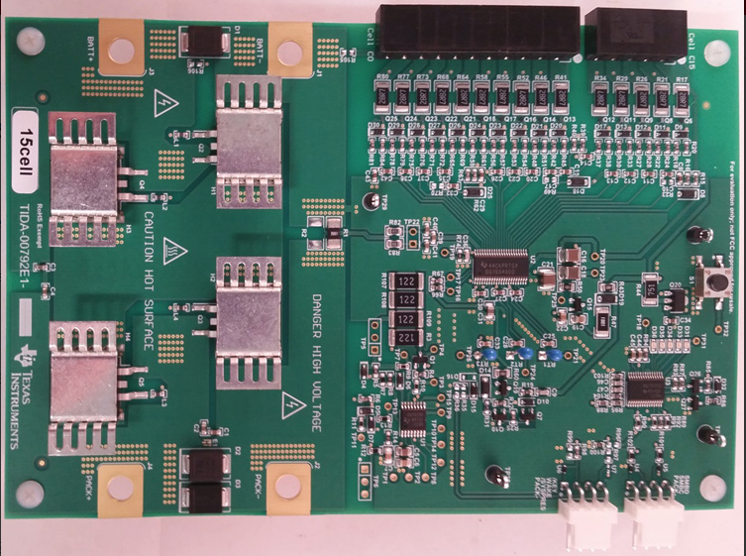

Figure 7: Section PCB (*8 for entire design)

# 8 Front line task

The job of Subgroup leader of the Electric Vehicle is to manage the team to make sure the work is being done. The team’s goal was initially to design a class 2 entry for formula student. This was however scaled back as the team had less interest than was initially anticipated. The two team members then set out to design a base on which a future City Racing electric vehicle could be built. Since the most distinguishing part of the Electric vehicle was the powertrain (energy storage + drive system) we decided to work on the battery system for energy storage and the motors to transfer power to the wheels.

We were able to achieve a good initial design that could be further improved upon and tested.

# References

[1] J. J. Eckert, L. C. A. Silva, E. S. Costa, F. M. Santiciolli, F. G. Dedini, and F. C. Corrêa, “Electric vehicle drivetrain optimisation,” *IET Electr. Syst. Transp.*, vol. 7, no. 1, pp. 32–40, 2017.

[2] L. C. S. E. S. C. F. M. S. F. G. D. F. C. C. Jony J. Eckert, "Electric vehicle drivetrain optimisation," *IEEE Electr. Syst. Transp.,* vol. 7, no. 1, pp. 32-40, 2017.

[3] FSAE Regulations; http://www.fsaeonline.com/content/2017_FSAE_Rules

.pdf

[4] D. Seward, Race car design. London: Palgrave, 2014.