Intro

Electric vehicles

greater efficiency

better for environment

better acceleration because o... reference tesla

Set out to build the core of an electric vehicle

my part

1 Introduction

The tractive system of the electric race car includes the battery, its container and the protection  
circuits and devices. The Ground Low Voltage System powers the rest of the vehicle and must be switched  
on before the tractive system.  
PART FUNCTIONS1. The Battery is the part of the tractive system that supplies energy to the motor. It can be  
considered the ‘fuel’ of the Electric Race car.  
2. The Battery container is a case made of metal designed to keep the battery  
(which has very high voltages) isolated from the rest of the vehicle. It prevents damage to the  
driver in the highly unlikely case of Electric shock or cell chemistry failure.  
3. The Battery Isolation relay is designed to prevent the by cutting off the entire tractive  
system from the powertrain in the event of over-voltage or high cell temperatures  
4. The Battery Management system (BMS) serves as the diagnostics hub of the entire tractive  
system and it monitors vital data on the Batterys. It also informs the Battery Induction  
relay to shut off the tractive system in the case of an emergency  
5. The Grounded low voltage (GLV) system is as the on-board power supply for the parts of the car  
that are not part of the tractive system and is less than 60VDC  
6. Other protection devices include GLV master switch, Isolation Monitoring Device (IMD), Brake  
System Plausibility Device (BSPD), Three Shutdown buttons, Brake Over-travel switch, Inertia  
Switch, Tractive System measuring points (TSMP), Battery fuses and the  
Tractive System Master Switch.

AIMS AND OBJECTIVESThe initial aims and objectives   
- To design a Battery that can provide enough energy for 22km of continuous driving,  
braking, turning and acceleration. This is estimated to be at least 5KWh (see calculations below)  
- To design the battery such that it can also provide very high bursts of energy over a short  
period of time in order to be able to compete in the acceleration event.  
- The battery must be as light as possible while delivering sufficient energy i.e. it should have  
high energy density  
- To design a Battery Container that can withstand the high g forces that it would be  
subjected to in racing conditions  
Number:  
- To design the case in such a way that it acts as the last line of defense in the case of severe failure  
- To design a case that seals properly in order to protect the battery from the elements  
- To design a Battery Management system (BMS) that is able to monitor the individual cells  
reliably and report the data back to the driver and the protective systems.  
- Reliability is very important in the BMS because failure of this system would be catastrophic as  
failure of subsequent systems would not be properly reported.  
- To design an Battery Isolation relay (AIR) that shuts off the entire tractive system when it  
receives critical temperature or voltage value from the cells

PERFORMANCE REQUIREMENTS (see Appendix for details of Standards)• The tractive system must be isolated from the vehicle frame and insulated from the GLV circuit.  
• Vehicle frame should be properly grounded  
• Cells must be built into segments and stored in an Battery container and insulated from the  
container.  
• The AIR must be a normally open, non-mercury type with a rating higher than the main tractive  
system fuse. It must completely isolate the container when opened and be insulated from the rest  
of the battery  
• There must be three shutdown switches (One in the cockpit, and one on either side of the vehicle)  
• There must be two Master switches to shut down the tractive system and the GLV system  
manually  
OPERATIONAL REQUIREMENTS (see calculations for details)• Battery case should be able to withstand 40g of acceleration.  
• Battery should be able to deliver 5kWh of energy  
• Battery should be able to discharge at least 17C (17 times its rated discharge capacity) for a  
short period of time i.e. during sudden acceleration without failure  
• Inertia switch must trigger after an 8g impact on the chassis  
MANUFACTURING REQUIREMENTS• Battery container would be constructed of Steel or Aluminium  
• Battery container should be rated to IP65 to survive the rain test. Sealing methods are to be  
investigated to attain this rating  
• Fireproof material rated to UL94-V0 would be needed for insulation of AIR and fuse  
• There should be an Independent power supply for Container Voltage indicator  
**CALCULATIONS** - Battery Capacity and Power  
Endurance course is about 22km long, lasts about 0.35hours and will need at least 4.675KWh of energy to  
complete (from 2016 results). Since this is the longest event, we can therefore conclude that a battery  
with a 5kWh capacity will be sufficient for this event. Therefore, an average power of 4.675/0.35 = 13.2kW  
will be needed. The battery should be able to deliver 13.2kW and have a capacity of 5kWh.  
---  
The maximum power that can be used by the motor is 85kW. If we use the full power during  
the Acceleration event, we would need a cell capable of discharging at 85kW/5kWh=17C.

Concpetual Design

Regenerative braking power requirement – 63kW (see table below)  
Max motor power draw - 80kW

It was decided that it would be more beneficial to make the project as simple as possible i.e. use  
robust and well tested schemes that have been widely used before. It was for this reason that the  
regenerative braking system was de-emphasized  
Tabular comparison of the three cell choices

|  |  |  |  |  |  |
| --- | --- | --- | --- | --- | --- |
|  |  | [Turnigy_graphene-4000mAh (advertised)](https://hobbyking.com/en_us/graphene-4000mah-4s-45c-w-xt90.html) | Graphene realistic performance | LG HB2 18650 | Sanyo NCR20700A |
|  | Cells | 4 | 4 | 1 | 1 |
| Ah | Ah | 4 | 4 | 1.5 | 3.1 |
| V | Volts nom | 14.8 | 14.8 | 3.65 | 3.6 |
| A | Max Discharge Current | 180 | 116 | 30 | 30.07 |
|  | Discharge C rating | 45 | 29 | 20 | 9.7 |
|  | Charge C rating | 10 | 6 | 5.33 | 3 |
| kg | Mass | 0.484 | 0.484 | 0.044 | 0.06 |
| mm | Size | 144 | 144 | 65 | **70.3** |
| mm |  | 51 | 51 | 18 | 20.35 |
| mm |  | 34 | 34 | 18 | 20.35 |
|  | Cost | £41.90 | £41.90 | £2.25 | £3.60 |
|  |  |  |  |  |  |
|  | **Energy Derived** |  |  |  |  |
| W/kg | Power to mass | 122 | 122 | 124 | 186 |
| kg | Total battery wt | 40.9 | 40.9 | 40.2 | 26.9 |
|  | # Units for 5kWh | 84 | 84 | 913 | 448 |
|  | Car cost | £3,520 | £3,520 | £2,054 | £1,613 |
|  |  |  |  |  |  |
|  | **Power derived** |  |  |  |  |
| kW | Max power per cell | 2.66 | 1.72 | 0.11 | 0.11 |
|  | # cells for 80kW | 30 | 47 | 731 | 739 |
|  | Cost to meet power | £1,257 | £1,969 | £1,645 | £2,660 |
| kg | Mass | 14.5 | 22.7 | 32.2 | 44.3 |
|  |  |  |  |  |  |
|  | **Simple car derived** |  |  |  |  |
|  | # cells | 84 | 84 | 913 | 739 |
|  | Cost | £3,520 | £3,520 | £2,054 | £2,660 |
| kg | Mass | 40.9 | 40.9 | 40.2 | 44.3 |
| kW | Max regen power | 49.7 | 29.8 | 26.6 | 24.7 |
|  | Assumed regen efficiency | 75% | 75% | 75% | 75% |
| kW | Braking power available | 66.3 | 39.8 | 35.5 | 33.0 |
| m/s | Assumed average speed | 17.3 | 17.3 | 17.3 | 17.3 |
| kW | Assumed braking power required | 62 | 62 | 62 | 62 |
|  | Amount of electrical braking | 80.6% | 48.3% | 43.2% | 40.1% |
|  |  |  |  |  |  |
| kWh | Nominal(1C) capacity | 4.9728 | 4.9728 | 4.998675 | 8.24724 |

**Concept 1**Turnigy 4000mAh 4S 45C LiPo (Lithium Polymer) pack is a high capacity cell from Hobbyking.  
Although the specifications show a very high charge and very high discharge rating, there is evidence  
online that the cells might be overrated and do not actually perform at advertised specifications. The  
tests I saw for a different cell reached about 65% of the advertised rating before overheating (a  
model advertised as 65C performed at a maximum of 41C) so I cut down the advertised ratings in  
the second tab to better anticipate the real conditions of this cell. It was also given a bad reliability  
rating in the decision matrix because of this  
**Concept 2**Sanyo 20700A is a high discharge cell made specifically for electric vehicles. Although it is quite a  
versatile cell, it was not chosen as it is quite difficult to find it for purchase. Another difficulty  
associated with it is one that is general to cylindrical cells. The structure makes it quite difficult to  
attach electrical leads to its terminal as it must be welded. The advantage of cylindrical over pouch  
cells is that the construction helps to keep the cell at an ideal pressure.  
**Concept 3**The LG HB2 is a cheap 18650 cell. The 18650 has been tested in numerous automotive applications  
(e.g. Tesla Vehicles and other FSAE vehicles) but the drawbacks of the cylindrical cell remain.  
Connecting it in a 91s10p configuration we get a total rating of 332V,15A (with a maximum burst of  
up to 300A) which is sufficient for our chosen motor.

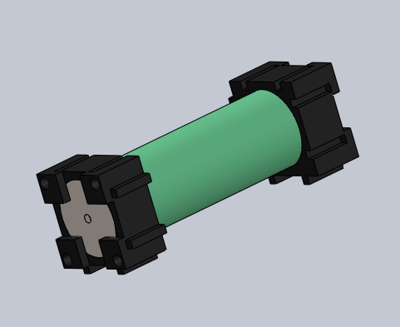  
**Decision Matrix**

|  |  |  |  |
| --- | --- | --- | --- |
|  | Concept 1 | Concept 2 | Concept 3 |
| Cost | 7 | 9 | 10 |
| Reliability | 5 | 9 | 8 |
| Weight | 9 | 9 | 8 |
| Ease of Setup | 10 | 7 | 7 |
|  | 31 | 34 | 33 |

From the decision matrix, we can see that the Concept 2 best fulfils our requirements as it is the  
lightest cell while being the second cheapest. The only drawback would be in the setup of the cell as  
it would be more difficult to assemble it because of the soldering required. This is considered an  
acceptable trade-off for the cost and weight.  
**Buy vs Make Analysis**It would not be practical to make the battery cells, so the best option is to buy.

Final Design

The design was altered considerably from the initial proposal. Though concept 2 was initally chosen, the parts required were not readily available so the next best concept (3) was chosen and the design altered.

Mechanical Configuration

**Battery Module**The battery module is assembled by taking eight LG HB2 18650 cells, adding an 18650-plastic spacer and then finally the Cu101 conductor. The module pcb is then screwed in to one side of the module. Eight of these cells are connected in parallel and they collectively make one battery module. There are  
120 such modules in the entire battery pack (Making a total of 960 cells).

Each module is in effect a 12A (1.5A*8), 3.6Volt battery and 120 modules (15  
per section *8sections) will be connected in series to give us a final pack voltage  
of 432V, I=12A (at 1C Discharge, 240A Max. Continuous discharge),  
P=5.18kW/18.65MJ.

**Section Calculations**EV3.3.3 states that each section must be no greater than 120V, 6MJ.  
Our section design here is 3.6V*15=54V /648Wh/ 2.332MJ which meets  
the requirements.

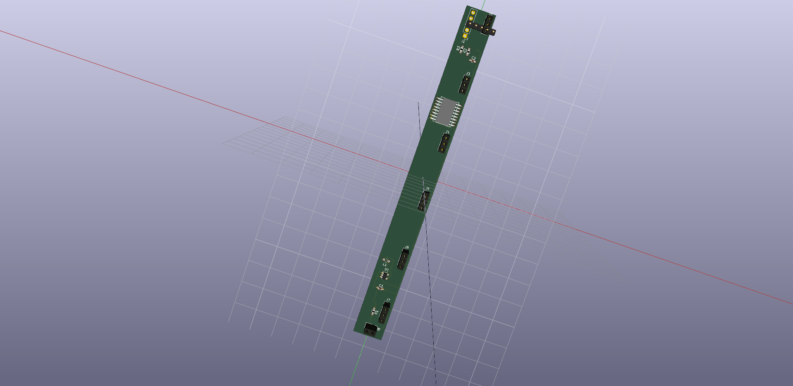 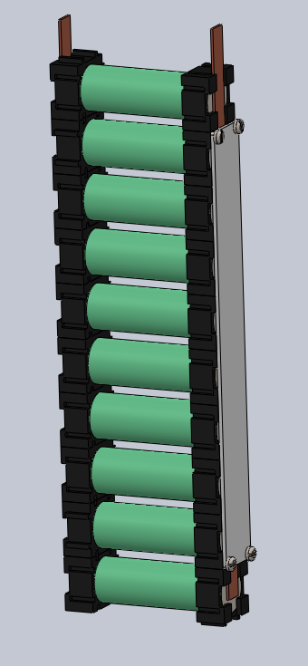

3d render of pcb for battery modules (the design requires 90 of these);

Assembled module with battery, plastic sleeve, conductor and pcb

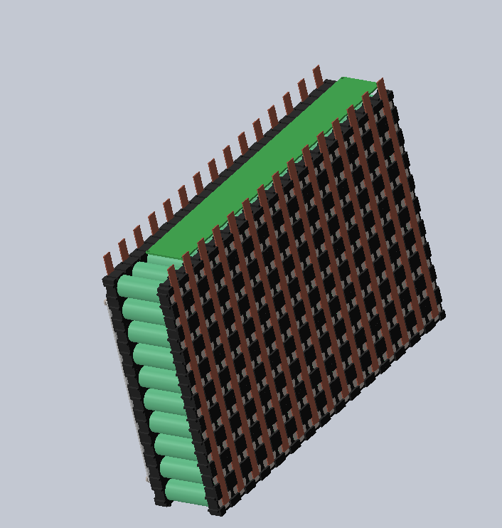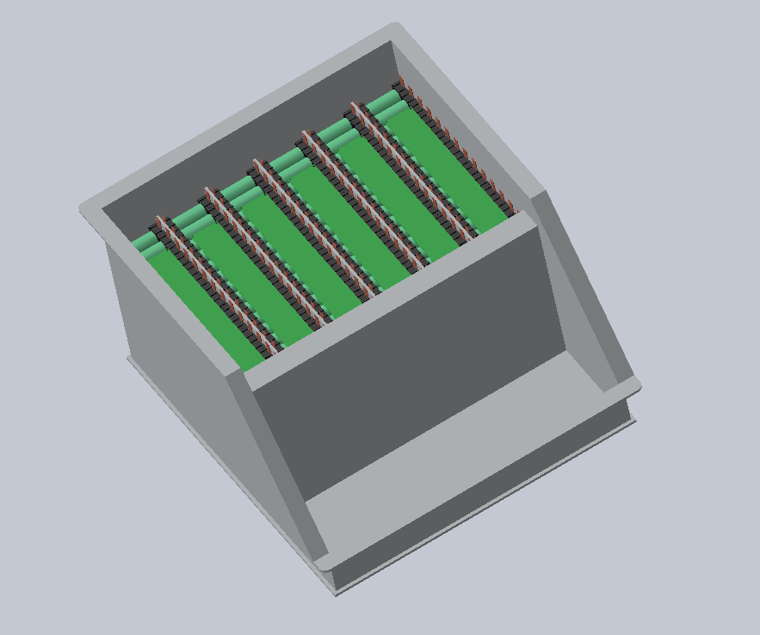

Assembled Section Sections assembled in Battery Box

**Battery box assembly**  
The battery box will be made of a 4mm thick, 505*458mm Aluminium plate as a  
base with four walls (and 300mm high) and a sloping front to facilitate easy maintenance. Internal sections fastened with M8 bolts will divide the box into eight  
sections and finally four 2.3mm thick external walls (280mm high) fastened with M8 bolts. The internal walls will then be covered with fire retardant formex and 15 modules inserted in each section. The PCB for each section will be inserted in the 32mm gap between the top of the modules and the top of the internal vertical wall. Finally, the top cover will be sealed with gaskets in order to fulfil the rain test requirement.

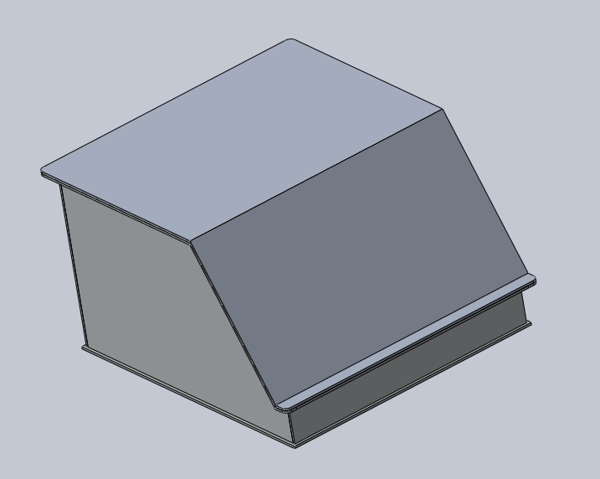

**Battery Management System  
Temperature Acquisition Circuit**The temperature sensors will be placed at the end of each cell. The sensor  
selected is a Texas Instruments LMT-84 in a TO-92 Package. This will be inserted  
into the module PCB which then connects to a module multiplexer. This  
multiplexer selects one cell per module and sends the temperature value to the  
Analog to Digital Converter (ADC), once the temperature is converted and sent  
to the microcontroller, the microcontroller signals to the multiplexer to take the  
next cell temperature and this goes on until all six cells in a module are  
measured. Since there are 18 modules in each section, there will be three such  
ADCs per section. Each ADC is responsible for six modules. The ADCs send the digital information of the cell temperatures to the  
Microcontroller using I2C communication. Instead of directly reading all 108 cells  
in a section (6 cells * 18 modules) which will require 108 analog pins or 18pcs of  
8-channel ADCs, we are able to save space and cost by using a local multiplexer  
to switch temperatures.  
  
The LMT84 is a precision CMOS temperature sensor which has a linear Voltage to  
temperature behaviour making it superior to NTC sensors (which have nonlinear  
behaviour and are very much affected by self-heating). It operates between  
1.5V to 5V (VDD)  
The TI SN74LV4051A-Q1 is an Automotive rated 8 Channel CMOS multiplexer  
that has one output. The switching is done by the microcontroller and all 90  
modules will have their local MUX unit which will all be connected by the same  
four GPIO pins from the µC. It comes in a compact 8.89*10.63*2.65mm SOIC  
package and will be inserted in a PCB just above the modules in the battery box.  
2V < VDD <5.5V  
The TI ADS7828-Q1 is an Automotive rated 12-bit, 8 Channel Analog to Digital  
Converter (ADC) with an I2C communications port and a 50kHz Sampling rate.  
It comes in a TSSOP 6.4*5mm package. 2.7V < VDD <5V  
  
**Battery Protection**A battery management system composed of TI parts (listed in the BOM submission) monitors each 15-cell section, each section pcb (shown below) can work autonomously to monitor and protect the battery, it will also perform voltage balancing among cells.

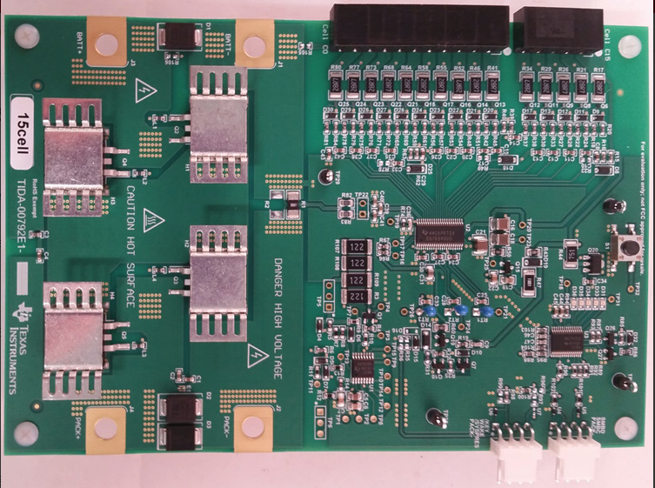

Section PCB (*8 for entire design)

Front line task

The job of Subgroup leader of the Electric Vehicle was initially to design a class 2 entry for formula student. This was however scaled back as the team had less interest than initially anticipated. The two team members then set out to design a base on which future CityRacing teBMS could build. Since the most distinguishing part of the Electric vehicle was the powertrain(energy storage + drive system) we decided to work on the battery system for energy storage and the motors to transfer power to the wheels.

We were able to achieve a good initial design that could be further improved upon and tested