数据库表格关系图

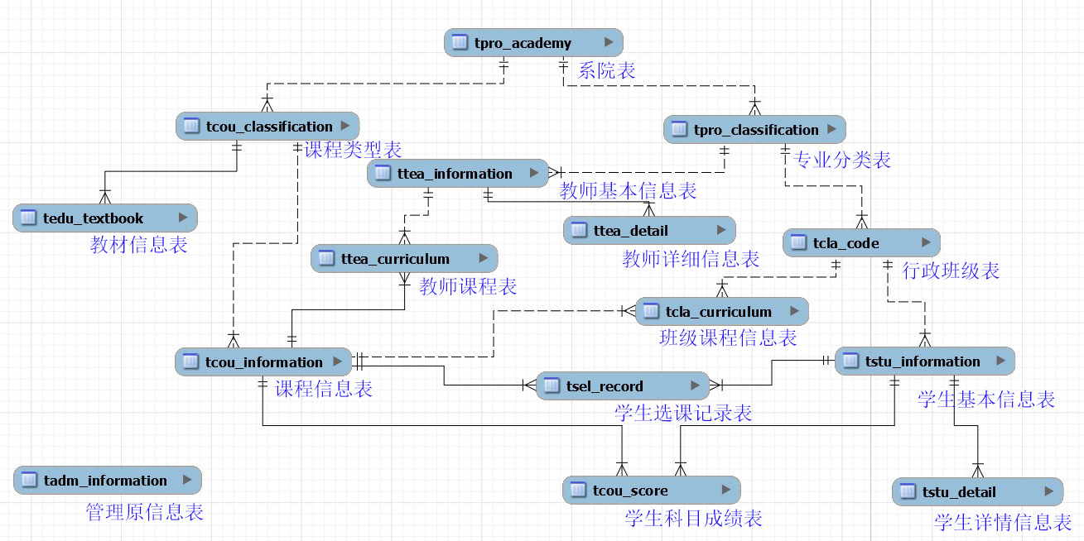
数据库表格详情图

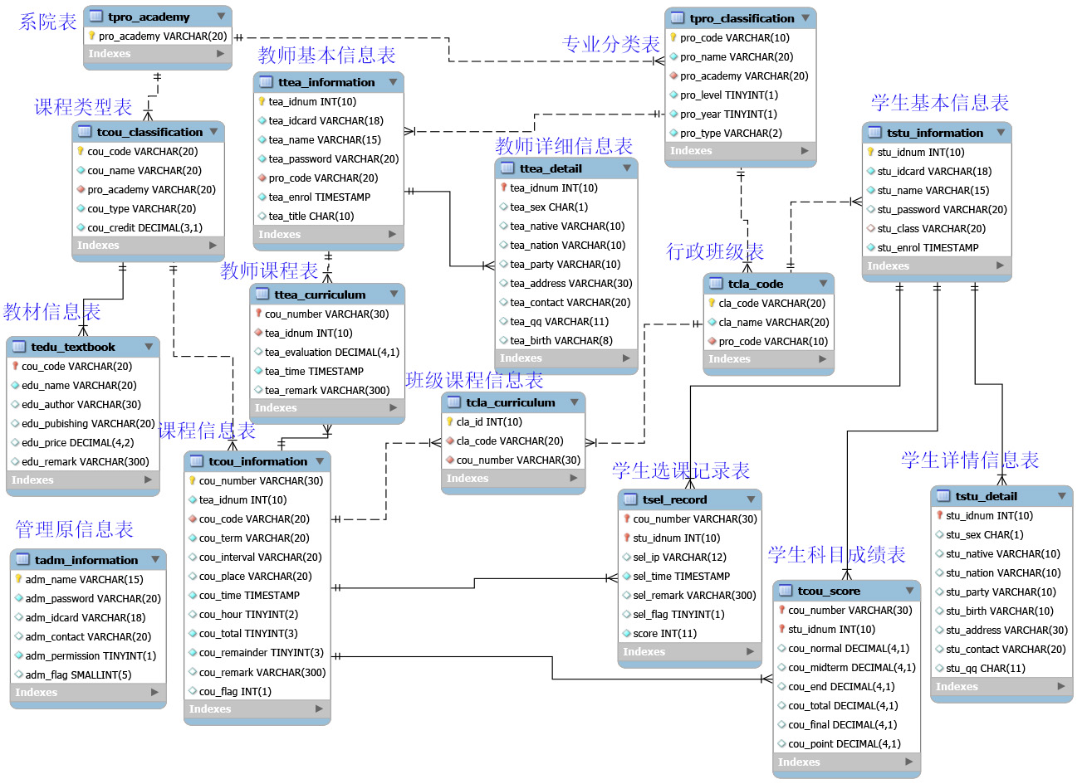
表格结构：
mysql> use edu_manage;
Database changed
mysql> show tables;
+----------------------+
| Tables_in_edu_manage |
+----------------------+
| tadm_information |
| tcla_code |
| tcla_curriculum |
| tcou_classification |
| tcou_information |
| tcou_score |
| tedu_textbook |
| tpro_academy |
| tpro_classification |
| tsel_record |
| tstu_detail |
| tstu_information |
| ttea_curriculum |
| ttea_detail |
| ttea_information |
+----------------------+
15 rows in set (0.00 sec)

mysql> desc tadm_information;
+----------------+----------------------+------+-----+---------+-------+
| Field | Type | Null | Key | Default | Extra |
+----------------+----------------------+------+-----+---------+-------+
| adm_name | varchar(15) | NO | PRI | NULL | |
| adm_password | varchar(20) | NO | | NULL | |
| adm_idcard | varchar(18) | YES | UNI | NULL | |
| adm_contact | varchar(20) | YES | | NULL | |
| adm_permission | tinyint(1) | NO | | 0 | |
| adm_flag | smallint(5) unsigned | YES | | 0 | |
+----------------+----------------------+------+-----+---------+-------+
6 rows in set (0.03 sec)

mysql> desc tpro_academy;
+-------------+-------------+------+-----+---------+-------+
| Field | Type | Null | Key | Default | Extra |
+-------------+-------------+------+-----+---------+-------+
| pro_academy | varchar(20) | NO | PRI | NULL | |
+-------------+-------------+------+-----+---------+-------+
1 row in set (0.03 sec)

mysql> desc tpro_classification;
+-------------+-------------+------+-----+---------+-------+
| Field | Type | Null | Key | Default | Extra |
+-------------+-------------+------+-----+---------+-------+
| pro_code | varchar(10) | NO | PRI | NULL | |
| pro_name | varchar(20) | NO | | NULL | |
| pro_academy | varchar(20) | NO | MUL | NULL | |
| pro_level | tinyint(1) | NO | | 1 | |
| pro_year | tinyint(1) | NO | | 4 | |
| pro_type | varchar(2) | NO | | 07 | |
+-------------+-------------+------+-----+---------+-------+
6 rows in set (0.02 sec)

mysql> desc tcla_code;
+----------+-------------+------+-----+---------+-------+
| Field | Type | Null | Key | Default | Extra |
+----------+-------------+------+-----+---------+-------+
| cla_code | varchar(20) | NO | PRI | NULL | |
| cla_name | varchar(20) | NO | | NULL | |
| pro_code | varchar(10) | NO | MUL | NULL | |
+----------+-------------+------+-----+---------+-------+
3 rows in set (0.02 sec)

mysql> desc cla_curriculum;
ERROR 1146 (42S02): Table 'edu_manage.cla_curriculum' doesn't exist
mysql> desc tcla_curriculum;
+------------+------------------+------+-----+---------+----------------+
| Field | Type | Null | Key | Default | Extra |
+------------+------------------+------+-----+---------+----------------+
| cla_id | int(10) unsigned | NO | PRI | NULL | auto_increment |
| cla_code | varchar(20) | NO | MUL | NULL | |
| cou_number | varchar(30) | NO | MUL | NULL | |
+------------+------------------+------+-----+---------+----------------+
3 rows in set (0.03 sec)

mysql> desc ttea_information;
+--------------+------------------+------+-----+-------------------+----------------+
| Field | Type | Null | Key | Default | Extra |
+--------------+------------------+------+-----+-------------------+----------------+
| tea_idnum | int(10) unsigned | NO | PRI | NULL | auto_increment |
| tea_idcard | varchar(18) | NO | | | |
| tea_name | varchar(15) | NO | | NULL | |
| tea_password | varchar(20) | NO | | 123456 | |
| pro_code | varchar(20) | NO | MUL | NULL | |
| tea_enrol | timestamp | NO | | CURRENT_TIMESTAMP | |
| tea_title | char(10) | YES | | NULL | |
+--------------+------------------+------+-----+-------------------+----------------+
7 rows in set (0.03 sec)

mysql> desc ttea_detail;
+-------------+------------------+------+-----+---------+-------+
| Field | Type | Null | Key | Default | Extra |
+-------------+------------------+------+-----+---------+-------+
| tea_idnum | int(10) unsigned | NO | PRI | NULL | |
| tea_sex | char(1) | YES | | 男 | |
| tea_native | varchar(10) | YES | | | |
| tea_nation | varchar(10) | YES | | | |
| tea_party | varchar(10) | YES | | | |
| tea_address | varchar(30) | YES | | | |
| tea_contact | varchar(20) | YES | | | |
| tea_qq | varchar(11) | YES | | NULL | |
| tea_birth | varchar(8) | YES | | NULL | |
+-------------+------------------+------+-----+---------+-------+
9 rows in set (0.03 sec)

mysql> desc ttea_curriculum;
+----------------+-----------------------+------+-----+-------------------+-------+
| Field | Type | Null | Key | Default | Extra |
+----------------+-----------------------+------+-----+-------------------+-------+
| cou_number | varchar(30) | NO | PRI | | |
| tea_idnum | int(10) unsigned | NO | MUL | NULL | |
| tea_evaluation | decimal(4,1) unsigned | YES | | NULL | |
| tea_time | timestamp | NO | | CURRENT_TIMESTAMP | |
| tea_remark | varchar(300) | YES | | NULL | |
+----------------+-----------------------+------+-----+-------------------+-------+
5 rows in set (0.03 sec)

mysql> desc tcou_classification;
+-------------+--------------+------+-----+---------+-------+
| Field | Type | Null | Key | Default | Extra |
+-------------+--------------+------+-----+---------+-------+
| cou_code | varchar(20) | NO | PRI | NULL | |
| cou_name | varchar(20) | NO | | NULL | |
| pro_academy | varchar(20) | NO | MUL | NULL | |
| cou_type | varchar(20) | NO | | NULL | |
| cou_credit | decimal(3,1) | NO | | NULL | |
+-------------+--------------+------+-----+---------+-------+
5 rows in set (0.02 sec)

mysql> desc tcou_information;
+---------------+---------------------+------+-----+-------------------+-------+
| Field | Type | Null | Key | Default | Extra |
+---------------+---------------------+------+-----+-------------------+-------+
| cou_number | varchar(30) | NO | PRI | | |
| tea_idnum | int(10) unsigned | NO | | NULL | |
| cou_code | varchar(20) | NO | MUL | NULL | |
| cou_term | varchar(20) | NO | | NULL | |
| cou_interval | varchar(20) | YES | | NULL | |
| cou_place | varchar(20) | YES | | NULL | |
| cou_time | timestamp | NO | | CURRENT_TIMESTAMP | |
| cou_hour | tinyint(2) | YES | | NULL | |
| cou_total | tinyint(3) unsigned | NO | | NULL | |
| cou_remainder | tinyint(3) unsigned | NO | | NULL | |
| cou_remark | varchar(300) | YES | | NULL | |
| cou_flag | int(1) | YES | | 1 | |
+---------------+---------------------+------+-----+-------------------+-------+
12 rows in set (0.03 sec)

mysql> desc tstu_information;
+--------------+------------------+------+-----+-------------------+----------------+
| Field | Type | Null | Key | Default | Extra |
+--------------+------------------+------+-----+-------------------+----------------+
| stu_idnum | int(10) unsigned | NO | PRI | NULL | auto_increment |
| stu_idcard | varchar(18) | NO | UNI | NULL | |
| stu_name | varchar(15) | NO | | NULL | |
| stu_password | varchar(20) | YES | | 123456 | |
| stu_class | varchar(20) | YES | MUL | NULL | |
| stu_enrol | timestamp | NO | | CURRENT_TIMESTAMP | |
+--------------+------------------+------+-----+-------------------+----------------+
6 rows in set (0.03 sec)

mysql> desc tsel_record;
+------------+------------------+------+-----+-------------------+-------+
| Field | Type | Null | Key | Default | Extra |
+------------+------------------+------+-----+-------------------+-------+
| cou_number | varchar(30) | NO | PRI | NULL | |
| stu_idnum | int(10) unsigned | NO | PRI | NULL | |
| sel_ip | varchar(12) | YES | | NULL | |
| sel_time | timestamp | NO | | CURRENT_TIMESTAMP | |
| sel_remark | varchar(300) | YES | | NULL | |
| sel_flag | tinyint(1) | YES | | 1 | |
| score | int(11) | NO | | 100 | |
+------------+------------------+------+-----+-------------------+-------+
7 rows in set (0.02 sec)

mysql> desc tcou_score;
+-------------+------------------+------+-----+---------+-------+
| Field | Type | Null | Key | Default | Extra |
+-------------+------------------+------+-----+---------+-------+
| cou_number | varchar(30) | NO | PRI | NULL | |
| stu_idnum | int(10) unsigned | NO | PRI | NULL | |
| cou_normal | decimal(4,1) | YES | | NULL | |
| cou_midterm | decimal(4,1) | YES | | NULL | |
| cou_end | decimal(4,1) | YES | | NULL | |
| cou_total | decimal(4,1) | YES | | NULL | |
| cou_final | decimal(4,1) | YES | | NULL | |
| cou_point | decimal(4,1) | YES | | NULL | |
+-------------+------------------+------+-----+---------+-------+
8 rows in set (0.03 sec)

mysql> desc tstu_detail;
+-------------+------------------+------+-----+---------+-------+
| Field | Type | Null | Key | Default | Extra |
+-------------+------------------+------+-----+---------+-------+
| stu_idnum | int(10) unsigned | NO | PRI | 0 | |
| stu_sex | char(1) | YES | | | |
| stu_native | varchar(10) | YES | | | |
| stu_nation | varchar(10) | YES | | | |
| stu_party | varchar(10) | YES | | | |
| stu_birth | varchar(10) | YES | | | |
| stu_address | varchar(30) | YES | | | |
| stu_contact | varchar(20) | YES | | | |
| stu_qq | char(11) | YES | | NULL | |
+-------------+------------------+------+-----+---------+-------+
9 rows in set (0.03 sec)

mysql> desc tedu_textbook;
+---------------+--------------+------+-----+---------+-------+
| Field | Type | Null | Key | Default | Extra |
+---------------+--------------+------+-----+---------+-------+
| cou_code | varchar(20) | NO | PRI | NULL | |
| edu_name | varchar(20) | NO | | NULL | |
| edu_author | varchar(30) | YES | | NULL | |
| edu_pubishing | varchar(20) | YES | | NULL | |
| edu_price | decimal(4,2) | YES | | NULL | |
| edu_remark | varchar(300) | YES | | NULL | |
+---------------+--------------+------+-----+---------+-------+
6 rows in set (0.03 sec)

