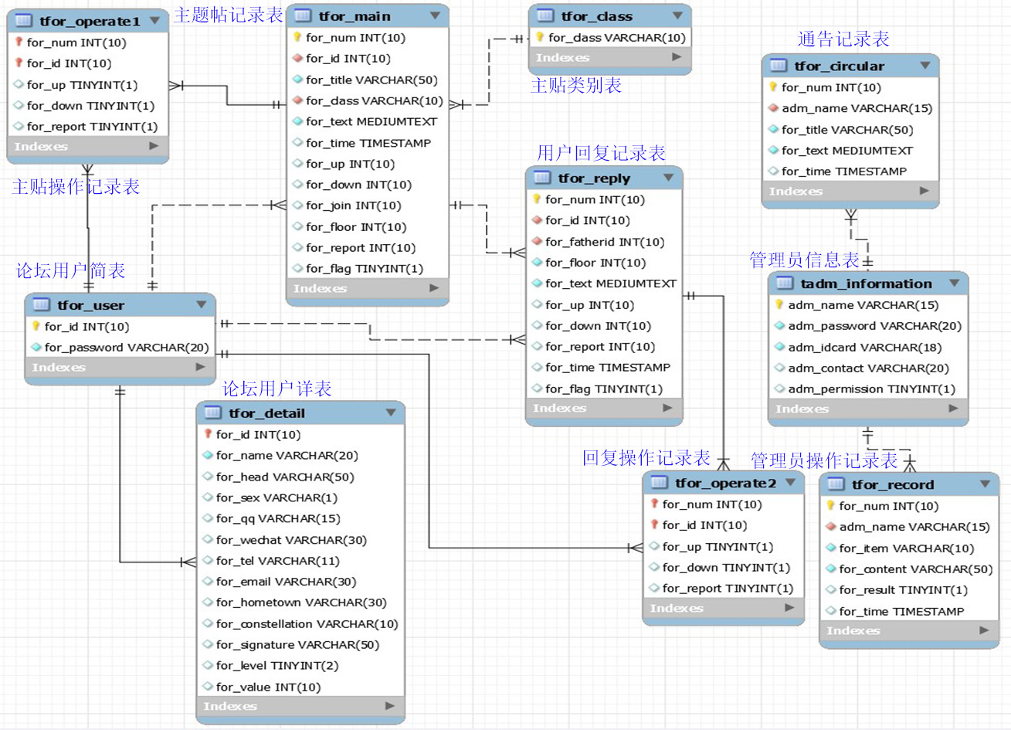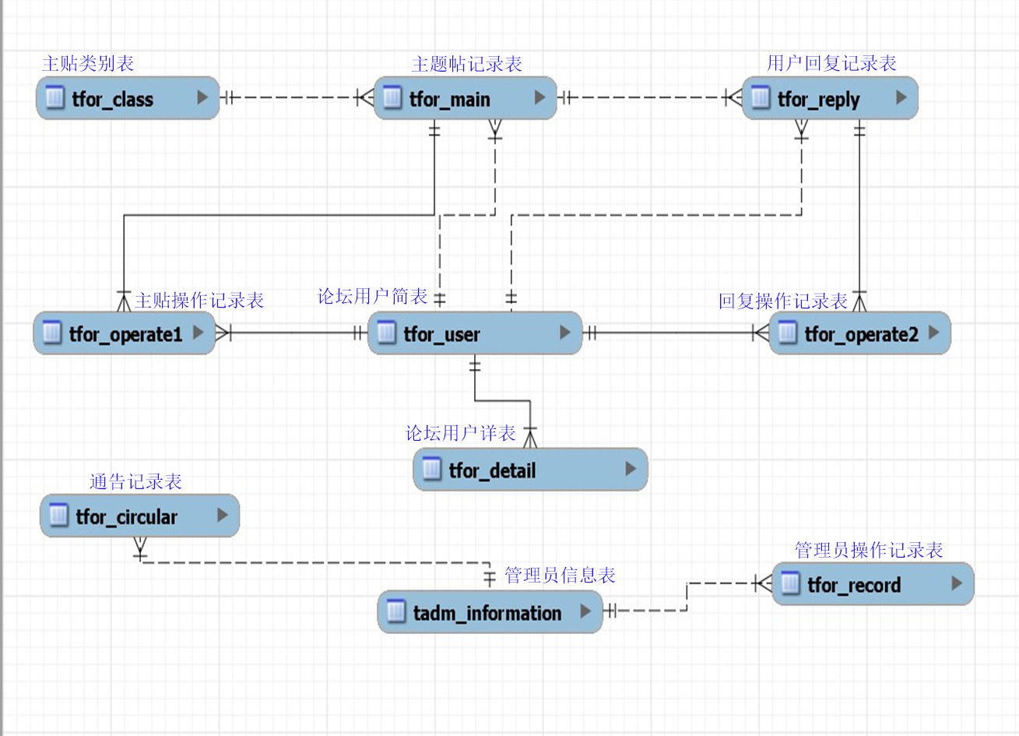

mysql> use forum;
Database changed
mysql> show tables;
+------------------+
| Tables_in_forum |
+------------------+
| tadm_information |
| tfor_circular |
| tfor_class |
| tfor_detail |
| tfor_main |
| tfor_operate1 |
| tfor_operate2 |
| tfor_record |
| tfor_reply |
| tfor_user |
+------------------+
10 rows in set (0.00 sec)

mysql> desc tadm_information;
+----------------+-------------+------+-----+---------+-------+
| Field | Type | Null | Key | Default | Extra |
+----------------+-------------+------+-----+---------+-------+
| adm_name | varchar(15) | NO | PRI | NULL | |
| adm_password | varchar(20) | NO | | NULL | |
| adm_idcard | varchar(18) | NO | UNI | NULL | |
| adm_contact | varchar(20) | YES | | NULL | |
| adm_permission | tinyint(1) | YES | | 0 | |
+----------------+-------------+------+-----+---------+-------+
5 rows in set (0.02 sec)

mysql> desc tfor_class;
+-----------+-------------+------+-----+---------+-------+
| Field | Type | Null | Key | Default | Extra |
+-----------+-------------+------+-----+---------+-------+
| for_class | varchar(10) | NO | PRI | NULL | |
+-----------+-------------+------+-----+---------+-------+
1 row in set (0.02 sec)

mysql> desc tfor_user;
+--------------+------------------+------+-----+---------+-------+
| Field | Type | Null | Key | Default | Extra |
+--------------+------------------+------+-----+---------+-------+
| for_id | int(10) unsigned | NO | PRI | NULL | |
| for_password | varchar(20) | NO | | NULL | |
+--------------+------------------+------+-----+---------+-------+
2 rows in set (0.02 sec)

mysql> desc tfor_detail;
+-------------------+------------------+------+-----+------------------+-------+
| Field | Type | Null | Key | Default | Extra |
+-------------------+------------------+------+-----+------------------+-------+
| for_id | int(10) unsigned | NO | PRI | NULL | |
| for_name | varchar(20) | NO | | NULL | |
| for_head | varchar(50) | YES | | default_head.png | |
| for_sex | varchar(1) | YES | | NULL | |
| for_qq | varchar(15) | YES | | NULL | |
| for_wechat | varchar(30) | YES | | NULL | |
| for_tel | varchar(11) | YES | | NULL | |
| for_email | varchar(30) | YES | | NULL | |
| for_hometown | varchar(30) | YES | | NULL | |
| for_constellation | varchar(10) | YES | | NULL | |
| for_signature | varchar(50) | YES | | NULL | |
| for_level | tinyint(2) | YES | | 0 | |
| for_value | int(10) unsigned | YES | | 0 | |
+-------------------+------------------+------+-----+------------------+-------+
13 rows in set (0.02 sec)

mysql> desc tfor_main;
+------------+------------------+------+-----+-------------------+----------------+
| Field | Type | Null | Key | Default | Extra |
+------------+------------------+------+-----+-------------------+----------------+
| for_num | int(10) unsigned | NO | PRI | NULL | auto_increment |
| for_id | int(10) unsigned | NO | MUL | NULL | |
| for_title | varchar(50) | NO | | NULL | |
| for_class | varchar(10) | NO | MUL | NULL | |
| for_text | mediumtext | NO | | NULL | |
| for_time | timestamp | YES | | CURRENT_TIMESTAMP | |
| for_up | int(10) unsigned | YES | | 0 | |
| for_down | int(10) unsigned | YES | | 0 | |
| for_join | int(10) unsigned | YES | | 0 | |
| for_floor | int(10) unsigned | YES | | 1 | |
| for_report | int(10) unsigned | YES | | 0 | |
| for_flag | tinyint(1) | YES | | 1 | |
+------------+------------------+------+-----+-------------------+----------------+
12 rows in set (0.02 sec)

mysql> desc tfor_reply;
+--------------+------------------+------+-----+-------------------+----------------+
| Field | Type | Null | Key | Default | Extra |
+--------------+------------------+------+-----+-------------------+----------------+
| for_num | int(10) unsigned | NO | PRI | NULL | auto_increment |
| for_id | int(10) unsigned | NO | MUL | NULL | |
| for_fatherid | int(10) unsigned | NO | MUL | NULL | |
| for_floor | int(10) unsigned | NO | | NULL | |
| for_text | mediumtext | NO | | NULL | |
| for_up | int(10) unsigned | YES | | 0 | |
| for_down | int(10) unsigned | YES | | 0 | |
| for_report | int(10) unsigned | YES | | 0 | |
| for_time | timestamp | YES | | CURRENT_TIMESTAMP | |
| for_flag | tinyint(1) | YES | | 1 | |
+--------------+------------------+------+-----+-------------------+----------------+
10 rows in set (0.03 sec)

mysql> desc tfor_operate1;
+------------+------------------+------+-----+---------+-------+
| Field | Type | Null | Key | Default | Extra |
+------------+------------------+------+-----+---------+-------+
| for_num | int(10) unsigned | NO | PRI | NULL | |
| for_id | int(10) unsigned | NO | PRI | NULL | |
| for_up | tinyint(1) | YES | | 0 | |
| for_down | tinyint(1) | YES | | 0 | |
| for_report | tinyint(1) | YES | | 0 | |
+------------+------------------+------+-----+---------+-------+
5 rows in set (0.02 sec)

mysql> desc tfor_operate2;
+------------+------------------+------+-----+---------+-------+
| Field | Type | Null | Key | Default | Extra |
+------------+------------------+------+-----+---------+-------+
| for_num | int(10) unsigned | NO | PRI | NULL | |
| for_id | int(10) unsigned | NO | PRI | NULL | |
| for_up | tinyint(1) | YES | | 0 | |
| for_down | tinyint(1) | YES | | 0 | |
| for_report | tinyint(1) | YES | | 0 | |
+------------+------------------+------+-----+---------+-------+
5 rows in set (0.02 sec)

mysql> desc tfor_circular;
+-----------+------------------+------+-----+-------------------+----------------+
| Field | Type | Null | Key | Default | Extra |
+-----------+------------------+------+-----+-------------------+----------------+
| for_num | int(10) unsigned | NO | PRI | NULL | auto_increment |
| adm_name | varchar(15) | NO | MUL | NULL | |
| for_title | varchar(50) | NO | | NULL | |
| for_text | mediumtext | NO | | NULL | |
| for_time | timestamp | YES | | CURRENT_TIMESTAMP | |
+-----------+------------------+------+-----+-------------------+----------------+
5 rows in set (0.03 sec)

mysql> desc tfor_record;
+-------------+------------------+------+-----+-------------------+----------------+
| Field | Type | Null | Key | Default | Extra |
+-------------+------------------+------+-----+-------------------+----------------+
| for_num | int(10) unsigned | NO | PRI | NULL | auto_increment |
| adm_name | varchar(15) | NO | MUL | NULL | |
| for_item | varchar(10) | NO | | NULL | |
| for_content | varchar(50) | NO | | NULL | |
| for_result | tinyint(1) | YES | | 1 | |
| for_time | timestamp | YES | | CURRENT_TIMESTAMP | |
+-------------+------------------+------+-----+-------------------+----------------+
6 rows in set (0.02 sec)

