

**EduLounge**

An Undergraduate Feasibility Study

Presented to the Faculty of College of Business Education

Inthezar Bai Ayunan

Nicole Joy Dawis

Mecah Secad

Rea Tapang

September 2024



**EduLounge**

An Undergraduate Feasibility Study

Presented to the Faculty of College of

Business Education

____________________

In Partial Fulfillment

of the Requirements of the Course

Feasibility Study for

the Degree Bachelor of Science in Business Administration

____________________

Inthezar Bai Ayunan

Nicole Joy Dawis

Mecah Secad

Rea Tapang

September 2024

**TABLE OF CONTENTS**

**PAGE**

COVER PAGE i

TITLE PAGE ii

TABLE OF CONTENTS iii

LIST OF TABLES iv

LIST OF FIGURES v

EXECUTIVE SUMMARY vi

**CHAPTER 1 MARKETING STUDY**

Service Description 1

Target Market 2

Area of Coverage 3

Consumer 3

Potential Market 4

Potential Product Demand 5

Supply 5

Demand and Supply Gap 5

Demand Supply Analysis 6

Price Structure 7

SWOT Analysis 8

Sales Projection and Sales Promotion Budget 9

Marketing Program Strategies 10

Competitor’s Strategy

Marketing and Selling Expense 11

**CHAPTER 2 TECHNICAL STUDY**

Manufacturing or Services Process 12

Labor Requirements 13

Raw Materials 14

Overhead Cost 15

Utilities and Freight In 16

Supplies 17

Business Location and Business Layout 18

**CHAPTER 3 ORGANIZATIONAL AND MANAGEMENT STUDY**

Form of Ownership 19

Organizational Set-Up 22

Key Personnel Duties and Responsibilities 23

Presentation of GANNT Chart of Activities 24

**CHAPTER 4 FINANCIAL STUDY**

Financial Assumption 26

Projected Cost 27

Sources of Financing 28

Financial Statement 29

Financial Ratios 30

**LIST OF TABLES**

**PAGE**

Table 1                   Potential Consumers 12

Table 2                   Potential Product Demand 13

Table 3                   Competitor 14

Table 4                   Demand Gap 14

Table 5                   Price Study of  Déjà Brew Cafe                                 15

Table 6                   Sales Projection (5 Year Plan) 16

Table 7                   Promotions Budget 17

Table 8                   Manpower Requirements 20

Table 9                   Presentation of Raw Materials 24

Table 10                 Equipment, and Furniture 24

Table 11                 Administrative Cost   25

Table 12                 Presentation of Supplies 26

Table 13                 GANNT Chart 33

Table 14                 Projected Cost  35

Table 15                 Initial Capital Contributions 36

Table 16                 Statement of Financial Position 37

Table 17                 Income Statement 38

Table 18                 Statement of Changes in Equity 39

Table 19                 Statement of Cash Flows 40

Table 20                 Profitability Ratio (Return on Assets) 40

Table 21                 Break Even Analysis 41

Table 22                 Profitability Ratio (Net Profit Ratio) 41

Table 23                 Break Even Analysis 42

Table 24                 Payback Period 42

**LIST OF FIGURES**

**Page**

Figure 1                       Business Location                     27

Figure 2                      Stand Design 28

Figure 3                       Floor Plan 28

Figure 4                        Organizational structure                                           41

**EXECUTIVE SUMMARY**

Edulounge Study Hub is a dedicated space designed for students, professionals, and freelancers to focus, collaborate, or study in a comfortable and productive environment. It provides high-speed internet, ample seating, and a quiet atmosphere. The hub is a haven for learning and productivity, seamlessly blending convenience and functionality for its patrons.

 The purpose of a study hub is to provide a quiet, comfortable, and focused environment for learning, studying, or working. It supports students and professionals by offering amenities like high-speed internet, adequate seating, and essential resources to enhance productivity. A study hub fosters concentration and collaboration, creating a space where individuals can achieve their academic or professional goals effectively.

Edulounge was formed by the partners of Inthezar Bai Ayunan, Rea Tapang, Nicole Joy Dawis, Mecah Secad. The space is designed to meet the needs of **university and college students**, **remote professionals**, **exam candidates**, **virtual assistants**, and **individuals currently not in the workforce**. Edulounge was believed to be a fast-growing business in 202 C.M. Recto Street, Barangay 34-D, Poblacion District, Davao City. This would probably increase the demand of service product.

**CHAPTER 1**

**MARKETING STUDY**

This chapter outlines the marketing aspects of a study hub and co-working space business, focusing on key elements such as product description, target market, area coverage, and demand-supply analysis. It emphasizes the importance of understanding customer needs and wants, as well as the need for creativity and innovation to deliver high-quality products and services. The feasibility of the business relies on a thorough analysis of market factors, pricing strategies, and sales projections to ensure long-term success.

**Service Description**

EduLounge is a flexible study hub and co-working space tailored to meet the needs of students, offering customizable rental spaces such as furnished or unfurnished open areas and conference rooms. The business focuses on affordability, providing competitive pricing and flexible terms to ensure accessibility for students with varying budgets. Conveniently located near universities and public transportation, EduLounge promotes a balanced lifestyle with easy access to essential amenities. With a user-friendly platform and dedicated support team, EduLounge helps students create personalized spaces that support both academic success and social growth.

**Target Market**

**EduLounge** targets a diverse range of users, including **students**, **professionals**, and **individuals seeking a focused environment for study or remote work**. It offers **flexible, affordable, and personalized spaces** tailored to the unique needs of its users. With customizable rental options, EduLounge caters to students, professionals, and exam takers alike — providing a **convenient, supportive space** that empowers users to achieve their academic, professional, and personal goals.

**Area of Coverage**

C.M. Recto, Poblacion District, Davao City., is a great location for a study hub because it’s accessible and surrounded by potential customers. It’s along C.M. Recto Avenue, a busy road where many students and professionals pass by every day. The place is also close to schools and universities like Ateneo de Davao University, Kalasag College and Univesrsity, Joji Ilagan Foundation, Santa Ana National High School, Holy Cross of Davao and San Pedro College, which means a lot of students might look for a comfortable space to study or work. Plus, C.M. Recto, Poblacion is known as a safe and organized area with plenty of offices and BPO companies, so it’s not just students but also freelancers and workers who could use the space. It’s really an ideal spot for a business that focuses on both learning and productivity.

**Consumer**

The EduLounge Study Hub business targets students, professional and non-workers who seek a peaceful study spot. To meet hectic schedules, the business provides flexible rental alternatives such as hourly and daily rates. It is especially useful for graduate students and adult learners who frequently balance work and studies. According to research, 56% of professionals prefer a cozy and friendly workplace. The business provides budget-friendly and adaptable options that appeal to students, young professionals, and individuals seeking out a peaceful spot to work and study.

**Table 1. Projected Market**

|  |  |  |
| --- | --- | --- |
| **Target Market** | **Number of Respondents** | **Percentage(%)** |
| **Students** | 40 | 66.7% |
| **Professionalworkers** | 15 | 25% |
| **Non-workers** | 5 | 8.3% |
| **Respondent who said No** | 0 | 0 |
| **Total Respondents** | 60 | 100% |

EduLounge Study Hub in C.M. Recto, Poblacion District, Davao City, shows the projected market for the study space rental business. The largest segment is **students (66.7%)**, showing that they are the primary target market who will most likely benefit from and utilize the service. **Professional workers (25%)** also represent a significant portion, indicating demand from individuals who may need a quiet place for work or further studies. **Non-workers (8.3%)** form a smaller share but still highlight potential users seeking a conducive environment for personal or academic pursuits. Importantly, **no respondents rejected the idea**, reflecting strong acceptance and a promising outlook for the business.

**Table 2. Frequency Demand Base on Survey**

|  |  |  |  |  |
| --- | --- | --- | --- | --- |
| **Category** | **Total Respondents** | **Visiting frequency/ month** | **Total Demand/ monthly** | **Total Demand/ Year** |
| Students | 40 | 5 | 200 | 2,400.00 |
| Professional Workers | 15 | 4 | 60 | 720.00 |
| Non- Workers/ Others | 5 | 2 | 10 | 120.00 |
| TOTAL | 60 | 11 | 270 | 3240.00 |

This indicates that students generate the highest demand with **200 visits monthly (2,400 annually)**, followed by professional workers with **60 visits monthly (720 annually)**, and non-workers with **10 visits monthly (120 annually)**. Overall, the projected demand reaches **270 visits per month or 3,240 per year**, confirming students as the primary users of the service.

**Table 3. Projected Person-Hours of Study Hub Use (Monthly & Annual)**

|  |  |  |  |  |
| --- | --- | --- | --- | --- |
| **Category** | **Total Visits / Month** | **Avg. Hours / Visit** | **Total Hours / Month** | **Total Hours / Year** |
| Students | 200 | 3 | 600 | 7,200 |
| Professional Workers | 60 | 3 | 180 | 2,160 |
| Non- Workers/ Others | 10 | 3 | 30 | 360 |
| TOTAL | 270 | _ | 810 | 9,720 |

This table shows the projected hourly use of the study hub, based on a maximum stay of three hours per visit. Students generate the highest occupancy, followed by professional workers and non-workers. Overall, the hub is expected to reach about **810 person-hours** per month, or **9,720 person-hours** per year.

**Table 4 : Demand and Supply Gap Projection**

|  |  |  |
| --- | --- | --- |
| **Provider** | **Projected Annual Demand (hours)** | **Projected Visits/Year** |
| Kugi Hub Coworking & Study | 8,000 | - |
| OurZone Study Hub Working Space | 6,500 | - |
| Z Workspace & Study Hub | 7,000 | - |
| Hygge Coffee | 9,000 | - |
| Coffee Paste | 4,500 | - |
| EduLounge | 9,720 | 3,240 visits/year |
| TOTAL | 44,720 | 3,240 visits/year |

This table highlights the demand and supply gap across different categories of users for a study hub business. The demand is driven by students, freelancers, office workers, and others in need of workspace or study areas. Projected Annual Demand (hours) is calculated by multiplying the annual number of visits by the average duration of each visit. The gap between available services and actual usage indicates potential opportunities for expansion or improvement.

**Table 5. Pricing Structure (26days/month)**

|  |  |  |  |
| --- | --- | --- | --- |
| **Services** | **Rate** (₱) | **Daily Usage** | **Daily Revenue**  (₱) |
| Cubicle Area | 30/hr | 15 users × 5 hrs | 2,250 |
| Open Space | 20/hr | 20 users × 5 hrs | 2,000 |
| Conference Room | 150/hr | 4 hrs/day | 600 |
| Nap Room | 5/hr | 30 users × 2 hrs | 300 |
| Printing Service | 1.50/page | |  | | --- | | 15 pages | | 22.5 |
| Snack Bar | 50 | 25 transaction | 1,250 |
| Tutoring Service | 200 | 3 hrs/day | 600 |
| **TOTAL DAILY REVENUE** |  |  | **₱ 7,022.5** |

The study hub is projected to earn about **₱7,022.50 per day** from its services. Most of the income comes from seat rentals in the cubicle area (₱2,250) and open space (₱2,000), followed by the snack bar (₱1,250). Other sources include the conference room (₱600), tutoring service (₱600), nap room (₱300), and printing (₱22.50). These figures reflect the expected daily usage and standard rates for each service.

**Table 6. Applied Student Promo**

|  |  |
| --- | --- |
| Effective billed Hours (0.8 of the regular charge) | 7,022.5 × (4/5 for cubicles only) |
| 20% Discount in cubicle area | (20% of 2,250) |
| **TOTAL** | **₱6,572.5** |

5,522.5 (daily) x 26 (days/month) = 143,585 (monthly)

143,585 (monthly) x 12 = 1,723,020 (annual - year 1)

This table shows the student discount rates for the study hub’s services. For the cubicle only **1 hour free** for every 5 hours of use.

**Table 7. SWOT Analysis**

|  |
| --- |
| **Strengths** |
| * Offers comfortable, well-designed study and co-working spaces. |
| * Strong digital marketing presence on Facebook, Instagram, and TikTok. |
| * Reliable high-speed internet and value-added services. |
| **Weaknesses** |
| * Limited seating capacity compared to larger competitors. |
| * Higher initial costs for equipment and promotions. |
| * Still building brand awareness in a competitive market. |
| **Opportunities** |
| * Growing demand for study hubs among students and young professionals. |
| * Potential to expand services like tutoring, printing, and events. |
| * Rising social media usage for cost-effective promotions. |
| **Threats** |
| * Strong competition with established study hubs in Davao City. |
| * Possible technical issues like slow internet or system glitches. |
| * Customer loyalty challenges if competitors’ lower prices or improve offers. |

This table summarizes the strengths, weaknesses, opportunities, and threats of EduLounge.

**Marketing Program Strategies**

To effectively market student study hubs, a comprehensive program should focus on building a strong brand identity and leveraging digital platforms. This involves conducting thorough market research to understand student preferences and tailoring offerings accordingly.

Establishing a vibrant online presence through social media channels like Instagram, TikTok, and Facebook will be key, utilizing engaging content such as study tips, success stories, and interactive posts to resonate with the student community. Promotional campaigns, such as limited-time discounts and referral programs, can encourage initial visits and foster loyalty. Additionally, partnering with campus influencers and organizations can amplify reach and create authentic connections.

Promotion strategies should also emphasize community engagement through events and workshops. Hosting study groups, skill-building sessions, and guest lectures can draw students in and create a sense of belonging. On-campus marketing efforts, including eye-catching flyers and booths during orientation, will help increase visibility. Implementing a feedback mechanism, such as surveys and suggestion boxes, ensures that students feel heard and can contribute to ongoing improvements. Collaborations with local businesses for cross-promotional discounts can further enhance the hub's appeal, making it a go-to destination for academic support and resources.

**Competitor’s Strategy**

In Davao City, study hub competitors focus on creating **c**omfortable and flexible spaces for students and professionals. Features commonly offered include ergonomic furniture, natural light, quiet zones, and cozy corners, designed to enhance productivity. Many hubs, such as **Kugi Hub** and **OurZone Study Hub**, provide extended operating hours to accommodate the varying schedules of students and freelancers.

**Kugi Hub Coworking and Study Space** is known for its spacious layout and quiet zones, but experiences **peak-hour crowding** that can limit available seating. **OurZone Study Hub Working Space** emphasizes ergonomic furniture and a structured environment but sometimes faces limited capacity during high-demand periods. **Z Workspace & Study Hub** offers a modern, well-lit environment, though noise control can be inconsistent during busy times. **Hygge Coffee** and **Coffee Paste** combine study-friendly spaces with café services. Hygge Coffee is appreciated for its cozy ambiance and extended hours, while Coffee Paste offers casual seating with refreshments. Both, however, can face challenges with noise and space constraints during peak periods.

Competitors also leverage technology and amenities to attract users, providing Wi-Fi, charging stations, and digital booking systems. While these enhance convenience, some users report occasional slow internet speeds or limited access to digital resources. Marketing strategies such as social media campaigns, seasonal promotions, and loyalty programs help increase visibility, but hubs that fail to adapt to student feedback or improve services consistently may struggle to retain customers in a competitive market.

**Marketing and Selling Expense**

**Table 8. Promotions Budget**

|  |  |  |  |  |  |  |  |
| --- | --- | --- | --- | --- | --- | --- | --- |
| Prootional Channel | Monthly Budget (₱) | Annual Budget  (₱) | Year 1  (₱) | Year 2  (₱) | Year 3  (₱) | Year 4  (₱) | Year 5  (₱) |
| Sponsored Content | 300 | 3,600 | 3,600 | 7,200 | 10,800 | 14,400 | 18,000 |
| Tiktok (Organic) | 200 | 2,400 | 2,400 | 4,800 | 7,200 | 9,600 | 12,000 |
| Instagram (Organic) | 0 | 0 | 0 | 0 | 0 | 0 | 0 |
| Poster (DIY) | 400 | 4,800 | 4,800 | 9,600 | 14,400 | 19,200 | 24,000 |
| **TOTAL** | **900** | **10,800** | **10,800** | **21,600** | **32,400** | **43,200** | **54,000** |

Table 8 presents the projected promotions budget, showing monthly, annual, and five-year allocations for each channel. Sponsored content, TikTok, and DIY posters comprise the main expenses, while Instagram (organic) requires no budget.

**CHAPTER 2**

**TECHNICAL STUDY**

In this section, it covers the technical aspects of the operation, as well as the flow of the operation. The manufacturing or service process, raw materials and supplies, production costs, labor requirements, plant size and production schedule, machinery and equipment, plant location and layout, building design, and overall view of Edulounge, utilities are all covered in this section.

**Services Process**

1. Customer arrives and books a seat (walk-in or online).
2. Staff assists with registration/payment.
3. Customer is guided to their designated space (cubicle, open area, nap room, etc.).
4. Staff ensures facilities like Wi-Fi, power outlets, and equipment are working.
5. Customers can request additional services (printing, tutoring, copying).
6. Staff monitors cleanliness, security, and noise control throughout the day.
7. End-of-day maintenance: cleaning, equipment check, and preparation for the next day.

**Service Practices — Diagram**

This illustrates the edulounge service framework, highlighting a structured five-step approach to enhance customer experience from the moment they arrive until they depart.

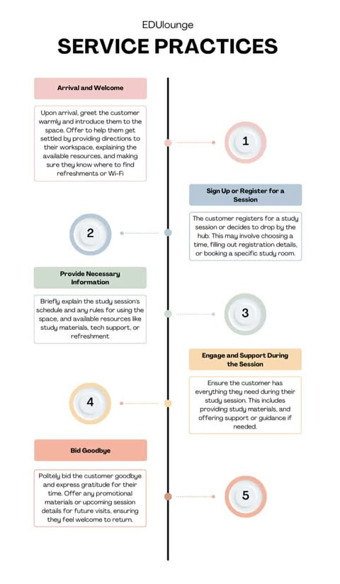

**Labor Requirements**

**Table 9 — Monthly and Annual Payroll**

|  |  |  |  |
| --- | --- | --- | --- |
| **Item** | **Employer** | **Employee** | **Notes** |
| **Gross Salary** | 13,260 | 13,260 | Base Pay |
| **SSS Employee**  **(₱)** | 1,350 | 675 | Based on MSC = 13,500 |
| **Employee’s Compensation (EC)** | 10 | --- | Employer only |
| **PhilHealth (₱)** | 331.50 | 331.50 | 0.5 x 5% |
| **Pag-IBIG**  **(₱)** | 100 | 100 | Capped at **₱100** |
| **Total Contribution** | 1,791.50 | 1,106.50 |  |
| **Net Monthly Salary** | --- | 12,153.50 | After EE share only |
| **13th Month Pay (₱)** | 13,260 |  | One month gross |

The table shows the breakdown of a ₱13,260 monthly salary, including employer and employee contributions to SSS, PhilHealth, and Pag-IBIG. After deductions of ₱1,106.50, the employee’s net monthly pay is ₱12,153.50, with a 13th-month pay equal to one month’s gross salary.

**Table 10 - Labor Cost per Month and per Year**

|  |  |  |  |  |  |
| --- | --- | --- | --- | --- | --- |
| **Position** | **Gross Salary**  **(₱)** | **Employer Contribution**  **(SSS + Pag- IBIG + PhilHealth + EC) (₱)** | **Monnthly Labor Cost**  **(₱)** | **13th Month Pay**  **(₱)** | **Total Annual Labor Cost**  **(₱)** |
| Receptionist | 13,260 | 1,791.50 | 15,051.50 | 13,260 | 193,878 |
| Cleaning Staff | 13,260 | 1,791.50 | 15,051.50 | 13,260 | 193,878 |
| **Total** | **26,520** | **3,583.00** | **30,103.00** | **26,520** | **387,756** |

“Monthly Labor cost = Gross Salary + Employer contribution”

“Anual = (Monthly Labor cost x 12) + 13th Month Pay”

**Raw Materials**

**Table 11 — Presentation of Raw Materials**

|  |  |  |  |  |
| --- | --- | --- | --- | --- |
| **Item Category** | **Units (per month)** | **Value per Unit (₱)** | **Monthly Total (₱)** | **Annual Total (₱)** |
| Printing & Paper Supplies | 100 reams / sheets equivalent | 120 | 12,000 | 144,000 |
| Ink & Toner (printer use) | 5 cartridges | 800 | 4,000 | 48,000 |
| Cleaning & Sanitation Supplies | 1 set | 3,000 | 3,000 | 36,000 |
| Pantry / Refreshments | 1 set | 2,500 | 2,500 | 30,000 |
| Miscellaneous Office Supplies | 1 set | 2,000 | 2,000 | 24,000 |
| Utilities (back-up load, prepaid) | 1 set | 1,500 | 1,500 | 18,000 |
| Maintenance Supplies (minor repairs, bulbs, batteries) | 1 set | 1,000 | 1,000 | 12,000 |
| **TOTAL** | — | — | **26,000** | **312,000** |

The hub’s monthly raw materials cost totals ₱26,000, covering printing paper, ink/toner, cleaning and sanitation supplies, pantry refreshments, office supplies, utilities, and minor maintenance items. This amounts to an **annual cost of ₱12,000**

**Table 12 — Furniture**

|  |  |  |  |  |  |
| --- | --- | --- | --- | --- | --- |
| **Item** | **Units** | **Value per Unit (₱)** | **Total Value (₱)** | **Useful Life (yrs)** | **Annual Depreciation (₱)** |
| Cubicle desks (with partitions) | 10 | 6,000 | 60,000 | 8 | 7,500 |
| Office chairs (all areas) | 25 | 1,800 | 45,000 | 6 | 7,500 |
| Long tables (shared desks) | 3 | 8,000 | 24,000 | 8 | 3,000 |
| Whiteboard / Glass board | 2 | 5,000 | 10,000 | 5 | 2,000 |
| Soft seating (sofa/lounge) | 2 | 12,000 | 24,000 | 6 | 4,000 |
| Snack bar counter + stools | 1 set | 20,000 | 20,000 | 8 | 2,500 |
| Conference table | 1 | 18,000 | 18,000 | 8 | 2,250 |
| Reception desk + chair | 1 set | 12,000 | 12,000 | 8 | 1,500 |
| Lockers / storage cabinets | 2 | 10,000 | 20,000 | 8 | 2,500 |
| Nap room – bunk beds | 2 | 15,000 | 30,000 | 8 | 3,750 |
| Nap room – sofa bed | 1 | 12,000 | 12,000 | 6 | 2,000 |
| Nap room – partitions & curtains | 1 set | 10,000 | 10,000 | 6 | 1,667 |
| **TOTAL** | — | — | **285,000** | — | **40,167** |

**Table 13 — Equipments**

|  |  |  |  |  |  |
| --- | --- | --- | --- | --- | --- |
| **Item** | **Units** | **Value per Unit (₱)** | **Total Value (₱)** | **Useful Life (yrs)** | **Annual Depreciation (₱)** |
| Charging stations / outlets | 10 | 1,500 | 15,000 | 5 | 3,000 |
| Projector / Smart TV | 1 | 25,000 | 25,000 | 5 | 5,000 |
| Speakerphone / mic system | 1 | 10,000 | 10,000 | 5 | 2,000 |
| WiFi router & network setup | 2 | 8,000 | 16,000 | 4 | 4,000 |
| Printer & photocopier | 1 | 20,000 | 20,000 | 5 | 4,000 |
| CCTV system (4 cameras + DVR) | 1 set | 25,000 | 25,000 | 5 | 5,000 |
| Air-conditioning units | 2 | 30,000 | 60,000 | 10 | 6,000 |
| Cleaning equipment set | 1 set | 8,000 | 8,000 | 5 | 1,600 |
| **TOTAL** | — | — | **179,000** | — | **30,600** |

The equipment and furniture table 12 and 13 presents the one-time investment required to set up the 25-seat study hub, including areas for cubicles, shared desks, and the conference room. To avoid repetition, similar items such as chairs and desks were merged into single categories. A nap room was also included to enhance comfort for long-hour users. Each item was assigned a useful life, and depreciation was calculated using the straight-line method to allocate costs over time. The table highlights a total investment cost of ₱454,000 with an annual depreciation of about ₱73,267, ensuring a realistic and sustainable cost projection.

**Table 14 — Administrative Cost Projection**

|  |  |  |  |
| --- | --- | --- | --- |
| **Expense Category** | **Source** | **Monthly Cost (₱)** | **Annual Cost (₱)** |
| Electricity | Local Provider | 12,195.20 | 146,342.4 |
| Water | Local Waterworks | 3,000 | 36,000 |
| Rent | Leased Property | 52,000 | 624,000 |
| **TOTAL** |  | 67,195.20 | 806,342.4 |

These our the recurring operational expense for electricity, Water, Internet Load, Rent and Freight- in, with a monthly cost of ₱67,195.20 and an annual total of ₱806,342.4.

**Production Schedule**

The study hub six days a week, offering organized study sesssions, flexible workpaces, and mindfulness breaks to support student focus and wellbeing. To encourage regular attendance, the “Study Buddy” program provides discounts and exclusive workshop for students who bring a friend, while a loyalty card frequent visitors with free stationery items. Themed study nights, such as “STEM Saturdays” and “ Creative arts Wednesday,” Attract student and poster connection with specific student academic interest.

**Business Location and Business Layout**

The business location will be located on C.M. Recto, Poblacion District, Davao City. The selected area is believed to have a proximity to major educational institutions, steady influx of potential renters and substantial student population increases the likelihood of consistent occupancy rates. The area is well-connected by public transportation, which is crucial for students who may not have access to personal vehicles. Easy commuting options enhance the attractiveness of rental spaces, as students prioritize convenience when choosing renting arrangements.

**Figure 1. Business Location**

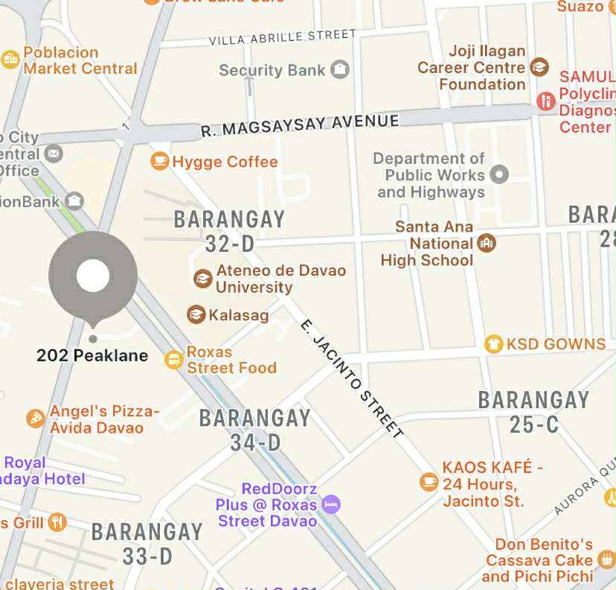

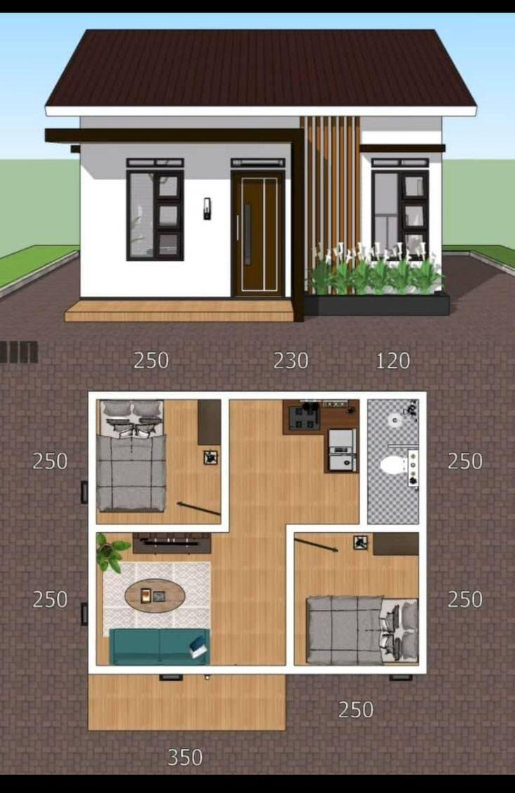**Figure 2. floor plan**

**Figure 3. Stand design**

**Service flow**

When customers enter the study hub and approach the cashier, the first step is to inquire about their intended needs—whether they’re looking for an open space, a private cubicle, or a conference room. The cashier will guide them through available options, explaining the details and pricing of each. If the customer is eligible for any promotions, such as discounts on long-term use or bundled services, the cashier will inform them and apply these benefits to their booking. For example, **If the customer is a student and avails 5 hours, the cashier will give them a student discount of 1 hour free.**

Once the payment is processed, the cashier will provide the customer with relevant details for their booking, including access codes or directions to the reserved area. If they’ve chosen a shared open space, the cashier will direct them to a designated area, while for private cubicles or conference rooms, the customer will be escorted or given a quick tour to familiarize them with the space. Throughout the experience, staff will remain available to assist with any additional needs such as equipment, Wi-Fi access, or refreshments, ensuring a seamless and supportive environment for the customer's study or work session.

**Waste Management**

**I**n the context of establishing a study hub in C.M. Recto, Poblacion District, Davao City. waste management is governed by several relevant laws and regulations. One key legislation is the Republic Act No. 9003, also known as the Ecological Solid Waste Management Act of 2000. This act mandates the implementation of solid waste management programs at the local government level, including segregation at source, recycling, and the establishment of waste disposal facilities.

Additionally, to consider local ordinances specific to Davao City, such as the Davao City Waste Management Ordinance, which complements national laws and provides specific guidelines tailored to the city’s needs. These regulations will ensure that our study hub adheres to proper waste management practices, promoting sustainability and environmental responsibility.

**CHAPTER 3**

**ORGANIZATIONAL AND MANAGEMENT STUDY**

This chapter provides an overview of how our customized study room rental business should be structured and managed, providing an outline of ownership, organizational structure, officers and key personnel duties and responsibilities, salaries and benefits, and gantt charts. It emphasizes fair compensation and a coordinated team to provide excellent study spaces for students.

In this fast-paced academic world, a student is most likely searching for the best studying space, the best suitable comfort spot to study where he or she can concentrate well. That is why we are excited to launch a tailor-made study room rental business, designed to meet the unique needs of students.

Our mission is that of helping students get personalized spaces tailored to their needs and schedules. Whether cramming for that exam or working on the next big group project, our doors are open for you to use at all times.

We will keep on building a friendly environment where students collaborate and exchange ideas towards achieving similar objectives. We commit ourselves to being your favorite place to study with partnerships with local schools and smart marketing.

**Form of Ownership**

EduLounge will be established as a general partnership, allowing multiple individuals to share ownership and management responsibilities. This would enable the owners to pool their resources so that they can share profits or losses and also pool their different skills so that they can make effective decisions. Benefits of the partnership are; simple setup defined roles, and profit sharing.

For a lawfully operating partnership in Davao City, there has to be a process of registration in the following step; obtaining a barangay certification and local business license from the Davao City business bureau, including a mayor’s permit; filing a partnership registration with the Securities and Exchange Commission (SEC), acquiring an Employer Identification Number (EIN) from the Bureau of Internal Revenue (BIR), and ensuring compliance with local zoning laws and health regulations. It can establish cooperation and accountability between partners, thereby ensuring the study room continues to remain operational for purposes of building legitimacy.

**Organizational Set up**

**Key Personnel Duties and Responsibilities**

**Figure 4. Organizational Structure**

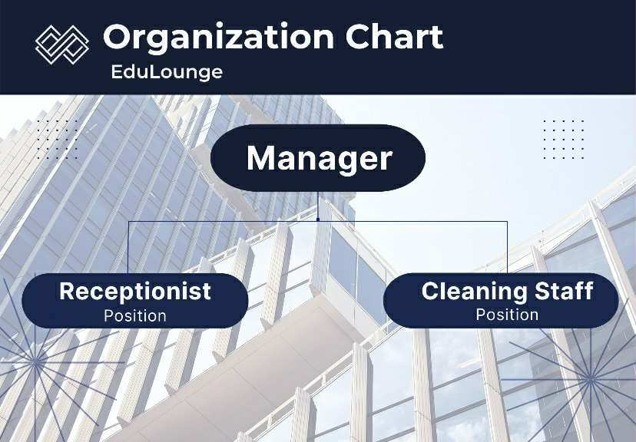

Manager Oversees operations, ensures staff performance, resolves issues, and maintains customer satisfaction**.** Receptionist: Handle customer inquiries, manage bookings, supervise cleaning staff, and maintain records for smooth daily operations. Cleaning Staff: Maintain cleanliness, follow assigned tasks from receptionist, and ensure a hygienic, welcoming environment.

**GANTT Chart of Activities**

**Table 14. GANTT Chart**

|  |  |  |  |  |  |  |  |
| --- | --- | --- | --- | --- | --- | --- | --- |
| **Activities** | **No. of Months** | **Duration in Months** | | | | | |
| **1** | **2** | **3** | **4** | **5** | **6** |
| Market research via survey of the target market | 1 |  |  |  |  |  |  |
| Start of the feasibility study | 2 |  |  |  |  |  |  |
| Investment of Partnership for financing | 1 |  |  |  |  |  |  |
| Acquiring all requirements and permits | 1 |  |  |  |  |  |  |
| Purchasing of machineries, equipment and supplies | 1 |  |  |  |  |  |  |
| Hiring of employees | 1 |  |  |  |  |  |  |
| Training of employees | 1 |  |  |  |  |  |  |
| Launching of the study hub |  |  |  |  |  |  |  |

The plan begins with a one-month market survey, followed by a two-month feasibility study. Financing is secured, then permits, equipment, and supplies are acquired in sequence. Hiring and training take one month each, leading to the launch of the study hub.

**CHAPTER 4**

**FINANCIAL STUDY**

This chapter presents the presumption of the proposed business. This includes the financial aspect of the study. It also includes the financial assumption, total projected cost, sources of financing statements, the financial analysis and notes to financial statements.

### **Financial Assumptions**

The financial assumptions for EduLounge are based on its projected revenue growth, cost control measures, and market conditions over a five-year horizon. **Revenue** is expected to grow by **5% annually**, supported by seat rentals, conference room bookings, printing and scanning services, and ancillary offerings such as snacks and study materials.

**Operating costs**—including rent for the 80 sqm space, utilities, and supplies—are projected to rise by about **2% per year**, reflecting inflation and moderate increases in usage. Within these, **management and administrative expenses** (e.g., staff salaries, office supplies, professional fees) are assumed to remain generally stable, with only slight increases tied to inflation.

**Depreciation** on fixed assets (furniture, office equipment, charging station, air-conditioning, and cleaning equipment) is estimated in total of **₱70,767 annually**, based on a five-year straight-line schedule. The **cost of consumables**—such as stationery, pantry items, and cleaning supplies—is expected to grow at **3% per year**.

No major new liabilities are anticipated; the business aims to remain debt-light and maintain a cash reserve equivalent to three months of operating costs. Steady demand from students and professionals, combined with efficient expense management, is expected to keep EduLounge’s cash flow positive after its first operating year.

**Projected Cost**

**Table 15. Projected Cost**

1. **Organizational Costs**

|  |  |
| --- | --- |
| **Item** | **Cost ( ₱ )** |
| SEC Regulatory Fees | 2,000 |
| Barangay Clearance | 700 |
| BIR Registration | 1,500 |
| Mayor's permit | 5,000 |
| Sanitary permit | 1,000 |
| Fire safety and inspection fee | 2,000 |
| Occupancy permit | 1,000 |
| Signage permit | 1,000 |
| Misc./ Documentary stamps’/ Notariel | 500 |
| **Total organizational cost** | **14,700** |

The total **organizational cost** for setting up the business is estimated at **₱14,700**. This includes mandatory fees such as SEC registration (₱2,000), barangay clearance (₱700), BIR registration (₱1,500), mayor’s permit (₱5,000), sanitary permit (₱1,000), fire safety inspection (₱2,000), occupancy permit (₱1,000), signage permit (₱1,000), and miscellaneous/documentary fees (₱500). These charges cover all the essential licenses and permits needed to legally operate the study hub.

1. **Revenue Projection (5% Growth/Year)**

|  |  |
| --- | --- |
| **Year** | **Annual Revenue** |
| 1 | 1,723,020 |
| 2 | 1,809,171 |
| 3 | 1,899,630 |
| 4 | 1,994,630 |
| 5 | 2,094,342 |

EduLounge earns from seat rentals, conference and nap rooms, printing, snacks, and tutoring. Revenue is based on daily users × rates × 26 days per month, with a 5% annual growth. A mix of core and support services ensures steady income.

1. **Fixed Assets**

|  |  |  |  |
| --- | --- | --- | --- |
| **Category** | **Total Value (** | **Useful Life (yrs)** | **Annual Depreciation** |
| Furnitures and Fixtures | 285,000 | 6-8 | 45,766.67 |
| Equipment and Electronics | 179,000 | 4-10 | 25,000 |
| **Total Fixed Asstes** | **464,000** | **--** | **₱70,766.67** |

EduLounge’s fixed assets include furniture, office equipment, air-conditioning units, charging stations, CCTV, and cleaning tools. These assets support daily operations and guest comfort. They were purchased at a total cost of **₱464,000**, with depreciation estimated at **₱70,766.67 annually** using a straight-line method over their useful lives.

1. **Operating Cost**

|  |  |
| --- | --- |
| **Category** | **Amount** |
| Rent/Base Lease | 52,000 |
| Electricity | 12,195.20 |
| Water | 3000 |
| Staff Salaries | 26,520 |
| SSS, PhiliHealth, Pag-IBIG, EC | 1,800 |
| Consumables | 26,000 |
| Marketing | 900 |
| Repairs and Maintenance | 1,000 |
| Miscellaneous/ Contingency | 1,500 |
| **Total (Monthly)** | **₱124,915.20** |

1. **Operating Cost Projection**

|  |  |  |
| --- | --- | --- |
| **Year** | **Monthly OPEX (₱)** | **Annual OPEX (₱)** |
| 1 | 124,915.20 | 1,498,982.4 |
| 2 | 127,413.50 | 1,528,962.00 |
| 3 | 130,000.77 | 1,560,009.24 |
| 4 | 132,600.78 | 1,591,209.36 |
| 5 | 135,252.80 | 1,623,033.60 |

Utilities, rent, general operating costs → 2%/year and Consumables → 3%/year. EduLounge’s monthly operating costs include rent for the 80-sqm space, electricity for air-conditioning, lighting, and devices, water, and internet. Staff salaries with government contributions form another major expense. Other costs cover printing and cleaning supplies, pantry items, marketing, minor repairs, and contingencies. Total operating expenses are estimated at **₱124,915.20 per month** (₱**1,498,982.4** annually), with a projected 2% yearly increase to reflect inflation and usage growth.

**Table 16. Initial Capital Contributions**

|  |  |
| --- | --- |
| **Partners** | **Invested amount (₱)** |
| Tapang, Rea | 110,000 |
| Secad, Mecah | 110,000 |
| Dawis, Nicole Joy  (Managing Partner) | 70,000 |
| Ayunan, Inthezar Bai | 110,000 |
| **Total** | **400,000** |

The table outlines the initial capital contributions of EduLounge’s partners, amounting to a total of **₱105,000**. Each partner provides a significant share to support startup operations, with the managing partner contributing both financially and through active leadership. This pooled investment ensures sufficient resources to launch the study hub and demonstrates the partners’ collective commitment to its long-term success.

**Table 17. Income Statement**

**EDULOUNGE**

**INCOME STATEMENT**

**PROJECTED 5 YEARS PLAN**

|  |  |  |  |  |
| --- | --- | --- | --- | --- |
| **Year** | **Revenue** | **Operating Cost** | **Depreciation** | **Net Income** |
| 1 | 1,723,020 | 1,498,982.4 | 73,267 | 150,770.60 |
| 2 | 1,809,171 | 1,528,962.00 | 73,267 | 206,942 |
| 3 | 1,899,630 | 1,560,009.24 | 73,267 | 266,353.76 |
| 4 | 1,994,630 | 1,591,209.36 | 73,267 | 330,153.64 |
| 5 | 2,094,342 | 1,623,033.60 | 73,267 | 398,041.40 |

Revenue grows steadily at 5% annually, reaching ₱2,094,342 by Year 5. Operating costs are managed effectively, with modest increases each year, while annual depreciation of ₱73,267 is accounted for. This results in consistent net income growth from ₱150,771 in Year 1 to ₱398,041 by Year 5, demonstrating profitability and efficient cost control throughout the five-year period.

**Table 18.Statement of Changes in Equity**

**EDULOUNGE**

**STATEMENT OF CHANGES IN EQUITY**

**PROJECTED 5 YEARS PLAN**

|  |  |  |  |
| --- | --- | --- | --- |
| **Year** | **Beginning Equity** | **Net Income** | **Ending Equity** |
| 1 | 105,000 | 150,770.60 | 255,770.60 |
| 2 | 255,770.60 | 206,942 | 462,712.60 |
| 3 | 462,712.60 | 266,353.76 | 729,066.36 |
| 4 | 729,066.36 | 330,153.64 | 1,059,220.00 |
| 5 | 1,059,220.00 | 398,041.40 | 1,457,261.40 |

EduLounge’s equity grows steadily over the five-year period, starting with an initial capital of ₱105,000. Strong net income each year increases equity from ₱255,771 in Year 1 to ₱1,457,261 by Year 5. This reflects consistent profitability and the reinvestment of earnings, highlighting the business’s financial strength and long-term sustainability.

**Table 19. Statement of Financial Position**

**EDULOUNGE**

**STATEMENT OF FINANCIAL POSITION**

**PROJECTED 5 YEARS PLAN**

|  |  |  |  |
| --- | --- | --- | --- |
| **Year** | **Assets** | **Liabilities** | **Equity** |
| 1 | 255,770.60 | 0 | 255,770.60 |
| 2 | 462,712.60 | 0 | 462,712.60 |
| 3 | 729,066.36 | 0 | 729,066.36 |
| 4 | 1,059,220.00 | 0 | 1,059,220.00 |
| 5 | 1,457,261.40 | 0 | 1,457,261.40 |

This tableprojected financial position shows steady growth over five years. Total assets increase from ₱255,771 in Year 1 to ₱1,457,261 by Year 5, fully funded by equity with no liabilities. This demonstrates the business’s strong financial health, sustainable growth, and ability to expand operations while maintaining financial independence.

**Table 20. Cash Flow**

**EDULOUNGE**

**STATEMENT OF CASH FLOW**

**PROJECTED 5 YEARS PLAN**

|  |  |  |  |  |  |
| --- | --- | --- | --- | --- | --- |
| **Year** | **Beginning Cash** | **Net Income** | **+Depreciation** | **=Cash before new PPE/dividends** | **Ending Cash** |
| **Start - up** | 400,000 | - | - | - | 400,000 |
| -Permits/Org. costs | - 14,700 |  |  |  | 385,300 |
| **-**Buy PPE | - 353,835 |  |  |  | 18,965 |
| **Year 1** | 31,465 | 150,771 | 70,767 | 253,003 | **242,003** |
| Year 2 | 253,003 | 206,942 | 70,767 | 530,712 | **522,212** |
| Year 3 | 530,712 | 266,354 | 70,767 | 867,833 | **861,833** |
| Year 4 | 867,833 | 330,154 | 70,767 | 1,268,754 | **1,265,254** |
| Year 5 | 1,268,754 | 398,041 | 70,767 | 1,737,562 | **1,736,562** |

This projects strong financial growth and stability over five years. Starting with ₱400,000 in cash, the business efficiently covers startup expenses and invests in equipment, generating a Year 1 net income of ₱150,771. With disciplined cost management and steady revenue growth, cash rises to ₱1,736,562 by Year 5, while total assets increase from ₱255,770 to ₱1.46 million. Fully equity-funded and free of liabilities, EduLounge demonstrates profitability, strong liquidity, and low financial risk, making it an attractive and sustainable investment opportunity.

**Financial Ratios**

**Table 21. Financial Ratios**

|  |  |  |  |  |  |  |
| --- | --- | --- | --- | --- | --- | --- |
| **Ratio** | **Basis** | **Y1** | **Y2** | **Y3** | **Y4** | **Y5** |
| **Net Profit Margin** | Net Income ÷ Revenue | 8.8% | 11.4% | 14.0% | 16.5% | 19.0% |
| **Return on Assets (ROA)** | Net Income ÷ Total Assets* | 39% | 39% | 31% | 26% | 23% |
| **Return on Equity (ROE)** | Net Income ÷ Equity | 39% | 39% | 31% | 26% | 23% |
| **Operating Expense Ratio** | Operating Cost ÷ Revenue | 87% | 84% | 82% | 80% | 78% |
| **Asset Turnover** | Revenue ÷ Total Assets* | 4.47 | 3.91 | 2.61 | 1.88 | 1.21 |
| **Payback Period (yrs)** | Initial Investment ÷ (Net Income + Depreciation) | **1.8** | – | – | – | – |

The study hub's financial metrics show strong profitability. With a total annual revenue of ₱2,259,000 and annual costs of ₱940,152, the business generates an annual net profit of ₱1,318,848. This results in a net profit margin of 58%, indicating a highly efficient and profitable operation.

**Table 22. Break-Even Analysis**

|  |  |
| --- | --- |
| **Description** | **Value (₱)** |
| Daily Revenue (actual) | 7,022.50 |
| Monthly Revenue (26 days) | 182,585 |
| Monthly Variable Costs | 26,000 |
| Contribution Margin | 156,585 |
| Contribution Margin Ratio | 0.86 |
| Monthly Fixed Costs | 131,021 |
| **Break-even Revenue (monthly)** | 152,349 |
| **Break-even Revenue (daily)** | 5,860 |
| Daily Margin Above Break-even | 1,162.50 |

EduLounge generates a daily revenue of ₱7,022.50, resulting in a monthly revenue of ₱182,585. After covering variable costs of ₱26,000, the contribution margin is ₱156,585 (86%). With monthly fixed costs of ₱131,021, the business reaches break-even at ₱152,349 per month, or ₱5,860 per day. Current daily revenue exceeds break-even by ₱1,162.50, indicating profitability.

**Table 23. Payback Period**

|  |  |  |
| --- | --- | --- |
| **Year** | **Cumulative Cash Flow (₱)** | **Notes** |
| 0 | 0 | Initial Investment ₱105,000 |
| 1 | 306,768 | Investment recovered in <1 year |
| 2 | 613,536 | Additional profit |
| 3 | 920,304 | — |
| 4 | 1,227,072 | — |
| 5 | 1,533,840 | — |

The initial investment of ₱105,000 is projected to be fully recovered within the first year of operations. With a monthly net cash flow of approximately ₱25,564, cumulative cash flow grows steadily, reaching ₱306,768 by the end of year one. This indicates a rapid payback, with continued profitability and increasing cash reserves over the subsequent four years.