**Academic Pathway Optimization**

Goodfellas

IS436 - 03

Deliverable 5

May 9th, 2019

**Project Members**

Paul Lyon

Tanner Yatsko

Jas Singh

Zach Jaquet

Benjamin Wang

Densu Kurian

William Chanmugam

Niels Verhoeven

**User Interface Design**

**Prototype: Homepage**

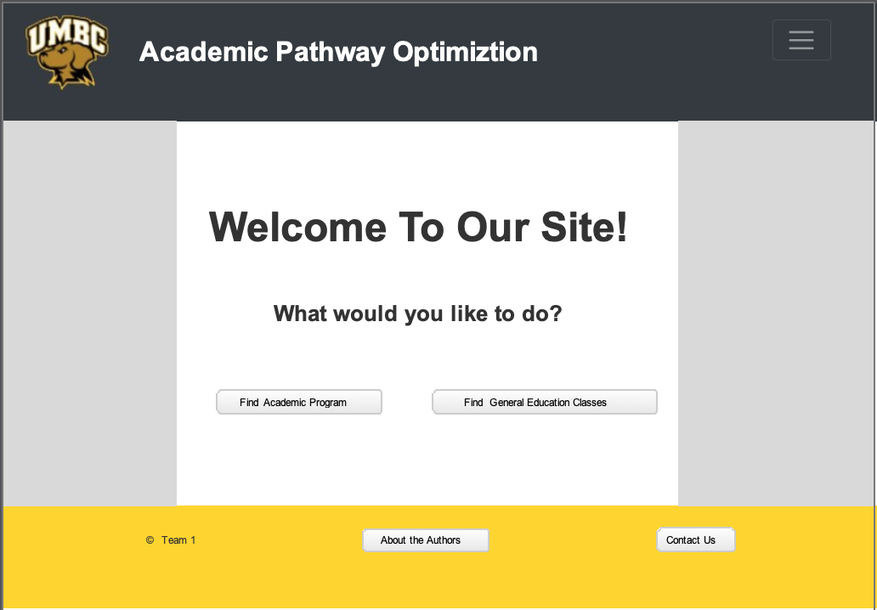

**Prototype: Search (Academic Programs)**

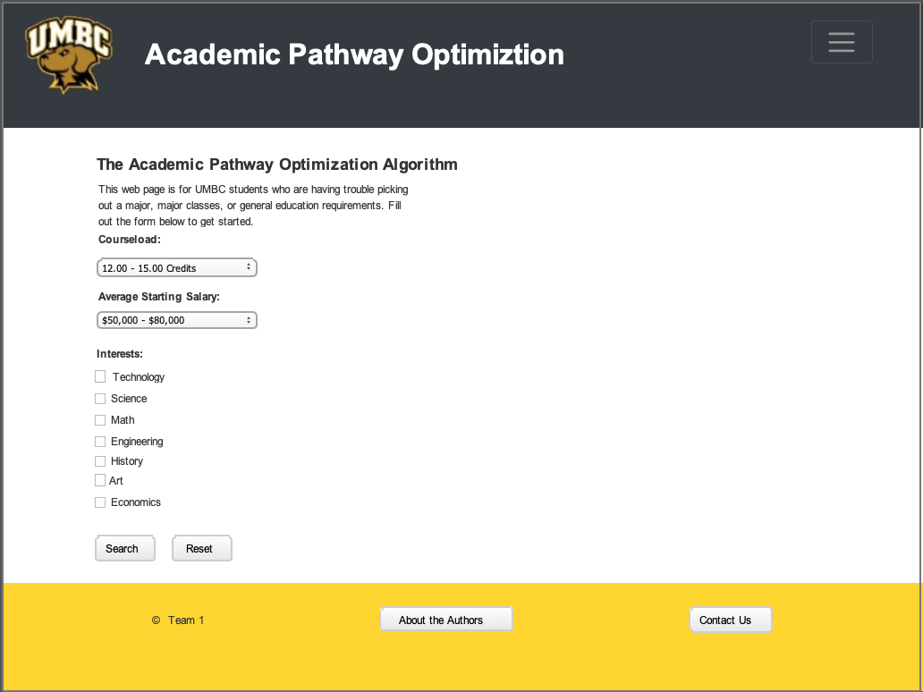

**Prototype: Search Results**

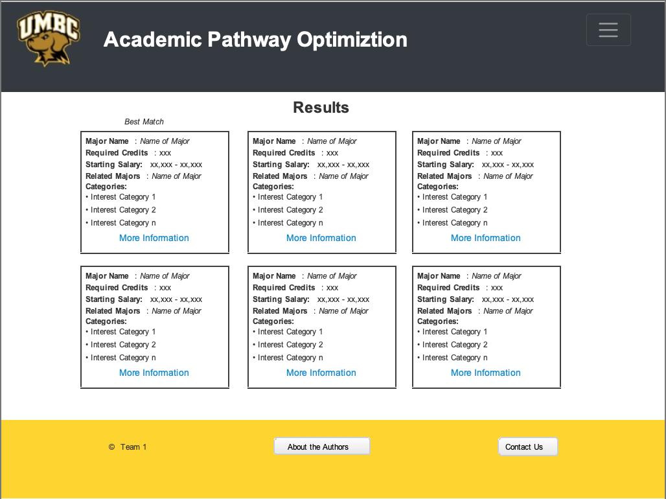

**Interface Standards:**

For our interface standards we decided to use the home page (shown above) as the default template with the same navigation, header, and footer for each page. Same font family (Arial) is used throughout the entire design to maintain consistency. Subtitles or labels are bolded. Links to other pages on the site outside of the menu are blue. Margins on the left and right side of the screen for the main content are at a minimum of 100px. The same type of buttons, grey with a slight edge curve and Arial text, are used throughout all three pages. The menu bar at the top right corner of each page can lead you to a different part of the site regardless of which page you are currently on.

**Program Design**

**Program Design Overview:**

The Academic Pathway Optimization Algorithm project runs primarily through a Django application. This application runs Django version 1.11, the latest LTR (Long Term Release) of the open source and python-based web framework. I chose Django v1.11 due to the security and continued developer support that choosing an LTR provides. The database portion of the site is supported through SQLite, while the front-end is supported primarily through the JavaScript/CSS Libraries jQuery v3.3.1 and Bootstrap v4.3.1. The system implementation mentioned in the next section of the report goes over how it was implemented and provides links to the files.

**Link to website (client):** <http://prod-env.mzmmzmveia.us-west-2.elasticbeanstalk.com/>

**Link to admin portal:** <http://prod-env.mzmmzmveia.us-west-2.elasticbeanstalk.com/admin>

**Link to table database layout:** [database information](https://github.com/FearTheLion/IS436GoodFellas/blob/master/History/Deliverable4/ERD.png)

**System Implementation**

**Implementation Explanation**

There are many ways that a Django project can be run, but only two that we have personally experimented with in this project. The first method to run the Django application is locally and the second is to deploy the project through Amazon Web Services (AWS). We will begin by covering the local implementation.

**Local Implementation**

1. Clone the project from GitHub.
2. Ensure Python 3.6 is installed on your system.
3. Install the dependencies outlined in the ‘requirements.txt’ file. I recommend using a Python Virtual Environment for this.
4. Using the command line, navigate to the root folder of the Django project (you will recognize it by the presence of a file named ‘manage.py’
5. Ensure your virtual environment is active (if you used one), and run the command ‘*python manage.py runserver’*
6. Open your web browser and navigate to http://127.0.0.1:8000
7. You should see the Academic Pathway Optimization Algorithm project displayed in front of you.

**AWS Deployment**

1. Clone the project from GitHub.
2. Ensure Python 3.6 is installed on your system.
3. Install the dependencies outlined in the ‘requirements.txt’ file. I recommend using a Python Virtual Environment for this.
4. Using the command line, navigate to the root folder of the Django project (you will recognize it by the presence of a file named ‘manage.py’.
5. Run the command ‘*pip install awsebcli*’.
6. Run the command ‘*eb init*’. Follow the on-screen prompts.
7. (optional) Run ‘*eb init again*’ to configure a default key pair so that you can connect to the EC2 instance running your application with SSH.
8. Run the command ‘*eb create*’ to create an AWS environment. Follow the on-screen prompts.
9. Run the command ‘*eb status’* to determine the URL assigned to your AWS environment.
10. Edit the ‘settings.py’ file located in the ‘academic_pathway’ folder to add the URL found in the previous step to the ‘ALLOWED_HOSTS’ setting.
11. Run the command ‘*eb deploy*’.
12. Finally, run the command ‘*eb console’* to open up the AWS web-based management console, or run the command ‘*eb open’* to navigate to the URL.
13. You should see the Academic Pathway Optimization Algorithm project displayed in front of you.

**Link to Files:**

[**https://github.com/FearTheLion/IS436GoodFellas/tree/master/academic-pathway-dev/academic_pathway**](https://github.com/FearTheLion/IS436GoodFellas/tree/master/academic-pathway-dev/academic_pathway)

**Completed Project Plan**

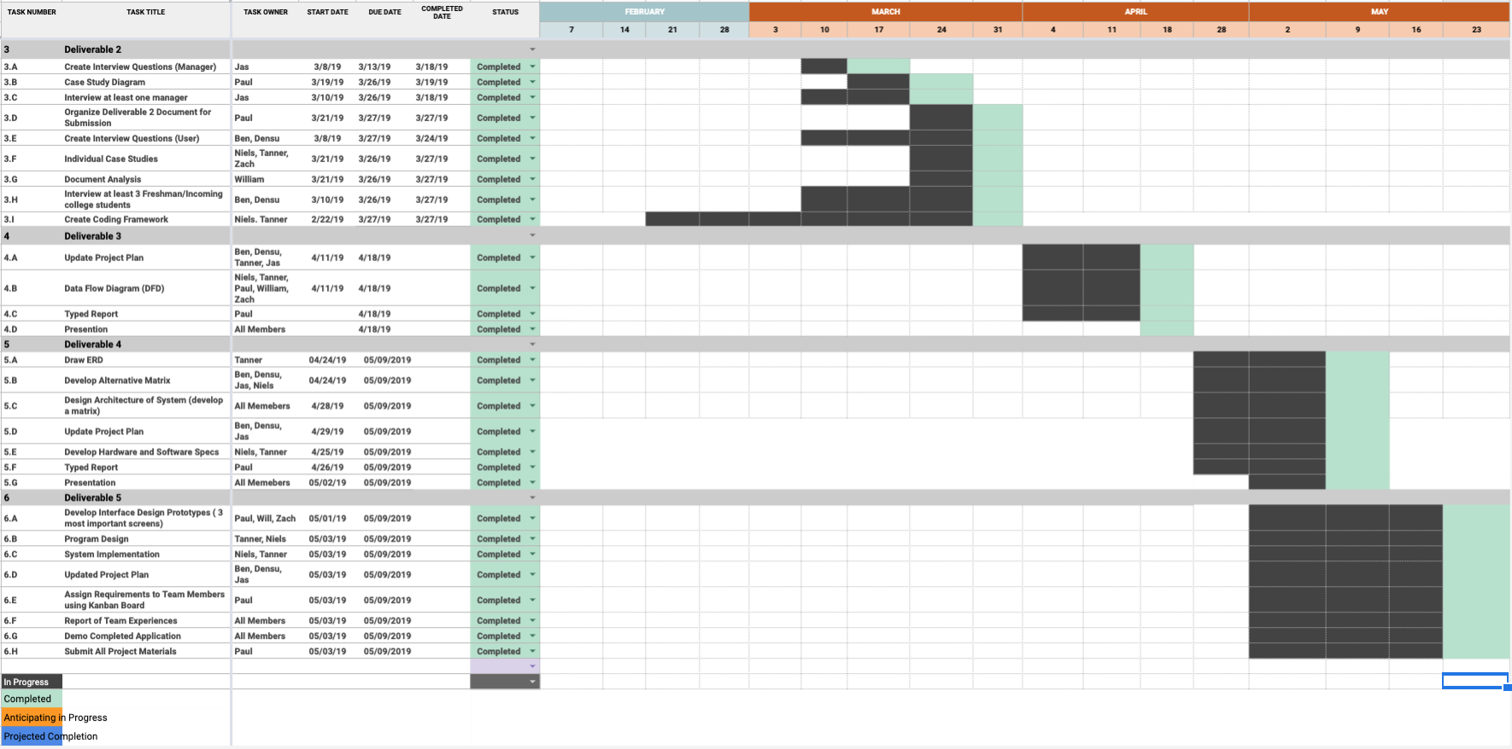

**Gantt Chart Summary:**

In our updated project plan we have a Gantt chart listing all tasks for each deliverable, to whom has participated in completing them, the start dates, due dates, and completion dates as well. This is so we can effectively negotiate and manage reasonable and achievable deadlines across the team. We color coded our chart with four different colors. Ideally you have two main colors representing “in progress” dates and a “completed” date. Since we have completed all our deliverables, all the tasks have reached the completed stage (green). Regarding the timeline/dates, the dates that class will be held in the future or already has been held were used.

**Kanban**

**Overall Kanban Board (Blue is Deliverable 5):**

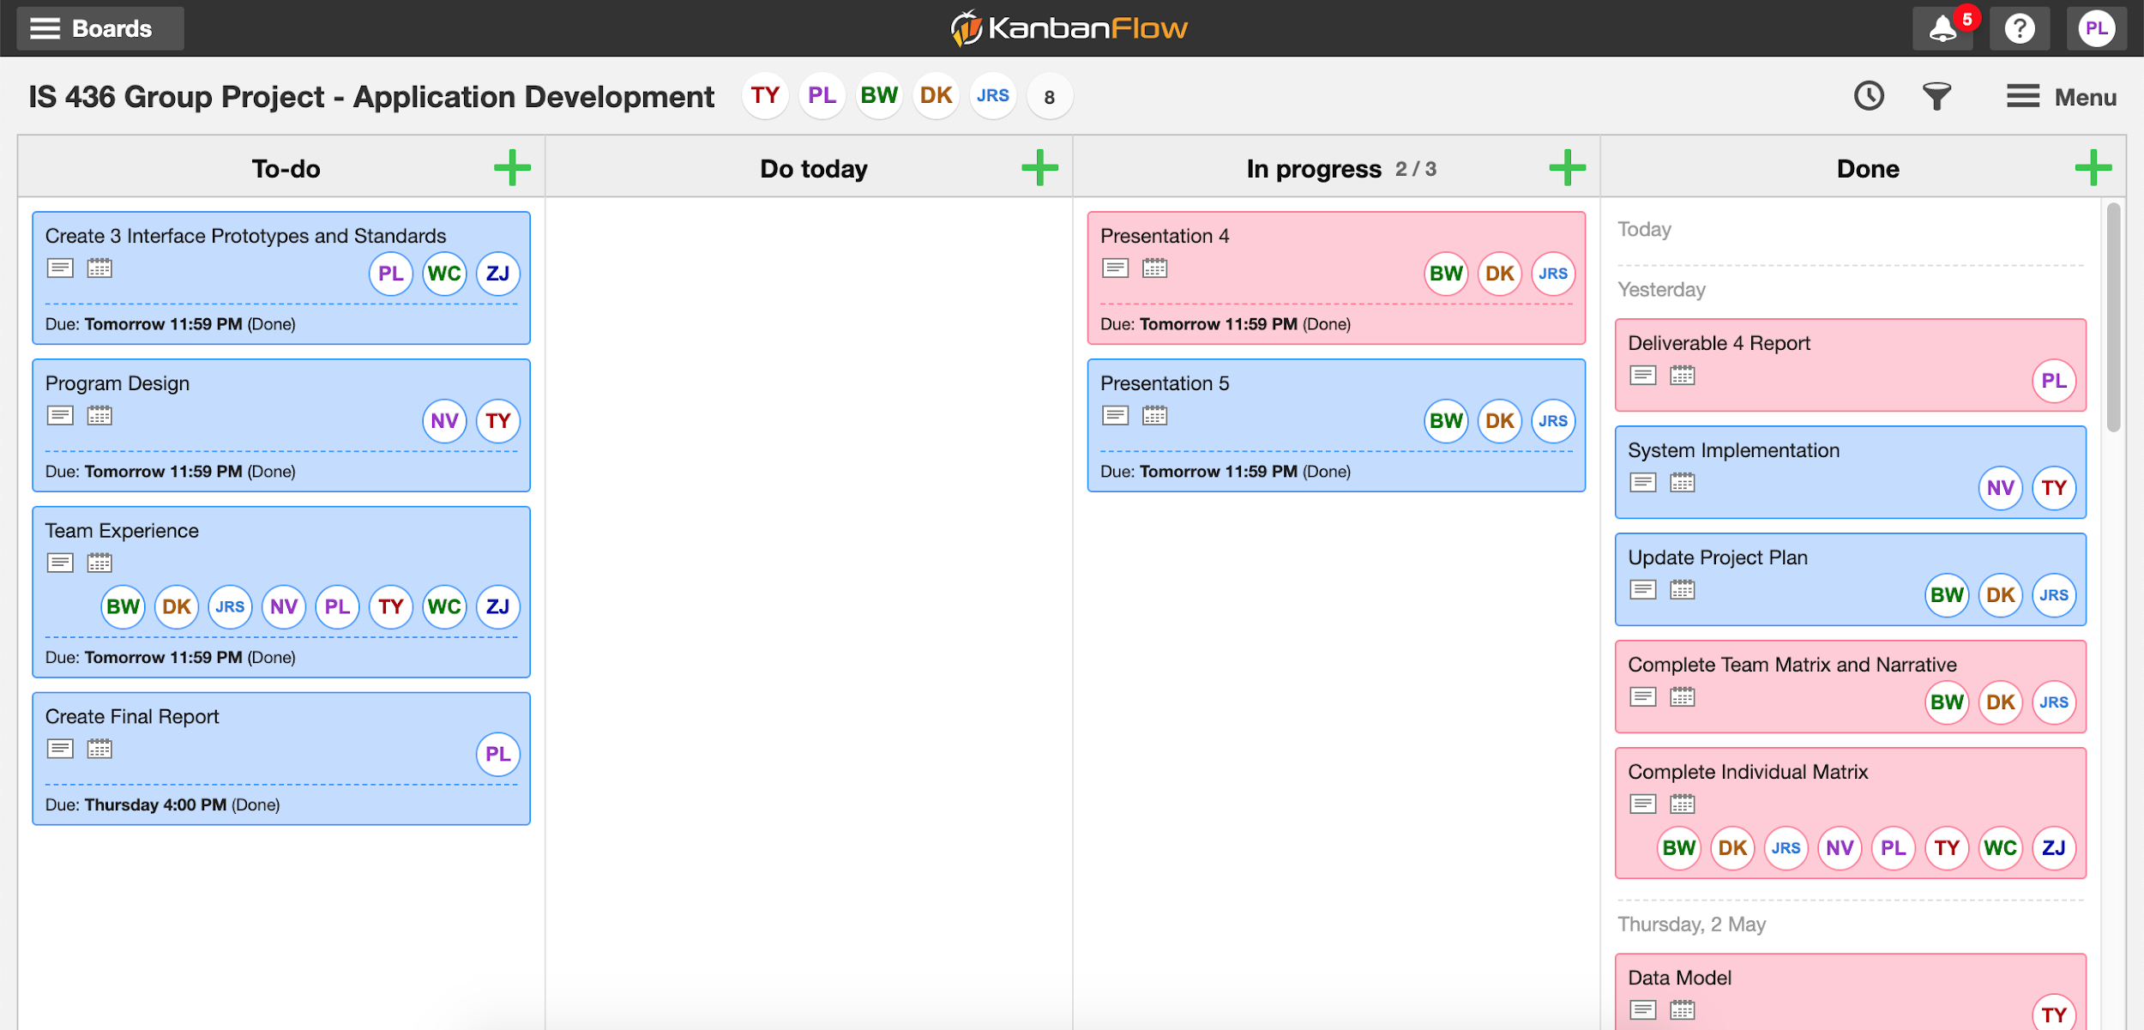

**Individual Assignment Description Example:**

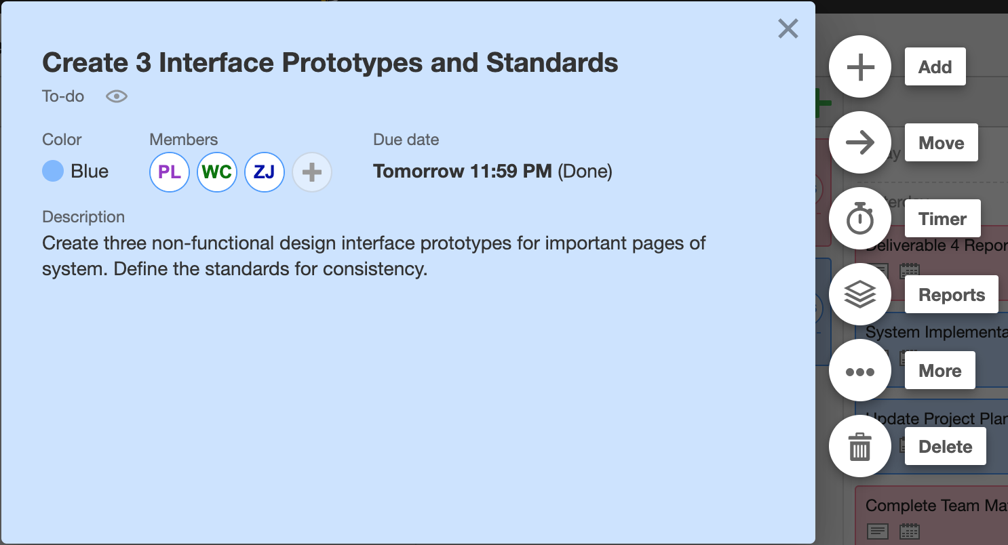

**Kanban Link:** [**https://kanbanflow.com/board/sPos7f**](https://kanbanflow.com/board/sPos7f)

**Team Experience**

We used multiple mediums to work together and contribute to our overall project. The tools we used to communicate, and work together included Google Drive, Google applications, GroupMe, Kanban, and GitHub. For the most part all deliverables were done on time. We had a rough start as we experienced some inefficiency in individual project management; such as completing a task on time or fulfilling all necessary parts of that task. However, to keep our act together, organizing multiple meetings throughout the week Wednesdays before class and Sundays the same weekends. This allowed us to make sure everyone was on top and coordinated. This improved our productivity and let us end strong.