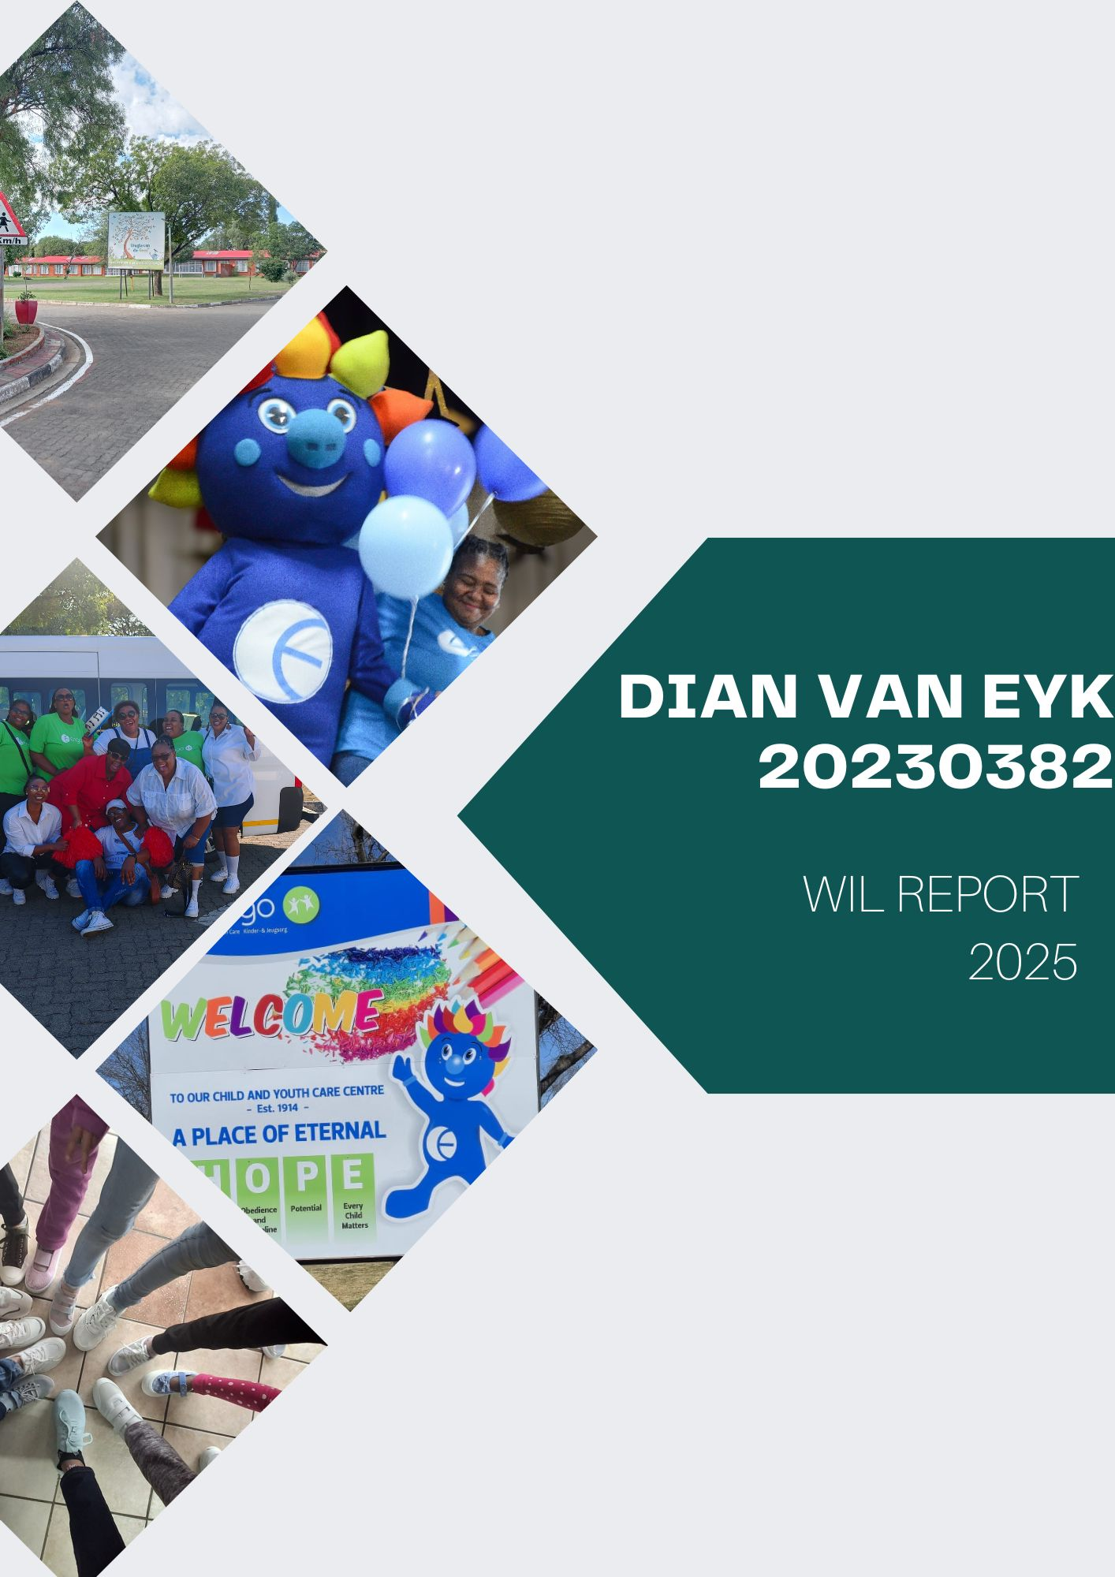

Contents
Introduction 3
Client Brief 3
Engo as a company 3
Wireframing 5
Final Wireframe designs 8
Client Feedback 8
Development 9
Challenges 18
Conclusion 19

Introduction
The Maintenance Report Management System for Engo Child and Youth Care System was developed to streamline the process of reporting, tracking, and managing maintenance tasks across facilities. Previously, maintenance requests were handled manually, often leading to delays, miscommunication, and incomplete records.
This digital system centralizes all maintenance-related data, ensuring efficient communication between staff, caretakers, and the maintenance team. By automating report generation and task tracking, the system enhances operational efficiency, reduces downtime, and supports the overall safety and comfort of the children and staff at Engo.

Client Brief
Engo Child and Youth Care System required a solution to manage the large volume of maintenance requests coming from multiple facilities. The goal was to replace the manual, paper-based reporting method with a digital platform that allows staff to:
- Submit maintenance requests quickly and accurately.
- Track progress and completion status.
- Eliminate high risk maintenance
The system needed to be secure, user-friendly, and accessible across devices, while also maintaining a record of completed and pending work to improve accountability and transparency within the organization.

Engo History and their childcare history over the years
Engo is a prominent non-profit welfare organisation based in the Free State, South Africa, with a rich history of over a century dedicated to the care and support of vulnerable individuals, particularly children and youth and is seen as the second biggest organization within this field in South Africa

Origins and Early History
Engo's origins trace back to 1902 with the establishment of the Charlotte Theron Child and Youth Care Centre in Bethlehem. This initiative was part of a broader movement by the Dutch Reformed Church to address the needs of children orphaned during the Anglo-Boer War. Following this, other centres were founded, including the Gedenk Child and Youth Care Centre in Ladybrand, which was established in 1904.
These centres provided essential care for orphaned and abandoned children, laying the foundation for Engo's future expansion.
Formal Establishment and Growth
In 1967, Engo was formally established as a welfare organisation, consolidating various child and youth care initiatives under a unified structure.
The organisation's mission expanded to include not only child and youth care but also services for families, the elderly, individuals with disabilities, and patients in need.
Decentralisation and Expansion
A significant development in Engo's history was the decentralisation of large orphanages into smaller, community-based Child and Youth Care Centres. This shift aimed to provide more personalised care and integrate services within local communities. For instance, the Gedenk Child and Youth Care Centre in Ladybrand was transformed into multiple smaller units, each capable of caring for 12 to 16 children, ensuring that care was more accessible and community-oriented.
Similarly, other centres such as the Winburg Orphanage, established in 1903, underwent transformations to meet contemporary needs.
The Winburg Orphanage, for example, was restructured in 1971 to accommodate 164 children, reflecting the evolving approaches to child care and welfare during that period.
Current Operations
Today, Engo operates a network of Child and Youth Care Centres across the Free State, providing 24-hour protection, care, education, development, and treatment programs.
These centres cater to children from diverse cultural backgrounds, offering a safe and nurturing environment for their growth and development.
Legacy and Impact
With over a century of service, Engo has become a cornerstone of support in the Free State, making a tangible difference in the lives of thousands. Its legacy is marked by a commitment to compassionate care and community integration, ensuring that vulnerable individuals receive the support they need to thrive

Wireframing
During the wireframing phase, the project team which was mostly me and the client discussing key changes to the program focused on designing a clean, intuitive user interface suitable for both administrative and maintenance staff.
Key screens included:
- Dashboard: Displays an overview of current and pending maintenance tasks.
- Report Submission Form: Allows users to submit detailed maintenance issues, including location and date submitted by the users.
The wireframes were iteratively refined based on user feedback to ensure clarity, ease of use, and alignment with the daily workflow of Engo’s maintenance and care staff.
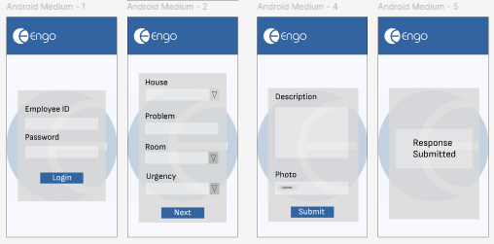
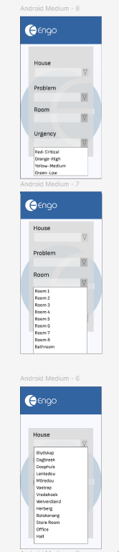
First draft of my wireframing for the maintenance application for Engo.
This is the mobile version of the app which was the main requested version of the application the client wished to use to make it easier for staff to access and use for reporting maintenance problems around the premises of the Engo Child and Youth Care
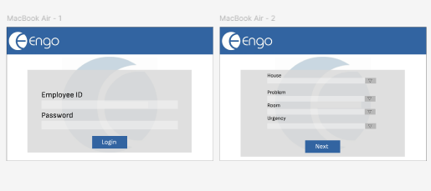
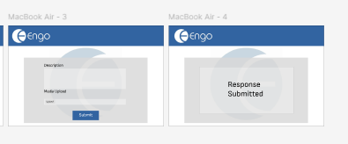
The desktop version of the application so the client can easily compare how the system will work on both mobile and desktop version and how the structure will be formed when I start with the final version of the application
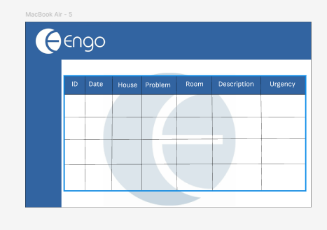
The main dashboard used for storing maintenance task so admin users can assign maintenance workers or repair men to focus on certain task and answer maintenance requests based on the urgency of the maintenance task based on a color-coding system suggested by the client

Final Wireframe designs
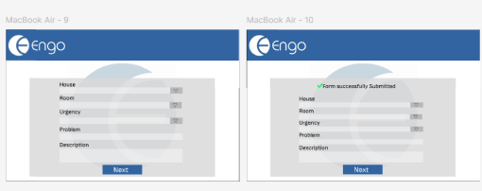
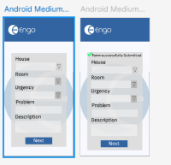
Final wireframe design based on client feedback with a simplified one-page form and a one-page confirmation page when the submit button has been submitted and gives a simple confirmation message saying that the form has been submitted and stored onto the database of Engo and can be accessed from that database

Client Feedback
The client was impressed with the work I had given for the wireframes and said I could start with the full development
Key changes they suggested were to make the problem dropdown an entry field because the problem on sight can range from a range of thing and problems which cannot be easily catalogue as a dropdown entry which would confuse user on identify and giving a name to a problem instead of trying to fit it into a certain category of problems which would cause confusion and problems down the road

Development
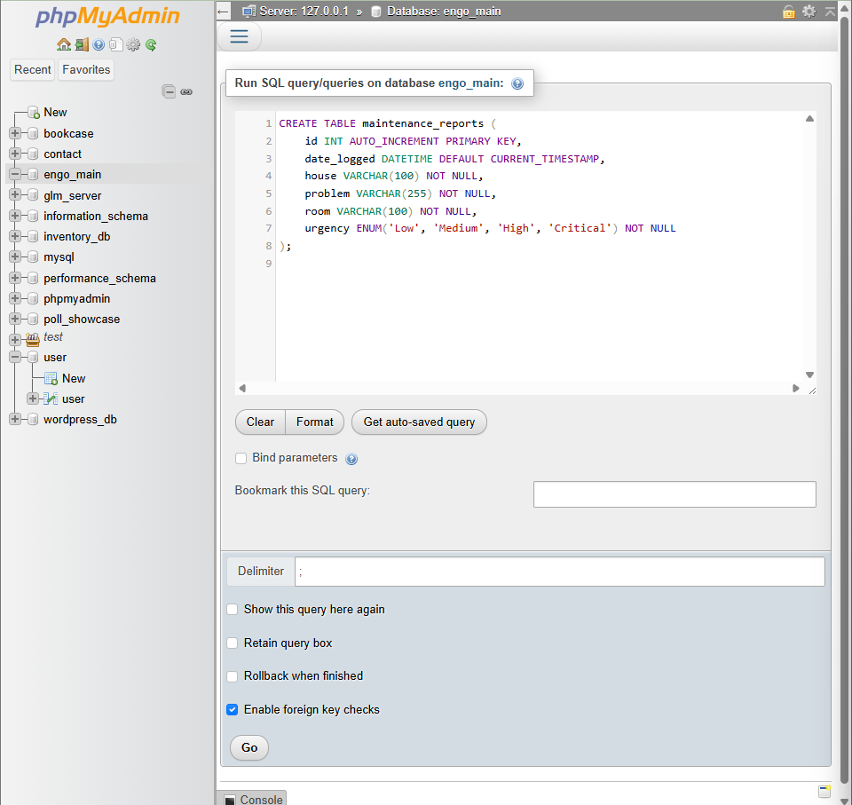
The first step
I created a server by clicking on new server and called it Engo_Main seeing that is the main Development for the webpage that would allow users to store information and then created the two following Pages for the website and two table called
- Employees
- Maintenance_Reports
If you wish to test the program I have exported both the server and the table of the server if you wish to test it fully
Maintenance Reports
CREATE TABLE maintenance_reports (
id INT(11) NOT NULL AUTO_INCREMENT,
date DATETIME DEFAULT CURRENT_TIMESTAMP,
house VARCHAR(100) NOT NULL,
problem VARCHAR(255) NOT NULL,
description VARCHAR(255) NOT NULL,
room VARCHAR(100) NOT NULL,
urgency VARCHAR(100) NOT NULL,
image VARCHAR(255) DEFAULT NULL, --
PRIMARY KEY (id)
);
A table to store the maintenance task
Employee
CREATE TABLE employee (
ID VARCHAR(250) NOT NULL,
Password VARCHAR(255) NOT NULL,
PRIMARY KEY (ID)
);
If you struggle recreating the webpage then I have left a copy of the server in the folder called Engo_main so you can run any test you want if you are curious to test the application yourself you are more than welcome to do that.
Then in the sql table I inserted the following data inside of ID and Password
ID:E001
Password:MySimplePassword
With this you will be able to access the entire database of the management system
So, using this I then turned to creating my form pages
So once again using a login page that will lead to the form page

<form method="POST" action="">
<label for="house">House:</label>
<select name="house" id="house" required>
<option value="">-- Select House --</option>
<option>Blydskap</option>
<option>Dagbreek</option>
<option>Doephuis</option>
<option>Lentedou</option>
<option>Môredou</option>
<option>Vastrap</option>
<option>Vredehoek</option>
<option>Welverdiend</option>
<option>Herberg</option>
<option>Bolokanang</option>
<option>Store Room</option>
<option>Office</option>
<option>Swimming Pool</option>
<option>Hall</option>
<option>Vehicle</option>
</select>

<label for="room">Room:</label>
<select name="room" id="room" required>
<option value="">-- Select Room --</option>
<option>Room 1</option>
<option>Room 2</option>
<option>Room 3</option>
<option>Room 4</option>
<option>Room 5</option>
<option>Room 6</option>
<option>Room 7</option>
<option>Room 8</option>
<option>Bathroom</option>
<option>NA</option>
</select>

<label for="urgency">Urgency:</label>
<select name="urgency" id="urgency" required>
<option value="">-- Select Urgency --</option>
<option value="Red-Critical">Red - Critical</option>
<option value="Orange-High">Orange - High</option>
<option value="Yellow-Medium">Yellow - Medium</option>
<option value="Green-Low">Green - Low</option>
</select>

<label for="problem">Problem:</label>
<input type="text" id="problem" name="problem" placeholder="Describe the problem..." required>

<label for="description">Additional Description (optional):</label>
<textarea id="description" name="description" rows="4" placeholder="Provide more details..."></textarea>

<button type="submit">Submit Report</button>
</form>
</div>
This code of the form in my webpage has entry field and drop downs for the houses and the area within each house area like the rooms and bathroom. And then text boxes to enter the problem and a description for it and then finally a
Submit button that takes the entered content from the user and will save it on our dashboard and display to admin user with a date as well.
By using the name tag and ID tags so the server and the webpage can identify and send the data from the form into the correct block of information in the admin dashboard and make data easier to read.
Dashboard
<?php
session_start();

// Redirect to login if not logged in
if (!isset($_SESSION['employee_id'])) {
header("Location: login.php");
exit;
}

// Optional: get employee ID from session
$employee_id = $_SESSION['employee_id'];
?>
<!DOCTYPE html>
<html lang="en">
<head>
<meta charset="UTF-8">
<title>Dashboard</title>
<style>
body {
font-family: 'Segoe UI', Tahoma, Geneva, Verdana, sans-serif;
margin: 0;
background: #d6d6d6;
color: #000;
}
/* Top navigation */
.top-nav {
height: 60px;
background: #3264A1;
color: white;
display: flex;
align-items: center;
padding: 0 20px;
box-shadow: 0 2px 4px rgba(0,0,0,0.2);
justify-content: space-between;
}
.top-nav h1 {
margin: 0;
font-size: 24px;
}
.top-nav a {
color: white;
text-decoration: none;
font-weight: bold;
}

/* Side navigation */
.side-nav {
width: 200px;
background: #3264A1;
position: fixed;
top: 60px;
bottom: 0;
padding-top: 20px;
}
.side-nav a {
display: block;
color: white;
padding: 12px 20px;
text-decoration: none;
margin-bottom: 5px;
}
.side-nav a:hover {
background: #ffffffff;
color: #000000;
}

/* Main content */
.main-content {
margin-left: 200px;
padding: 20px;
margin-top: 60px;
}

h2 {
color: #3264A1;
}

</style>
</head>
<body>

<!-- Top Navigation -->
<div class="top-nav">
<h1>Dashboard</h1>
<a href="Login.php">Logout</a>
</div>

<!-- Side Navigation -->
<div class="side-nav">
<a href="Dashboard.php">Home</a>
<a href="Report.php">Reports</a>
</div>

<!-- Main Content -->
<div class="main-content">
<h2>Welcome, <?= htmlspecialchars($employee_id) ?>!</h2>
<p>You are now logged in. Use the side navigation to the reports.</p>
</div>

</body>
</html>
The dashboard has many functions and features for users to utilize a home section serving as a small introduction to the webpage and a guide on how to use the application for new employees
With a side navigation you employees can switch between a home page and a table with all the maintenance reports
The page is easy to navigate and has all the necessary code needed to function properly and allow for easy user access

Challenges
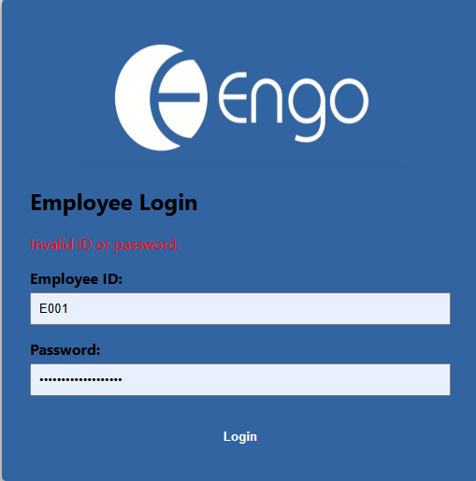
I had a strange error when it came to developing the webpage I had created the webpage and got an incorrect password error over and over again for a unknown even tho the data I enter was the one I entered I created the password
It turns out the code snippet I used for reading the password and it turns out I accidently set it to give me a hashed password
<?php
echo password_hash('MySecurePass123', PASSWORD_DEFAULT);
?>
Which print out the password in the console and I had to add it to the server which it would translate into MySimplePassword but then the code not knowing what is the true password which caused the error
So, I went to the Server and edit the code to read the code as a string instead of hashed password and then edited the code to read the code as string
$stmt = $conn->prepare("SELECT ID, Password FROM employees WHERE ID = ?");
$stmt->bind_param("s", $id);
$stmt->execute();
$result = $stmt->get_result();
Now the password and username can be read and you can enter the dashboard and from without any error occurring even if the password was entered correctly into the text fields

Conclusion
Even tho the project is still a work in progress I will continue to work and improve on the bases I have shown you in this project and ensuring my client is fully satisfied with the program and can be integrated around other location that Engo own and use it to maximise repairs and safety around their facility and maximizing their maintenance request so they can keep with the amazing social work and helping their children live in a safe place and ensuring that employees can help keep their work place functional and less stressful due to a good maintenance management system

