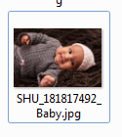

Caption ID of Parent: 1502293

Source: Shutterstock

Source ID: 181817492

Rights Type: Royalty Free

Credit: © Samuel Borges Photography/Shutterstock.com

K12 Credit: Baby girl wearing a pink cap. © Samuel Borges Photography/Shutterstock.com

RM Assets Embedded: No

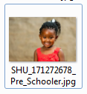

Caption ID of Parent: 1502292

Source: Shutterstock

Source ID: 171272678

Rights Type: Royalty Free

Credit: © karelnoppe/Shutterstock.com

K12 Credit: Smiling pre-school girl. © karelnoppe/Shutterstock.com

RM Assets Embedded: No

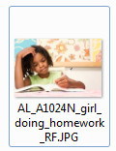

Caption ID of Parent: 116571

Source: Alamy

Source ID: A1024N

Rights Type: Royalty Free

Credit: © GoGo Images Corporation/Alamy

K12 Credit: Girl writing. © GoGo Images Corporation/Alamy

RM Assets Embedded: No

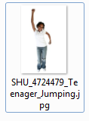

Caption ID of Parent: 1502289

Source: Shutterstock

Source ID: 4724479

Rights Type: Royalty Free

Credit: © Jaimie Duplass/Shutterstock.com

K12 Credit: Teenager jumping. © Jaimie Duplass/Shutterstock.com

RM Assets Embedded: No

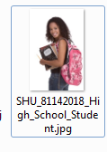

Caption ID of Parent: 1502290

Source: Shutterstock

Source ID: 81142018

Rights Type: Royalty Free

Credit: © OLJ Studio/Shutterstock.com

K12 Credit: Smiling high school student with books. © OLJ Studio/Shutterstock.com

RM Assets Embedded: No

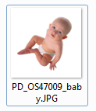

Caption ID of Parent: 102737

Source: Photodisc

Source ID: OS47009

Rights Type: Royalty Free

Credit: © Photodisc

K12 Credit: Baby boy. © Photodisc

RM Assets Embedded: No

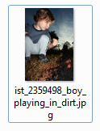

Caption ID of Parent: 106380

Source: iStockphoto

Source ID: 2359498

Rights Type: Royalty Free

Credit: © iStockphoto.com

K12 Credit: Boy playing in dirt. © iStockphoto.com

RM Assets Embedded: No

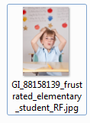

Caption ID of Parent: 950175

Source: Getty Images

Source ID: 88158139

Rights Type: Royalty Free

Credit: © Getty Images

K12 Credit: Frustrated elementary student. © Getty Images

RM Assets Embedded: No

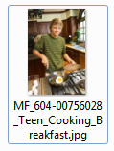

Caption ID of Parent: 213933

Source: Corbis

Source ID: 604-00756028

Rights Type: Royalty Free

Credit: © MedioImages/Corbis

K12 Credit: Teen cooking. © MedioImages/Corbis

RM Assets Embedded: No



Caption ID of Parent: 1502291

Source: Shutterstock

Source ID: 140816914

Rights Type: Royalty Free

Credit: © Accord/Shutterstock.com

K12 Credit: Teenager talking on telephone. © Accord/Shutterstock.com

RM Assets Embedded: No