OLUWATOMINI KEVIN OGUNYEMI
ASPIRING IT PROFESSIONAL • CYBERSECURITY • NETWORKING • WEB DEVELOPMENT
☎ +234 903 240 3833  ✉ ogunyemikevin@gmail.com | GitHub github.com/Fearless11024  Location Nigeria
PROFILE
Motivated aspiring IT professional studying Aptech ACNS (Cybersecurity and Networking). Developing practical skills in networking, web development, and programming through coursework, independent practice, and network simulations.
EDUCATION
Aptech — ACNS (Cybersecurity and Networking) | In progress; expected completion 2028
Secondary School Education — Graduated 2026
TECHNICAL SKILLS
WEB DEVELOPMENT  HTML • CSS • JavaScript | PROGRAMMING  C++ (beginner)
NETWORKING  IP addressing • Subnet masks • LANs • VLANs • DHCP • SSH | TOOLS & PRACTICE  Cisco Packet Tracer • Router and switch configuration
PROJECTS & PRACTICAL LEARNING
Web development practice — Created websites using HTML, CSS, and JavaScript; continuing to develop personal web projects.
Cisco Packet Tracer simulations — Practised network-device configuration and concepts including IP addressing, subnet masks, VLANs, DHCP, SSH, and LANs.
CERTIFICATIONS
SoloLearn course certificates
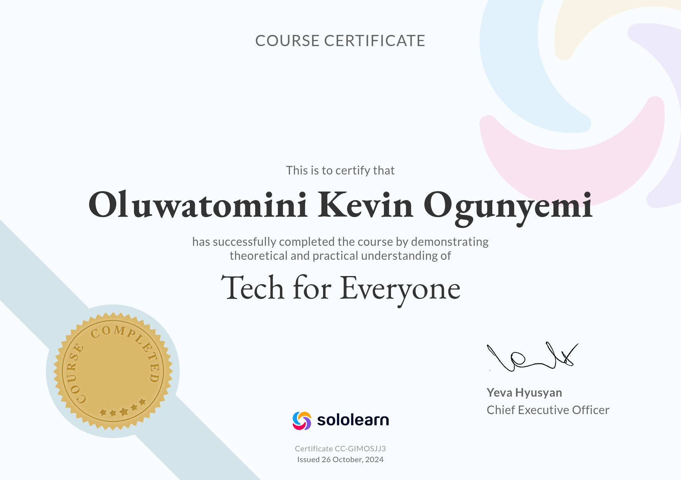  Tech for Everyone  Issued 26 October 2024 | 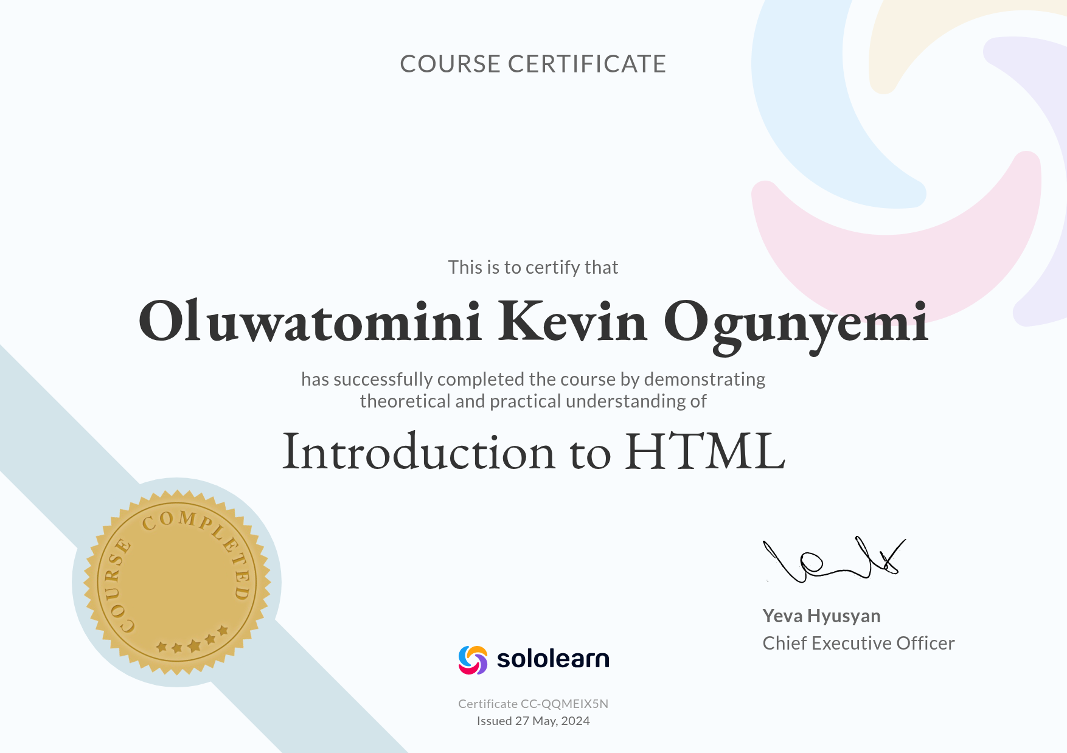  Introduction to HTML  Issued 27 May 2024
CAREER OBJECTIVE
To secure an IT internship or entry-level learning opportunity to strengthen practical experience in cybersecurity, networking, and web development while growing as a technology professional.

