Standard Operating Procedure
Techolution HR Automation Dashboard
Google Sheets · Apps Script · HtmlService Web App

Author | Ruthvik Nagulapally · ruthviknagulapally@gmail.com
For | Aadish Jain · aadish.jain@techolution.com
Date | 14 June 2026
Stack | Google Sheets + Apps Script (V8) + HtmlService

1. What this is
A live HR dashboard for Techolution's India + US workforce. Two surfaces — a Dashboard tab inside the workbook and a deployed Web App URL — both fed by the same source data, both reflecting HR edits within ~7 seconds. No buttons, no manual refresh.
Everything required by §4.1–§4.6 of the brief is in. All seven differentiators from §5 are in too: modular project (17 files), workflow engine, HR Health Score, test harness, self-monitoring, changelog, and this diagram (next page).

Verification protocol coverage
# | Reviewer step | How it's handled
1 | Rename columns | Alias map + uniqueness-guarded fuzzy fallback in 02_Headers.gs
2 | Add 3 employees | onEdit + 1.5s debounce + 5s poll = ~7s end-to-end
3 | Change DOJ | Confirmation = DOJ + 180; recomputed live
4 | Delete offboarded row | Cache busted; quarterly attrition recomputes
5 | Auth gate | doGet checks Session email against _Config allowlist
6 | Logs history | Bootstrap seeds ~100 backdated rows; every trigger adds more
There's also an automated harness for this — run HR Automation → Run Verification Protocol from the sheet menu. It mutates the sheet, asserts each step, restores state. Results land in the QA tab. All six PASS in the latest run.

2. Architecture
Three layers: the Google Sheet (database), the Apps Script backend (compute), and an HtmlService Web App (UI). Source edits flow through trigger-driven cache invalidation. The Web App polls a cached snapshot every 5 seconds so server load stays bounded under multi-user load.
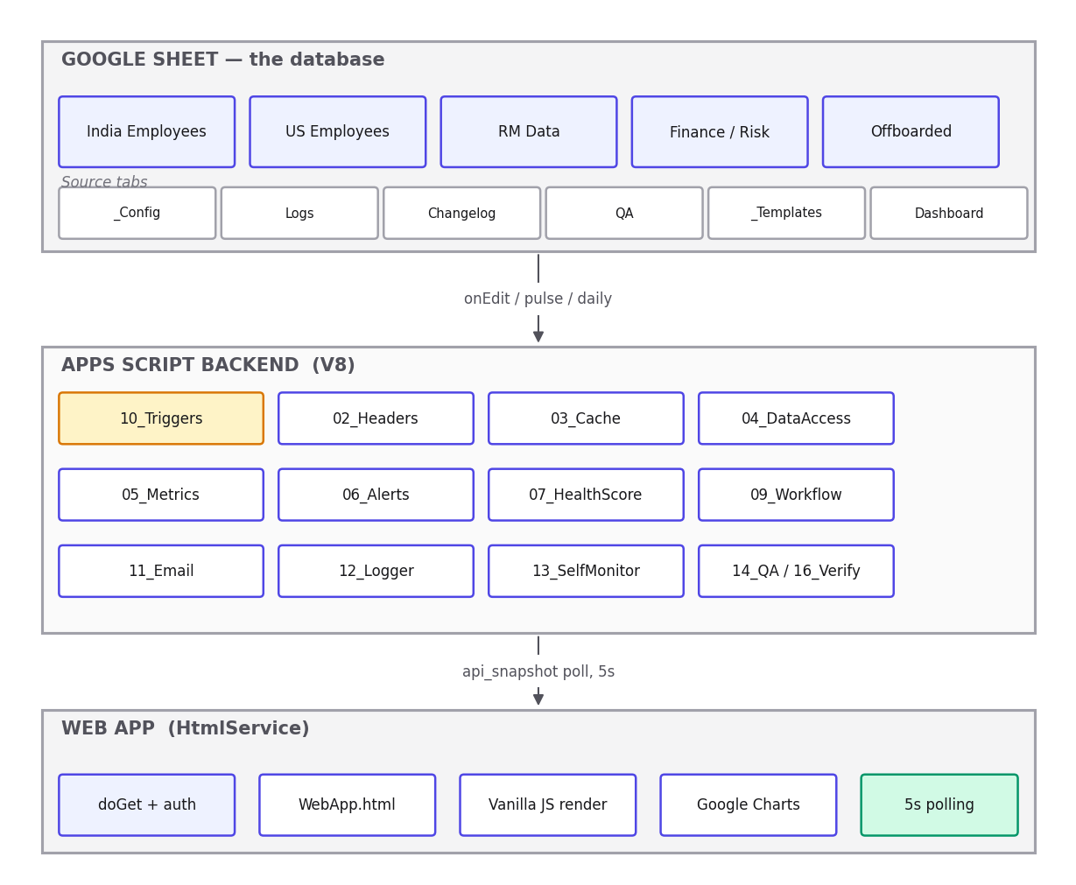
System architecture — 17 Apps Script modules; Web App polls api_snapshot every 5s.

Helper tabs
Tab | Role
_Config | Every threshold, the allowlist, the column aliases. Only place to tune the system.
Logs | Append-only execution history with timestamps, RunId, level, function, message, duration.
Changelog | One row per pipeline run. Useful for trend reading.
QA | Test harness output — both the 11-assertion run and the 6-step verification harness.
_Templates | Email subject + HTML body per template key.
Dashboard / Org Chart / Drill-Down | Rendered by the script. Don't type into Dashboard.

3. Real-time reflection
§4.3 is the strictest mandate in the brief — both surfaces have to update without HR doing anything. Here's how that works.

Latency budget
Stage | Time
onEdit fires + cache bust + lock acquire | ~0.4 s
Burst-coalesce wait (1.5s of edit-idle) | + 1.5 s
rebuildDashboard run | + 0.5–2 s
Web App's next poll | + up to 5 s
TOTAL worst case | ≈ 7 s

Why this design
The hard problem is preventing the rebuild's own writes from re-triggering onEdit forever. Three layers of defence:
- withSilentWrite — sets a ScriptProperty before writes, clears it in finally. onEdit early-returns if the flag is set.
- Tab-name allowlist — even if the flag leaks, onEdit ignores edits to Dashboard / Logs / Changelog / QA / Org Chart / _Templates by name.
- Circuit breaker — if more than 20 rebuilds fire in 60s, the trigger logs CRITICAL and suppresses rebuilds for 5 minutes. A one-shot reset trigger re-enables and deletes itself.
Polling instead of push is forced by the platform — HtmlService web apps can't keep a WebSocket open. 5 seconds is the sweet spot: feels live, stays within execution quota.
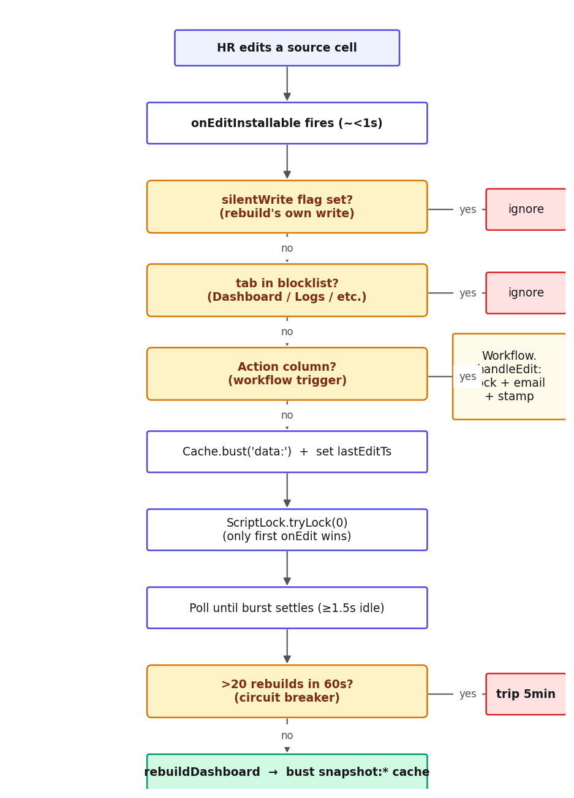
The full path from cell edit to rendered update.

4. HR Health Score
A 0–100 composite of four equally-weighted pillars (0–25 each). Equal weighting is a deliberate audit choice — there's no "why 30%?" question to defend. Bands: ≥80 Green, 60–79 Amber, <60 Red.
Pillar | Source signal | Formula
Stability | Quarterly attrition rate | 25 × (1 − min(attr, 0.25) / 0.25)
Alert Load | Critical alerts ÷ headcount | 25 × (1 − min(ratio, 0.20) / 0.20)
Risk Posture | Employees in 30-day risk window ÷ headcount | 25 × (1 − min(risky / hc, 0.30) / 0.30)
Productivity | Average productivity ÷ target | 25 × clamp(avgProd / target, 0, 1)

Worked example
Illustrative numbers — 95-employee workforce, end of Q2 2026:
Pillar | Input | Maths | Earned
Stability | 1.5% quarterly attrition | 25 × 0.94 | 23.5
Alert Load | 5 critical alerts / 95 employees | 25 × 0.735 | 18.4
Risk Posture | 9 employees in 30-day risk window | 25 × 0.683 | 17.1
Productivity | Avg 0.74 vs target 0.80 | 25 × 0.925 | 23.1
 |  | Total | 82.1 → Green
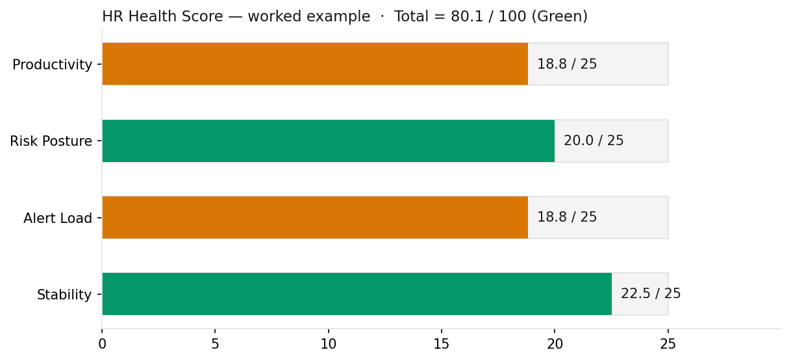
Pillar weights, productivity target, and the band cutoffs all live in _Config. No code change to tune.

5. Daily use

In the sheet
HR works on the source tabs — India Employee Database, US Employee Database, RM Data, Finance · Productivity Risk Report, Offboarded Resources. Within ~2 seconds of any edit, the Dashboard tab re-renders. The Drill-Down tab has four filter dropdowns in row 3 (Region, Department, Reporting Manager, Status) that redraw the results table on change.
To add a new monthly allocation column on RM Data, just append a column on the right with the month label (e.g. Jun 2026). The current month is auto-discovered each run — no config to update.

In the Web App
Sign in with Google. If your email is on the allowlist (see §6), the dashboard loads. It auto-refreshes every 5 seconds and pauses when the tab is hidden. Sections: KPI strip, HR Health Score, alerts (tabbed Critical / Warning / LWD / Probation), Department Breakdown, Attrition Trend, Org Chart, Drill-Down.

Workflow actions
India and US tabs have an Action column with three dropdown choices: Start Offboarding, Schedule PIP, Approve Confirmation. Picking one sends the corresponding email, stamps Action Status = Done, and prevents a second pick. The same dropdown selection on the same row is a no-op with a toast — the engine reverts the cell to — and logs a WARN.

The Reporting Manager / Org Chart caveat
The org chart links each row's Reporting Manager value to another row's Employee Name. In the starter dataset shipped with the assignment, none of those values actually match — so every employee ends up looking like a root, and the chart is a flat row of cards.
The resolver tries hard before giving up — exact match, then case-insensitive, then Emp ID, then substring (so "Ruth N." matches "Ruthvik Nagulapally"). When fewer than 30% of links resolve, it logs a WARN. The fix is in the source data, not the code: clean the Reporting Manager column so the values appear in the Employee Name column too. Within ~7 seconds, the chart picks up the hierarchy.

6. Configuration
Everything tunable lives in two tabs. _Config holds thresholds, the allowlist, and column aliases. _Templates holds email subject + HTML body per template key. No code changes needed.

Key _Config rows
Section · Key | What it controls
allowlist · emails | Who can open the Web App. Supports exact emails (aadish.jain@techolution.com), domain wildcards (*@techolution.com), and full open (*). For review periods, the domain wildcard is the right choice — any Techolution Google account gets through, non-Techolution doesn't.
thresholds · lwdAlertDays / probationConfirmDays / probationLengthDays | Alert windows. Defaults 45 / 30 / 180 per brief §4.4.
thresholds · productivityTarget / lowProductivity / benchAllocation | Productivity floor and allocation floor. Used by alerts + Health Score productivity pillar.
health.weights · * / health.bands · green / amber | Tune the Health Score weights (default 25 each, sum to 100) and band cutoffs (default 80 / 60).
aliases.<tab> · <canonical> | Comma-separated list of accepted column header names per canonical name (empId, doj, lwd, etc.). This is what makes column renames safe — add a new alias here when your sheet's headers diverge.

Email templates
Edit _Templates rows. Placeholders are double curly braces — {{empName}}, {{empId}}, {{dept}}, {{rm}}, {{doj}}, {{actorName}}. The daily digest template also gets {{lwdTable}} and {{probTable}} — pre-rendered HTML tables of active alerts. Changes apply on the next email send.

7. Troubleshooting
Most common symptoms, what causes them, and what to do.
Symptom | Cause | Fix
Web App is blank | Deployed version is on old code, OR doGet caught an error and bootstrapSnapshot has an error field. | Manage Deployments → New version. Open DevTools console — if there's a ReferenceError, the JSON injection rendered wrong. Check the Apps Script editor's Executions tab for the failing doGet.
Sheet Dashboard not updating after an edit | Triggers not installed, OR circuit breaker tripped (suspected loop), OR rebuild errored. | Menu: HR Automation → Install Triggers. Check Logs for repeated rebuildDashboard ERROR rows. Circuit breaker auto-resets in 5 min.
Workflow email didn't arrive | Mail quota exhausted (100/day on personal Gmail), template missing, or recipient mistyped. | Check Logs for the workflow run. Look at MailApp.getRemainingDailyQuota(). Confirm template exists in _Templates.
SchemaDriftError in Logs | A column was renamed to something the alias map doesn't know AND fuzzy match couldn't resolve. | Add the new column name to _Config aliases.<tab>.<canonical> as a new comma-separated entry.
Org Chart shows employees side-by-side, no hierarchy | Reporting Manager values don't match any Employee Name (true for the starter dataset). | Clean the source data — match values across the two columns. Code requires no change.
clasp push fails: "invalid argument" | Using clasp 3.x (broken), OR Apps Script API not enabled in user settings. | Pin clasp at v2.4.2. Enable the API at script.google.com/home/usersettings.
Web App still shows old data after clasp push | clasp push only updates HEAD code. The deployed URL is pinned to a specific version. | Deploy → Manage Deployments → pencil → New version → Deploy.

8. Maintaining the code

Toolchain gotchas worth saving you a day
- Pin clasp at v2.4.2. clasp 3.x has a regression that breaks push with an opaque "invalid argument" error.
- Enable the Apps Script API at script.google.com/home/usersettings on the Google account you deploy from. Without it, clasp push fails the same way.
- clasp push updates HEAD, but the Web App URL is pinned to a specific deployment version. After every push, go to Manage Deployments → pencil → New version → Deploy. The URL stays the same.
- Apps Script's HtmlService CSP blocks eval and Function() — that rules out standard Alpine.js and Tailwind v3 Play CDN. The Web App is vanilla JS + Tailwind v2 static CSS. Stick to that for future UI work.

Project structure
17 .gs files, single concern each. Numeric prefixes (00 → 99) are for human navigation; load order doesn't matter since all cross-file references happen at call time. Each module uses the same namespace-on-IIFE pattern — see 03_Cache.gs for a clean example.

Adding a new module
- New file under src/, named like XX_NewModule.gs.
- Wrap it in the namespace pattern: var NewModule = NewModule || {}; (function(ns){ ns.fn = ... })(NewModule);
- If it needs onEdit handling, add a branch in 10_Triggers.gs's onEditInstallable.
- If it exposes a Web App call, name the function api_* in 15_WebAPI.gs.
- Add at least one assertion in 14_QA.gs that exercises the happy path.

Version control
Apps Script has built-in version history (File → See version history), and the local clone is a git repo too. Both are useful — Apps Script version history is the fastest rollback path, git history is the trail of why a change happened.
To roll back the Web App: Manage Deployments → edit the active deployment → pick the prior version → Deploy. URL is unchanged.

Appendix. Brief requirement mapping
Every §4 and §5 line in the brief, mapped to the SOP section and file that satisfies it.
Brief requirement | Where to find it
§4.1 Sheet Dashboard sections (KPI / LWD / Probation / Dept / Attrition / Risk) | §2, §5 · rendered by 00_Main.rebuildDashboard
§4.1 Org chart on separate tab | §5 (caveat) · 08_OrgChart.gs
§4.1 Drill-Down filters | §5 · 00_Main.applyDrilldown
§4.2 Web App deployed + authentication | §5, §6, §8 · doGet in 00_Main.gs
§4.3 Real-time reflection | §3 entire · 10_Triggers.gs
§4.4 Intern LWD alerts (45d window) | §5 · 06_Alerts.gs lwdWithin
§4.4 Probation alerts (DOJ + 180) | §4, §5 · 06_Alerts.gs probationDue
§4.4 Daily email digest | §6 · 11_Email.gs sendDailyDigest
§4.4 Thresholds in _Config, not in code | §6 · 01_Config.gs
§4.5 Time-based + event-driven triggers | §3 · 10_Triggers.gs
§4.5 Append-only Logs tab | §2 · 12_Logger.gs
§4.5 Header-agnostic column lookup | §1, §7 · 02_Headers.gs
§4.5 Human-readable input validation | §7 · every catch path returns text, not stack
§4.6 SOP — daily use, config, troubleshooting, code maintenance | §5, §6, §7, §8
§5 #1 Modular Apps Script project | §2 (17 .gs files)
§5 #2 Workflow engine | §5 · 09_Workflow.gs
§5 #3 HR Health Score | §4 · 07_HealthScore.gs
§5 #4 Built-in test harness | §1 · 14_QA.gs + 16_Verification.gs
§5 #5 Self-monitoring | §7 · 13_SelfMonitor.gs
§5 #6 Changelog tab | §2 · 12_Logger.gs
§5 #7 Architecture diagram in SOP | §2

