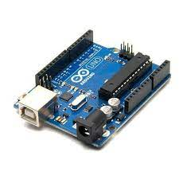**CONTROLLER: ARDUINO UNO R3**

The Arduino Uno R3 is a microcontroller board based on a removable, dual-inline-package (DIP) ATmega328 AVR microcontroller. It has 20 digital input/output pins (of which 6 can be used as PWM outputs and 6 can be used as analog inputs). Programs can be loaded on to it from the easy-to-use Arduino computer program. The Arduino has an extensive support community, which makes it a very easy way to get started working with embedded electronics. The R3 is the third, and latest, revision of the Arduino Uno.

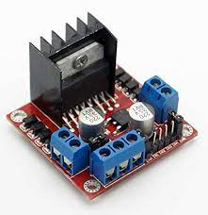**MOTOR DRIVER: L298D**

The L298N is a dual H-Bridge motor driver which allows speed and direction control of two DC motors at the same time. The module can drive DC motors that have voltages between 5 and 35V, with a peak current up to 2A.

Let’s take a closer look at the pinout of L298N module and explain how it works. The module has two screw terminal blocks for the motor A and B, and another screw terminal block for the Ground pin, the VCC for motor and a 5V pin which can either be an input or output.

This depends on the voltage used at the motors VCC. The module have an onboard 5V regulator which is either enabled or disabled using a jumper. If the motor supply voltage is up to 12V we can enable the 5V regulator and the 5V pin can be used as output, for example for powering our Arduino board. But if the motor voltage is greater than 12V we must disconnect the jumper because those voltages will cause damage to the onboard 5V regulator. In this case the 5V pin will be used as input as we need connect it to a 5V power supply in order the IC to work properly.

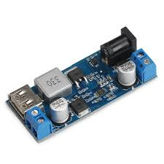**POWER DRIVER:**

It is a Power Supply Module/USB Charger, Input voltage: DC 9V ~ 36V, Output voltage: 5.2V, Suitable for DIY an Voltage Regulated Power Supply, Charging module, Industrial equipment Voltage convert, Power Supply Transformers, Laptop Power Supply, Batteries Buck, Car Power Supply, LED drive,Advertising screen, USB Charger, Monitoring System etc

**Product Parameters:**

* Input voltage: DC 9V ~ 36V
* Output voltage: DC 5.2V

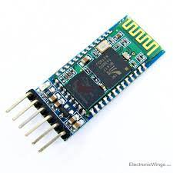**BLUETOOTH MODULE: HC05**

Wireless communication is swiftly replacing the wired connection when it comes to electronics and communication. Designed to replace cable connections HC-05 uses serial communication to communicate with the electronics. Usually, it is used to connect small devices like mobile phones using a short-range wireless connection to exchange files. It uses the 2.45GHz frequency band. The transfer rate of the data can vary up to 1Mbps and is in range of 10 meters.   
The HC-05 module can be operated within 4-6V of power supply. It supports baud rate of 9600, 19200, 38400, 57600, etc. Most importantly it can be operated in Master-Slave mode which means it will neither send or receive data from external sources.