* Connection for Bluetooth with Arduino

Bluetooth Arduino

VCC 5V

GND GND

TX PIN 4

RX PIN 3

* Connection for Motor Driver with Arduino

Motor Driver Arduino

IN1 PIN 8

IN2 PIN 9

IN3 PIN 10

IN4 PIN 11

* Connect 5V, GND, +12v of the motor driver to the supply label given below
* Arduino is programmed so do not code/program it again.
* For Bluetooth controlling use the Arduino Joystick

(<https://play.google.com/store/apps/details?id=uncia.robotics.joystick>) you can download from play store.

* Instruction for the software setting and connection for the Bluetooth
  + Turn on the Bluetooth search for device name with HC05, then pair the device, you will be asking for the password 🡪 enter ‘1234’ and pair.
  + Connecting the Bluetooth in the software , you would see the Bluetooth symbol in left top corner click on that and just search for HC05 and pair/connect it.
  + Open the software (Arduino Joystick) on the left top corner Ξ 🡪 click on that in mode select button Mode to button mode

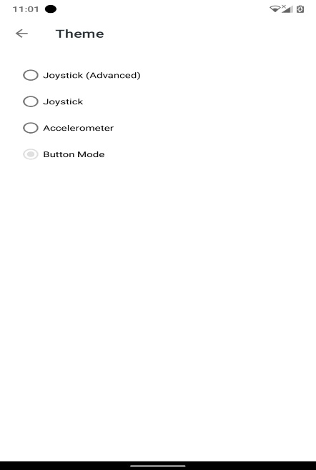

* + Then go back and then select the setting change the character as given below

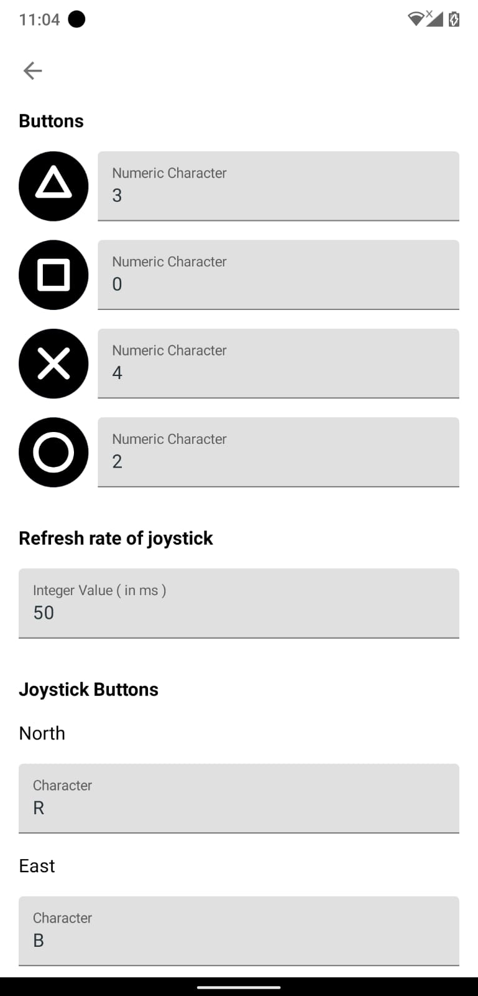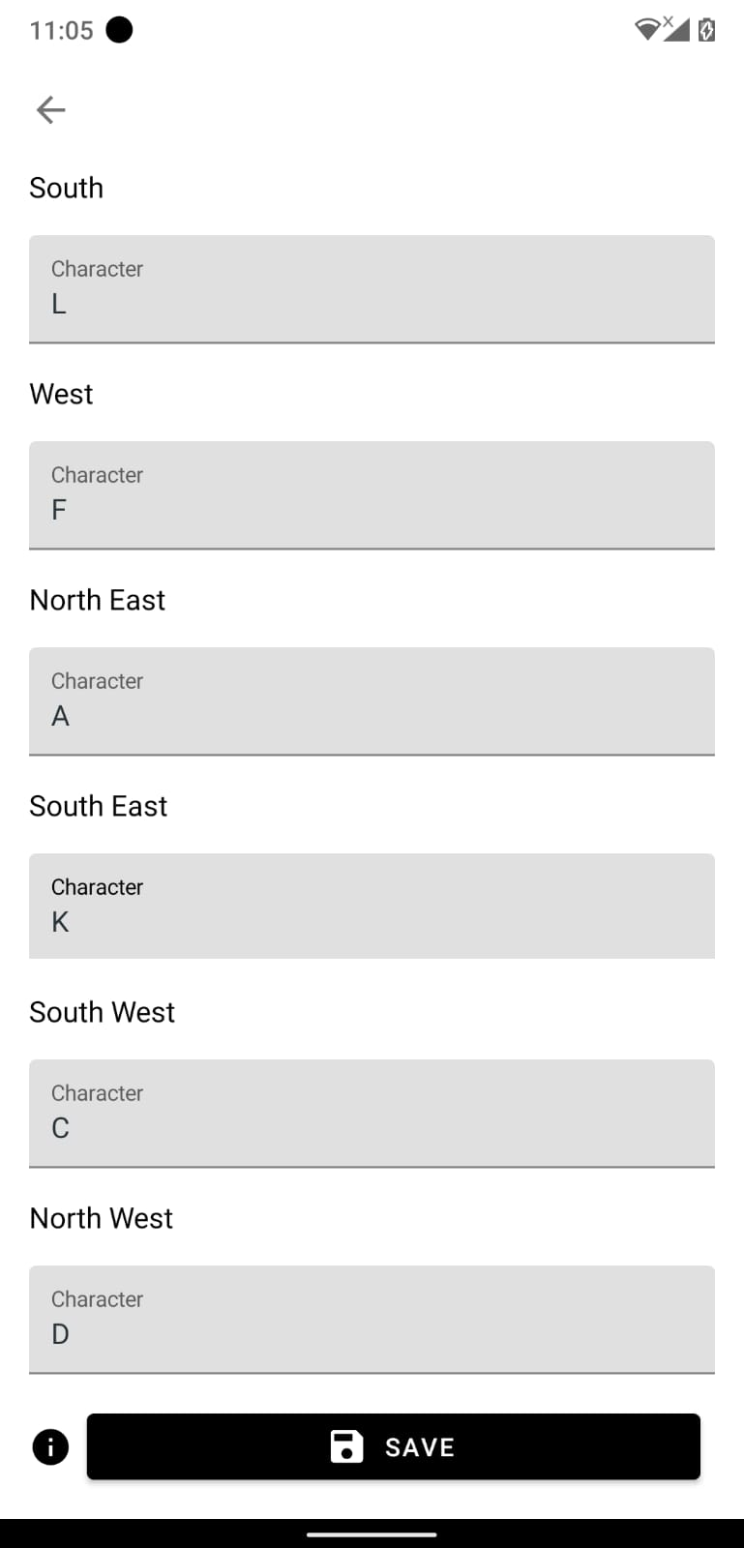

* + And check on the save button
  + 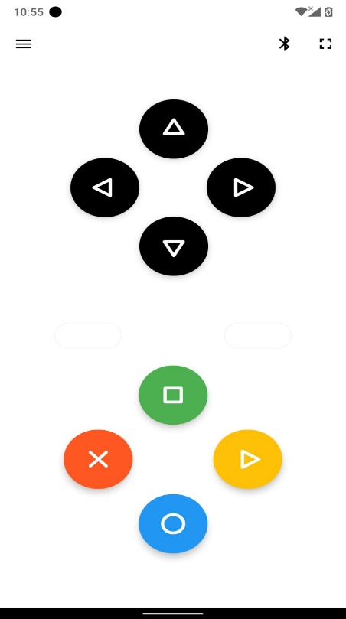Controlling for the remote is as follows
  + Forward, Backward, Left, Right are black button and the button with blue colour is for stopping the vehicle