

BAHÇEŞEHİR UNIVERSITY
FACULTY OF ENGINEERING

DEPARTMENT OF COMPUTER ENGINEERING

SENTIMENT ANALYSIS

Submitted by
YUNUS EMRE AYDAR
CEM KONUK
Advisor
ph.d TEVFİK AYTEKİN

İSTANBUL, May 2017

BAHÇEŞEHİR UNIVERSITY
FACULTY OF ENGINEERING
DEPARTMENT OF COMPUTER ENGINEERING

This project work submitted by Cem Konuk and Yunus Emre Aydar has been done under my supervision. I hereby state that the work outlined in this report satisfies the requirements of the compulsory “Capstone Project” course, and Cem Konuk and Yunus Emre Aydar can take the capstone project examination.
Signature and Date
………………………….
ADVISOR NAME-SURNAME
Cem Konuk and Yunus Emre Aydar have taken and passed the capstone project examination in our presence on January ……., 2015. We hereby certify that this project work fulfills all requirements of “Capstone Project” course.
THE EXAMINATION COMMITTEE
Committee Member Signature
- ………………………….. ………………………..
- ………………………….. ………………………..
- ………………………….. ………………………..
I have reviewed this capstone project report submitted by Cem Konuk and Yunus Emre Aydar I hereby endorse the project work described here as a “Capstone Project I.”

SUMMARY

We firstly tested some positive and negative words on a sentence that we created. After that, we resolved that the sentence is positive, negative, or neutral with respect to number of positive and negative words. We started to receive sample sentences via a text document after we checked our algorithm so far, and we expended our positive and negative word capacity. At that time, we experienced some technical issues. When we do not create our own sentences and receive them automatically, the algorithm read some incomplate words and rated the whole sentences improperly. We solved this problem by creating a different algorithm which is checking every positive
and negative words before it enter the loop. After we solved this technical problem, we tried to receive sentences as tweets from Twitter, and to do this we placed the tweets as sample sentences using a platform which getting database of Twitter. After we tested our algorithm working properly, we designed our project with using GUI.

ÖZET

Projemize başlarken kendi oluşturduğumuz cümleleri kendi oluşturduğumuz pozitif ve negatif kelimelerle test ederek başladık. Sonra bu cümlelerden çıkan pozitif ve negatif kelime sayısına göre cümlenin olumlu, nötr ve olumsuz olduğuna karar verdik. Sistemin bu haliyle çalışılabilirliğini test ettikten sonra cümleleri bir metin dosyası aracılığıyla otomatik olarak almaya başladık. Daha sonra pozitif ve negatif kelime hazinemizi de genişlettik. Bu sırada teknik hatalar yaşadık. Cümleleri kendimiz oluşturmayıp otomatik olarak aldığımızda istemediğimiz ara kelimeleri de derecelendirdiğimizi ve yanlış sonuç aldığımızı fark ettik. Bu hataları her olumlu veya olumsuz kelimeyi işleme geçirmeden önce önüne ve sonuna gelen ekleri kontrol eden bir algoritme yaratarak çözdük. Bu problemleri çözdükten sonra cümleleri örnek cümlelerle değil Twitter’den atılan tweetlerle almayı denedik ve bunun için Twitter’dan veri çektiğimiz bir platformla, atılan tweetleri projemize örnek cümleler olarak yerleştirdik. Bu son haliyle algoritmanın problemsiz bir şekilde çalışabildiğini test ettikten sonra GUI kullanarak projemiz için tasarım yaptık.

ACKNOWLEDGEMENTS
We want to thank our design project advisor Tevfik Aytekin on helping and guiding us on our project. Also we want to thank our friends who have always supported us during this thesis study.

Yunus Emre Aydar
Cem Konuk
İstanbul, May 2017

TABLE OF CONTENTS

SUMMARY II
ÖZET III
ACKNOWLEDGEMENTS IV
TABLE OF CONTENTS V
LIST OF FIGURES AND TABLES VI
ABBREVIATIONS VII
1 Introduction 1
2 Related Works 1
3 Materials and Methods 2
4 Experimental Results 3
5 Conclusion 3
6 References 4
7 Curriculum Vitae 5

LIST OF FIGURES AND TABLES
Figure 1-1: Proposed System of Sentiment Analysis 1
Figure 2-1: A Brief Explanation of Sentiment Classifier 2

ABBREVIATIONS

GUI: Graphical User Interface
API: Application Programming Interface
Twitter4J: An unofficial Java library for the Twitter API.

Introduction

Sentiment analysis is the process of analysing natural language text for discovering

the opinions or emotions (e.g., positive, negative, or neutral) of the users on specific

topics or products. In this project the aim to collect tweets from the Twitter stream

(some other datasets will also be used) and do basic sentiment analysis. The project

which is Sentiment Analysis attracted our attention. Because, we thought that the

project was convenient to develop our skills. We developed our Java skills and we

learned concept of Sentiment Analysis throughout the project. 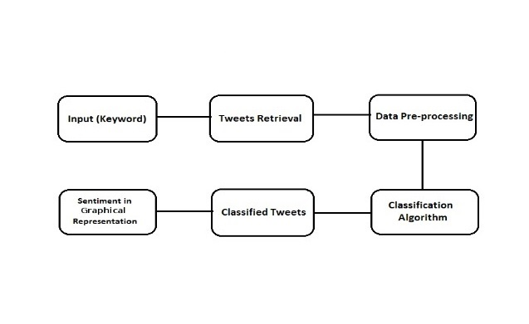

Related Works
Sentiment analysis refers to the use of natural language processing, text analysis, computational linguistics, and biometrics to systematically identify, extract, quantify, and study affective states and subjective information. Natural language processing is a field of computer science, artificial intelligence, and computational linguistics concerned with the interactions between computers and human language. There are many examples of sentiment analysis being used in a variety of fields such as online retail, to all forms of blogging to find out the opinion of people on a specific topic.

Materials and Methods
Firstly, we took tweets using open source Twitter Libraries. Then, the program decided whether positive, negative, or neutral words used mostly by classifier. After processing every tweet, we showed the overall positive, negative, neutral scores with a graphical user interface. We used Java programming language and Twitter4J library to retrieve data from Twitter.

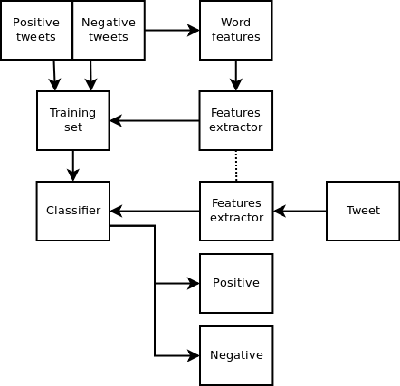

Experimental Results
We experienced some technical issues. When we do not create our own sentences and receive them automatically, the algorithm read some incomplate words and rated the whole sentences improperly. Some technical difficulties occured while designing console screen with GUI. We had some issues with the ‘not’ word and it causes changing the meaning oppositely, after we checked if the word is positive or negative then we also check if it has a ‘not’ before itself by determining the word’s char position.

Conclusion
Our goals in this project is receiving tweets for a specific keyword from Twitter and rating this tweets if it is positive or negative comment. We firstly tried to rate sentences that we create. To rate a sentences, we searched this sentence how many positive and negative words it has. Then, we found a source that has approximately 2000 positive and negative words via internet. We created two arrays and we received these words from two different positive and negative text documents by the arrays. We found sentence examples from the popular websites which are IMDB, Amazon, and Yelp in order to apply our algorithm. We turned sentences into text document. Thus, we was able to transfer our sentences to algorithm. After this algorithm worked properly so far, we tried to find a way to access Twitter database and receive tweets for a keyword. Then, we discovered a website which we used libraries for Twitter API from. With the help of this libraries, we typed keyword and received tweets which contains this keyword. After that, we wanted to design our project with using GUI related to completed algorithm. Designing contained console screens, main menu screen, and twitter search screen. Main menu included the two search types which are text search and twitter search. Basis language of our system is English.

6 References

[1] https://dev.twitter.com/ ( Twitter Developers )

[2] https://apps.twitter.com/ ( Twitter Application Management )

[3] http://twitter4j.org/en/ ( TWITTER4J )

[4] https://en.wikipedia.org/wiki/Sentiment_analysis ( WIKIPEDIA )

[5] Java: How to Program, 9th Edition ( The Book by Paul Deitel & Harvey Deitel )

[6] Java Swing, 2nd Edition ( The Book by Marc Loy, Robert Eckstein, Dave Wood, James Elliott, and Brian Cole )

[7] https://stackoverflow.com/ ( Stack Overflow )

[8] http://sentiwordnet.isti.cnr.it/ ( SentiWordNet )

[9] http://sentistrength.wlv.ac.uk/ ( SentiStrength )

[10] https://archive.ics.uci.edu/ml/datasets/Sentiment+Labelled+Sentences ( UCI )

