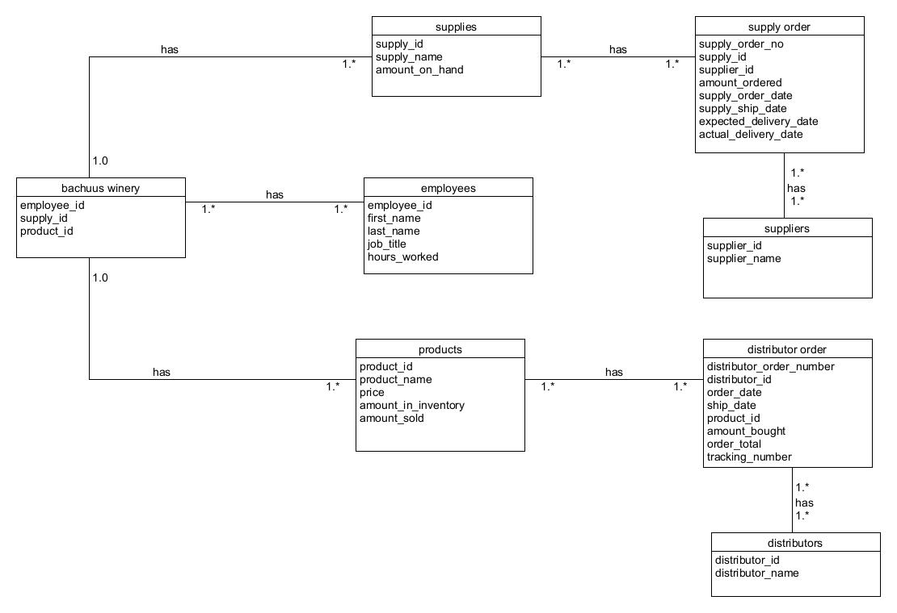
Business Rules:
A Company has many Employees
A Company has many Distributors
A Distributor has many Orders
A Company has many Suppliers
A Supplier has many Supplies
A Company has many Products
Ship Date must be after Order Date
Delivery Date must be After Order and Ship Date
Total Prices are Calculated Automatically
We have set distributors for products to be sold to
We have set suppliers to buy supplies from
No Tables have empty fields.

