Record # 1:

Questions: Are all suppliers delivering on time? Is there a large gap between expected delivery and actual delivery? A month-by-month report should show problem areas.

Description: This record will run a query showing the expected delivery dates and the actual delivery dates of each supply order.

Code:
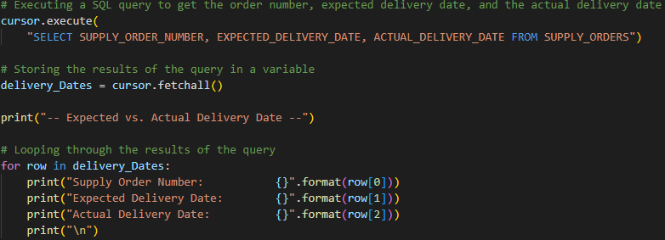
Output:
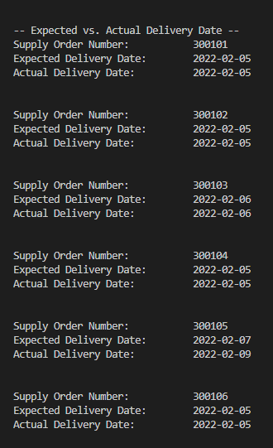
Record #2:

Questions: The wine distribution, are all wines selling as they thought? Is one wine not selling? Which distributor carries which wine?

Description: This record creates a join from the “Products” table, “Distributor” table and the “distributor order” table and runs a query displaying the distributor, the wine name, and the amount the wine has sold.

Code:
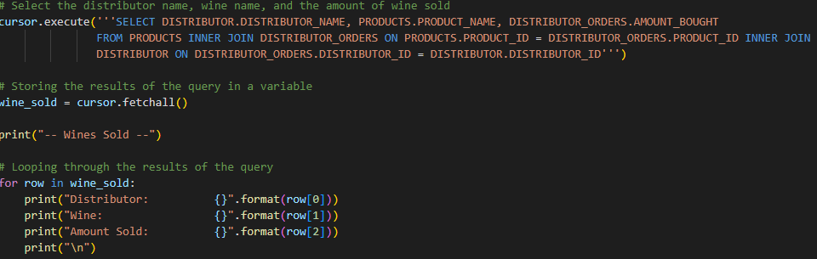Output:
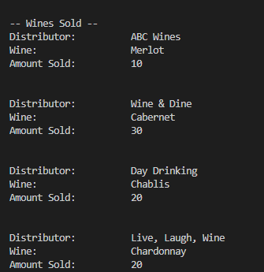

Record #3:

Question: Employee time. During the last four quarters, how many hours did each employee work?

Description: This record creates a join combining the “employee” and “hours worked” tables to display each employee and how many hours they have worked over the last four quarters.

Code:
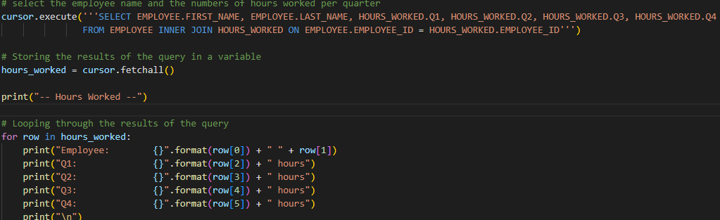
Output:
