Object Relational Diagram

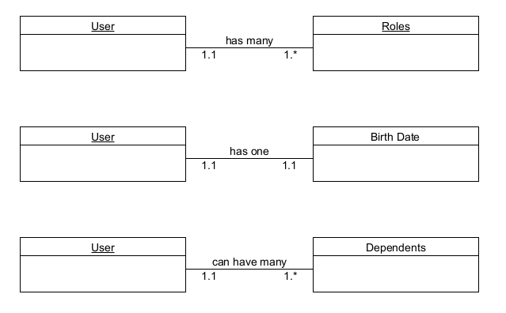

NoSQL Data Structures

*// User*

{

user_id: 1,

name: “John Smith”

}

*// Roles*

{

role_id: 1,

user_id: 1,

role: “Manager”

}

*// Birth Date*

{

birth_id: 1,

user_id: 1,

birth_date: “05/23/1976”

}

*// Dependents*

{

dependent_id: 1,

user_id: 1,

dependent_name: “Jimmy Smith”

}

{

dependent_id: 2,

user_id: 1,

dependent_name: “Billy Smith”

}