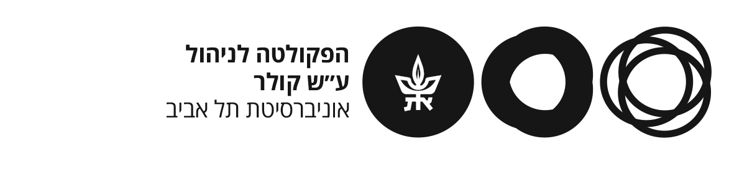

***Final Project Report***

***Introduction to Machine Learning – Second Semester 2025******Tel Aviv University – Digital Sciences for High-Tech***

***Project name:***

Classification of Mortgage Loan Applications – Florida HMDA 2013 Dataset  
  
**Group Number- 31:**

Mellissa Ghandour: ID-326541521

Jude Younis: ID- 315868968

## **Project Summary – Loan Default Classification (Group 31)**

This project focused on predicting whether a mortgage loan will be approved (1) or rejected (0) using structured applicant data. We approached it as a binary classification task, applying data preprocessing, model experimentation, and performance optimization techniques.

## **Project Goals**

* Classify mortgage loan applications using known and anonymized features
* Experiment with different models, from basic classifiers to advanced ensemble methods
* Tune hyperparameters to maximize performance (measured by AUC). And win! But unfortunately, we lost by 0.0003 to first place.
* Deliver a clean, reproducible pipeline and a professional project report

## **Tools & Technologies Used**

* **Language**: Python 3.11
* **Environment**: Jupyter Notebook (via Anaconda)
* **Libraries**: pandas, scikit-learn, LightGBM, XGBoost, matplotlib, seaborn
* **Automation**: We built a self-contained environment capable of testing multiple models across datasets and parameter settings. It automatically logs results and saves outputs for later analysis.

## **Files Included in Submission (31.zip)**

| **File Name** | **Description** |
| --- | --- |
| notebook_31.ipynb | Full Jupyter Notebook with code, experiments, plots, and model evaluations |
| report_31.pdf | PDF report summarizing preprocessing, modeling steps, and conclusions |
| results_31.csv | Prediction probabilities on the test set in the required format |
| example_results.csv | Provided by the course team as a formatting reference (not created by us) |

All filenames and formats match the course submission requirements. The final submission is zipped as 31.zip.

## **Model Development Overview**

* **Preprocessing**: Imputation, normalization, one-hot encoding, and ID feature analysis
* **Baseline Models**: Logistic Regression, KNN, Decision Trees
* **Advanced Models**: Random Forest, AdaBoost, XGBoost, LightGBM
* **Feature Engineering**: Feature selection and experiments with new variables
* **Automation**: A robust pipeline tested dozens of model configurations and stored all results
* **Best AUC Achieved**: 0.9807+ with LightGBM after tuning and feature selection

## **Reproducibility & Environment Setup**

To reproduce our results or continue developing, follow these steps:

**1. Clone the Repository**

Open your terminal (or Command Prompt) and run the following:

Windows / macOS / Linux:

git clone https://github.com/Featherless-Biped/IntroToML_FinalProject.git  
cd IntroToML_FinalProject

**2. Create a Virtual Environment**

We recommend using venv:

For Windows:

python -m venv .venv  
.venv\Scripts\activate

For macOS / Linux:

python3 -m venv .venv  
source .venv/bin/activate

**3. Install Dependencies**

pip install -r requirements.txt

**4. Launch Jupyter Notebook**

jupyter notebook

## **How to Run the Final Model Only**

If you're interested in running only the final trained model on the processed data:

* Scroll to the **bottom code cell** of notebook_31.ipynb
* This section:
  + Loads the cleaned dataset
  + Applies all preprocessing steps
  + Loads the trained model with tuned parameters
  + Outputs predictions and evaluation metrics

There is **no need to re-run the entire notebook**. The final code block is self-contained and ready to use.

For additional documentation, development history, and version control, visit our GitHub repository:  
[**https://github.com/Featherless-Biped/IntroToML_FinalProject**](https://github.com/Featherless-Biped/IntroToML_FinalProject)