Implementation of Software Product Line with FOP
(2D Game)

Luo lei,Songxuan wu,Liang liang
Data & Knowledge Engineering (DKE; M)
Otto-von-Guericke University Magdeburg

1. Requirement of Quality
At the end of the internship, the game must have the following features:
- Platform: The game can be played in PC and mobile phone. It is a required feature.
- Language: English, German can be selected in PC. The language of the game in mobile phone is only English. It is a required feature.
- AI: Two levels of AI can be chose: "easy" and "hard". It is a required feature.
- GUI: The game can be displayed by linear graphs or images. In PC-platform, two different sizes(800*600 and 1280*800) can be chose. There is no size-choice in mobile phone. It is a required feature.
- Record: The player can choose, if his score is recorded or not. When yes, at the end of the game, there will be a high score table. The player can check his ranking. It is an optional feature.
- Sound effects: The player can choose, if the game has sound effects or not. It is an optional feature.
- Tools: The player can choose, how many types of tools the game has. There can be maximum six different types of tools in the game:
1. Increase the HP of the player's tank
2. Increase the moving speed of the player's tank
3. Increase the fire speed of the player's tank
4. Be invincible in 20 seconds
5. Kill all the enemies at the moment
6. Stop the movement of all the enemies in 20 seconds
It is an optional feature.
- Tanks: At the beginning of the game, the player can choose his favorite tank. Three different kinds of tanks can be chosen:
1. "U.S. M1 Abrams":
-HP level: 7
-Moving speed level: 6
-Fire speed level: 7
2. "Germany Leopard 2":
-HP level: 10
-Moving speed level: 5
-Fire speed level: 5
3. "China Type-99":
-HP level: 5
-Moving speed level: 10
-Fire speed level: 5
It is a required feature.
During testing, we check all the above mentioned features. In addition, 10 people will play this game to confirm whether the difficulty of the game is suitable or not, and to find bugs.

2. UML design
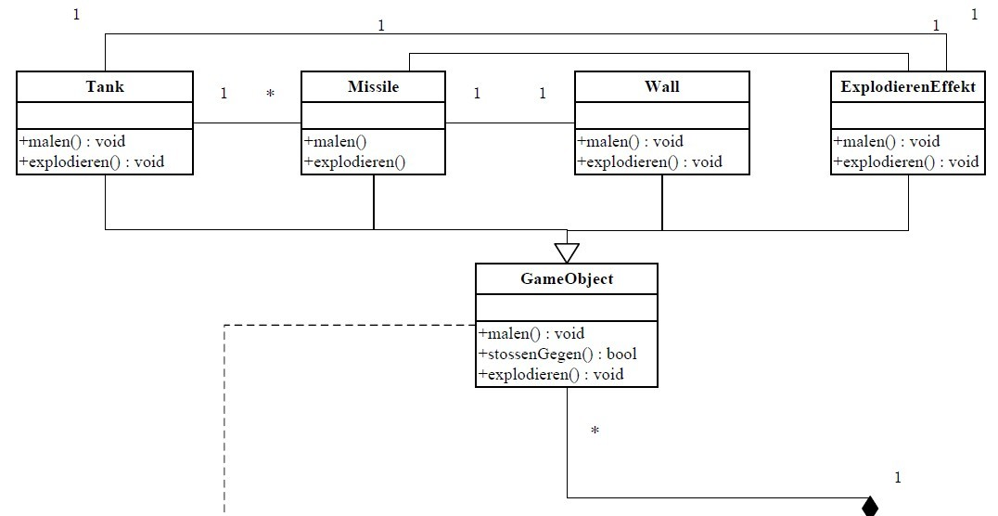
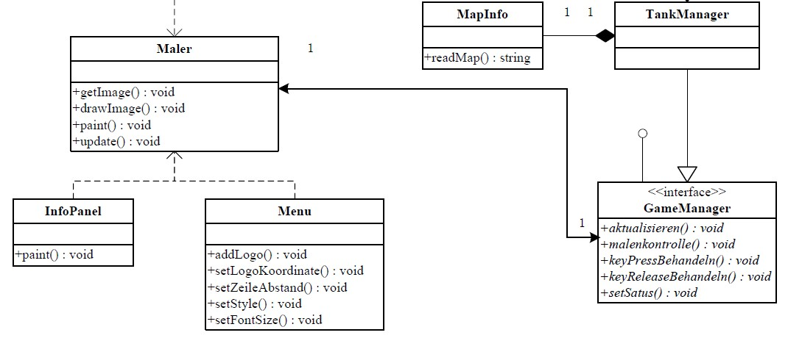

3. Final feature-tree
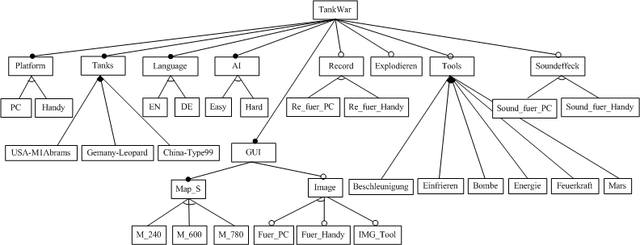
4. Important things
- This game can be run under the PC and in the mobile phone, which supports CLDC1.1 and MIDP2.0.
- Considering the requirement of quality, our game reached our goals, that is, to implement a 2D game using FOP.
- The most important thing learned from this internship is that, we should design a good overview (UML, feature tree, schedule, group working) before programming, especially involved in using FOP and also supporting mobile phone. Besides, we realize deeply the advantage of FOP: it is easier and faster to generate the multi-version of software product.
- We have deviated from our schedule a little bit because we had no experience in mobile phone programming before. At first we made the feature “mobile phone” as one independent feature and implement it at the end of the schedule. But in fact, we should think about it all the time, because of the differences between the libraries in PC and in mobile phone. This mistake took us about 1 week to reconsider our project.
- There are still many spaces for improvement:
- Using the same frame for developing other similar games
- Using more complicated AI algorithm
- Adding more game maps, tanks, tools, sound effects…

