How to Flash and Upload Code to ATtiny85 (HW-260 USB Board) Using an Arduino UNO and Micronucleus
This guide provides step-by-step instructions to burn the correct bootloader and upload a Blink sketch to an ATtiny85-based HW-260 USB board using an Arduino UNO as a programmer and Micronucleus CLI.

1. Burn the Micronucleus Bootloader to ATtiny85 Using Arduino UNO

1.1. Set Up the Arduino UNO as an ISP Programmer
- Connect the Arduino UNO to your PC and open Arduino IDE 2.0.
- Go to: File > Examples > 11. ArduinoISP > ArduinoISP.
- Select the Board: Arduino UNO (Tools > Board > Arduino AVR Boards > Arduino UNO).
- Select the Port: Check Tools > Port and select the Arduino UNO port.
- Upload the ArduinoISP sketch to the UNO.

1.2. Wire the Arduino UNO to the ATtiny85
Use the following wiring to connect the ATtiny85 to the Arduino UNO:
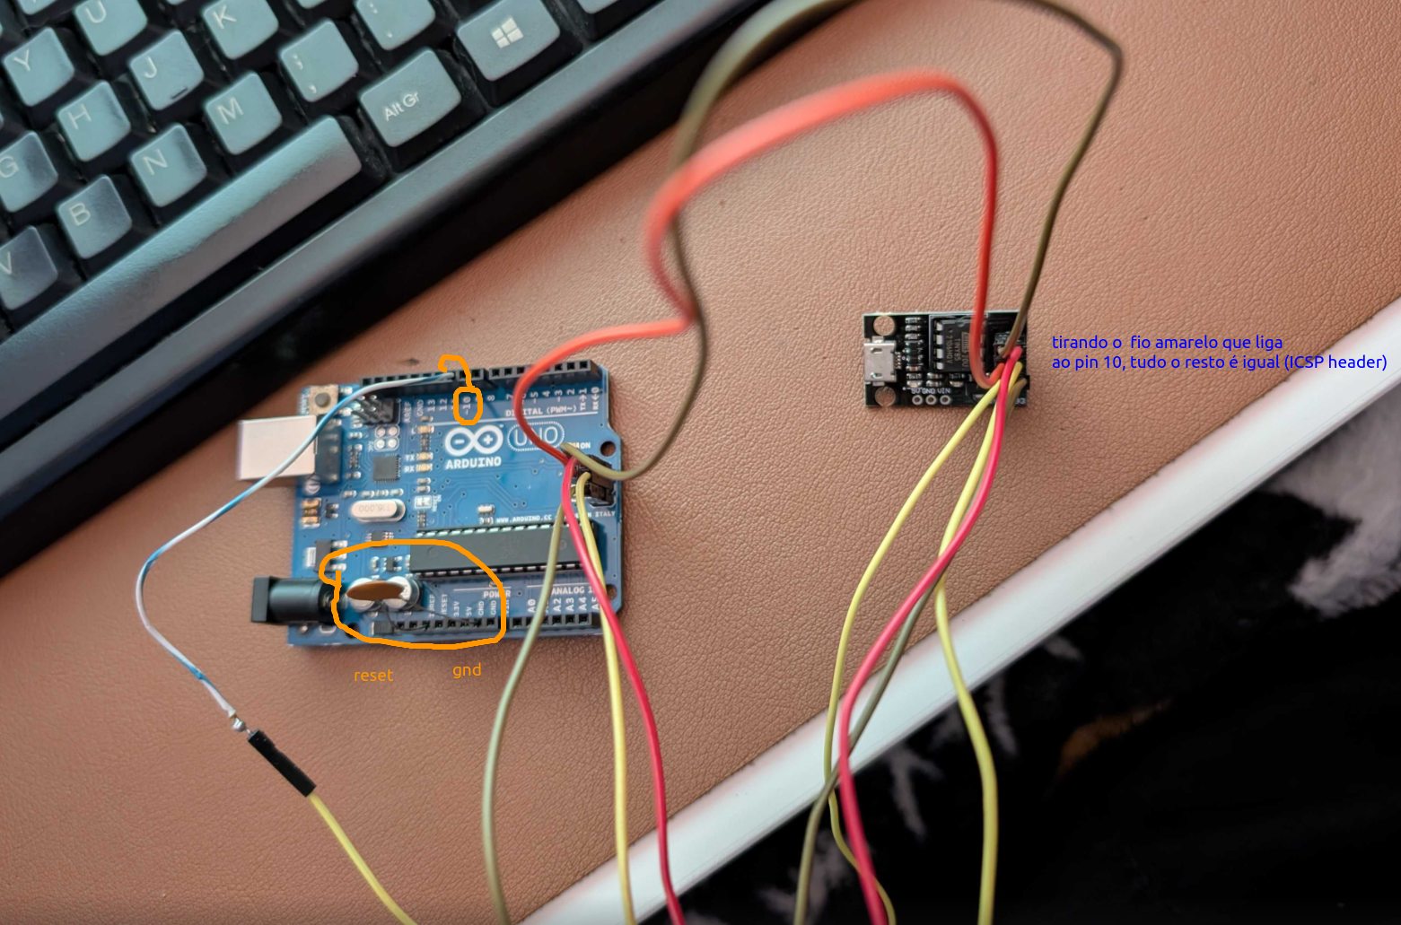
💡 Tip: Add a 10µF capacitor between RESET and GND on the Arduino UNO to prevent it from resetting. (Ou um 223 cerâmico também serviu).

1.3. Burn the program hex using Arduino UNO as ISP:
avrdude -c stk500v1 -b 19200 -P /dev/ttyACM0 -p t85 -U flash:w:/home/milhas/.var/app/cc.arduino.IDE2/cache/arduino/sketches/A590DD0DB7006373D259ECE8839E819F/key.ino.hex -U lfuse:w:0xe1:m -U hfuse:w:0xdd:m -U efuse:w:0xfe:m
  - Replace /dev/ttyACM0 with the correct port of your Arduino UNO.

----

const int LED_PIN = 1; // Define LED pin as constant

void setup() {
pinMode(LED_PIN, OUTPUT); // Set pin 1 as output
}

void loop() {
digitalWrite(LED_PIN, HIGH); // Turn LED on
delay(1000);
digitalWrite(LED_PIN, LOW); // Turn LED off
delay(1000);
}

