程序运行界面
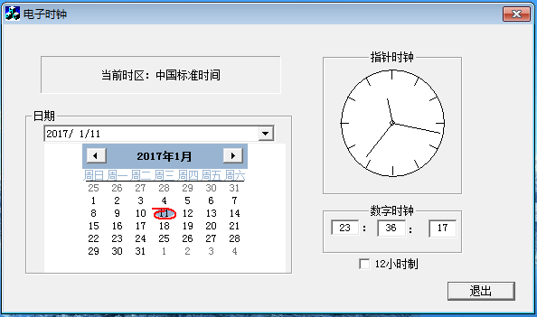
12小时制与24小时制切换
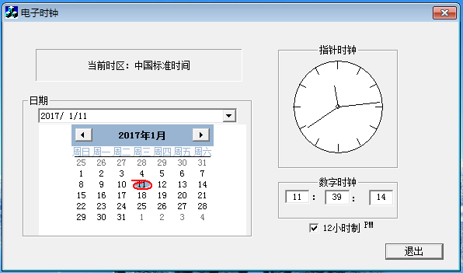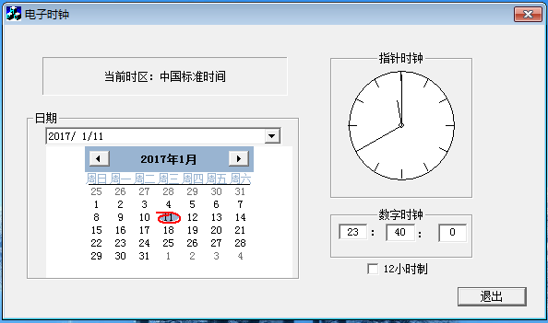

时间更改
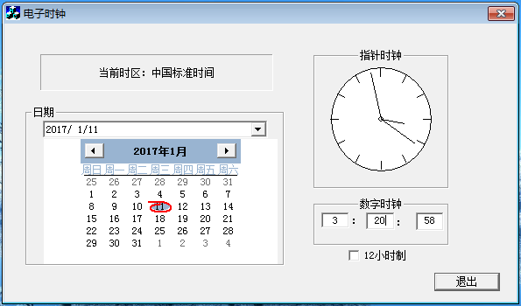
日期更改
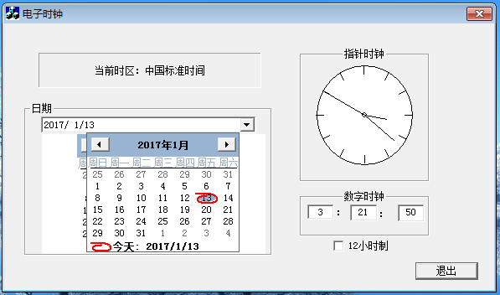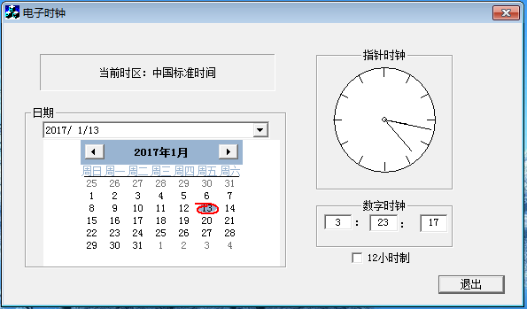
程序源代码清单
// 练习3Dlg.cpp : implementation file
#include<graphics.h>
#include "stdafx.h"
#include "练习3.h"
#include "练习3Dlg.h"
#include "math.h"
#ifdef _DEBUG
#define new DEBUG_NEW
#undef THIS_FILE
static char THIS_FILE[] = __FILE__;
#endif
static int m_second;
static int m_minute;
static int m_hour;

////////////////////////////////////////////////////////////////////////////
// CAboutDlg dialog used for App About

class CAboutDlg : public CDialog
{
public:
CAboutDlg();

// Dialog Data
//{{AFX_DATA(CAboutDlg)
enum { IDD = IDD_ABOUTBOX };
//}}AFX_DATA

// ClassWizard generated virtual function overrides
//{{AFX_VIRTUAL(CAboutDlg)
protected:
virtual void DoDataExchange(CDataExchange* pDX); // DDX/DDV support
//}}AFX_VIRTUAL

// Implementation
protected:
//{{AFX_MSG(CAboutDlg)
//}}AFX_MSG
DECLARE_MESSAGE_MAP()
};

CAboutDlg::CAboutDlg() : CDialog(CAboutDlg::IDD)
{
//{{AFX_DATA_INIT(CAboutDlg)
//}}AFX_DATA_INIT
}

void CAboutDlg::DoDataExchange(CDataExchange* pDX)
{
CDialog::DoDataExchange(pDX);
//{{AFX_DATA_MAP(CAboutDlg)
//}}AFX_DATA_MAP
}

BEGIN_MESSAGE_MAP(CAboutDlg, CDialog)
//{{AFX_MSG_MAP(CAboutDlg)
// No message handlers
//}}AFX_MSG_MAP
END_MESSAGE_MAP()

////////////////////////////////////////////////////////////////////////////
// CMy3Dlg dialog

CMy3Dlg::CMy3Dlg(CWnd* pParent /*=NULL*/)
: CDialog(CMy3Dlg::IDD, pParent)
{
//{{AFX_DATA_INIT(CMy3Dlg)
m_hour = 0;
m_minute = 0;
m_second = 0;
m_bTime = FALSE;
m_strData = _T("");
//}}AFX_DATA_INIT
// Note that LoadIcon does not require a subsequent DestroyIcon in Win32
m_hIcon = AfxGetApp()->LoadIcon(IDR_MAINFRAME);
}

void CMy3Dlg::DoDataExchange(CDataExchange* pDX)
{
CDialog::DoDataExchange(pDX);
//{{AFX_DATA_MAP(CMy3Dlg)
DDX_Control(pDX, IDC_MONTHCALENDAR1, m_monthCtrl);
DDX_Control(pDX, IDC_DATETIMEPICKER1, m_timeCtrl);
DDX_Text(pDX, IDC_EDIT1, m_hour);
DDV_MinMaxInt(pDX, m_hour, 0, 23);
DDX_Text(pDX, IDC_EDIT2, m_minute);
DDV_MinMaxInt(pDX, m_minute, 0, 59);
DDX_Text(pDX, IDC_EDIT3, m_second);
DDV_MinMaxInt(pDX, m_second, 0, 59);
DDX_Check(pDX, IDC_CHECK1, m_bTime);
DDX_Text(pDX, IDC_STATIC6, m_strData);
//}}AFX_DATA_MAP
}

BEGIN_MESSAGE_MAP(CMy3Dlg, CDialog)
//{{AFX_MSG_MAP(CMy3Dlg)
ON_WM_SYSCOMMAND()
ON_WM_PAINT()
ON_WM_QUERYDRAGICON()
ON_WM_TIMER()
ON_EN_CHANGE(IDC_EDIT1, OnChangeEdit1)
ON_EN_CHANGE(IDC_EDIT2, OnChangeEdit2)
ON_EN_CHANGE(IDC_EDIT3, OnChangeEdit3)
ON_BN_CLICKED(IDC_CHECK1, OnCheck1)
ON_NOTIFY(DTN_DROPDOWN, IDC_DATETIMEPICKER1, OnDropdownDatetimepicker1)
ON_NOTIFY(DTN_DATETIMECHANGE, IDC_DATETIMEPICKER1, OnDatetimechangeDatetimepicker1)
//}}AFX_MSG_MAP
END_MESSAGE_MAP()

////////////////////////////////////////////////////////////////////////////
// CMy3Dlg message handlers

BOOL CMy3Dlg::OnInitDialog()
{
CDialog::OnInitDialog();
// Add "About..." menu item to system menu.
// IDM_ABOUTBOX must be in the system command range.
ASSERT((IDM_ABOUTBOX & 0xFFF0) == IDM_ABOUTBOX);
ASSERT(IDM_ABOUTBOX < 0xF000);

CMenu* pSysMenu = GetSystemMenu(FALSE);
if (pSysMenu != NULL)
{
CString strAboutMenu;
strAboutMenu.LoadString(IDS_ABOUTBOX);
if (!strAboutMenu.IsEmpty())
{
pSysMenu->AppendMenu(MF_SEPARATOR);
pSysMenu->AppendMenu(MF_STRING, IDM_ABOUTBOX, strAboutMenu);
}
}
// Set the icon for this dialog. The framework does this automatically
// when the application's main window is not a dialog
SetIcon(m_hIcon, TRUE); // Set big icon
SetIcon(m_hIcon, FALSE); // Set small icon

// TODO: Add extra initialization here
SetTimer(0,1000,NULL);
int a,b,c;
CTime curtime=CTime::GetCurrentTime();
a=curtime.GetHour();
b=curtime.GetMinute();
c=curtime.GetSecond();
m_second=c;
m_minute=b;
m_hour=a;
//m_timeCtrl.SetMonCal();
return TRUE; // return TRUE unless you set the focus to a control
}

void CMy3Dlg::OnSysCommand(UINT nID, LPARAM lParam)
{
if ((nID & 0xFFF0) == IDM_ABOUTBOX)
{
CAboutDlg dlgAbout;
dlgAbout.DoModal();
}
else
{
CDialog::OnSysCommand(nID, lParam);
}
}

// If you add a minimize button to your dialog, you will need the code below
// to draw the icon. For MFC applications using the document/view model,
// this is automatically done for you by the framework.

void CMy3Dlg::OnPaint()
{
if (IsIconic())
{
CPaintDC dc(this); // device context for painting
SendMessage(WM_ICONERASEBKGND, (WPARAM) dc.GetSafeHdc(), 0);

// Center icon in client rectangle
int cxIcon = GetSystemMetrics(SM_CXICON);
int cyIcon = GetSystemMetrics(SM_CYICON);
CRect rect;
GetClientRect(&rect);
int x = (rect.Width() - cxIcon + 1) / 2;
int y = (rect.Height() - cyIcon + 1) / 2;

// Draw the icon
dc.DrawIcon(x, y, m_hIcon);
}
else
{
CDialog::OnPaint();
}
}

// The system calls this to obtain the cursor to display while the user drags
// the minimized window.
HCURSOR CMy3Dlg::OnQueryDragIcon()
{
return (HCURSOR) m_hIcon;
}

void CMy3Dlg::OnTimer(UINT nIDEvent)
{
// TODO: Add your message handler code here and/or call default
CRect rect;
CWnd *pWnd=GetDlgItem(IDC_STATIC);
CDC *pDC=pWnd->GetDC();
pWnd->GetClientRect(&rect);
int centerX=rect.Width()/2;
int centerY=rect.Height()/2;
//表盘
pDC->Ellipse(20,20,rect.Width()-20,rect.Height()-20);
//表心
pDC->Ellipse(centerX-3,centerY-3,centerX+3,centerY+3);
int clockradius=centerY>centerX?centerX:centerY;
clockradius=clockradius*0.9;
double keduDRadius=0.7*clockradius;
double keduXRadius=0.82*clockradius;
double hourradius=0.4*clockradius;
double minuteradius=0.7*clockradius;
double secondradius=0.8*clockradius;

for(int i=0;i<12;i++) //刻度
{
pDC->MoveTo(centerX+keduDRadius*cos((i*30*PI)/180),
centerY+keduDRadius*sin((i*30*PI)/180));
pDC->LineTo(centerX+0.85*clockradius*cos((i*30*PI)/180),
centerY+0.85*clockradius*sin((i*30*PI)/180));
}
m_second+=1;
if(m_second>59)
{
m_second=0;
m_minute+=1;
UpdateData(FALSE);
}
if(m_minute>59)
{
m_minute=0;
m_hour+=1;
UpdateData(FALSE);
}
if(m_hour>23)
{
m_hour=0;
UpdateData(FALSE);
}

double secondRadians=m_second*(2*PI/60);
double minuteRadians=m_minute*(2*PI/60)+secondRadians/60;
double hourRadians=m_hour*(2*PI/12)+minuteRadians/12;

//时针
pDC->MoveTo(centerX,centerY);
pDC->LineTo(centerX+hourradius*sin(hourRadians),
centerY-hourradius*cos(hourRadians));

//分针
pDC->MoveTo(centerX,centerY);
pDC->LineTo(centerX+minuteradius*sin(minuteRadians),
centerY-minuteradius*cos(minuteRadians));
//秒针
pDC->MoveTo(centerX,centerY);
pDC->LineTo(centerX+secondradius*sin(secondRadians),
centerY-secondradius*cos(secondRadians));

UpdateData(FALSE);

CDialog::OnTimer(nIDEvent);

}

void CMy3Dlg::OnChangeEdit1()
{
// TODO: If this is a RICHEDIT control, the control will not
// send this notification unless you override the CDialog::OnInitDialog()
// function and call CRichEditCtrl().SetEventMask()
// with the ENM_CHANGE flag ORed into the mask.
UpdateData();
if(m_bTime)
{
if(m_hour>12)

{
m_hour=m_hour-12;
m_strData="PM";

}
else
{
m_strData="AM";

}
}
UpdateData(false);
// TODO: Add your control notification handler code here
}

void CMy3Dlg::OnChangeEdit2()
{
// TODO: If this is a RICHEDIT control, the control will not
// send this notification unless you override the CDialog::OnInitDialog()
// function and call CRichEditCtrl().SetEventMask()
// with the ENM_CHANGE flag ORed into the mask.b
UpdateData();
// TODO: Add your control notification handler code here

}

void CMy3Dlg::OnChangeEdit3()
{
// TODO: If this is a RICHEDIT control, the control will not
// send this notification unless you override the CDialog::OnInitDialog()
// function and call CRichEditCtrl().SetEventMask()
// with the ENM_CHANGE flag ORed into the mask.
UpdateData();
// TODO: Add your control notification handler code here

}

void CMy3Dlg::OnCheck1()
{
// TODO: Add your control notification handler code here
UpdateData();
int a;
a=m_hour;
if(m_strData=="PM")
{
a=a+12;
}
if(m_bTime)
{
if(a>12)
{
a=a-12;
m_strData="PM";
}
else
{
m_strData="AM";
}
}
else
{

if(m_hour>12)
{
a=a+12;
}
m_strData=" ";
}
m_hour=a;
UpdateData(FALSE);
}

void CMy3Dlg::OnDropdownDatetimepicker1(NMHDR* pNMHDR, LRESULT* pResult)
{
// TODO: Add your control notification handler code here
COleDateTime m_data;
m_timeCtrl.GetTime(m_data);
m_timeCtrl.SetTime(m_data);
CMonthCalCtrl *pCtrl=m_timeCtrl.GetMonthCalCtrl();
pCtrl->SetToday(m_data);
*pResult = 0;
}

void CMy3Dlg::OnDatetimechangeDatetimepicker1(NMHDR* pNMHDR, LRESULT* pResult)
{
// TODO: Add your control notification handler code here
COleDateTime m_data;
m_timeCtrl.GetTime(m_data);
m_timeCtrl.SetTime(m_data);
m_monthCtrl.SetCurSel(m_data);
m_monthCtrl.SetToday(m_data);
*pResult = 0;
}
《Visual C++语言》
课程设计任务书
题 目 |  | 电子时钟
学生姓名 |  |  |  | 学号 |  | 专业班级
设  计  内  容  与  要  求 | 1．设计目的：  （1）熟悉Visual C++开发环境；  （2）熟悉Visual C++应用程序向导AppWizard、类向导classWizard的使用；  （3）熟悉Visual C++Dialog结构；  （4）熟悉Visual C++开发软件的过程；  （5）掌握软件设计文档的书写方法；  2．设计内容及基本要求：  程序应提供的基本管理功能有：  - 能够配置年月日和时分秒的设置；  - 能够按照秒刷新显示；  - 能够提供显示方式选择。  3．撰写课程设计报告。报告内容要求如下：  设计题目、目的、内容；  设计思路；  系统框图；  各功能模块的功能、实现方法、源代码、测试手段及结果；  编程模块的源代码清单；  设计时碰到的问题及解决方法；
起止时间 |  |  | 2016年 1 月 2 日 至 2016 年 1 月 13 日
指导教师签名 |  |  | 年 月 日
系（教研室）主任签名 |  |  | 年 月 日
学生签名 |  |  | 年 月 日

