Class Diagram

Class Table

|  |  |  |  |
| --- | --- | --- | --- |
| Class ID | Class Name | Class ID | Class Name |
| Class-01 | Admin | Class-14 | ProductDAO |
| Class-02 | Customer | Class-15 | ProductDAOImpl |
| Class-03 | Register | Class-16 | ProductService |
| Class-04 | Product | Class-17 | ProductServiceImpl |
| Class-05 | ProductOrder | Class-18 | OrderDAO |
| Class-06 | AdminDAO | Class-19 | OrderDAOImpl |
| Class-07 | AdminDAOImpl | Class-20 | OrderService |
| Class-08 | AdminService | Class-21 | OrderServiceImpl |
| Class-09 | AdminServiceImpl | Class-22 | AdminController |
| Class-10 | CustomerDAO | Class-23 | CustomerController |
| Class-11 | CustomerDAOImpl | Class-24 | ProductController |
| Class-12 | CustomerService | Class-25 | OrderController |
| Class-13 | CustomerServiceImpl |  |  |

1. Entity

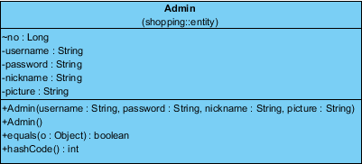

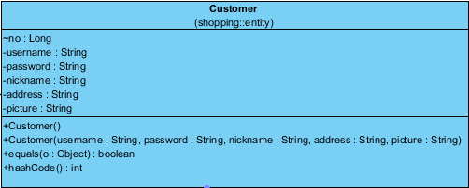

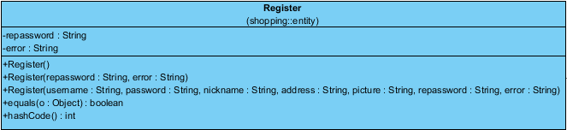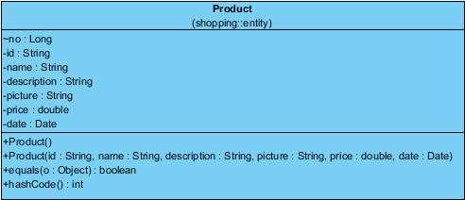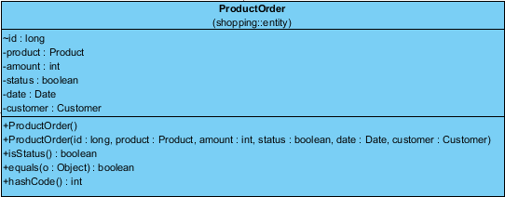

1. Relationship between entities



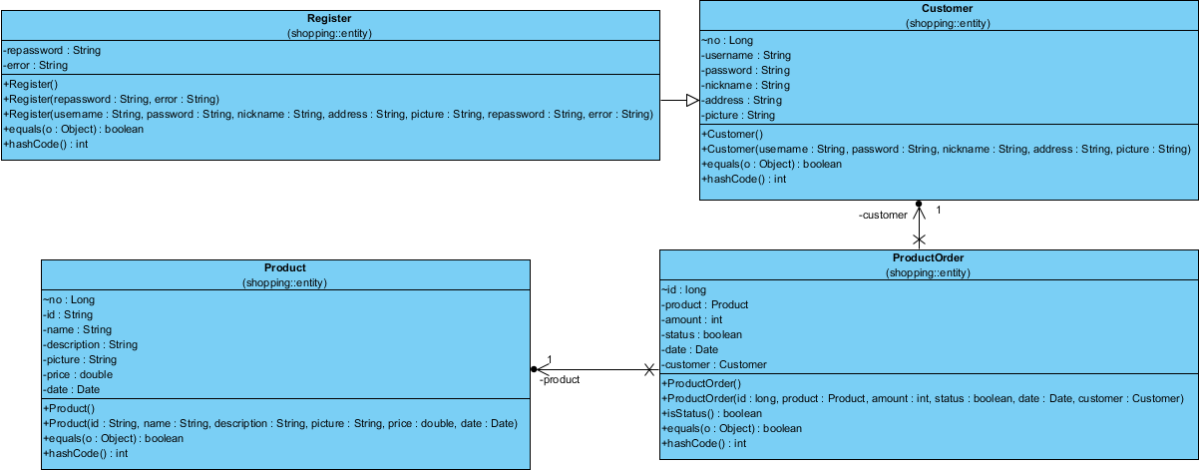

1. ER Diagram

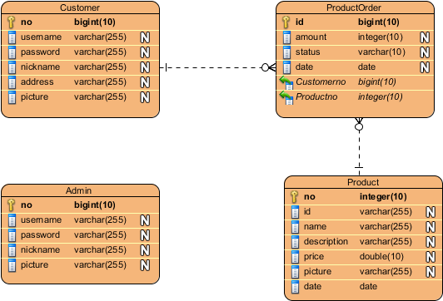

1. Service Classes

4.1 Admin Service for Admin Entity 4.2 Customer Service for Customer Entity

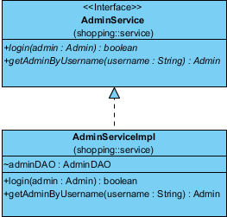 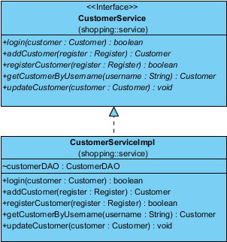

4.3 Product Service for Product Entity 4.4 Order Service for ProductOrder Entity

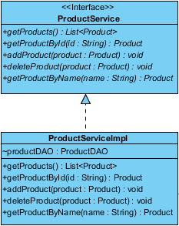 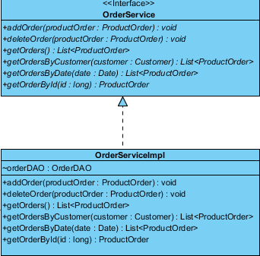

1. Inheritance

Register class inherits from Customer class, because Register has all attributes of Customer.

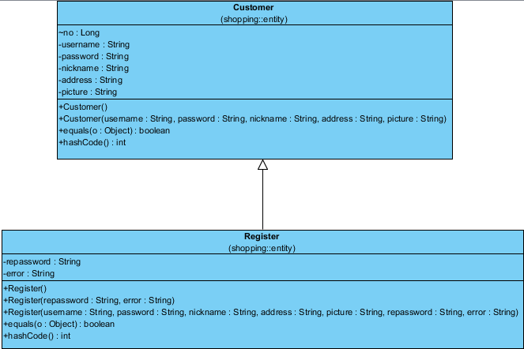

1. Design Pattern

6.1 DAO pattern

6.1.1 Admin

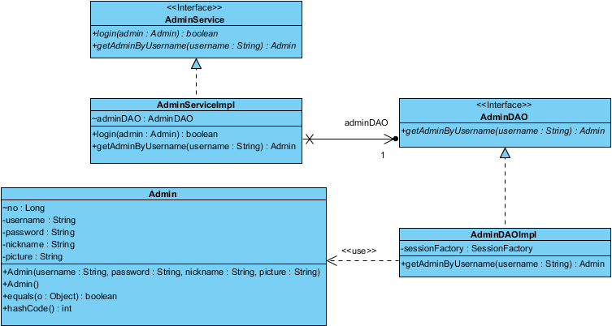

* + 1. Customer

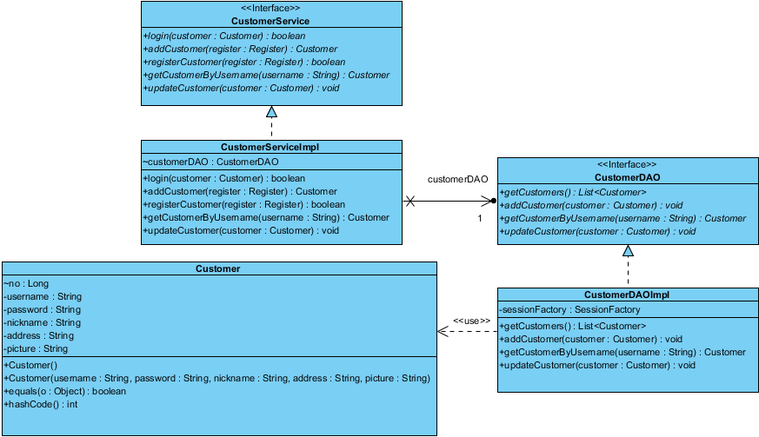

* + 1. Product

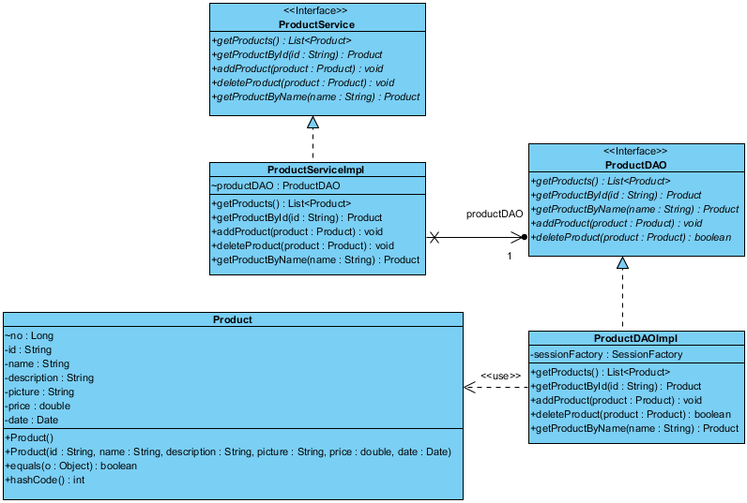

* + 1. ProductOrder

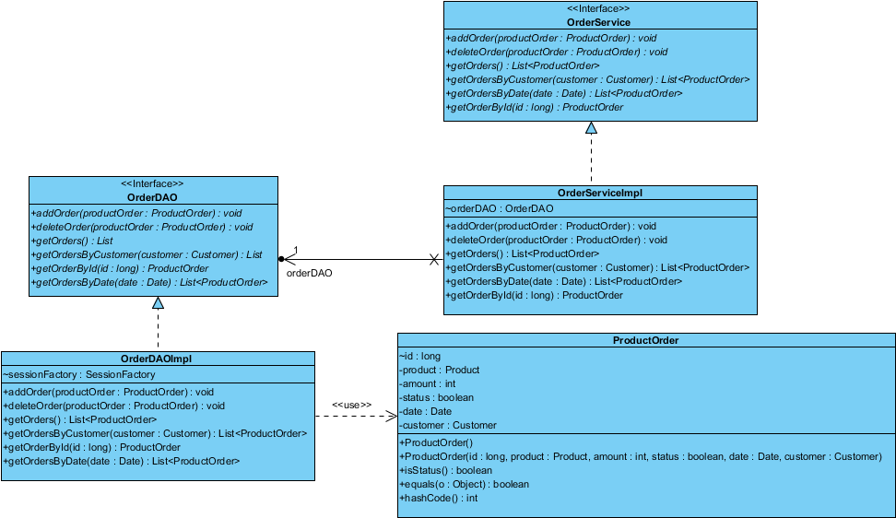

* 1. MVC framework

6.2.1 Admin Controller

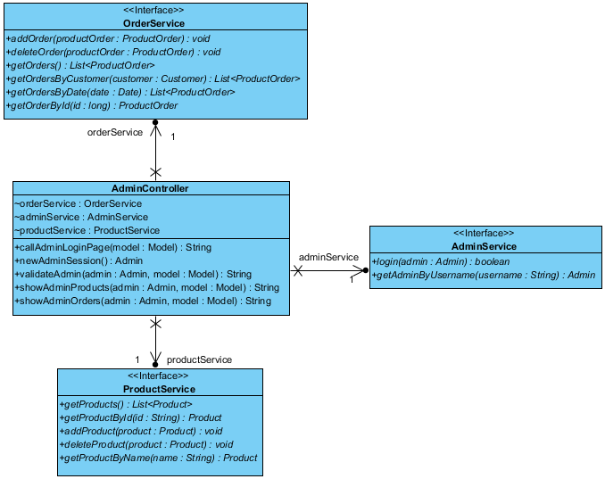

* + 1. Customer Controller

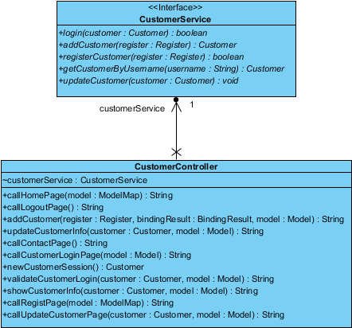

* + 1. Product Controller

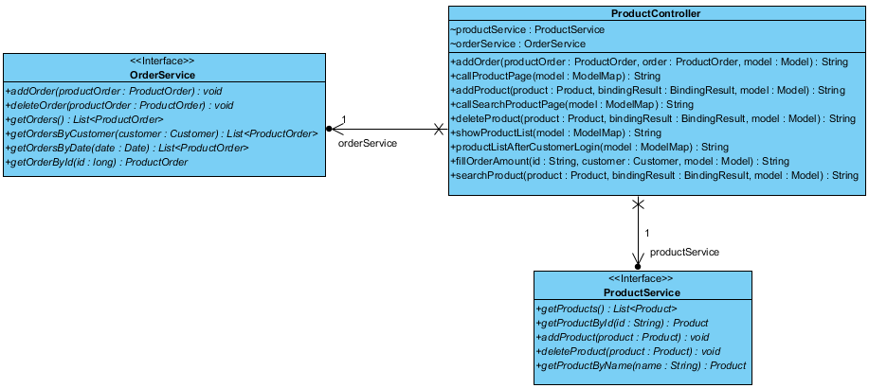

* + 1. Order Controller

