Seurat

Abstract
Analysis of new and previously published single cell sequencing datasets reveals that the
SARS-CoV2 receptors Ace2 and Tmprss2 are expressed in olfactory support cells, stem cells and perivascular cells, but not in neurons. Our aim is to proved how Covid19 syndrome leads to olfactory dysfunction.

Summary
The nasal epithelium is divided in three main sections: respiratory epithelium (RE), olfactory epithelium (OE) and olfactory bulb (OB).
The RE includes many types of cells, such as basal cells, cyliated cells, secretory cells and microvillar cells.
The OE includes OSN (olfactory sensory neurons) that are important because they detect odors via receptors expressed on their dendritic cilia. The OSN are supported by many other cells like substencular cells, microvillar and Bowman’s gland cells, GBC, HBC (horizontal basal cell).
The substencular cells mantain local salt and water balance, phagocytose and detoxify potentially damaging agents.
Microvillar cells and Bowman’s gland cells mantain OE homeostasis and its function.
GBC cells are resposible for regenerating OSN during normal epithelial turn over.
HBC cells act as reserve stem cells activating upon tissue damage.

Our purpose was to prove if the olfactory dysfunction might be caused by the binding between the receptors Ace2 and Tmprss2 of Sars-Cov2 and all the others cells of the nasal epithelium except for OSN.
This because OSN are responsible of detecting odors and so we want to prove that they are disabled by secondary ways, for example by the binding between substencular cells and Ace2 and Tmprss2
Methods
In order to show this, we analyzed the single cell RNAseq datasets from human (2 patients for RE and 2 patients for OE) and mouse (juvenile mouse olfactory bulb) libraries.

Results
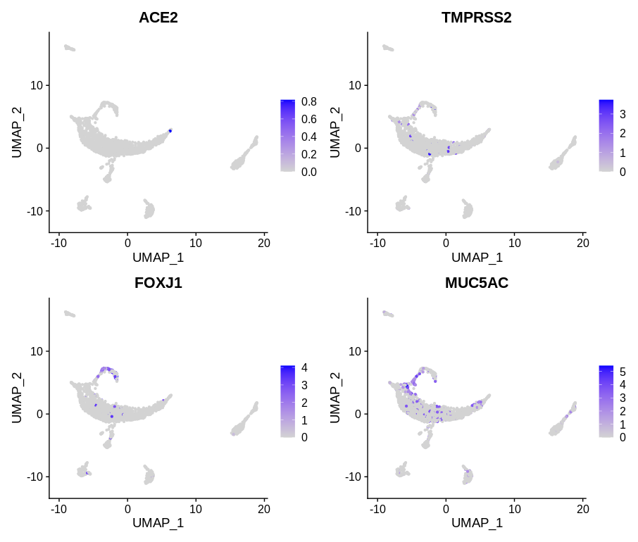

Figure 1) UMAP visualization of RE cells cluster of patient 4 showing expression of Cov2 entry genes (Ace2 and Tmprss2) and respiratory celiated gene (Foxj1) and respiratory secretory gene (Muc5ac)

As we can see in figure 1 the gene of the receptor of Sars-CoV2, TMPRSS2, is expressed in the same cells of FOXJ1 and MUC5AC, even if in low quantity. So from this UMAP graph we can suppose that the Sars-CoV2 can be binded throught its receptor at respiratory ciliated cells and respiratory secretory cells.

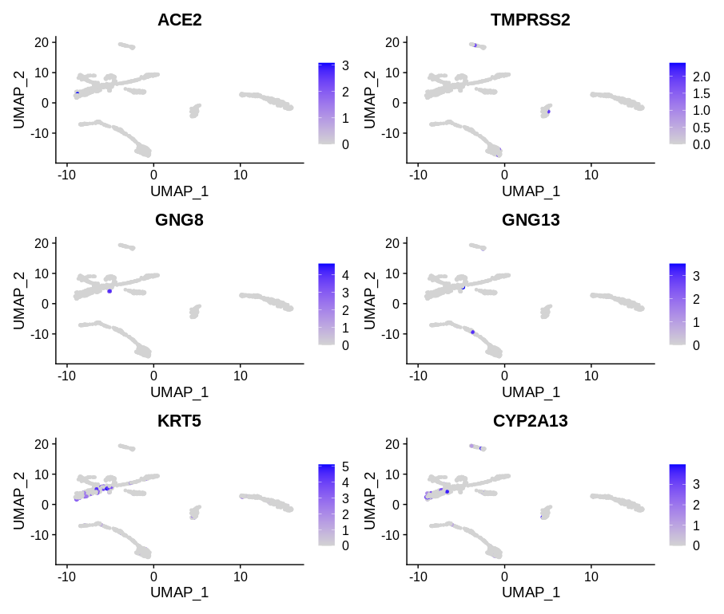

Figure 2) UMAP visualization of OE cells cluster of patient 3 showing expression of Cov2 entry genes (Ace2 and Tmprss2) and olfactory sensory neurons genes (Gng8 and Gng13) and horizontal basal cells gene (Krt5) and substencular cell gene (Cyp2a13)

The Figure 2 is very important because show us that the genes for the receptors of Sars-CoV2, ACE2 and TMPRSS2, are not expressed in the OSNs. Infact as we can see in the UMAP graph, the gene for ACE2 is expressed in the HBC, instead the gene for TMPRSS2 is expressed in the substencular cells. This proved that Sars-Cov2 doesn't bind to the OSNs.

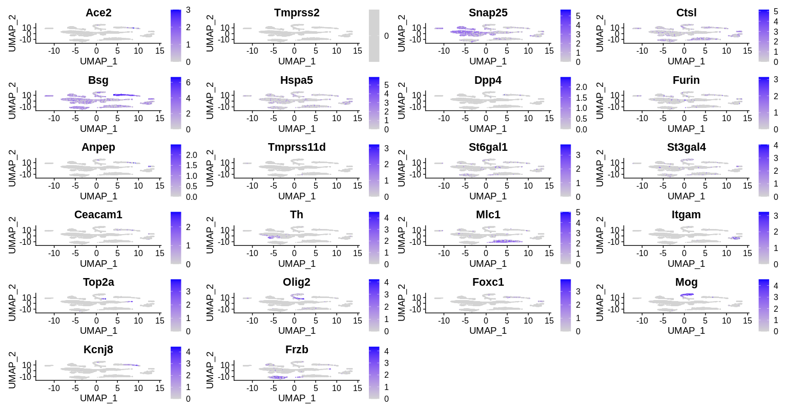

The Figure 3 UMAP visualization of the mouse olfactory bulb cells cluster showing expression of Cov2 and Cov entry genes (Ace2, Tmprss2, Ctsl, Bsg, Hspa5, Dpp4, Furin, Anpep, Tmprss11d, St6gal1, St3gal4) and vascular cells genes (all the others).

This last figure show us how the Sars-CoV2 is able to be expressed also in the cells of the olfactory bulb, expecially with the gene of Ctsl. Also genes of CoV are expressed with an higher level in this OB cells.

Conclusion
The identification of non neuronal cell types in the OE and bulb susceptible to Cov2 infection suggests three possible mechanism for the loss of smell/odors reported in Covid19 patients.
1 - local infection of support cells and vascular pericytes in the nose and bulb could cause significant inflammatory responses whose downstream effects could alter the function of OSNs or bulb neurons.
2 - damage to support cells (which are responsible for local water balance and ionic balance) could indirectly influence signaling from OSNs to the brain; our finding that a subset of microvillar cells are homologues of pulmonary ionocytes — which play a key role in maintaining extracellular chloride gradients in the lung — is consistent with this model.
3 - damage to sustentacular cells and Bowman’s gland cells in mouse models leads to diffuse architectural damage to the entire OE, which could abrogate smell perception.

