Terraform-Jenkins Assesment -

Added webhook for jenkins –

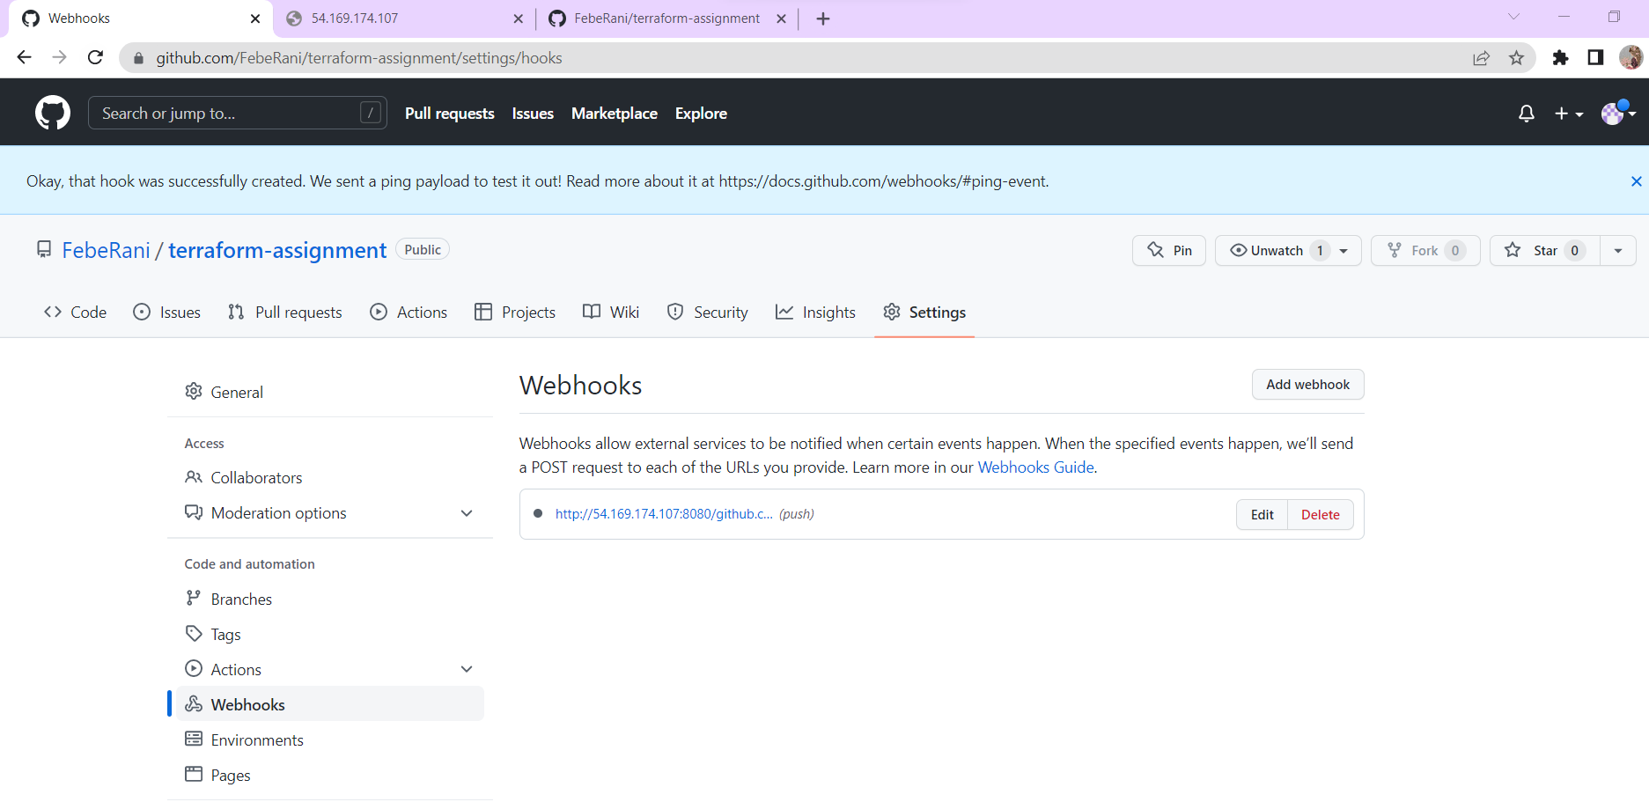

Jenkins job building

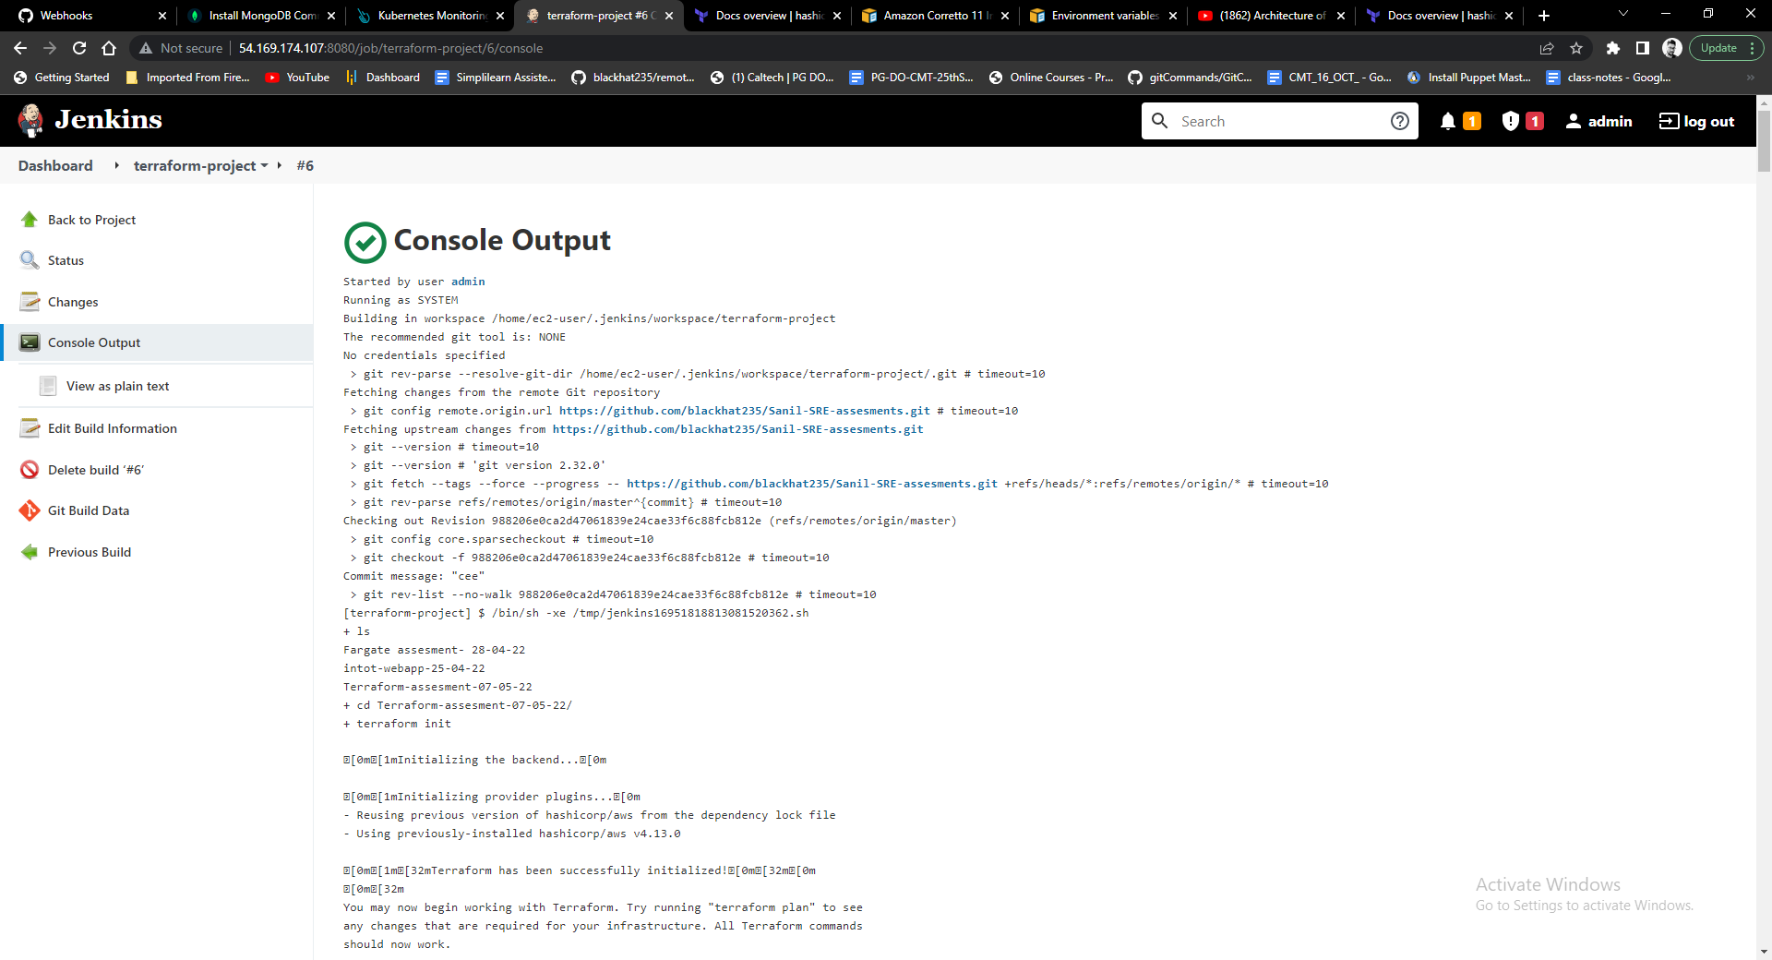

* Jenkins metrics exposed using promethus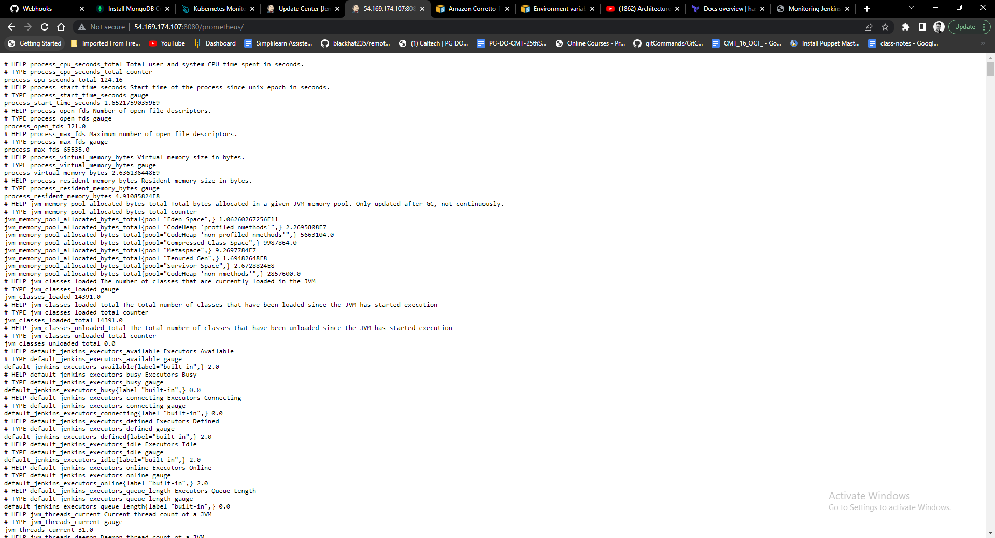



* Install Prometheus, Grafana

using prometheus read jenkins metrics

and create visualization for some important metrics using grafana

