**GoParkWalk**

**Software Design Document**

Contents

**Introduction** 1

Project Aims 1

Investigation 1

Stakeholders 2

**Proposed Solution – Summary** 2

**Requirements** 3

Non-functional Requirements: 3

**Using the Proposed Solution** 3

Activity Diagram 5

**Implementing the Proposed Solution** 6

**Conclusion** 6

# **Introduction**

## Project Aims

* Allows students to leave their homes and socialise whilst they are getting some exercise.
* Students will only be able to use the program if they are vaccinated.
* Will make sure that the students’ data is not being collected when they don’t want it to.
* Will somehow alert the user when other students are nearby.
* Will use a multitude of features to bring the two users together so that they can converse.
* Allow the user to see information about the other user before they meet.
* Will have necessary steps implemented to keep both parties safe from the virus.
* Geolocational data can be used by universities to see the social interaction between students.

The most crucial goal for the program is to allow for social interaction between students in a safe manner. This program is designed to be used during a pandemic in which students have felt a lack of social interaction and have become isolated. Therefore, we should focus on rekindling social interaction with one another. The lack of social interaction has led to negative effects on the mental wellbeing of students and is therefore a vital point. At the same time, however, we must consider the safety concerns and should design a program that will allow this vital social interaction, whilst keeping all parties safe, and following the government guidelines.

## Investigation

Online research and observation played a major part in determining the necessary requirements of my program. From my research, I was able to delve into the government guidelines, comprehend their rules, and then accurately design a program that would adhere to these rules and keep the users safe. By going out to local parks, I was able to observe people and how they were interacting. I noticed that most people were either conversing in groups or were on their phones. This influenced my requirements, as I decided that we would allow for the program to work in the background, and continuously search for other users. Interviews also played a crucial role, as they meant I was able to understand how users were feeling, and what specific features would be good to include within the program. A suggestion that came up multiple times was a way to communicate via text, which would result in users finding fellow users more quickly, rather than solely relying on the GPS.

## Stakeholders

Those who will primarily benefit from the new system:

Students - Upon implementing the program, students will be the ones making use of the app. We are providing them a way to continue with their social lives, whilst simultaneously implementing measures that will ensure that they keep themselves and others safe. Students will be interested in this as, during the pandemic, people have been made to stay at home, resulting in negative impacts on both their social lives and mental health. Through this app, they can safely go out and socialise, and, as an added benefit, they can also get some exercise.

Universities - Universities would have access to the geolocational data of all their students who make use of the program. From this, they would be able to identify the students who are less sociably active, and so may be struggling. Then, if necessary, the university will have the means to provide them with help in regard to this. It would encourage the students to go out to exercise and socialise, which would then benefit the university, as it would bring the students in the same course closer together. It would also positively impact the overall mental wellbeing of the students, thus meaning they would work harder and more effectively.

# **Proposed Solution – Summary**

My solution to this program is:

* Allow students who have an NHS COVID Pass to login to use the program.
* The program will allow the user to turn the location tracking features on or off.
* The program will be running in the background whilst the user utilises other applications.
* The program will send a notification to the user when it has located another student nearby who studies the same course.
* The program will then check, using facial recognition, if the user is wearing a face mask.
* The program will allow the user to view the other users Instagram account, so that they can see who they will be meeting beforehand.
* The program will also allow the user to message the other user meaning they can find each other faster.
* The program will make use of GPS and Bluetooth to direct the user towards the other user.
* The program will make sure using GPS and Bluetooth that, once both users have met, then they will keep at least 2-meters apart.

To make use of the program, the user will have to have a mobile device that has a front facing camera to allow facial recognition to take place. The user will need to have GPS and Bluetooth turned on so that the device can track their position and will need to have access to the user’s Instagram account so that other users can see them ahead of time. They will also need to abide by the rules such as wearing a face mask and keeping 2-meters away.

The program will be interfacing with the NHS COVID Pass database so that it can confirm that the students using the program are vaccinated, thus keeping everyone safe. It will also need to interface with university systems so that it can send the geolocational data to universities. Also, it will need access to Instagram accounts so that users can see ahead of time who they are meeting. Instagram stood out among other social media platforms, as the purpose of Instagram is to have a feed of content about the user available for others to look at all the time, whereas other platforms the media is only available for a limited time e.g., Snapchat.

# **Requirements**

The use case diagram on the left shows the functionalities of the program. The student can login to the program if they are vaccinated, can turn the features on/off, check if the user is wearing a face mask, can message the other user, check the location of the other user, can check the users remain 2-meters apart and can access the other users Instagram account.

## Non-functional Requirements:

* Security – Information must be protected. The personal details of the users must be protected as well as the geolocational data. This is to prevent malicious users from gaining access to this. To protect access login details are needed to use the program.
* Usability – Should be simple and easy to understand and use. Any student should be able to understand how to use the program.
* Performance – Should be able to handle many users making use of the program at the same time.
* Maintainability – The system must be able to be maintained cost-effectively over the expected lifetime of the program.
* Feasibility – Should be able to complete the project in the given budget and given time.
* Reliability – The system should be operational most of the time and any downtime should be kept to a minimum.

# **Using the Proposed Solution**

|  |
| --- |
| Logging in |
| David is a student who wants to make use of the ‘GoParkWalk’ app. He opens the app and is greeted by the login page.  If he then enters the correct login details, then it will sign him into his profile.  If the details he enters are incorrect then it will provide him with an error and then redirect him to the login page. |

|  |
| --- |
| Turning on/off features |
| David is a student who wants to make use of the ‘GoParkWalk’ app. He has successfully logged into his profile, and now is given the option to turn on the features so he can find students or turn it off.  If he chooses to turn the features on, then the program will make his location available to other devices that are also making use of the app, and his device will start searching for other users that are nearby, and send a notification when another user is detected.  If he chooses to turn the features off, then his location will no longer be made available to other devices, and his device will stop searching for other users that are nearby.  The system can always be turned on or off, meaning that if the user does not want to meet new people, then they can do so. |

|  |
| --- |
| Verifying Face Mask |
| David is a student who is making use of the ‘GoParkWalk’ program. He has turned on the features which means he is looking to meet new students. He has been alerted that there is a student nearby and a camera screen has popped up on the program, checking if he is wearing a mask.  If he is wearing a mask, then the program will allow him to use other features of the program, and will direct him in the correct route.  If he is not wearing a mask, then the program will alert him to wear one, and will not proceed to give him the location of the other user until it recognizes he is wearing a mask.  The program will always check that the user is wearing a mask before it gives the location of the other user. This is so that both parties remain safe from the virus.  After David has been confirmed wearing the mask, the program will redirect him to a list of options, allowing him to access the map, the messaging feature or access their Instagram. |

|  |
| --- |
| Message Other User |
| David is a student who has been confirmed wearing a face mask and has been given the options to look at the other user’s social media, look at the map or message the other user.  If he then chooses the messaging feature, then he can converse with the other user and locate their precise position.  If he decides not to look at the map for now, then he can choose another option available on the page.  After David has chosen the messaging feature, he can always choose to go back and look at the other features. |

|  |
| --- |
| Locate Other User |
| David is a student who has been confirmed wearing a face mask and has given the options to look at the other user’s social media, look at the map or message the other user.  If he chooses to use the map feature, then he will be able to see the location of the other user, and then walk in that direction.  If he decides not to look at the map for now, then he can choose another option available on the page.  After David has chosen the map feature, he can always choose to go back and look at the other features. |

|  |
| --- |
| Access Instagram Profile |
| David is a student who has been confirmed wearing a face mask and has given the options to look at the other user’s social media, look at the map or message the other user.  If he chooses to look at their Instagram profile, then they will be redirected to the other users feed, where they can look through the posts.  If he decides not to look at the Instagram profile, then he can choose another option available on the page.  After David has finished looking at the Instagram profile, he can go back and look at the other features. |

|  |
| --- |
| Check User is 2 meters apart |
| David is a student who has met up with the other user. They are now conversing.  If he gets within a 2-meter distance of the user, then an alert will be sent to both their phones, telling them that they are too close, and that they should move back.  If he does not get within a 2-meter distance, then no alerts will be sent to the users, and they will be allowed to freely carry on their conversation without any interruption.  The program will always be checking if the user is further than 2-meters from the other user.  After the user has finished with their conversation, they can end the conversation on the program and look for other users if they want to. |

## Activity Diagram

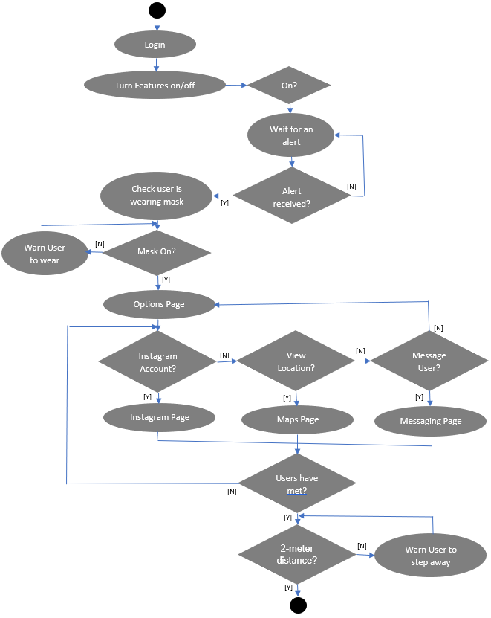

[Y]

[N]

**Implementing the Proposed Solution**

In terms of the hardware needed, we need mobile devices that can make use of Bluetooth and GPS to track location, and a front facing camera of good quality, so that we are able to use facial recognition. We will need to develop a brand-new app that implements all the required features, and we will then need to interface this application with Instagram, and the NHS COVID Pass. We will be storing all the data we received from the app and data we need on a cloud-based server which will connect to our mobile devices. The non-functional requirements will be tested by stakeholders to make sure that it does work exactly how it should work.

# **Conclusion**

Legal issues with our project include the success of our protection of geolocational data that we gather from the students using the program. To combat this, we will make sure that the data is well protected and encrypted, so that those who should not have access to it will not be able to get a hold of this data. Ethical issues include whether it is right allowing our technology to track where users go, who they are meeting, etc. To get around this issue, we have implemented a feature that lets the user choose when this data will be recorded and when it will not. Sociological issues include fears surrounding that, by promoting an application of this type during a pandemic, there would be major effects on the number of COVID cases. To make sure that we are all safe, we have implemented features that will make sure that the students abide by government regulations.

My proposal follows good software engineering principles. I have managed to achieve this by creating a simple, easy to use program that can be used by anyone. By keeping it simple, I can abide by the budget constraints, as well as the time constraints. Although the program was designed to be simple, we have not made sacrifices on the main purpose of the program, and, with the functionality we have made available, we have devised a solution that works. We have also considered feedback from out stakeholders often, so that we can shape the program into something that they, as a user, are happy with and would like to make use of.

Although I am happy with the proposed solution, I have recognised that there are some issues that have yet to be addressed. This includes how the program would work in areas where GPS is weak, as well as with the current technology with GPS and Bluetooth. As there are still margins for error when guiding a person, we cannot be sure that the GPS and Bluetooth will work 100% of the time accurately to bring together the 2 users.