ASSIGNMENT 2

CLOUD COMPUTING

Submitted to, Submitted by,

Grace Miss Febin Vinod

INTMCA S9

Roll no 25

**What is Cloud Computing**

Cloud computing is a revolutionary paradigm in information technology that allows individuals and organizations to access and utilize a vast array of computing resources and services over the internet. It replaces the traditional model of owning and managing physical hardware and software with a more flexible and scalable approach.. It is a technology that uses remote servers on the internet to store, manage, and access data online rather than local drives. The data can be anything such as files, images, documents, audio, video, and more.

There are the following operations that we can do using cloud computing:

* Developing new applications and services
* Storage, back up, and recovery of data
* Hosting blogs and websites
* Delivery of software on demand
* Analysis of data
* Streaming videos and audios

**Cloud Computing Architecture**

As we know, cloud computing technology is used by both small and large organizations to store the information in cloud and access it from anywhere at anytime using the internet connection.

Cloud computing architecture is a combination of service-oriented architecture and event-driven architecture.

Cloud computing architecture is divided into the following two parts –

1. Front End
2. Back End

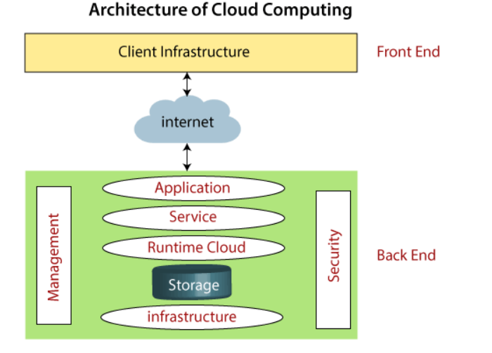

**Front End**

The front end is used by the client. It contains client-side interfaces and applications that are required to access the cloud computing platforms. The front end includes web servers (including Chrome, Firefox, internet explorer, etc.), thin & fat clients, tablets, and mobile devices.

**Back End**

The back end is used by the service provider. It manages all the resources that are required to provide cloud computing services. It includes a huge amount of data storage, security mechanism, virtual machines, deploying models, servers, traffic control mechanisms, etc.

**Types of Cloud**

Cloud computing is a revolutionary technology transforming how we store, access, and process data. It simply refers to delivering computing resources, such as servers, storage, databases, software, and applications, over the Internet. Cloud computing uses a network of remote computer systems housed on the net to save and process data rather than relying on physical infrastructure.

**Public Cloud:** Public cloud services are available to anyone over the internet. These services are owned and operated by third-party providers, making them cost-effective and scalable. Examples include AWS, Azure, and Google Cloud.

**Private Cloud:** Private cloud infrastructure is dedicated to a single organization and is often hosted on-premises. It provides more control and security but can be costlier to set up and maintain.

**Hybrid Cloud:** Hybrid cloud combines both public and private cloud resources, allowing data and applications to move seamlessly between them. It provides flexibility and is suitable for organizations with varying workload requirements.

**Cloud Service Models**

There are the following three types of cloud service models -

Infrastructure as a Service (IaaS)

Platform as a Service (PaaS)

Software as a Service (SaaS)

**IaaS** is also known as Hardware as a Service (HaaS). It is a computing infrastructure managed over the internet. The main advantage of using IaaS is that it helps users to avoid the cost and complexity of purchasing and managing the physical servers.

**PaaS** cloud computing platform is created for the programmer to develop, test, run, and manage the applications.

**SaaS** is also known as "on-demand software". It is a software in which the applications are hosted by a cloud service provider. Users can access these applications with the help of internet connection and web browser.

**Benefits of Cloud Computing**

1. **Scalability:** Cloud resources can be easily scaled up or down to meet changing demands, making it cost-efficient and adaptable.
2. **Cost-Efficiency:** Users pay for only the resources they consume, eliminating the need for large upfront capital investments in hardware.
3. **Flexibility:** Cloud services are accessible from anywhere with an internet connection, enabling remote work and collaboration.
4. **Reliability:** Leading cloud providers offer robust infrastructure with high availability and redundancy, reducing the risk of downtime.
5. **Security:** Cloud providers invest heavily in security measures, often surpassing what individual organizations can implement.

