   

**Advanced Diploma in I.T, Networking & Cloud Computing.**

**PROGRESSIVE PROJECT REPORT**

**CORONA VACCINE MANAGEMENT SYSTEM**

**Submitted by:- FEBI.S.RAJ**

**Under the guidance of:- Poovaragavan**

**Directorate General of Training**

**ADVANCED TRAINING INSTITUTE**

**Trivandrum.**



**1.ABSTRACT:-**

*Teleconferencing or Chatting, is a method of using technology to bring people and ideas together despite of the geographical barri- ers. The technology has been available for years but the acceptance it was quit recent. Our project is an example of a chat server. It is made up of 2 applications the client application, which runs on the users Android Device and server application, which runs on any Android Device on the network. To start chatting client should get connected to server where they can do private and group chat security measures were taken during the last one.*

**2. INTRODUCTION**

*Communication is a mean for people to exchange messages. It has started since the beginning of human creation. Distant communication began as early as 1800 century with the introduction of television, telegraph and then telephony. Interestingly enough, telephone communication stands out as the fastest growing technology, from ﬁxed line to mobile wireless, from voice call to data transfer. The emergence of computer network and telecommunication technologies bears the same objective that is to allow people to communicate. All this while, much eﬀorts has been drawn towards consolidating the device into one and therefore indiscriminate the services. Chatting is a method of using technology to bring people and ideas together despite of the geograph- ical barriers. The technology has been available for years but the acceptance it was quit recent. Our project is an example of a chat server. It is made up of applications the client application which runs on the users mobile and server application which runs on any pc on the network. To start chatting our client should get connected to server where they can do Group and private chatting. 1.1 Problem Statement This project is to create a chat application with a server and users to enable the users to chat with each others. To develop an instant messaging solution to enable users to seamlessly com- municate with each other. The project should be very easy to use enabling even a novice person to use it. 1.2 Project Scheduling This document provides a scalable scheduling tool and associated schedule development, analysis, and monitoring methods that can be used by Imple- menting Agencies (IA) to prepare, monitor, and report project schedules. Our Project is not that complex so we will not use very complex scheduling method*

**7.SYSTEM REQUIREMENT:-**

* **HARDWARE REQUIREMENTS:-**
* Processor : Pentium-III (or) Higher
* Ram : 2GB/4GB/8GB (OR) Higher
* Hard disk: 500GB/1TB
* **SOFTWARE REQUIREMENTS:-**
* Operating system: windows 7/10
* Node.js, javascript,
* **SCREENSHOTS**

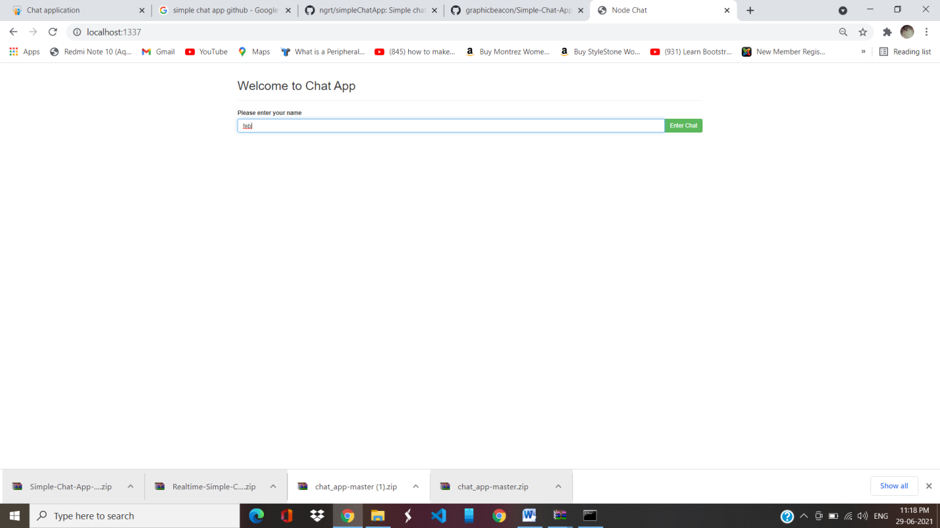

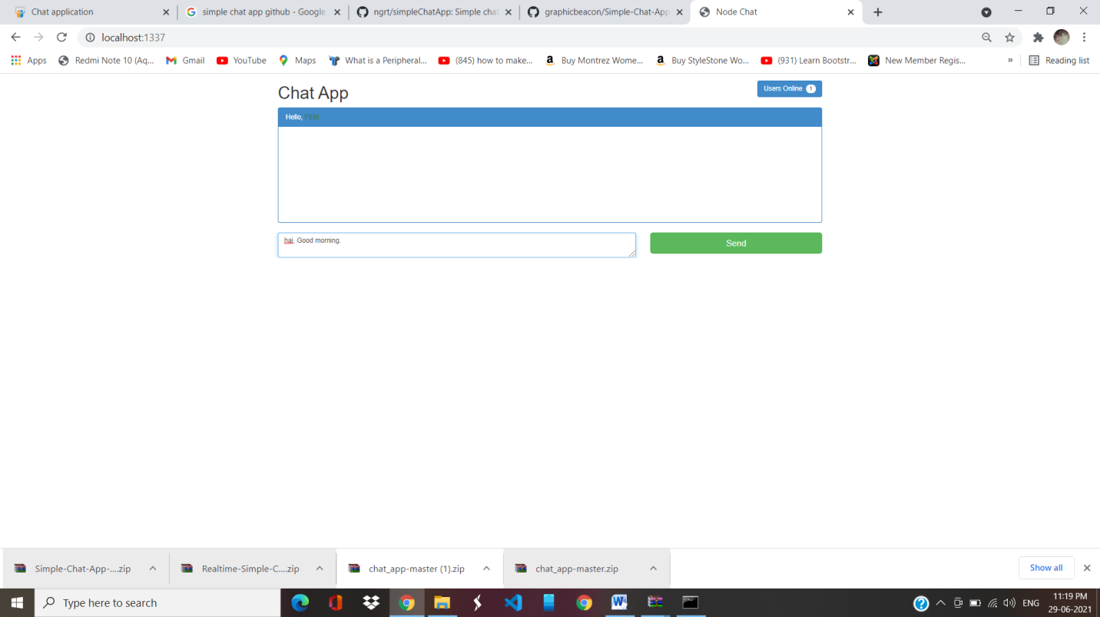

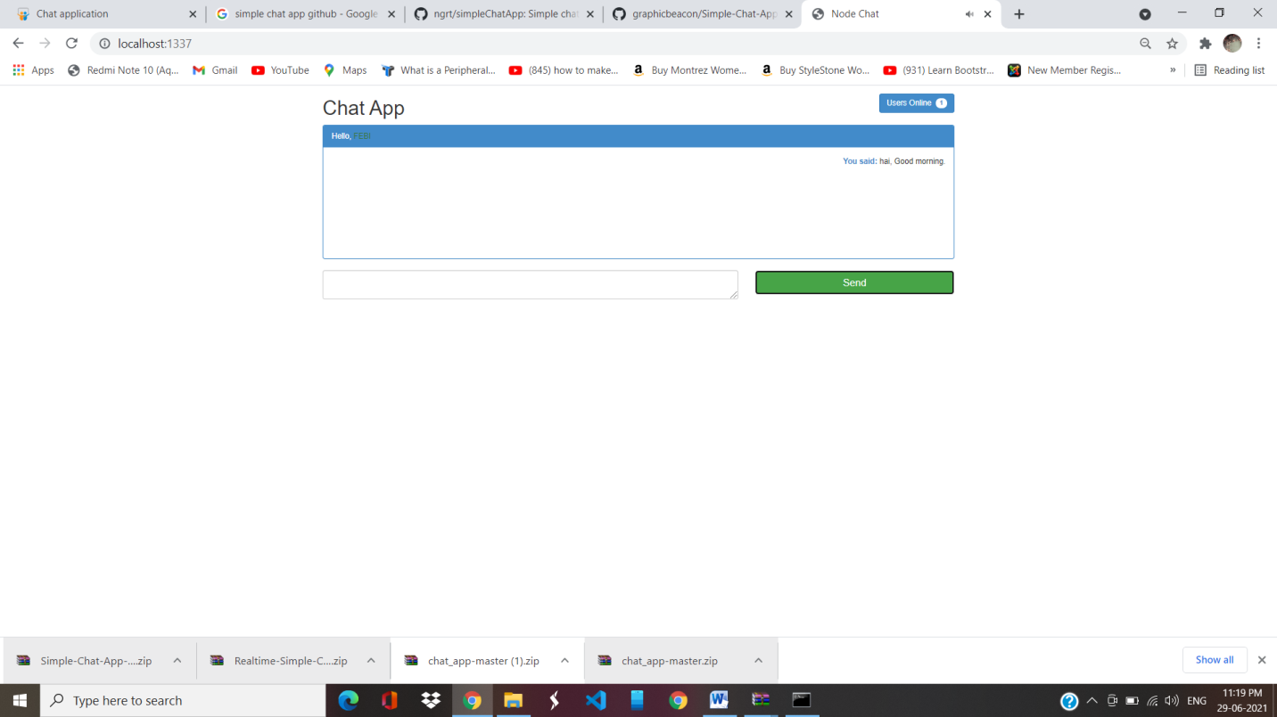

Thank you