   

**Advanced Diploma in I.T, Networking & Cloud Computing.**

**PROGRESSIVE PROJECT REPORT**

**CORONA VACCINE MANAGEMENT SYSTEM**

**Submitted by:- FEBI.S.RAJ**

**Under the guidance of:- Poovaragavan**

**Directorate General of Training**

**ADVANCED TRAINING INSTITUTE**

**Trivandrum.**



**INDEX**

|  |  |  |
| --- | --- | --- |
| **S.NO.** | **CONTENT OF THE PAGE** | **Page**  **no** |
| **1** | **ABSTRACT.** |  |
| **2** | **INTRODUCTION.** |  |
| **3** | **SYSTEM ANALYSIS.** |  |
| **4** | **FEASIBILITY**   * **TECHNICAL FEASIBILITY** |  |
| **5** | **SOFTWARE DEVELOPMENT ENVIRONMENT** |  |
| **6** | **SYSTEM DESIGN**   * **DATA FLOW DIAGRAM** * **ER DIAGRAM** |  |
| **7** | **SYSTEM REQUIREMENT**   * **SOFTWARE SPEACIFICATION** * **HARDWARE SPECIFICATION** |  |
| **8** | **TESTING** |  |
| **9** | **FUTURE ENHANCEMENT** |  |
| **10** | **APPENDICES**   * **SOUCE CODE**   **SCREEN SHOTS** |  |
| **11** | **CONCLUTION** |  |
|  |  |  |

**1.ABSTRACT:-**

The number of severe acute respiratory syndrome coronavirus 2 (SARS-CoV-2)-infected patients keeps rising in most of the European countries despite the pandemic precaution measures. The current antiviral and anti-inflammatory therapeutic approaches are only supportive, have limited efficacy, and the prevention in reducing the transmission of SARS-CoV-2 virus is the best hope for public health. It is presumed that an effective vaccination against SARS-CoV-2 infection could mobilize the innate and adaptive immune responses and provide a protection against severe forms of coronavirus disease 2019 (COVID-19) disease. As the race for the effective and safe vaccine has begun, different strategies were introduced. To date, viral vector-based vaccines, genetic vaccines, attenuated vaccines, and protein-based vaccines are the major vaccine types tested in the clinical trials. Over 80 clinical trials have been initiated; however, only 18 vaccines have reached the clinical phase II/III or III, and 4 vaccine candidates are under consideration or have been approved for the use so far. In addition, the protective effect of the off-target vaccines, such as *Bacillus* Calmette-Guérin and measles vaccine, is being explored in randomized prospective clinical trials with SARS-CoV-2-infected patients. In this review, we discuss the most promising anti-COVID-19 vaccine clinical trials and different vaccination strategies in order to provide more clarity into the ongoing clinical trials.

**2. INTRODUCTION**

Public opinion is mixed on the safety and efficacy of any vaccine, and misinformation has a direct impact on vaccine coverage. Achieving high vaccination rates requires a robust and transparent public education campaign that provides accurate vaccine information, progress on the distribution plan, and guidance needed to access a vaccination. A key aspect of any campaign is a web destination that helps the public access this important information, ask questions, and request assistance. Coronavirus Vaccine Outreach is typically implemented by health and human services agencies that want to take a transparent and equitable approach, clearly communicate vaccination plans, and increase public confidence. The Coronavirus Vaccine Outreach solution delivers a set of capabilities that help you to launch a vaccine distribution web destination, provide the public critical information that helps them understand when, and where, they can be vaccinated, and engage medical volunteers that may be needed to support widespread administration of the vaccine.

**3. SYSTEM ANALYSIS.**

System analysis is the process of gathering and interpreting facts, diagnosing problems and using the information to recommend improvements on the system. System analysis is a problem solving activity that requires intensive communication between the system users and system developers. System analysis or study is an important phase of any system development process. The system is viewed as a whole, the inputs are identified and the system is subjected to close study to identify the problem areas. The solutions are given as a proposal. The proposal is reviewed on user request and suitable changes are made. This loop ends as soon as the user is satisfied with the proposal.

**4.FEASIBILITY:-**

Feasibility is an important phase in the software development process it enables the developers to have an assessment of the product being developed. It refers to the feasibility study of the product in the terms of outcomes of the product, operational required for implemented thing it. Feasibility study should be performed on the basis of various criteria and parameters. The various feasibility studies are:

* **TECHNICAL FEASIBILITY:-**

A technical feasibility study assesses the details of how you intend to deliver a product or service to customers. Think materials, labor, transportation, where your business will be located, and the technology that will be necessary to bring all this together. It’s the logistical or tactical plan of how your business will produce, store deliver and track its product or service.

**DATA FLOW DIAGRAM**

A Data Flow Diagram (DFD) is a structured analysis and design tool that can be used for flowcharting. A DFD is a network that describes the flow of data and the processes that change or transform the data throughout a system. This network is constructed by using a set of symbols that do not imply any physical implementation.

**USER**

**REGISTRATION DB**

**LOGIN PAGE**

**SUCCESSFUL**

**ER DIAGRAM**

Registration

Vaccine Details

Need Status

user

Family Details

Has

Hasas

**7.SYSTEM REQUIREMENT:-**

* **HARDWARE REQUIREMENTS:-**
* Processor : Pentium-III (or) Higher
* Ram : 2GB/4GB/8GB (OR) Higher
* Hard disk: 500GB/1TB
* **SOFTWARE REQUIREMENTS:-**
* Operating system: windows 7/10
* Server side: PHP
* Client side: HTML, Boostrap, css.
* Database : MYSQL,SQL
* **User Module**
* **Registration**

A new user will have to register in the system by providing essential details in order to view the products in the system. The admin must accept a new user by unblocking him.

* **Login**

A user must login with his user name and password to the system after registration.

* **Source code**

**Login**

<!DOCTYPE html>

<html>

<head>

<title>Login page</title>

<link rel="stylesheet" href="log1.css">

</head>

<body>

<h1 class="reg">REGISTRATION</h1>

<h1 class="win">Winning Over Covid</h1>

<h1 class="wel">Welcome!</h1>

<p class="vacc">Vaccine & Verifier</p>

<form action="log1.php" method="post">

<label for="uname"><b>Mobile Number</b></label>

<input type="text" placeholder="Enter Number" name="uname" required>

<label for="psw"><b>Password</b></label>

<input type="password" placeholder="Enter Password" name="psw" required>

<p><a class="add" href="reg.php">Login</a></p>

</div>

<span class="psw">Forgot <a href="#">password?</a></span>

</div>

</form>

</body>

</html>

**Registration**

<?php

$ID = $name = $address = $mob = $email = $comment = $gender = "";

if ($_SERVER["REQUEST_METHOD"] == "POST") {

$ID = test_input($_POST["ID"]);

$name = test_input($_POST["name"]);

$comment = test_input($_POST["comment"]);

$mob = test_input($_POST["mob"]);

$email = test_input($_POST["email"]);

$gender = test_input($_POST["gender"]);

}

function test_input($data) {

$data = trim($data);

$data = stripslashes($data);

$data = htmlspecialchars($data);

return $data;

}

?>

<html>

<Link rel="stylesheet" href="reg.css">

<h2 class="regi">PHP Form Validation Example</h2>

<form method="post" action="<?php echo htmlspecialchars($_SERVER["PHP_SELF"]);?>">

<p class="id">ID:</p> <input class="id1" type="number" name="ID"><br><br>

<p class="name">Name:</p><input class="name1" type="text" name="name"><br><br>

<p class="add">Address:</p> <textarea class="add1" name="comment" rows="5" cols="40"></textarea><br><br>

<p class="mob">Mobilenumber:</p> <input class="mob1" type="number" name="mob"><br><br>

<p class="email">E-mail:</p> <input class="email1" type="text" name="email"><br><br>

<br><br>

<p class="gen">Gender:</p>

<input class="fem1" type="radio" name="gender" value="female"><p class="fem">Female</p> <br><br>

<input class="male1" type="radio" name="gender" value="male"><p class="male">Male</p> <br><br>

<input class="other1" type="radio" name="gender" value="other"><p class="other">Other</p> <br><br>

<br><br>

<input class="sub" type="submit" name="submit" value="Submit">

</form>

</html>

<?php

echo "<h2>Your Input:</h2>";

echo $ID;

echo "<br>";

echo $name;

echo "<br>";

echo $comment;

echo "<br>";

echo $mob;

echo "<br>";

echo $email;

echo "<br>";

echo $gender;

?>

* **SCREENSHOTS**

**Login page**

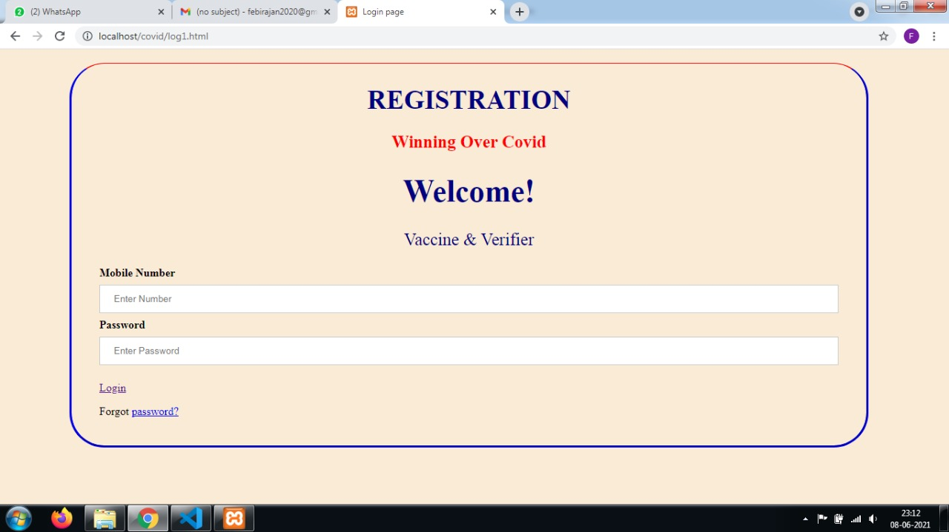

**Registration Page**

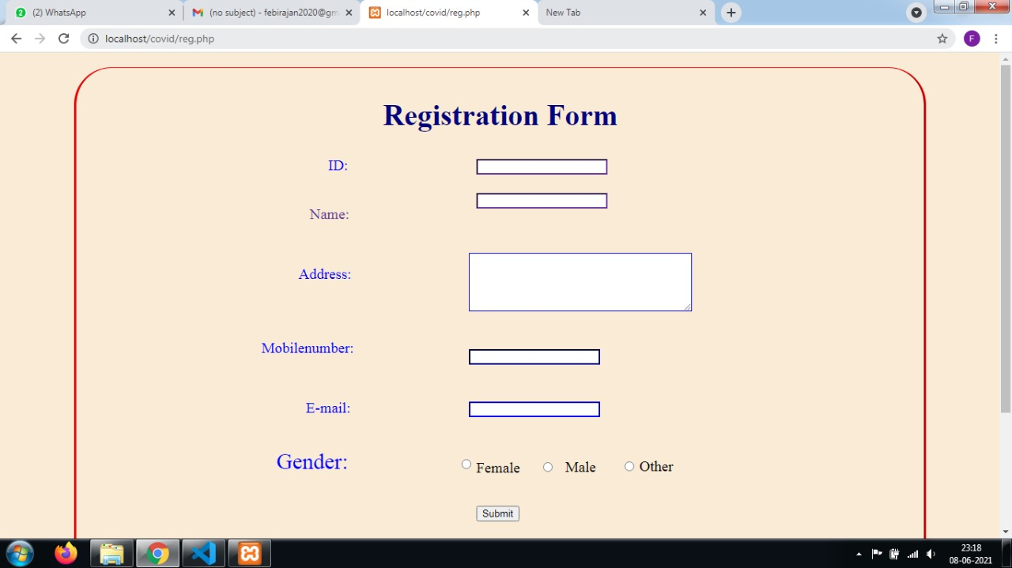

**CONCLUTION**

[Vaccine management](https://www.cronj.com/vaccine-management.html) is going to be the new normal. Since, with all the efficiency it provides it will be adapted with a lightning speed! Furthermore, it will help in increasing the recovery rates, making an automated effort to do the society some exceptional good.CronJ IT extends a hand in developing a smoother path for this new journey. Our management[solutions](https://www.cronj.com/portfolio.html) have been well appreciated by our clients.People dreaded stepping out during the pandemic. They used to check the news for checking the affected and recovery rates. So, we built a COVID-19 tracker for providing information and creating awareness.