Makefile Usage

Revision History
Revision | Date | Author | Changes
20080522 | 2008/05/22 | Chris Hsu | - Add source code robustness checking tool (Splint) document.

Index
Revision History 1
Index 2
Necessary Tools 3
Makefile Tree 4
MakeCommon Content 5
Makefile Help 6
MakeOption.txt 7
Makefile for Project 9
MakeConfig.txt for Project 11
Makefile for each Module 12
Makefile for each Class 14
Makefile Commands 15
Log Files for Warning/Error Messages 16
Dependency Files 17
Robustness Checking 18
Limitation 19
Troubleshooting 21

Necessary Tools
．ARM ADS 1.2
You have to install ARM ADS 1.2 first for the ARM compiler, linker, libraries and environment variables (ARMCONF and ARMINC).

．GNU make
Please go to GNU web site (http://www.gnu.org/software/make/) to download the free GNU maker. Then build it for Win32 (see README.W32) to get the maker execution file.

．Cygwin
Please visit Cygwin web site (http://cygwin.com/) to download the Cygwin setup file and install it. After that, please copy the GNU maker to the “bin” directory of Cygwin, and add this directory to the PATH environment variable.

．arm-gcc.exe and cc1.exe
Please visit GNU RAM web site (http://gnuarm.org) to download the tool. These are used for dependency files generating. Please rename gcc.exe to arm-gcc.exe and also put them in the Cygwin\bin directory.

．Splint
Please visit Splint web site (http://www.splint.org/win32.html) to download the Splint Win32 setup file and install it. This tool is optional and for source code robustness checking only.

．DOS command shell

．Novatek NMake package
NMake package (NMake-yyyymmdd.exe) includes GNU make, Cygwin, arm-gcc.exe, cc1.exe and Splint.

Makefile Tree
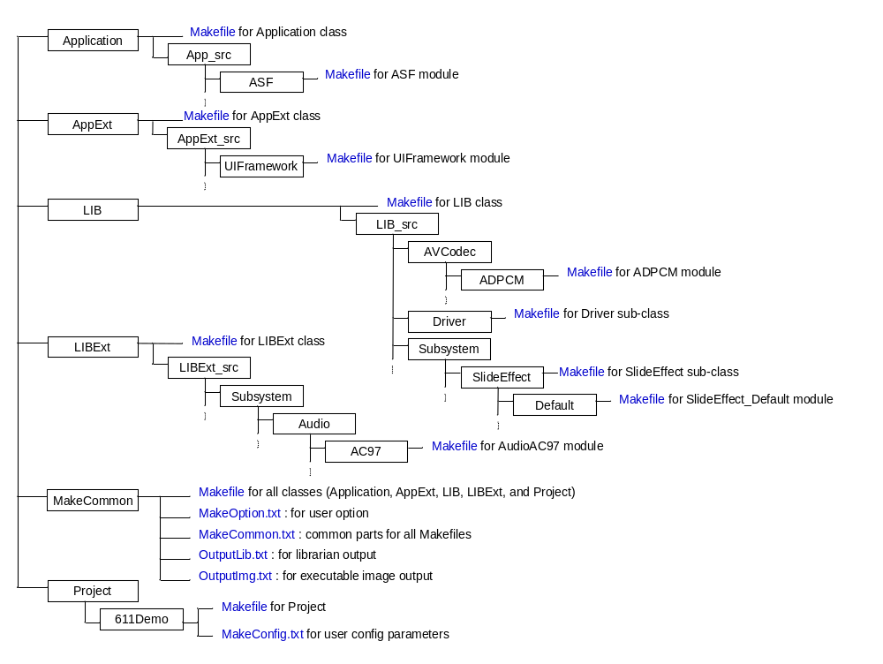

MakeCommon Content
．Makefile
The Makefile for all classes (Application, AppExt, LIB, LIBExt) and Project. It will call the Makefiles under each class and search the first Makefile under Project directory for project. You should modify this file if you wanted to add/delete classes.

．MakeOption.txt
This is the make option for user to select. It includes saving the warning / error message to file or not, …etc.

．MakeCommon.txt
This is the common parts of all Makefiles. It includes basic C and ASM flags, compiler rules, and so on. It doesn’t need to modify this file normally.

．OutputLib.txt
This file is used to output librarian. It doesn’t need to modify this file normally.

．OutputImg.txt
This file is used to output executable image. It doesn’t need to modify this file normally.

Makefile Help
Please visit GNU Make manual on-line help for more detailed information http://www.gnu.org/software/make/manual/make.html

．Split long line
You can split one long line into multiple short lines using backslash-newline. This is like using one long line, but is easier to read. For example:
SRC = \
ASFDecTsk.c \
ASFEncTsk.c \
AudioDecTsk.c
is equivalent to
SRC = ASFDecTsk.c ASFEncTsk.c AudioDecTsk.c

．Comments in Makefile
‘#’ in a line of a Makefile starts a comment. It and the rest of the line are ignored, except that a trailing backslash not escaped by another backslash will continue the comment across multiple lines. A line containing just a comment (with perhaps spaces before it) is effectively blank, and is ignored. If you want a literal #, escape it with a backslash (e.g., \#). Comments may appear on any line in the Makefile, although they are treated specially in certain situations.

Within a command script (if the line begins with a TAB character) the entire line is passed to the shell, just as with any other line that begins with a TAB. The shell decides how to interpret the text: whether or not this is a comment is up to the shell.

Within a define directive, comments are not ignored during the definition of the variable, but rather kept intact in the value of the variable. When the variable is expanded they will either be treated as make comments or as command script text, depending on the context in which the variable is evaluated.

MakeOption.txt
．LOG_ERR
Log compiler, linker error and warning message to file or not.

ON: Log message to file. [Default]
OFF: Output message to stdout (console).

．CLEAN_LOG
Delete log file or not when you type “make”.

ON: Delete log file when you type “make”. [Default]
OFF: Don’t delete log file when you type “make”, you should type “make clean” to delete the log file.

．KEEP_GOING
Keep going or not when some targets can't be made.

ON: Keep going when some targets can’t be made.
OFF: Stop when some targets can’t be made. [Default]

．ISOLATE_DEP
Isolate creating dependency files process.

ON: You have to run "make dep" to create dependency files. [Default]
OFF: Dependency file will be created when making the file.

．RELEASE_SYMBOL
Generate debug symbol in release target.

ON: Generate debug symbol in release target.
OFF: Don't generate debug symbol in release target. [Default]

．COPY_BIN_2_STG
Copy bin file to storage after bin file is created. You have to set an environment variable named “NVT_STG_PATH" (without quote) to work with this function. Example: set "NVT_STG_PATH" to "H:/" (without quote).

ON: Copy bin file to storage after bin file is created. [Default]
OFF: Don't copy bin file to storage after bin file is created.

SPLINT_PARAMETER
Parameters for source code robustness checking tool (Splint). Please don’t modify “export SPLINT_PARAMETER := -linelen 100 -warning-stream-stderr”. Only modify the lines after the line mentioned above in the following format “SPLINT_PARAMETER += XXX” to turn on / off the checking behavior.

Makefile for Project
The Makefile located in Project/DIRName directory is used to build the project.

．PRJ_NAME
Set the name of executable image file (.axf) and image map file (.txt). The difference between Debug and Release target is there will be a “_D” sign after PRJ_NAME for Debug target.

．SCATTER
Set the file name of scatter description file. Scatter description file will tell linker how to place the code in binary file.

．SRC
Set C source files list. These files will be built by C compiler. You can assign the list by the following format, the filename should contain related path to current directory.
SRC = \
CFile1.c \
CFile2.c \
DIR1/CFile3.c \
DIR1/CFile4.c \
DIR2/CFile5.c

．ASM
Set assembly source files list. These files will be built by assembler. You can assign the list by the following format, the filename should contain related path to current directory.
ASM = \
ASMFile1.s \
ASMFile2.s \
DIR1/ASMFile3.s \
DIR2/ASMFile4.s

．INC_DIR
Set include path list. Include path is used to search header files. Makefile will pass all sub-paths of the include path to C compiler or assembler, you only have to add the top path of include path to the list. Include path usually contains current project path and global include path. You can assign the list by the following format, the path should be related path to current directory.
INC_DIR = . \
../../Include

．IMG_BASE_DIR
Set the output library directory. Makefile will output object files (.o), dependency files (.d), ARM executable file (.axf), image map file (.txt) and binary file (.bin) to the directory. The directory should be related path to the current directory. IMG_BASE_DIR/Debug is for Debug target and IMG_BASE_DIR/Release is for Release target. You don’t have to modify this value normally (Keep it as “$(PRJ_NAME)_Data”).

．CFLAGS_D and CFLAGS_R
They are optional parameters for C compilert. CFLAGS_D is for Debug target and CFLAGS_R is for Release target. You can specify optional parameters such as “-OTime” to optimized code for time (Default is optimized for space) or any pre-defined values to the compiler. Please refer to ARM C compiler document for more detailed information about the parameters.

．GCCFLAGS
This is the optional parameters for GCC compiler (arm-gcc.exe). We will call GCC to create dependency file (.d). You should pass every pre-defined value that assign in CFLAGS_D or CFLAGS_R to GCC too.

．ASMFLAGS_D and ASMFLAGS_R
They are optional parameters for assembler. ASMFLAGS_D is for Debug target and ASMFLAGS_R is for Release target. You can specify optional parameters or any pre-defined values to the assembler. Please refer to ARM assembler document for more detailed information about the parameters.

．APP_BASE_DIR, APPEX_BASE_DIR, LIB_BASE_DIR and LIBEX_BASE_DIR
Set the Application, AppExt, LIB and LIBExt directory. The path should be related path to the current directory.

．MAKE_COMMON_DIR
Set the MakeCommon directory. The path should be related path to the current directory.

．include $(MAKE_COMMON_DIR)/OutputImg.txt
This statement must be presented in the end of Makefile.

MakeConfig.txt for Project
This file is used for user to configure some project related parameters, such as CHIP version, output binary file name, and selection of external device (LCD, SENSOR, LENS, AUDIO, and STORAGE).

．CHIP
What chip using in this project. The options are exclusive.

．BIN_NAME
Set the FW image binary file name.

．MULTI_REGIONS
Set this option to ON if the scatter description file contains more than 2 load regions. Otherwise, set this option to OFF.

．LCD
Select LCD panel (TV module is always included). The options are exclusive.

．SENSOR
Select sensor module. The options are exclusive.

．AUDIO
Select audio module. The options are exclusive.

．STORAGE
Select storage module. The options are exclusive.

Makefile for each Module
The Makefile located in each module’s source directory is used to build the module. For example, the Makefile in “Application/App_src/ASF” directory is used to build ASF module. All source code files should be placed in this directory too.

．PRJ_NAME
Set the output library name of the module. The output library name will be PRJ_NAME.a for Release target and PRJ_NAME_D.a for Debug target. For example, set PRJ_NAME to “AppASF” and you will get two library files named “AppASF.a” and “AppASF_D.a” in respective directory.

．SRC
Set C source files list of the module. These files will be built by C compiler. You can assign the list by the following format, the filename should contain related path to current directory.
SRC = \
CFile1.c \
CFile2.c \
DIR1/CFile3.c \
DIR1/CFile4.c \
DIR2/CFile5.c

．ASM
Set assembly source files list of the module. These files will be built by assembler. You can assign the list by the following format, the filename should contain related path to current directory.
ASM = \
ASMFile1.s \
ASMFile2.s \
DIR1/ASMFile3.s \
DIR2/ASMFile4.s

．INC_DIR
Set include path list of the module. Include path is used to search header files. Makefile will pass all sub-paths of the include path to C compiler or assembler, you only have to add the top path of include path to the list. Include path usually contains current project path and global include path. You can assign the list by the following format, the path should be related path to current directory.
INC_DIR = . \
../../../Include

．IMG_BASE_DIR
Set the output library directory of the module. The directory should be the root directory for each class (For example, Application, AppExt, etc…) and should be related path to the current directory. Makefile will output Debug target library to IMG_BASE_DIR/Debug and Release target library to IMG_BASE_DIR/Release.

．CFLAGS_D and CFLAGS_R
They are optional parameters for C compiler of the module. CFLAGS_D is for Debug target and CFLAGS_R is for Release target. You can specify optional parameters such as “-OTime” to optimized code for time (Default is optimized for space) or any pre-defined values to the compiler. Please refer to ARM C compiler document for more detailed information about the parameters.

．ASMFLAGS_D and ASMFLAGS_R
They are optional parameters for assembler of the module. ASMFLAGS_D is for Debug target and ASMFLAGS_R is for Release target. You can specify optional parameters or any pre-defined values to the assembler. Please refer to ARM assembler document for more detailed information about the parameters.

．MAKE_COMMON_DIR
Set the MakeCommon directory. The path should be related path to the current directory.

．include $(MAKE_COMMON_DIR)/OutputLib.txt
This statement must be presented in the end of Makefile.

All the object and dependency files will be placed in the PRJ_NAME_Data directory of current directory. For example, “AppASF_Data/Debug/ObjectCode” is the directory for .o and .d files of ASF library in Debug target and “AppASF_Data/Release/ObjectCode” is the directory for .o and .d files of ASF library in Release target.

Makefile for each Class
Located in the root directory of each class, the Makefile is used to build all the libraries of the class. You don’t need to add/delete the directory of each library, the Makefile will search them automatically. Currently there are 4 Makefiles for classes and 2 sub-class Makefiles for LIB class:
．Makefile in AppExt directory for AppExt class
．Makefile in Application directory for Application class
．Makefile in LIB directory for LIB class
．Makefile in SlideEffect directory for SlideEffect sub-class
．Makefile in Driver directory for Driver sub-class
．Makefile in LIBExt directory for LIBExt class

Usually, you don’t have to modify Makefile for each class except you want to keep some library files (.a) to prevent them removed by “make clean”. To keep library files in each class. You have to modify the following variable in Makefile of respective class.

．KEEP_LIB_D or KEEP_LIB_R
Set the kept library files list to prevent them removed by “make clean”. KEEP_LIB_D is the kept library files list for Debug target and KEEP_LIB_R is for Release target. You can assign the list by the following format.
KEEP_LIB_D = \
Debug/Mp3Dec_D.a \
Debug/Kernel_D.a \
Debug/Debug_D.a

KEEP_LIB_R = \
Release/Mp3Dec.a \
Release/Kernel.a \
Release/Debug.a

Makefile Commands
In command shell and under correct directory (which the designated Makefile is located):
When “ISOLATE_DEP” option in MakeOption.txt is OFF:
．Use “make” to make objects for both of Debug and Release target.
．Use “make clean” to clean all related files (.o, .d, .axf, .bin, … and so on).
．Use “make rebuild” to clean all related files then rebuild them.
．Use “make debug” to make objects for Debug target only.
．Use “make release” to make objects for Release target only.
．Use “make chk” to check source code robustness.
．Use “make chkclean” to clean source code robustness checking files.

When “ISOLATE_DEP” option in MakeOption.txt is ON:
．Use “make” to create dependency files and make objects for both of Debug and Release target.
．Use “make clean” to clean all related files (.o, .d, .axf, .bin, … and so on).
．Use “make rebuild” to clean all related files then rebuild them.
．Use “make dep” to create dependency files only for both Debug and Release target.
．Use “make debug” to make objects for Debug target only.
．Use “make release” to make objects for Release target only.
．Use “make chk” to check source code robustness.
．Use “make chkclean” to clean source code robustness checking files.

Log Files for Warning/Error Messages
When “LOG_ERR” option in MakeOption.txt is ON, it will log the warning / error messages in each class, they are,
．log_Prj.txt for Project (under Project/DIRName directory)
．log_App.txt for Application (under Application directory)
．log_AppExt.txt for AppExt (under AppExt directory)
．log_Lib.txt for LIB (under LIB directory)
．log_LibExt.txt for LIBExt (under LIBExt directory)

All of above files will be copied in MakeCommon directory while using make command under this directory. But if make process is stopped by error, the copy process may not be completed, so you have to go to each class directory to see the log files.

Additionally, you can choose to log the message to file or not (just print them on stdout) by setting the “LOG_ERR” option in MakeOption.txt.

You can run “dumplog” command in command shell to dump the log file to console if you want to verify warning / error messages in console.

Dependency Files
The dependency files, whose auxiliary is “.d”, are put in the same directory with object files. If “ISOLATE_DEP” option in MakeOption.txt is OFF, they are created simultaneously with object files. Otherwise, you have to run “make dep” to create them. They will be included in Makefile to check the up-to-date issue, and only the objects which are not up-to-date will be updated at making time.
If “ISOLATE_DEP” option in MakeOption.txt is ON, the dependency files won’t be re-created when build the source code. You have to re-create dependency files manually by running “make dep” if you add or remove any header file in modified .c or .h files.

Robustness Checking
The checking files (“XXX_chk.txt”) are put in the “AAA_Data\CheckData” and the root folder of each class (For example: \LIB), where AAA is the PRJ_NAME of the module. To turn on / off of what items to check, please modify MakeOption.txt. For more information about the robustness checking tool (Splint), please visit the Splint homepage (http://www.splint.org/manual/).

Limitation
．No “space” in file or directory name
Make can’t handle file or directory named with any “space”. Please don’t create file or directory named with any “space”. If the project is located in some directory that its full path contains any space character, you might get the following error message:
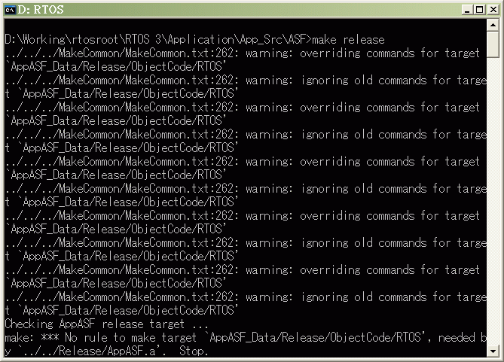

．File or directory name are case-sensitive
File or directory name are case-sensitive. Please handle with care when you create new file or directory, and make sure the extension of each source file is lower case (Ex: *.c, *.s). The following directory name must be exactly the same, please don’t rename them:
．/AppExt
．Debug
．Release
．/Application
．Debug
．Release
．/Include
．/LIB
．Debug
．Release
．/LIBExt
．Debug
．Release
．/MakeCommon
．/Project

．Directory name can’t be *_Data
Make clean will remove all the directories named “*_Data” under current directory. Please don’t create such directory, or your directory will be removed during “make clean” process.

Troubleshooting
．Cygwin
Q: I have ever installed and then removed Cygwin on my system. I got some error message during make process.
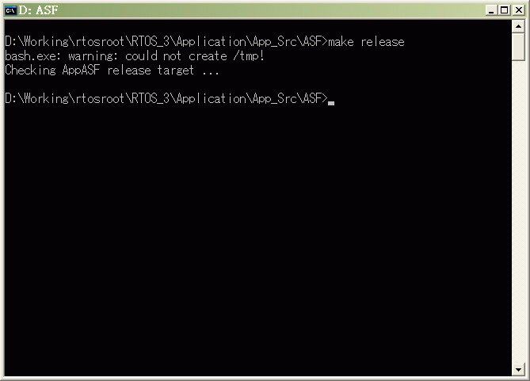
A: Run regedit.exe and remove the following registry keys:
．HKEY_CURRENT_USER\Software\Cygnus Solutions
．HKEY_LOCAL_MACHINE\SOFTWARE\Cygnus Solutions

