**Hal : Lamaran Pekerjaan**

Kepada

Yth Bapak/Ibu Pimpinan/HRD

Di,

Tempat

Dengan Hormat,

Saya yang bertanda tangan dibawah ini adalah :

Nama : Khumedi

Tempat, tanggal lahir : Brebes, 04 April 1990

Pendidikan Terakhir : Sekolah Menengah Kejuruan (SMK)

Alamat : Jl. Cendrawasih XII Blok F No. 164 RT 03/013

No. HP : 085720370538

Email : [basarikhumed@gmail.com](mailto:basarikhumed@gmail.com)

Dengan ini bermaksud mengajukan surat lamaran pekerjaan untuk posisi Security, Office Boy dan Staff Kurir di perusahaan yang Bapak/Ibu pimpin. Sebagai bahan pertimbangan, saya lampirkan berkas – berkas sebagai berikut :

1. Curiculum Vitae
2. Foto copy KTP
3. Foto Copy Ijazah Terakhir
4. Pas Foto 4x6 – 1 Lembar
5. Foto Copy SKCK

Demikian surat lamaran ini saya buat. Besar harapan saya untuk dapat bekerja ditempat yang Bapak/Ibu pimpin. Atas kesempatannya saya ucapkan terima kasih.

Hormat Saya,

Khumedi

Curiculum Vitae

Khumedi

+6285720370538

Basarikhumed@gmail.com

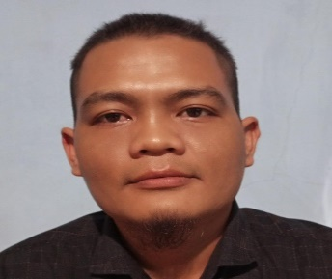

**Courier Staff** is my passion and I have experience almost 2 year. I understand very well how couriers work ini detail. I am a fast learner and hard worker. Loves to meet new people and new experiences. I am highly motivated in gaining experiences and learning as much as I can.

### Highlights

* Resistance to stress
* Good manners
* Hard Worker
* Friendly and Cheerfull
* Able to work under pressure

### Education

SMK Bhakti Praja Dukuhwaru

### Skill

* Internet Knowledge

### Hobbies

* Playing chess - great way to unwind, destress, and keep the mind sharp.
* Fishing

### Experience

02/2019 to Present

**Courier Staff**

**PT. RAGA BAGUS OTAK JUARA**

* Deliver goods on time
* Ensure that the goods received by customers are in good condition and not damaged.
* Maintin good relationships with customers
* Make Daily reports of goods sent and received by customers.

01/2018 to 01/2019

**Waiters**

**Kedai Pak Ciman**

* Welcome and open doors for customers
* Preparing guest seating
* Serving customers and taking orders
* Serving food and drinks according to customer orders

10/2014 to 10/2017

**Waiters**

**Restoran Seri Bidara**

* Welcome and open doors for customers
* Preparing guest seating
* Serving customers and taking orders
* Serving food and drinks according to customer orders

