- Câte rânduri are datasetul?
SELECT
COUNT(*)
FROM store

- Care este valoarea totală a vânzărilor (sales)?
SELECT
ROUND(SUM(sales)::numeric,1) AS total_sales
FROM store

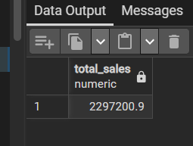

- Care este profitul total (profit)?
SELECT
ROUND(SUM(profit)::numeric,1) AS total_profit
FROM store

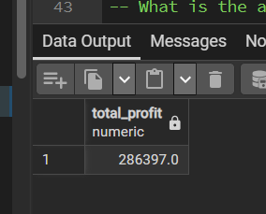

- Care este media discountului (discount)?
SELECT
ROUND(AVG(discount)::numeric,1) AS avg_discount
FROM store

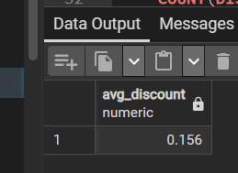

- Câte segmente (segment) există și care sunt acestea?
SELECT
COUNT(DISTINCT segment) AS unique_segments
FROM store


- Care sunt cele mai frecvente 5 state în care s-au făcut comenzi?
SELECT
state,
COUNT(order_id)
FROM store
GROUP BY 1
ORDER BY 2 DESC
LIMIT 5

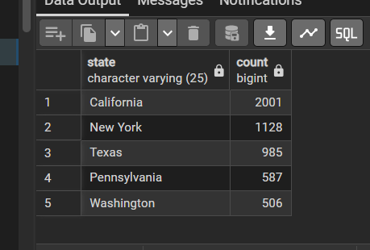
- Care este numărul total de clienți unici (customer_id)?
SELECT
COUNT(DISTINCT customer_id) AS unique_customers
FROM store

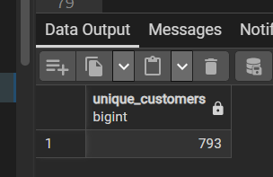

- Care este cea mai populară metodă de livrare (ship_mode)?
SELECT
ship_mode,
COUNT(ship_mode)
FROM store
GROUP BY 1
ORDER BY 2 DESC

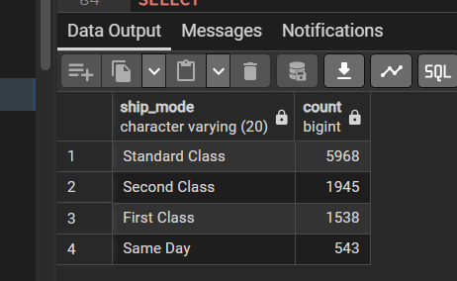

- Care este cea mai vândută categorie (category)?
SELECT *
FROM
(
SELECT
category,
COUNT(order_id),
RANK() OVER(ORDER BY COUNT(order_id) DESC) AS ranking
FROM store
GROUP BY 1
)
WHERE ranking = 1

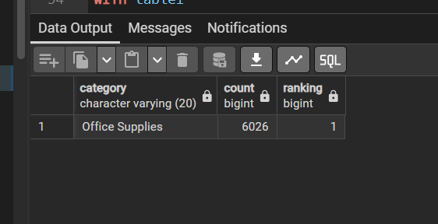

10 Care este cel mai mare profit obținut într-o singură comandă?
WITH table1
AS
(
SELECT
order_id,
MAX(profit),
RANK() OVER(ORDER BY MAX(profit) DESC) AS ranking
FROM store
GROUP BY 1
)

SELECT *
FROM table1
WHERE ranking <= 1

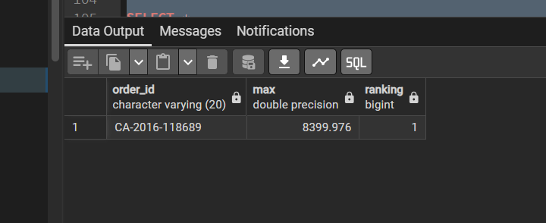

- Care este profitul total pe fiecare categorie de produse?
SELECT
category,
ROUND(SUM(profit)::numeric,1) AS total_profit
FROM store
GROUP BY 1

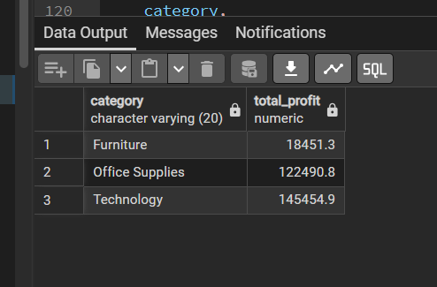
2 Care este rata medie a profitului (profit / sales) per categorie?

SELECT
category,
ROUND(AVG(profit / sales * 100)::numeric,1) AS profit_margin
FROM store
GROUP BY 1

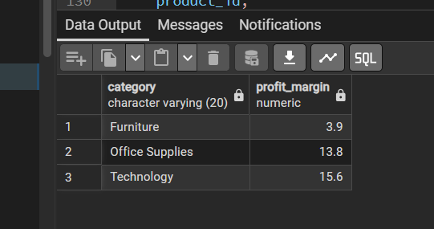
- Care sunt top 10 produse cu cele mai mari vânzări totale?
-- Which are the top 10 best-selling products by total sales?
SELECT *
FROM
(
SELECT
product_id,
product_name,
ROUND(SUM(sales)::numeric,1),
RANK() OVER(ORDER BY SUM(sales) DESC) AS ranking
FROM store
GROUP BY 1,2
)
WHERE ranking <= 10

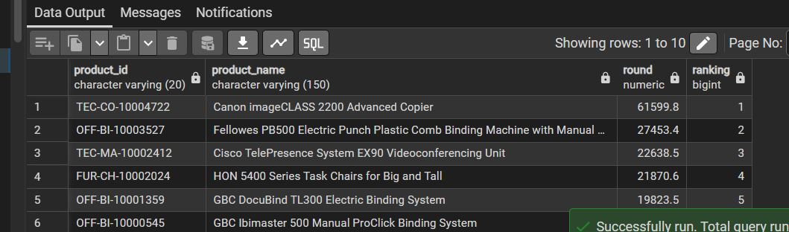
- Care sunt cele mai profitabile 5 state?
SELECT *
FROM
(
SELECT
state,
ROUND(SUM(profit)::numeric,1),
RANK() OVER(ORDER BY SUM(profit) DESC) AS ranking
FROM store
GROUP BY 1
)
WHERE ranking <= 5

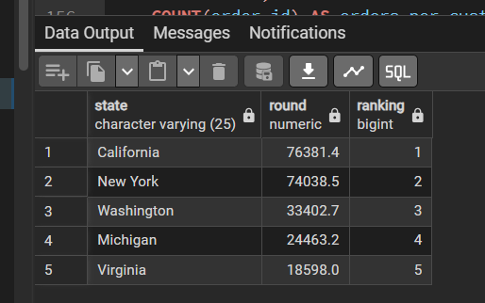
- Care este numărul de comenzi per client și profitul mediu per client?
SELECT
customer_id,
COUNT(order_id) AS orders_per_customer,
ROUND(AVG(profit)::numeric,1) AS avg_profit
FROM store
GROUP BY 1

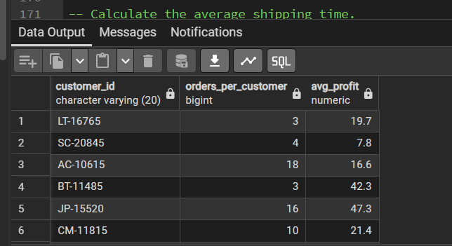
- Determină ziua săptămânii cu cele mai multe comenzi.
SELECT
TO_CHAR(order_date, 'FMDay') AS ziua,
COUNT(order_id) AS nr_comenzi_per_zi
FROM store
GROUP BY 1
ORDER BY 2 DESC
LIMIT 1

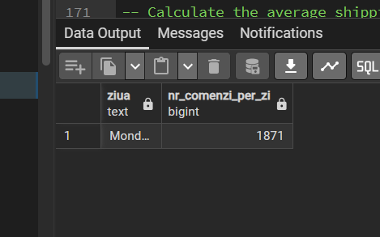
- Calculează timpul mediu de livrare (ship_date - order_date).
SELECT
AVG(ship_date - order_date) AS avg_shipping_days
FROM store

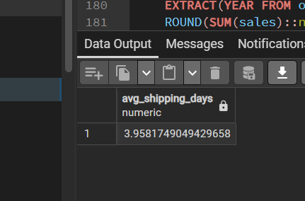
- Care este anul cu cele mai mari vânzări totale?
SELECT
EXTRACT(YEAR FROM order_date),
ROUND(SUM(sales)::numeric,1) AS total_sales
FROM store
GROUP BY 1
ORDER BY 2 DESC
LIMIT 1

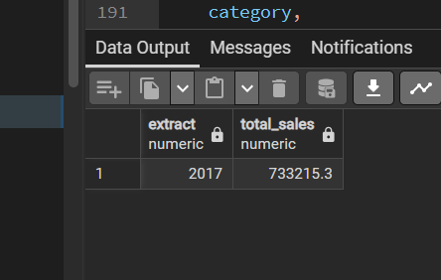
- Care este distribuția comenzilor între segmente (Consumer, Corporate, etc.)?
SELECT
segment,
category,
COUNT(order_id)
FROM store
GROUP BY 1,2
ORDER BY 1

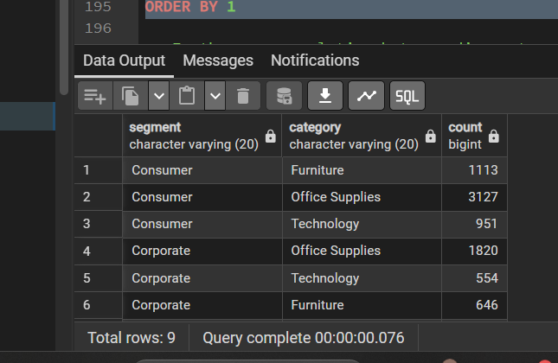
10 Există vreo corelație între discount și profit?

SELECT
ROUND(CORR(discount, profit)::numeric,1)
FROM store

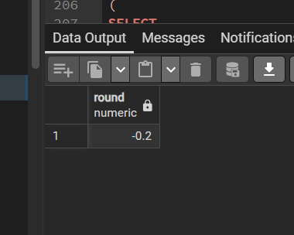
1 Identifică produsele cu pierdere totală (profit < 0) și determină top 5 cele mai neprofitabile.

SELECT *
FROM
(
SELECT
product_id,
product_name,
SUM(profit),
RANK() OVER(ORDER BY SUM(profit) ASC) AS ranking
FROM store
GROUP BY 1,2
HAVING SUM(profit) < 0
)
WHERE ranking <= 5

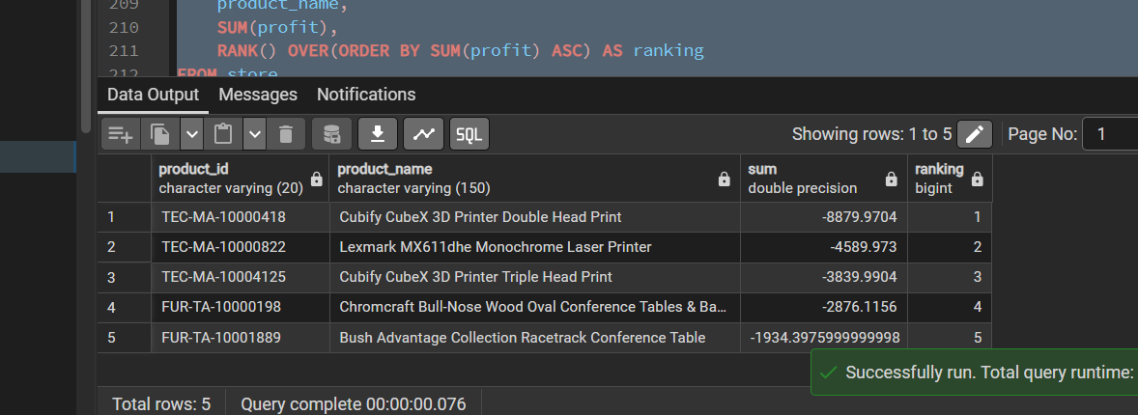

- Calculează cifra de afaceri lunară și arată trendul (crește sau scade?).
WITH table1
AS
(
SELECT
EXTRACT(MONTH FROM order_date) AS monthh,
ROUND(SUM(sales)::numeric,1) AS total_rev
FROM store
GROUP BY 1
),
table2
AS
(
SELECT
table1.monthh AS monthh,
table1.total_rev AS current_month,
LAG(table1.total_rev) OVER(ORDER BY table1.monthh ASC) AS last_month
FROM table1
)

SELECT
monthh,
last_month,
current_month,
ROUND((current_month - last_month) / last_month * 100,1) AS perc_growth,
CASE
WHEN (current_month - last_month) / last_month * 100 > 0 THEN 'UP'
WHEN (current_month - last_month) / last_month * 100 < 0 THEN 'DOWN'
ELSE 'NULL'
END AS segmentation
FROM table2

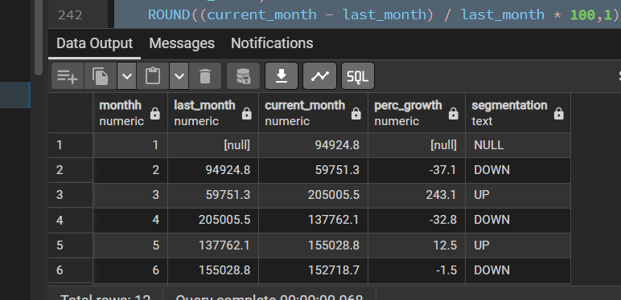
- Determină clienții loiali — cei care au plasat comenzi în cel puțin 3 ani diferiți.
with table1
AS
(
SELECT
customer_id,
EXTRACT(YEAR FROM order_date) as yearr,
COUNT(*) AS counter
FROM store
GROUP BY 1,2
ORDER BY 1
)

SELECT
DISTINCT customer_id
FROM(
SELECT
*,
RANK () OVER(PARTITION BY table1.customer_id ORDER BY yearr) AS ranking
FROM table1
)
WHERE ranking >= 3

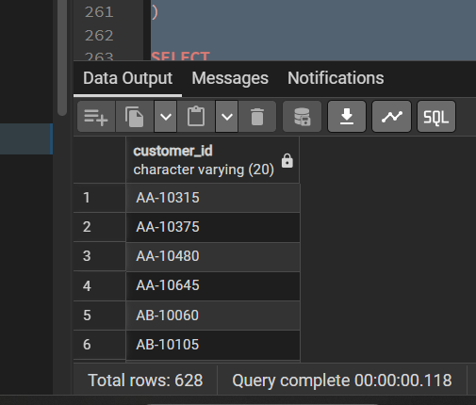

- Analizează dacă reducerea (discount) afectează negativ profitul (folosind o corelație sau regresie simplă).

SELECT
ROUND(CORR(discount,profit)::numeric,1)
FROM store
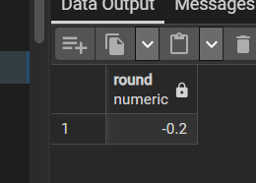

5 Care este contribuția fiecărui segment la profitul total (în %)?

WITH table1
AS
(
SELECT
segment,
SUM(profit) AS total_profit
FROM store
GROUP BY 1
)

SELECT
table1.segment,
total_profit,
ROUND((total_profit / (SELECT SUM(profit) FROM store))::numeric * 100,1) As percentage
FROM table1
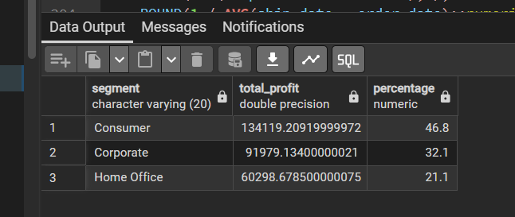

6 Care este timpul mediu de livrare per regiune și corelează-l cu satisfacția (poți estima satisfacția invers proporțional cu timpul de livrare).

with table1
AS
(
SELECT
region,
ROUND(AVG(ship_date - order_date),1),
ROUND(1 / AVG(ship_date - order_date)::numeric,3) AS satisfaction
FROM store
GROUP BY 1
)

SELECT
CORR(ship_date - order_date, t1.satisfaction)
FROM store as s
JOIN table1 as t1
ON s.region = t1.region

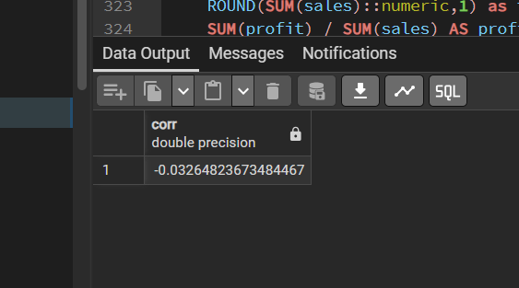
7Detectează produse care se vând mult, dar au profit scăzut (high sales, low margin).

SELECT *
FROM
(
SELECT
product_id,
product_name,
COUNT(product_id),
ROUND(SUM(sales)::numeric,1) as total_sales_per_product,
SUM(profit) / SUM(sales) AS profit_margin
FROM store
GROUP BY 1,2
HAVING COUNT(product_id) >= 5
)

WHERE total_sales_per_product >
(SELECT AVG(total_sales_per_product) FROM
(SELECT SUM(sales) AS total_sales_per_product FROM store GROUP BY product_id))
ORDER BY profit_margin ASC

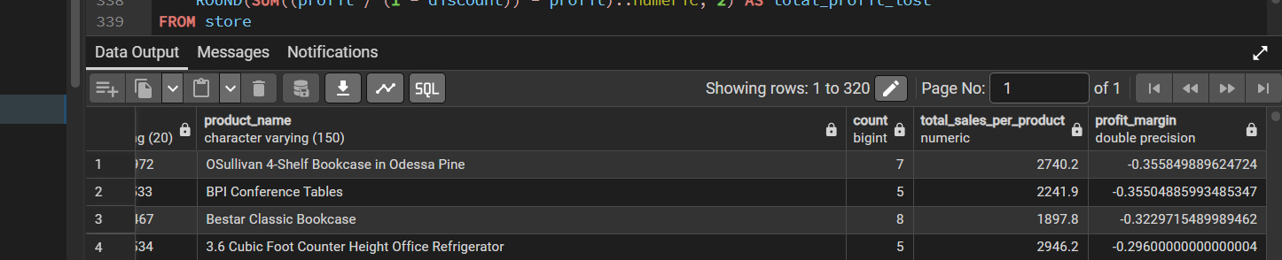

- Care este valoarea totală a vânzărilor pierdute din cauza discounturilor (compară profitul real cu profitul fără discount)?
SELECT
ROUND(SUM((profit / (1 - discount)) - profit)::numeric, 2) AS total_profit_lost
FROM store
WHERE discount > 0

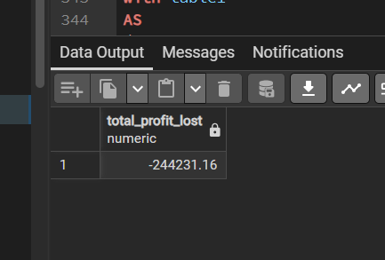

- Creează o matrice categorie × regiune cu profitul total și evidențiază zonele neperformante.
with table1
AS
(
SELECT
region,
category,
ROUND(SUM(profit)::numeric,1) AS total_profit
FROM store
GROUP BY 1,2
ORDER BY 1
)

SELECT
table1.region,
table1.category,
table1.total_profit,
ROUND(AVG(table1.total_profit) OVER(),1),
CASE
WHEN table1.total_profit > AVG(table1.total_profit) OVER() THEN 'Normal'
ELSE 'Underperforming'
END AS segmentation
FROM table1

