Phone prices Analyst

-- 1. Select all columns from the table.

SELECT
COUNT(*)
FROM phones



-- 2.Display only the brand and model.

SELECT
brand,
model
FROM phones

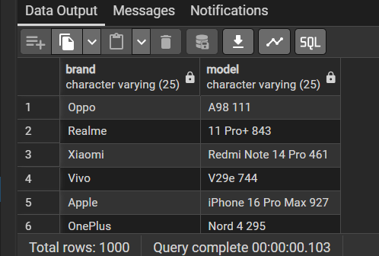

-- 3. Show all phones with a price under 500 USD.

SELECT
brand,
model,
price_usd
FROM phones
WHERE price_usd < 500

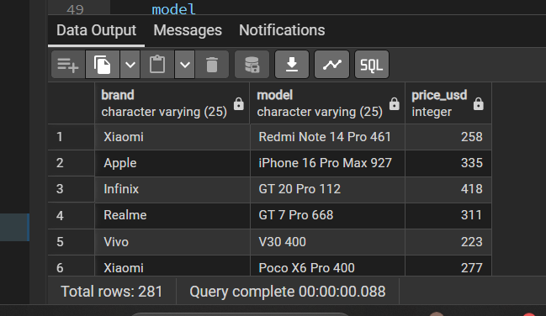

-- 4.Show all phones that support 5G.

SELECT
brand,
model
FROM phones
WHERE fiveg_support = 'Yes'

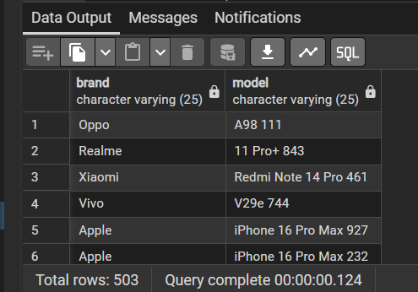

-- 5. Display all distinct operating systems (OS).

SELECT
DISTINCT os
FROM phones

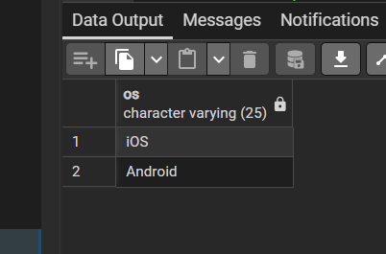

-- 6. Show all phones released in June.

SELECT
brand,
model
FROM phones
WHERE release_month = 'June'

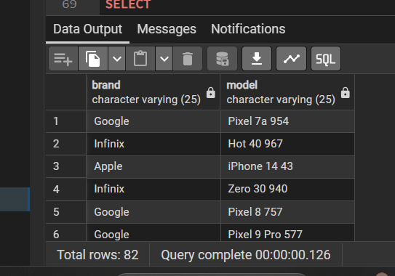

-- 7. Display the models that have more than 8GB of RAM.

SELECT
model
FROM phones
WHERE ram_gb > 8

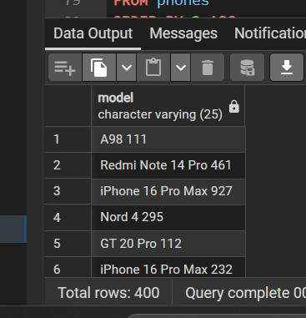

-- 8. Show all models ordered by price in ascending order.

SELECT
model,
price_usd
FROM phones
ORDER BY 2 ASC

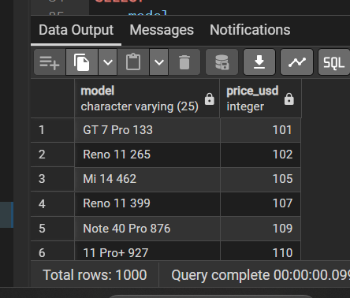

-- 9. Show all models ordered by rating in descending order.

SELECT
model,
rating
FROM phones
ORDER BY 2 DESC

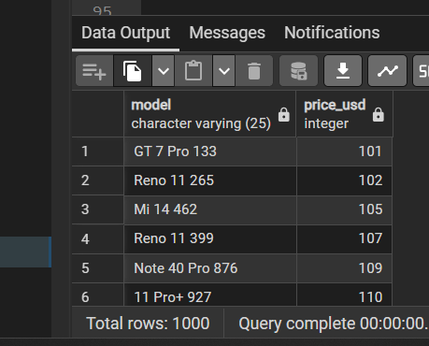

-- 10. Display the total number of phones in the table.

SELECT
COUNT(model) AS total_phones
FROM phones

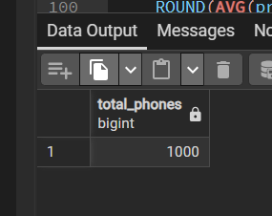

-- 11. Display the average phone price for each brand.

SELECT
brand,
ROUND(AVG(price_usd)::numeric,1) AS avg_price
FROM phones
GROUP BY 1

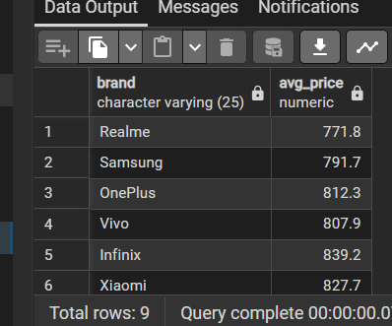

-- 12. Show the phone with the largest battery capacity.

SELECT
brand,
model,
battery_mah
FROM phones
ORDER BY 3 DESC
LIMIT 1

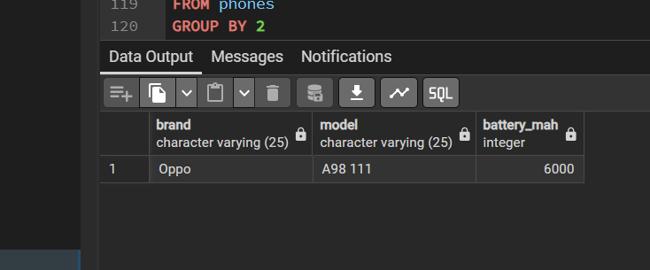

-- 13. Display the number of models available for each OS.

SELECT
COUNT(model) AS counter,
os
FROM phones
GROUP BY 2

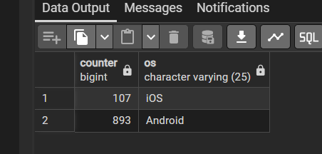

-- 14. Find all models released between June and August (months 6–8).

SELECT
model,
release_month
FROM phones
WHERE release_month = 'June' OR release_month = 'July' OR release_month = 'August'
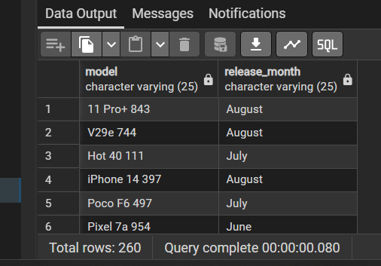

-- 15. Display the models that have both RAM ≥ 8GB and price < 700 USD.

SELECT
model,
ram_gb,
price_usd
FROM phones
WHERE price_usd < 700 AND ram_gb >= 8

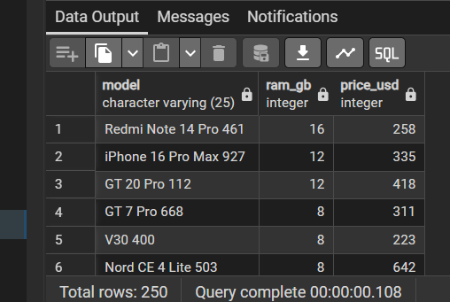

-- 16. Show the brands that have at least 110 models in the table.
SELECT *
FROM
(
SELECT
brand,
COUNT(model) AS counter
FROM phones
GROUP BY 1
)
WHERE counter > 110

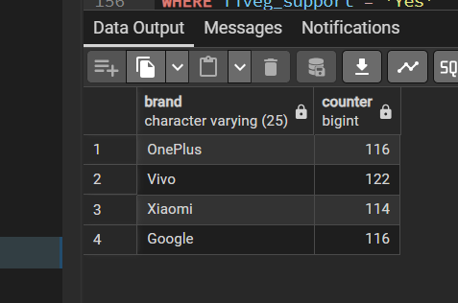

-- 17. Calculate the average rating for phones that support 5G.

SELECT
ROUND(AVG(rating)::numeric,2) AS avg_rating
FROM phones
WHERE fiveg_support = 'Yes'

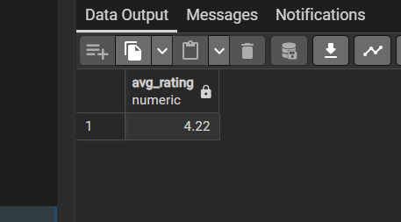

-- 18. Display all models that do NOT support 5G.

SELECT
model,
fiveg_support
FROM phones
WHERE fiveg_support != 'Yes'

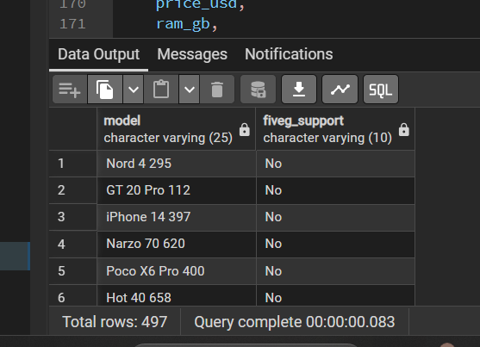

-- 19. Find the model with the best “price/performance” ratio defined as price_usd / ram_gb.

SELECT
model,
price_usd,
ram_gb,
price_usd / ram_gb AS price_perf
FROM phones
ORDER BY 4 ASC
LIMIT 1

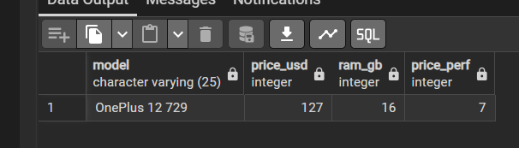

-- 20. Display the number of models released each month, ordered from highest to lowest.

SELECT
release_month,
COUNT(model)
FROM phones
GROUP BY 1
ORDER BY 2 DESC

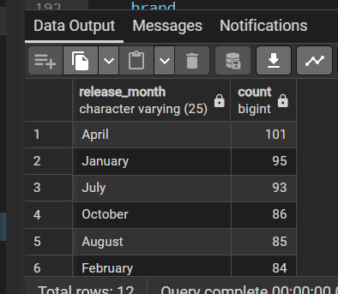

-- 21. Display the top 3 models with the highest rating for each brand,
-- and if ratings are equal, sort by price in descending order.
SELECT *
FROM
(
SELECT
brand,
model,
rating,
price_usd,
ROW_NUMBER () OVER(PARTITION BY brand ORDER BY rating DESC, price_usd DESC) AS ranking
FROM phones
)
WHERE ranking <= 3

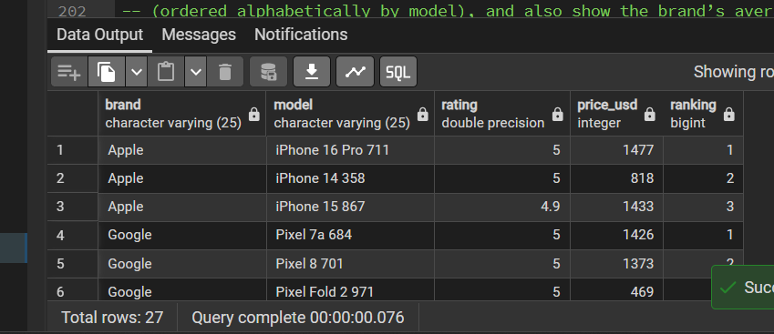

-- 22. For each brand, calculate the price difference between each model and the previous model of the same brand
-- (ordered alphabetically by model), and also show the brand’s average price.
WITH table1
AS
(
SELECT
brand,
model,
price_usd,
LAG(price_usd) OVER(PARTITION BY brand ORDER BY model)AS previous
FROM phones
)

SELECT
t1.brand,
t1.model,
t1.price_usd,
t1.previous,
price_usd - previous AS difference,
ROUND(AVG(price_usd) OVER(PARTITION BY brand)::numeric,1)
FROM table1 as t1
WHERE previous IS NOT NULL

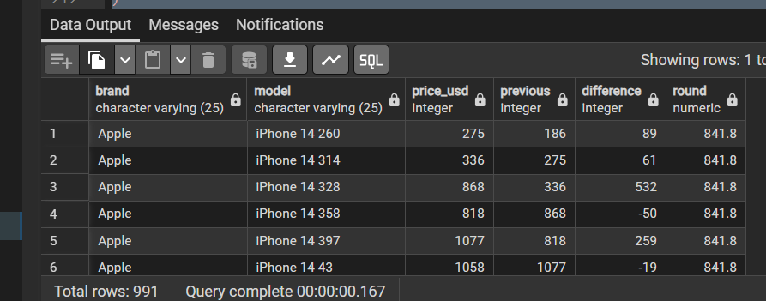

-- 23. For each year, determine the model with the highest price increase compared to the previous model
-- of the same brand (using LAG()).
WITH table1
AS
(
SELECT
brand,
model,
price_usd,
year,
LAG(price_usd) OVER(partition BY brand ORDER BY year,model) AS previous
FROM phones
ORDER BY year ASC
),
table2
AS
(
SELECT
t1.brand,
t1.model,
t1.price_usd,
t1.previous,
t1.year,
(price_usd - previous)AS price_increase
FROM table1 AS t1
WHERE previous IS NOT NULL
)
SELECT *
FROM
(
SELECT
brand,
model,
price_usd,
previous,
price_increase,
year,
ROW_NUMBER() OVER(PARTITION BY year,brand ORDER BY price_increase DESC) AS ranking
FROM table2 as t2
)
WHERE ranking <= 1

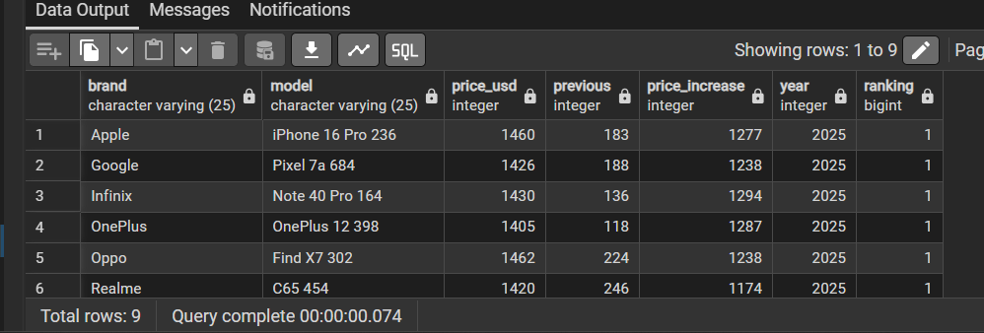

-- 24. Compute the mean, median, and 90th percentile of price for each brand.
WITH table1
AS
(
SELECT
brand,
ROUND(AVG(price_usd)::numeric,1) as mean,
PERCENTILE_CONT(0.5) WITHIN GROUP (ORDER BY price_usd) as mediann,
PERCENTILE_CONT(0.9) WITHIN GROUP (ORDER BY price_usd) as percentile_90
FROM phones
GROUP BY 1
),
table2
AS
(
SELECT
brand,
model,
price_usd,
ROW_NUMBER() OVER(PARTITION BY brand ORDER BY price_usd) AS ranking
FROM phones
)

SELECT
t1.brand,
t2.model,
t1.mean,
t1.mediann,
t1.percentile_90,
t2.price_usd,
t2.ranking
FROM table1 as t1
LEFT JOIN table2 as t2
ON t1.brand = t2.brand
ORDER BY t1.brand, t2.price_usd

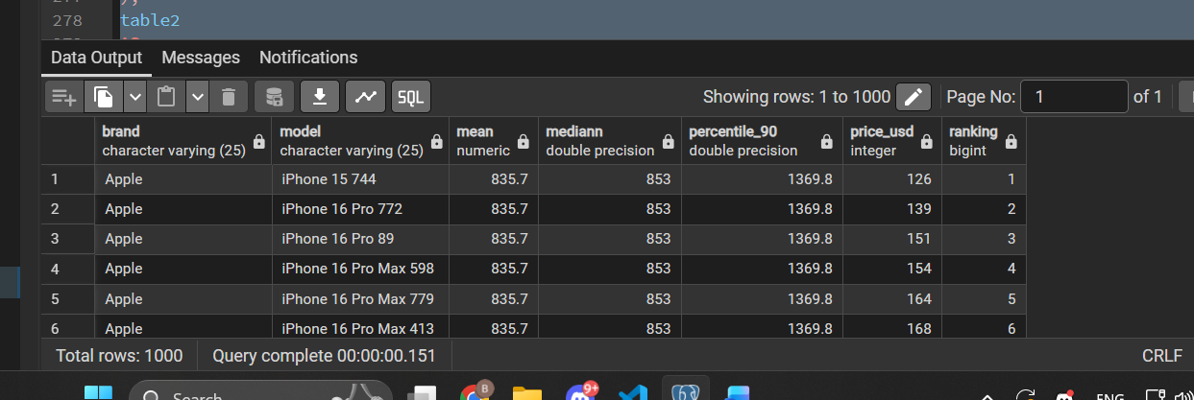

-- 25. Find the top 5 manufacturers with the highest average ratio of (camera_mp / display_size_inch).

SELECT
brand,
ROUND(AVG(camera_mp / display_size_inch)::numeric,2) AS avg_ratio
FROM phones
GROUP BY 1
ORDER BY 2 DESC
LIMIT 5

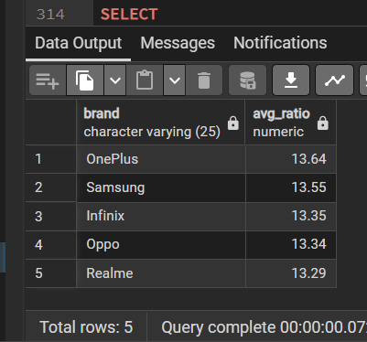

-- 26. Compute the correlation between battery_mah and display_size_inch for each brand.

SELECT
brand,
ROUND(CORR(battery_mah, display_size_inch)::numeric,3) AS correlation
FROM phones
GROUP BY 1

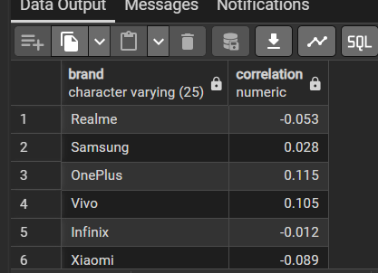

-- 27. Return all models released in the last 6 months relative to the most recent date
-- in the dataset (without hardcoding any year).

SELECT
brand,
model,
release_month
FROM phones
WHERE (release_month = 'June' OR
release_month = 'July' OR
release_month = 'September' OR
release_month = 'October' OR
release_month = 'November' OR
release_month = 'August') AND
year = 2025

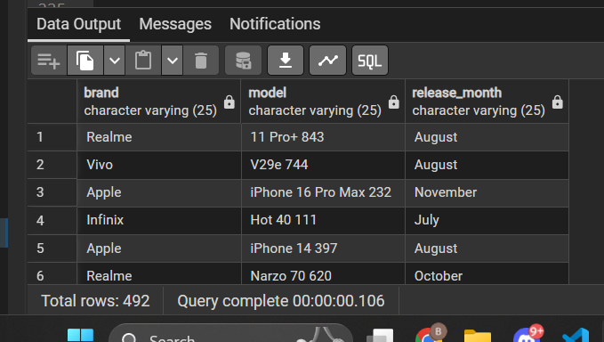

-- 28. Find all models with a large battery but weak charging, defined as:
-- battery_mah > percentile_cont(0.75) and
-- charging_watt < percentile_cont(0.25)
-- (across the entire dataset)
with table1
AS
(
SELECT
PERCENTILE_CONT(0.75) WITHIN GROUP(ORDER BY battery_mah) AS batt_perc,
PERCENTILE_CONT(0.25) WITHIN GROUP (ORDER BY charging_watt) AS char_perc
FROM phones
)

SELECT
brand,
model,
battery_mah,
charging_watt,
t1. batt_perc,
t1.char_perc
FROM phones
JOIN table1 as t1
ON TRUE
WHERE battery_mah > t1.batt_perc
AND
charging_watt < t1.char_perc

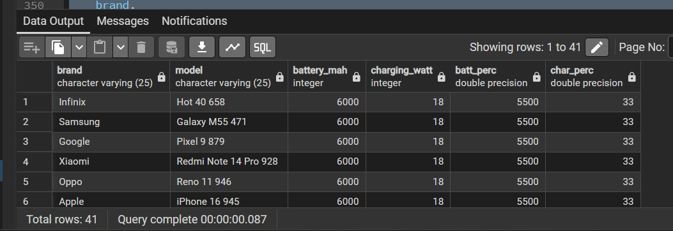

-- 29. Create a CTE that assigns a performance category to each processor
-- (e.g., Snapdragon 8 → high, Snapdragon 4 → low), then compute the average price per category.
-- everything + snapdragon 7+ gen 2 medium, snapdragon 6 gen 1 low and snapdragon 8 gen 3 high
WITH table1
AS
(
SELECT
brand,
model,
price_usd,
processor,
CASE
WHEN processor = 'Snapdragon 6 Gen 1' THEN 'Low'
WHEN processor = 'Snapdragon 8 Gen 3' THEN 'High'
ELSE 'Medium'
END AS category
FROM phones
)

SELECT
category,
ROUND(AVG(price_usd)::numeric,2)
FROM table1 as t1
GROUP BY 1

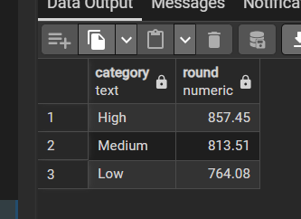

-- 30. Display all models that have a higher price than the average price of all models with the same processor.
with table1
AS
(
SELECT
processor,
AVG(price_usd) AS avg_price
FROM phones
GROUP BY 1
)

SELECT
p.model,
p.price_usd,
t1.avg_price,
p.processor
FROM phones as p
JOIN table1 as t1
ON p.processor = t1.processor
WHERE p.price_usd > t1.avg_price

