Student grades

-- Retrieve all students who scored above 80 on the exam

SELECT
student_id,
exam_score
FROM grades
WHERE exam_score > 80

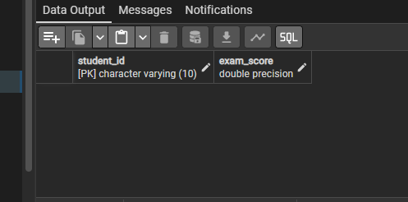

-- What is the total number of students in the dataset?

SELECT
COUNT(DISTINCT student_id) as nr_of_students
FROM grades



-- Show students who slept less than 6 hours per night

SELECT
student_id,
sleep_hours
FROM grades
WHERE sleep_hours < 6

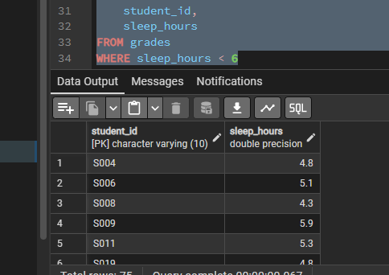

-- What is the average exam score across all students?

SELECT
AVG(exam_score) AS avg_score
FROM grades

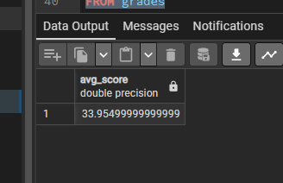

-- Display the top 5 students with the highest previous scores

SELECT
student_id,
previous_scores
FROM grades
ORDER BY 2 DESC
LIMIT 5

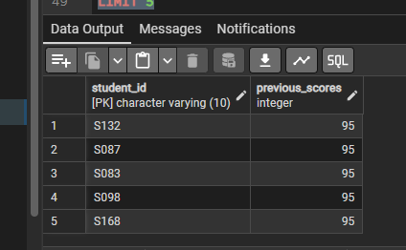

-- Find students with perfect attendance (100%)

SELECT
student_id,
attendance_percent
FROM grades
WHERE attendance_percent = 100

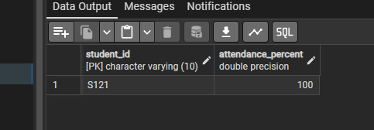

-- What is the range of study hours among all students?

SELECT
MIN(hours_studied) AS minimum_hours,
MAX(hours_studied) AS maximum_hours
FROM grades

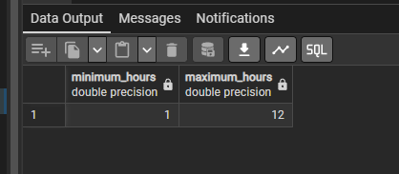

-- How does study time relate to exam performance? Group students by study hours categories
-- (Low: <3h, Medium: 3-6h, High: >6h) and calculate their average exam scores
with table1
AS
(
SELECT
student_id,
hours_studied,
exam_score,
CASE
WHEN hours_studied < 3 THEN 'Low'
WHEN hours_studied BETWEEN 3 AND 6 THEN 'Medium'
ELSE 'High'
END AS category
FROM grades
)

SELECT
*,
ROUND(AVG(exam_score) OVER(partition by category)::numeric,1)
FROM table1

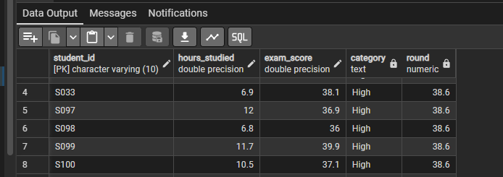

--Which students show significant performance inconsistency?
--Identify students where the difference between their previous scores and exam scores is greater than 15 points

SELECT
student_id,
exam_score,
previous_scores
FROM grades
WHERE ABS(previous_scores - exam_score) > 15

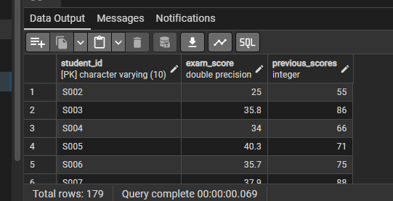

-- What is the impact of attendance on exam results? Categorize students by attendance levels and calculate average exam scores for each category
with table1
AS
(
SELECT
student_id,
attendance_percent,
exam_score,
CASE
WHEN attendance_percent <= 30 THEN 'Low'
WHEN attendance_percent > 30 AND attendance_percent <= 70 THEN 'Medium'
ELSE 'High'
END AS segmentation
FROM grades
)

SELECT
segmentation,
AVG(exam_score) AS avg_score
FROM table1
GROUP BY 1

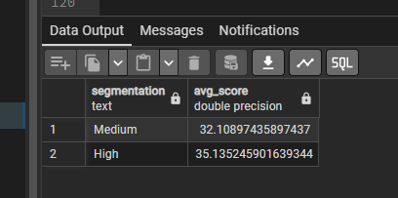

-- Identify at-risk students (exam score below 50) and show their study habits and attendance patterns

SELECT
student_Id,
hours_studied,
sleep_hours,
attendance_percent,
exam_score
FROM grades
WHERE exam_score < 50

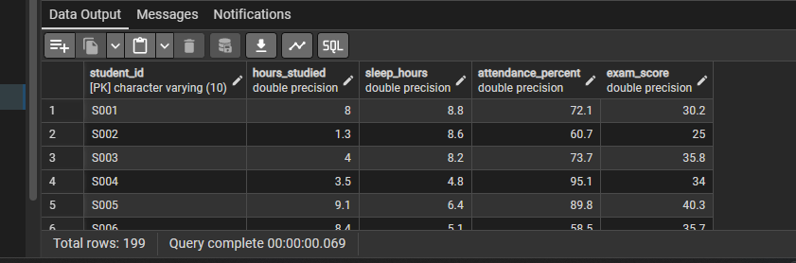

-- Is there a correlation between sleep and academic performance? Group students by sleep categories and compare their average exam scores and study hours
with table1
AS
(
SELECT
student_id,
sleep_hours,
exam_score,
CASE
WHEN sleep_hours <= 5 THEN 'LowSleep'
WHEN sleep_hours > 5 AND sleep_hours <= 7 THEN 'NormalSleep'
ELSE 'LotsOfSleep'
END AS sleepcategory
FROM grades
)

SELECT
sleepcategory,
AVG(exam_score) AS avg_score
FROM table1
GROUP BY 1

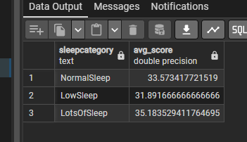

-- What percentage of students studied more than 4 hours but still scored below average on the exam?
SELECT
ROUND(COUNT(*) / (SELECT COUNT(*) FROM grades)::numeric * 100) AS percentage
FROM(
SELECT
student_id,
hours_studied,
exam_score
FROM grades
WHERE hours_studied > 4
)
WHERE exam_score < (SELECT AVG(exam_score) FROM grades)

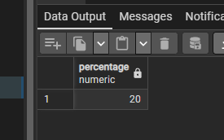

-- Compare the average exam scores between students who sleep more than 7 hours versus those who sleep less
with table1
AS
(
SELECT
ROUND(AVG(exam_score)::numeric,1) as avg_score_less
FROM grades
WHERE sleep_hours < 7
),
table2
AS
(
SELECT
ROUND(AVG(exam_score)::numeric,1) as avg_score_more
FROm grades
WHERE sleep_hours > 7
)

SELECT
t1.avg_score_less,
t2.avg_score_more
FROM table1 as t1
CROSS JOIN table2 as t2

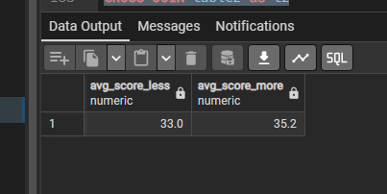

-- Perform cluster analysis by dividing students into 3 equal performance tiers based on exam scores and compare their study habits,
-- sleep patterns, and attendance across tiers
with table1
AS
(
SELECT
student_id,
hours_studied,
sleep_hours,
attendance_percent,
exam_score,
NTILE (3) OVER(ORDER BY exam_score DESC) ranking
FROM grades
)

SELECT
COUNT(*),
ROUND(AVG(hours_studied)::numeric,1) AS avg_hours,
ROUND(AVG(sleep_hours)::numeric,1) AS avg_sleep,
ROUND(AVG(attendance_percent)::numeric,1) AS avg_att,
ROUND(AVG(exam_score)::numeric,1) AS avg_score
FROM table1
GROUP BY ranking

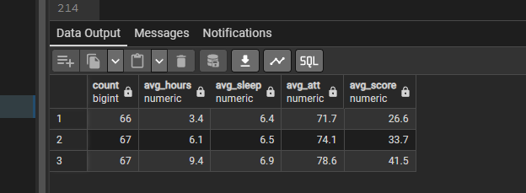

-- Which factor has the strongest correlation with exam performance? Calculate correlation coefficients between all numerical variables and exam score

SELECT
ROUND(CORR(hours_studied, exam_score)::numeric,2) AS hour_corr,
ROUND(CORR(sleep_hours, exam_score)::numeric,2) AS sleep_corr,
ROUND(CORR(attendance_percent, exam_score)::numeric,2) AS attend_corr,
ROUND(CORR(previous_scores, exam_score)::numeric,2) AS prevscore_corr
FROM grades

