- What is the total number of people in the dataset?


- What is the average age of people in the dataset? (using age_category)
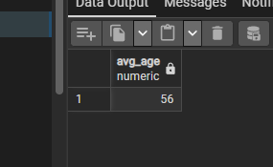

- How many people have diabetes?


- What is the ratio between men and women?
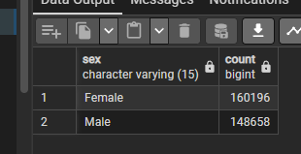

- What is the average BMI of people in the dataset?

- How many people have a history of smoking?


- What is the average daily fruit consumption?
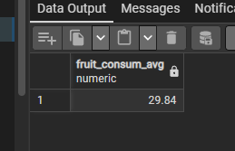
- How many people exercise regularly?


9. What is the rate of depression among people with diabetes vs. without diabetes?

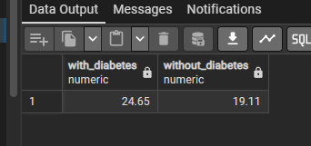

- Is there a correlation between alcohol consumption and the presence of skin cancer?
- What is the average BMI for people with heart disease vs. without?
- How does green vegetable consumption vary by age category?
- What is the prevalence of arthritis in men vs. women?
- Is there a difference in fried potato consumption between smokers and non-smokers?
- What is the relationship between the frequency of checkups and the presence of other types of cancer?
- How are people with depression distributed across different BMI categories?

- What are the most important risk factors that predict diabetes in this dataset? (multivariate analysis)
- Can we identify clusters of people with healthy vs. unhealthy profiles based on their behaviors? (clustering analysis)
- Is there a non-linear relationship between age and the probability of having heart disease?
- What is the combined impact of fruit and green vegetable consumption on the risk of depression?
- Can we build a model to predict the risk of diabetes based on lifestyle factors?
- Are there significant interactions between smoking and alcohol consumption in their relationship with cancer?
- What is the trend in general health across different age groups and how does it correlate with lifestyle behaviors?
- Which variables have the strongest confounding effect in the analysis of the relationship between exercise and heart disease?

- Which population segment would benefit the most from a diabetes prevention program?
- Which lifestyle behaviors should be targeted in a public health campaign?
- How could we personalize health recommendations based on demographic profile and behaviors?

