ZEPTO

-- Find the top 10 best-value products based on the discount percentage
with table1
AS
(
SELECT
category,
name,
discountpercent,
price,
ROW_NUMBER () OVER(ORDER BY discountpercent DESC) AS ranking
FROM fruits
)

SELECT
*
FROM table1
WHERE ranking <= 10

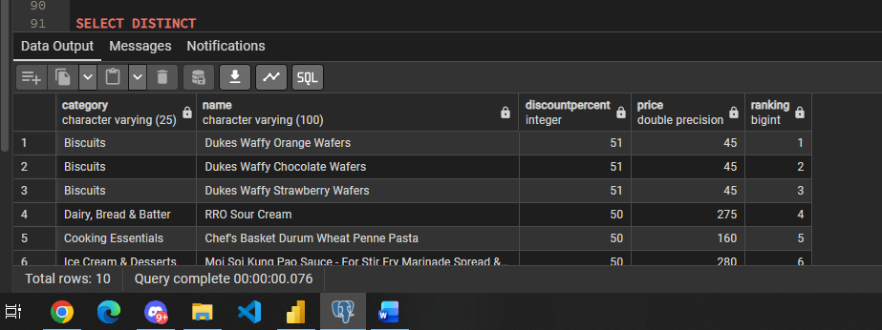

-- what are the products with the highest price but out of stock

SELECT DISTINCT
name,
price
FROM fruits
WHERE outofstock = 'True'
ORDER BY price DESC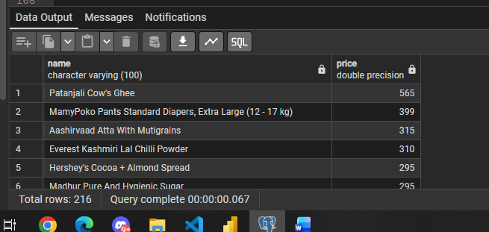

-- calculate the estimated revenue for each category

SELECT
category,
SUM(price * availablequantity) AS total_revenue
FROM fruits
GROUP BY 1
ORDER BY total_revenue DESC
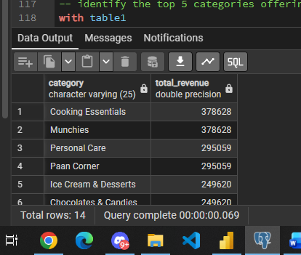

-- find all the products where the price is greater than 500 rupees and discount is less than 10%

SELECT
category,
name,
price,
discountpercent
FROM fruits
WHERE price > 500 AND discountpercent < 10

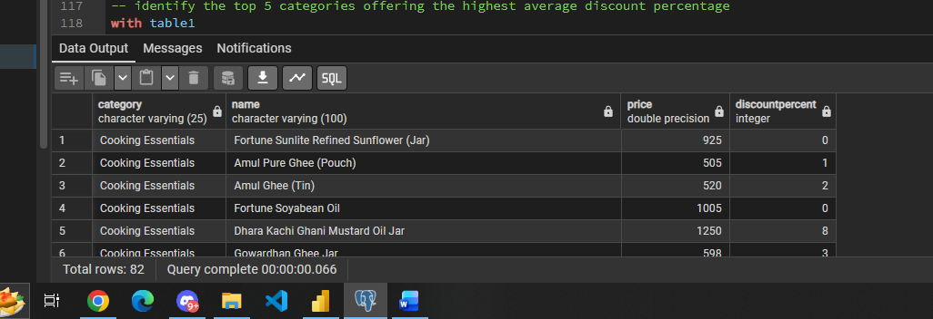

-- identify the top 5 categories offering the highest average discount percentage
with table1
AS
(
SELECT
category,
ROUND(AVG(discountpercent),2) as avg_discount
FROM fruits
GROUP BY 1
)

SELECT
*
FROM table1
ORDER BY avg_discount DESC
LIMIT 5

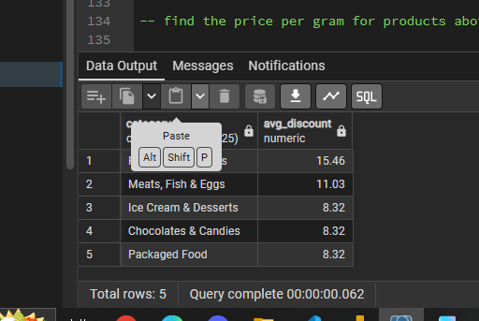

-- find the price per gram for products above 100g and sort by best value

SELECT
DISTINCT name,
price,
weightingms,
ROUND((price / weightingms)::numeric,2) as price_per_gms
FROM fruits
WHERE weightingms > 100
ORDER BY price_per_gms ASC

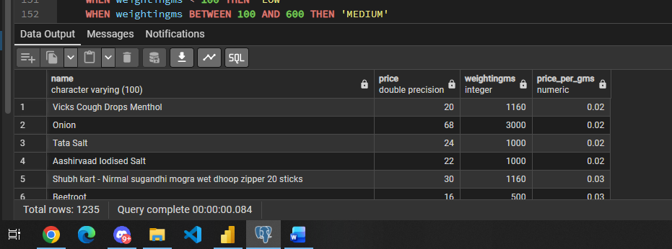

-- group the products into categories like low, medium and bulk
-- i'll go for < 100 low, 100 < and > 600 medium and 600 < bulk
SELECT
name,
weightingms,
CASE
WHEN weightingms < 100 THEN 'LOW'
WHEN weightingms BETWEEN 100 AND 600 THEN 'MEDIUM'
ELSE 'BULK'
END AS segmentation
FROM fruits

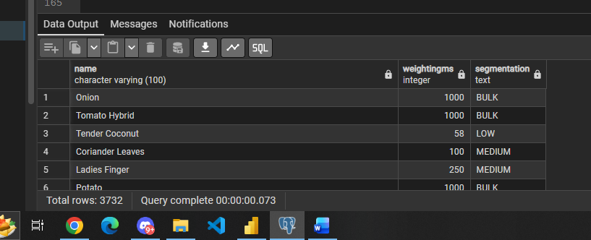

-- what is the total inventory weight per category

SELECT
category,
SUM(weightingms * availablequantity) AS total_weight_per_cgy
FROM fruits
GROUP BY 1

