• Write a query to count the total number of bookings for each booking_status.
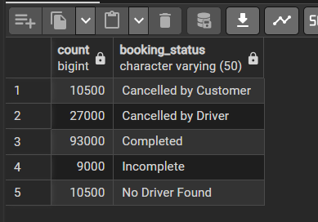

• Retrieve all booking_ids where the booking_value is greater than 500.

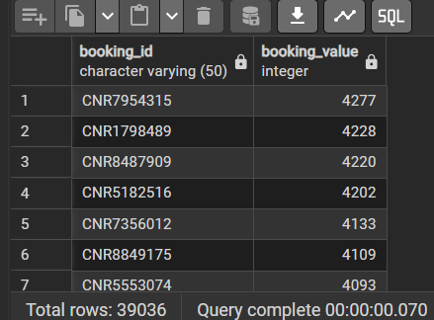

• List all unique pickup_location names present in the database.
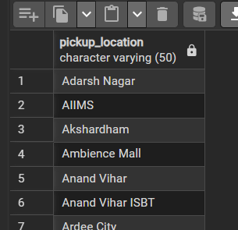

• Find all rides completed using a 'Prime Sedan' as the vehicle_type.

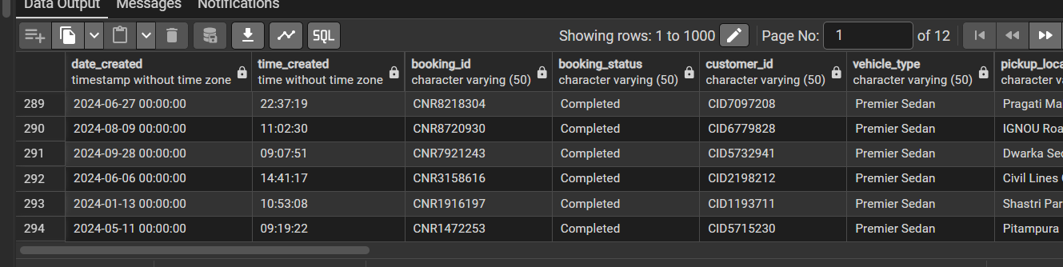

• Calculate the average customer_rating for all completed rides.

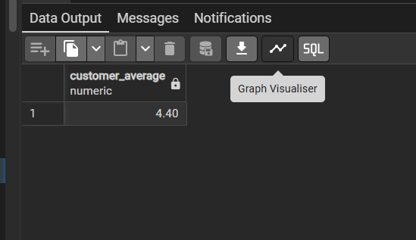

• Retrieve all bookings created on the date '2024-01-15'.

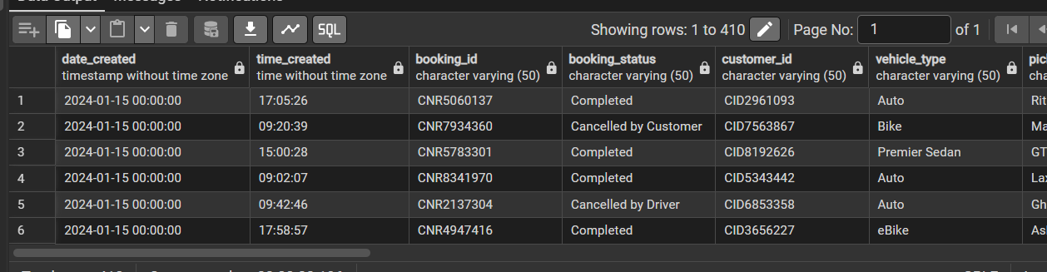
• Find all customers whose pickup_location starts with the letter 'A' using LIKE.

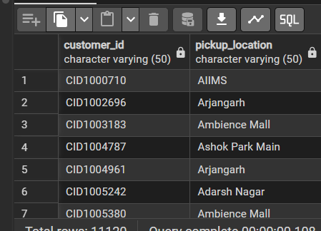

• Select the top 5 highest booking_value entries, ordered from largest to smallest.

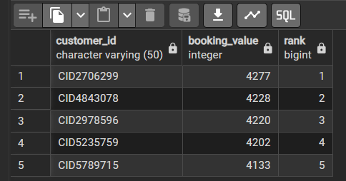

• Count how many rides have a NULL value in the driver_cancellation_reason column.

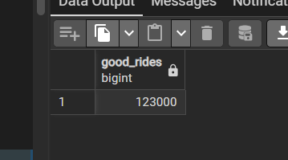
• Identify the most used payment_method using LIMIT 1.
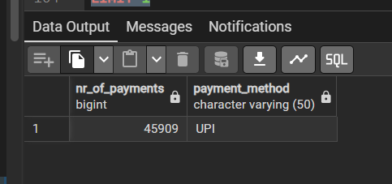

• Use EXTRACT(HOUR FROM time_created) to find which hour of the day has the most bookings.
• Calculate the percentage of rides cancelled by customers versus the total number of bookings.
• Find customer_ids who have made more than 10 bookings.
• List each vehicle_type and its total revenue, but only for types that generated more than 5000 in total.
• Create a column value_category using a CASE statement (e.g., >200 is 'High', else 'Low').
• Calculate the average ride_distance for each vehicle_type.
• (Assuming a separate Customer table) Join the bookings with customers to find the names of people who used 'Cash' payment.
• For all cancelled_rides_by_driver, list the top 3 most common driver_cancellation_reason.
• Group the total booking_value by month using DATE_TRUNC.
• Find the difference between customer_rating and driver_ratings for each booking.

• Customer Ranking: Use RANK() to rank customers within each pickup_location based on their total booking_value.
• Calculate a 7-day rolling average of the daily total booking_value.
• Using a CTE, find the average time difference between a customer's first and second booking.
• Use PERCENT_RANK() or NTILE to identify the top 10% of rides in terms of distance.
• Identify customers who have cancelled 3 or more rides in a row using LAG().
• Create a summary table showing total bookings per vehicle_type as columns and booking_status as rows (using FILTER or CASE).
• Identify booking_ids where avg_vtat is 2 standard deviations above the mean for that specific vehicle_type.
• For each customer, find the most common drop_location following a specific pickup_location.
• Calculate the percentage contribution of each vehicle_type to the total daily revenue using OVER().
• Find the customer_ids who had an incomplete_ride and then booked another ride successfully within 2 hours.

