Fund Distributions Process (FDP)

**Purpose of the document**

The Fund Distributions Process Document outlines any Federal Agency (Agency) Fund Distributions Process

“This document has been prepared by ETASC BPM & RPA CoE for consumption by partners within the bank in support of their Robotics Process Automation efforts. If the baseline templates need to be altered to suit your program’s needs, the changes have to be carefully vetted by business, technology and ETASC CoE. All suggestions on enhancements to this template should be directed to DG RPA-Team.”

|  |  |
| --- | --- |
| **Document Name:** | **Fund Distributions Process (FDP)** |
| **Project Name:** | **FundDistributions** |

Table of Contents

1.0 Introduction 3

Objectives 3

Process Key Contacts 3

2.0 Process Overview 4

Enter Funds Distributions Window: 4

Prerequisites for Entering Fund Distributions: 5

Recording and Entering Fund Distributions 6

Fund Distributions Process Map 8

Fund Distributions Entry Steps 9

Business Exceptions Handling 9

Applications Used in the Process 10

Additional Process Documentation 10

# Introduction

The Fund Distributions Process Document outlines any Federal Agency (Agency) using the Enter Funds Distributions window to record Lower level budget execution transactions, such as apportionments, allocation, and allotments.

### Objectives

N/A

### Process Key Contacts

N/A

|  |  |  |  |
| --- | --- | --- | --- |
| **Role** | **Name** | **Contact details** | **Notes** |
| Process Owner |  |  |  |
| Process SME |  |  |  |
| * |  |  |  |

*\*Add other roles to the table as needed.*

# Process Overview

Budget execution transactions, such as apportionments, allocation, and allotments are recorded in the Enter Funds Distributions window of Budget Fund Distributions.

### Enter Funds Distributions Window:

You can use enter funds distributions window to complete these tasks:

* Distribute funds to lower budget levels.
* Access budget levels and data appropriate to a user's access privileges.
* Distribute funds by quarter or some other time period based on the general ledger date.
* Capture budgetary data for open and future periods based on the general ledger date but only data for open periods can be posted to General Ledger.
* Validate available funds against general ledger summary templates to ensure that total distributions do not exceed appropriation amounts.
* Create journal entries in Subledger Accounting.
* View funds checking results via the Budgetary Control results report.

Below screen displays **Enter Funds Distributions** window:

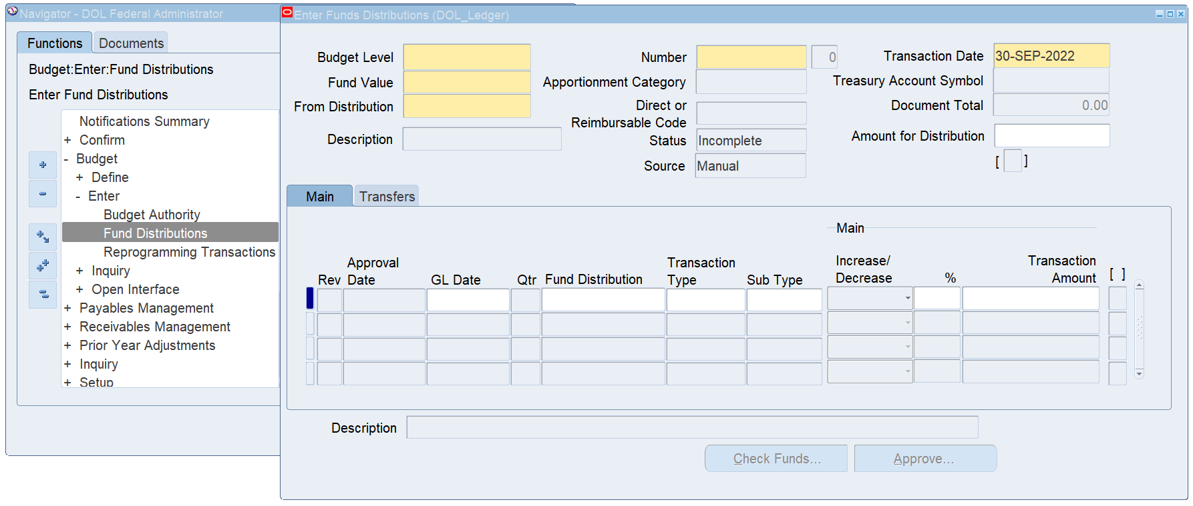

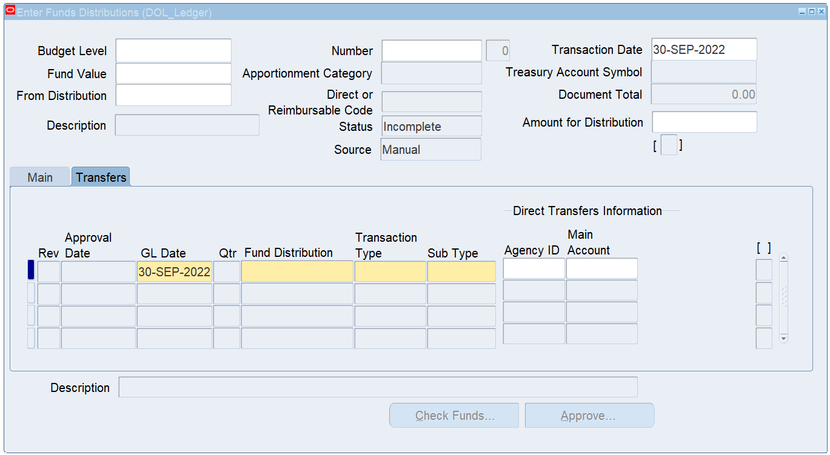

### Prerequisites for Entering Fund Distributions:

To process Budget Execution transactions, you must:

1. Define Budget levels.
2. Define Transaction types and if needed, transaction sub types.
3. Define Budget Distributions

### Budget Levels

Budget execution has an unlimited number of levels for budget control and details. Each of the budget levels uses a window with fields for the data required at that level. Users choose the number of budget levels and their names.

**Note:** Budget level names are assigned during the setup process.

**Example**

The ABC agency uses these hierarchies:

* Appropriation, level 1, distributes budget authority by fund value using the Enter Budget Authority window.
* Apportionment, level 2, allocates appropriated funds based on fund value and category by time period or activity.
* Allotment, level 3, distributes budgetary resources to a more detailed reporting structure, such as organization, object class, project, or activity.

Both apportionment and allotment transactions are recorded using the Enter Funds Distribution window.

### Recording and Entering Fund Distributions

To record and generate Direct or Reimbursable Code and Treasury Account Symbol navigate to the Enter Funds Distributions window as follows: Federal Administrator -> Budget-> Enter-> Fund Distributions-> Open



The above screen shot and below table describes selected fields on the Enter Funds Distributions window

|  |  |
| --- | --- |
| **Field Name** | **Description** |
| Budget Level | Budget level for which users are distributing funds. If the budget level is entered after the fund value is entered, the list of values is restricted to the budget levels that are defined for the fund value. |
| Fund Value | Fund values from Define Budget Distributions. List of values includes fund values that have a corresponding transaction defined in a previous budget level. |
| From Distribution | Distributions available from previous level for the fund value selected. This field is blank when the source is reprogramming. |
| Description | Budget distribution account segment description. |
| Number | Unique number to identify the budget transaction for a particular combination of budget level, set of books and source. |
| Apportionment Category | Automatically displayed for fund value. |
| Direct or Reimbursable Code | Automatically displayed for fund value. |
| Transaction Date | Defaults to current date. |
| Treasury Account Symbol | Treasury Account Symbol as defined in the Define Fund Attributes window. |
| Direct or Reimbursable Code | Automatically displayed for fund value. |
| Transaction Date | Defaults to current date. |
| Treasury Account Symbol | Treasury Account Symbol as defined in the Define Fund Attributes window. |
| Revision Number] | Revision number; increments by 1 when transaction updated and saved. |
| Status | Document status. Valid values include Incomplete, In Process, Approved, Rejected, Requires Re-approval, Forwarded, Not Reserved, and Reserved. |
| Source | Defaults to Manual for transactions entered in the budget execution module; indicates Reprogramming if the transaction was created from the reprogramming process. |
| Document Total | Control total for the sum of the transaction amounts. |
| Amount for Distribution | Amount available for distribution. |
| Rev | Revision number; after document approval, increments by 1 for the appropriate line level transaction revision. |
| GL Date | Accounting period to which the transaction is to be posted; must fall within an open or future-entry general ledger period. The GL date cannot be after the cancellation date of the Treasury Account Symbol. |
| Qtr | Fiscal year quarter; automatically populated when GL Date selected. |
| Fund Distribution | Values of enabled budget segments for distributions to fund value at current budget level. |
| Transaction Type | Transaction type; defined in the Define Transaction Types window. |
| Sub Type | Conditionally required based on the transaction type setup. |
| Increase/Decrease | Indicates if transaction is an increase or a decrease. |
| % | Percent of amount available for distribution that should be distributed at this line; enabled only when distribution amount provided. |
| Transaction Amount | Dollar amount. If users enter the % field, the amount is calculated as amount available percentage provided. |
| Check Fund... | Initiates funds checking process. |
| Approve... | Initiates budget execution transaction approval process. If workflow is enabled, the Approve Document window appears. Authorized users can forward document to a different approver. |

### Fund Distributions Process Map

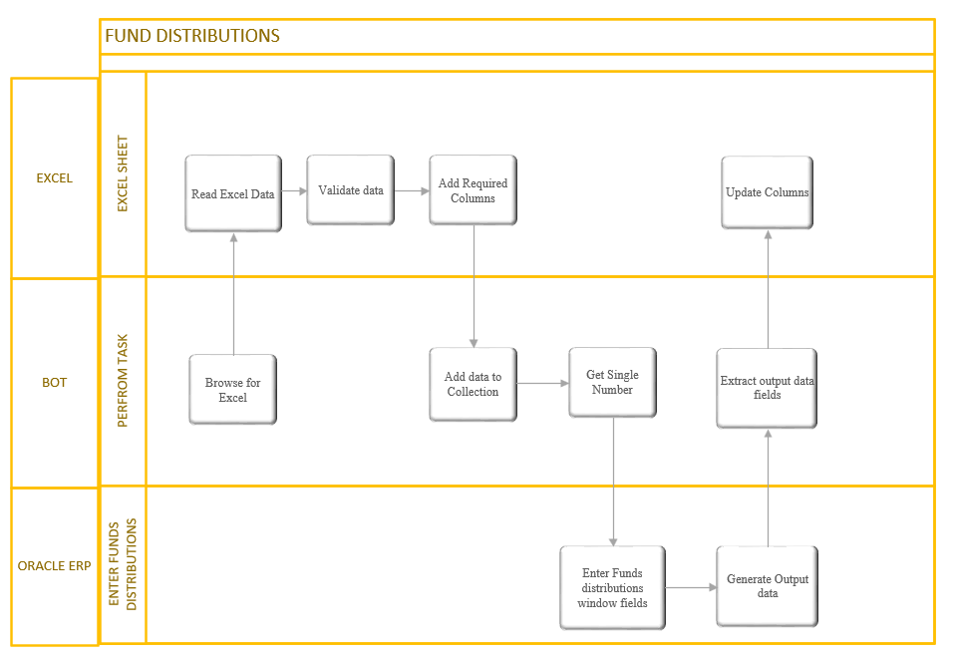

### Fund Distributions Entry Steps

|  |  |
| --- | --- |
| **Step** | **Short Description of Key Process Steps** |
| 1 | Navigate to Enter Funds Distributions window. |
| 2 | Enter Budget Level. |
| 3 | Enter a Number. |
| 4 | Enter Transaction Date. |
| 5 | Enter From Distribution. |
| 6 | Enter Amount for Distribution if provided. |
| 7 | Enter GL Date. |
| 8 | Enter Fund Distribution. |
| 9 | Enter Transaction Type. |
| 10 | Enter Sub Type. |
| 11 | Select Increase/ Decrease. |
| 12 | Enter % if enabled and provided. |
| 13 | Click on Save icon. |
| 14 | Extract Direct or Reimbursable Code field. |
| 15 | Extract generated Treasury Account symbol field. |
| 16 | Extract Status field. |
| 17 | Extract Document Total field. |
| 18 | Click No if Decision Pop up appears. |

### Business Exceptions Handling

**This section provides the possible exceptions**

|  |  |  |  |  |
| --- | --- | --- | --- | --- |
| **#** | **Exception name** | **Step #** | **Parameters** | **Action to be taken** |
| 1 | Validation Failure |  |  | Click ok on Note pop up and Close window |
| 2 | Document Number Error |  |  | Click ok on Error pop up and Close window |
| 3 | GL Date Error |  |  | Click on OK and Close window |

### Applications Used in the Process

**N/A**

|  |  |  |  |  |  |  |
| --- | --- | --- | --- | --- | --- | --- |
| **#** | **Application name & version** | **System**  **Language** | **Login Module** | **Interface** | **Environment/**  **Access method** | **Comments** |
| 1 | *Oracle ERP* |  |  | *Oracle ERP*  *Frontend: Java*  *Applet based*  *Oracle Forms,*  *HTML screens* |  |  |
| 2 | *Excel*  *Spreadsheets* |  |  | *MS windows* |  |  |

*\*Add more rows to the table as needed.*

### Additional Process Documentation

N/A

|  |  |  |
| --- | --- | --- |
| **Additional Process Documentation** | | |
|  |  |  |
|  |  |  |
|  |  |  |
|  |  |  |