TreasuryConfirmation - Solution Design Document (SDD)

7/2/2022

DataParticles

Document Name: | TreasuryConfirmation - Robotics Solution Design Document (SDD)
Project Name: | TreasuryConfirmation

Revision History
Rev. # | Date | Sect./Page # | Revision Summary | Author
D0.1 | 06/27/2022 | All | Initial Draft | Hariharan Gouri, Rajesh Sudileti
D0.2 | 06/27/2022 | All | Added project name | Hariharan Gouri, Rajesh Sudileti
D0.3 | 07/02/2022 | 08 of 16 | Added Workflow Names and Flowcharts | Hariharan Gouri, Rajesh Sudileti

Table of Contents

1.0 Automated Master Project Details 4
Introduction 4
Summary 4
Developer(s) 4
Bitbucket Repo 4
Post Production Owners 4
2.0 Runtime Guide 5
List of Packages 5
Master Project Runtime Details 5
Runtime Diagram – Architectural Structure of the Master Project 7
Running the Automation as RDA 7
3.0 Project Details 7
4.0 Production Orchestrator Assets 8
5.0 Compliance Considerations 9
Impact Analysis 9
Operation Risk Analysis 9
Resiliency Strategies 9
Control Plan 9
6.0 Future Improvements 9
7.0 Debugging Tips 10
8.0 Post UAT Specifications 10
9.0 Approvals 11
10.0 Glossary 12

Automated Master Project Details

Introduction
[Please have the developer fill in to reflect the actual information for the master project released for production.]
# | Item | Details
1 | Master project name and version | TreasuryConfirmation
2 | Robot type (attended / unattended / mix) | Attended
3 | Is Orchestrator used? (Yes / No) | Yes – Package & Process
4 | Scalable? (Yes/ No) | Yes
5 | Schedule (when will the process run) | Attended Automation – User will manually trigger the process from UiPath Assistant

Summary:

Bot enters the given Payment Instructions into the Treasury Confirmation and Reconciliation of Oracle ERP web application based on the process type which is Confirmation or Back Out of respective Payment Instruction and the final on-screen display status will be updated into the final output excel sheet.

Upon getting Unconfirmed status bot will execute the concurrent program by entering the request number and retrieves the log messages, will be updated as bot comments into the final output excel sheet.

Final output sheet will be shared to SME.

Developer(s): Hariharan Gouri, Rajesh Sudileti

Runtime Guide

List of Packages
[Please list packages and provide a high-level description for each.]
# | Package name | High-level description
1 | TreasuryConfirmation
2
3
4
*Add rows to the table as needed.

Master Project Runtime Details
[Please document key details for the automated process.]
# | Item | Details  (If a section does not apply please mark the field as “n/a”. No empty fields. )
1 | Production environment details | NA
2 | Prerequisites to run | - Edge browser needs to be installed.  - IE mode needs to be enabled in Edge browser.  - Install UiPath extension in Edge browser.  - Install UiPath assistant.
3 | Input Data | Treasury Confirmation Input File (Excel) – User will select input file during bot run.
4 | Expected Output (output data) | Updated excel sheet with on-screen display Status, Bot status, Bot Comments and Timestamp post Treasury Confirmation bot run.
5 | How to start the automated process? | Attended Automation – User will manually trigger the process from UiPath Assistant
6 | How to resume the process from a particular step? | - User prompted for ‘InputFilePath’ in UiPath form: User will need to browse for input file path and hit submit on UiPath form to resume.  - User prompted to enter Oracle ERP credentials in input box: User will need to enter credentials and hit login to resume.
7 | Reporting (queues reporting, Kibana or another platform) | Output data in excel will be sent in an email to SME for every bot run.
8 | Manual Error Handling (roll back or manually complete failed transactions). Procedures to reset the item (e.g. “set status as investigating”) | User will need to manually complete failed transactions for system exceptions.
 | How to resume the process in case of error | Recovery mechanism is included in the bot.
 | How to manually fix transactions with error | User can make required corrections in input file based on bot comments and restart bot.
9 | Use of Orchestrator | Yes
 | Password policies (e.g. specific compliance requests) | Passwords will not be saved in Orchestrator.  User will enter password during bot run for Oracle ERP login.
 | Stored Credentials:  (Never hard code credentials in the workflow) | No  User will enter password during bot run for Oracle ERP login.
 | List of Queues Names (Follow naming convention ProcessName_QueueName) | No Queues used
10 | Multiple resolutions supported  (in case of image automation/ Citrix) | N/A
 | Recommended resolution | N/A

Runtime Diagram – Architectural Structure of the Master Project
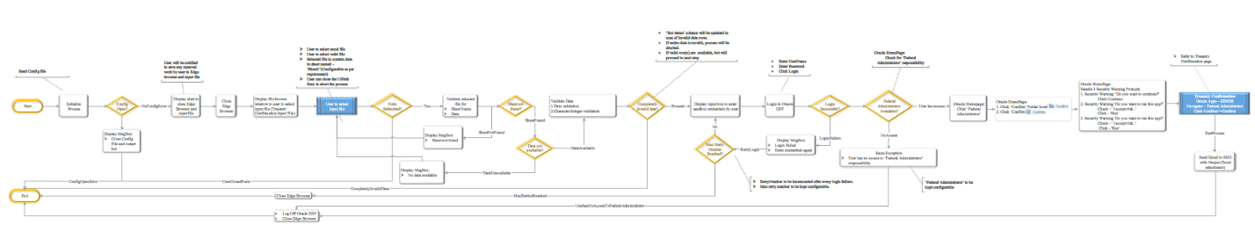

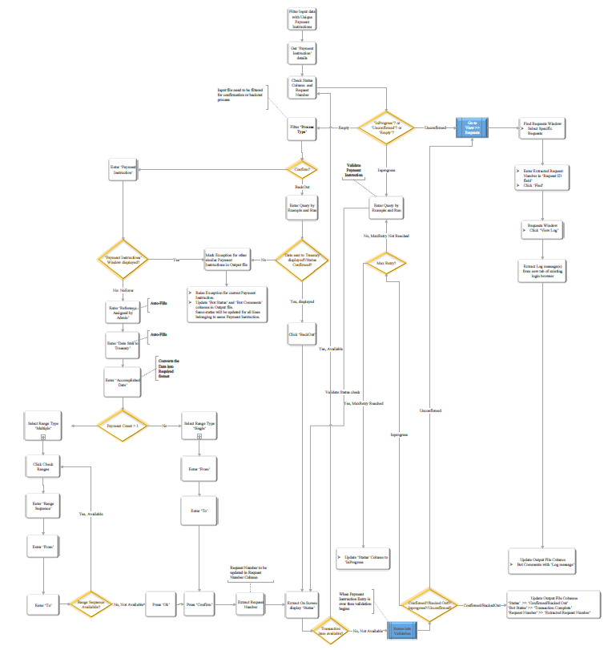

Running the Automation as RDA

Launch ‘UiPath Assistant’.
- Install process ‘TreasuryConfirmation’ if not installed already.
- Click on play icon to run process.

Project Details
[In this section please describe all the projects that compose the automated process.
Add to the title of this section the actual project name of the automated process.
# | Item | Details (If a section does not apply please mark the field as “n/a”. No empty fields. )
1 | Environment used for development (name, location, configuration details, etc.) | Dev Orchestrator
2 | Environment prerequisites  (OS details, libraries, required apps) | - Edge browser needs to be installed.  - IE mode needs to be enabled in Edge browser.  - Install UiPath extension in Edge browser.  - Install UiPath assistant.
3 | Logging level | Info, Warn, Error
4 | Details about automation (if the apps were automated using UI Automation, Image & Text) | UI Automation
5 | In case of FOR, can the user operate the computer while the robot is running? | User cannot use same system during bot run.
6 | Repository for project (where the developed project is stored) | FedBotFactory/TreasuryConfirmation
7 | List of reused components | TBD
8 | Custom logs defined in the workflows (where Throw Activity used, or custom log message defined) | TBD
9 | Frequent errors found in the development phase | TBD
10 | Workarounds used in the automation phase | TBD
11 | Configuration method (assets, excel file, Json file) | Excel
12 | Configuration details (path for input files, configuration Orchestrator assets used) | TBD

Workflow(s)
Define below all the workflow files (.xaml files) used in the project, with the Input and Output data.
# | Workflow file name | Description | Input Argument | Output Argument
1 | InitAllSettings | Read Config file | in_ConfigFile  in_ConfigSheets | out_Config
2 | BrowseFile | Opens a UiPath form to select input file | in_Config | out_strFilePath
3 | ReadTreasuryConfirmationInputFile | Read input file | in_strInputFilePath  in_Config | out_dtMainData
4 | ValidateTreasuryConfirmationInputFile | Validates data in input file | in_Config  in_strOutputFilePath  io_dtMainData
5 | GetUniquePaymentInstructions | Filter Unique Payment Instructions and maps to Transaction Data | in_config  in_dtMainData | out_icollTransactionData
6 | CloseEdge | Closes Edge browser If it’s open | in_Config
7 | LaunchOracleERP | Launches Oracle ERP applications | in_Config
8 | LoginOracleERP | Login to Oracle ERP applications | in_config
9 | SiteNotSecure | Handles Site not secure dialogues | in_config
10 | LoginPage | Login to Oracle ERP applications using given credentials and retries upon failure to login | in_config
11 | NavigateToTreasuryConfirmation | Navigates to Treasury Confirmation window | in_config  in_Responsibility
12 | HandleSecurityWarnings | Handles Security warnings | in_config
13 | ReopenTCPNavigator | Treasury Confirmation window will be reopened by closing it | in_config
14 | GetTransactionData | Maps Transaction Data | in_Config  in_TransactionNumber  io_dt_TransactionData  io_dt_MainData  io_MaxNumOfLoops | out_TransactionID  out_TransactionItem
15 | GetNextItem | Check Transaction Number and move to next process | in_Config  in_TransactionNumber  io_dt_TransactionData  io_dt_MainData  io_MaxNumOfLoops | out_TransactionItem
16 | GetPaymentInstructionsData | Assign variables with Transaction Item containing Payment Instructions | in_dtMain  in_Config  in_TransactionItem | out_MasterRow  out_dtPaymentInstruction
17 | TreasuryConfirmationAndReconciliation | Confirmation or Back out or Unconfirmed Process | in_Config  in_MasterRow  in_dtMain  in_dtPaymentInstruction | out_strErrorLogMessage  out_strStatusCheck  out_strRequestNumber
18 | ConfirmationOrBackOutProcess | Confirmation or Backout process | in_Config  in_MasterRow  in_dtMain  in_dtPaymentInstruction  in_strPaymentInstruction  in_strProcessType  in_strAccomplishedDate  in_strDateSentToTreasury  in_strReferenceAssignedbyAdmin | out_strRequestNumber  out_strSingleRangeOrMultipleRangeOrBackedOutStatusCheck
19 | ConfirmationProcess | Confirmation Process | in_strPaymentInstruction  in_strAccomplishedDate  in_dtMain  in_dtPaymentInstruction  in_Config  in_MasterRow | out_strRequestNumber  out_strSingleOrMultipleRangeStatusCheck
20 | MultipleRange | Payment instructions with Multiple Range | in_dtMain  in_blnNoteDisplayed  in_blnErrorAccountEntry  in_dtPaymentInstruction  in_Config | out_strMultipleRangeRequestNumber  out_strMultipleRangeStatusCheck
21 | SingleRange | Payment Instructions with Single Range | in_blnNoteDisplayed  in_blnErrorAccountEntry  in_MasterRow  in_config | out_strSingleRangeRequestNumber  out_strSingleRangeStatusCheck
22 | BackOutProcess | Payment Instructions with Back out | in_strReferenceAssignedbyAdmin  in_strDateSentToTreasury  in_strAccomplishedDate  in_strBackOutPaymentInstruction  in_Config | out_strBackOutRequestNumber  out_strBackedOutStatusCheck
23 | ValidatePaymentInstructions | Validates Payment instructions | in_strReferenceAssignedbyAdmin  in_strDateSentToTreasury  in_strAccomplishedDate  in_strValidatePaymentInstruction  in_strRequestNumber  in_Config | out_strValidationStatusCheck  out_strErrorLogMessage
24 | ViewLogs | For Unconfirmed status retrieves log messages | in_strRequestNumber  in_Config | ut_strErrorLogMessage
25 | UpdateBotStatus | Final update of Bot Status, Bot Comments and Time Stamp | in_dtMaindata  in_Config  in_BotStatus  in_BotComments  in_ColumnName  in_ColumnValue  in_strRequestNumber  in_strStatusCheck

LoginOracleERP Workflow – Flowchart
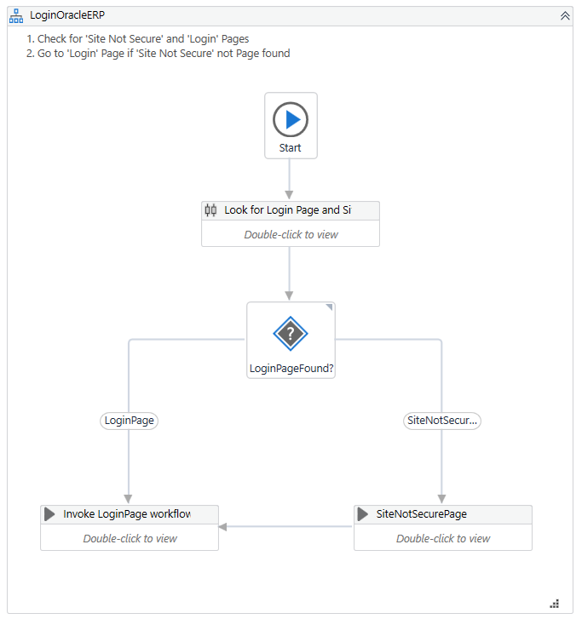

TreasuryConfirmationAndReconciliation Workflow – Flowchart
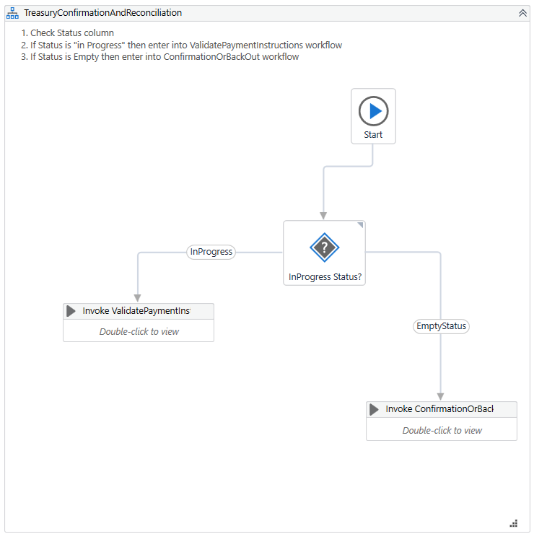

ConfirmationOrBackOutProcess Workflow – Flowchart
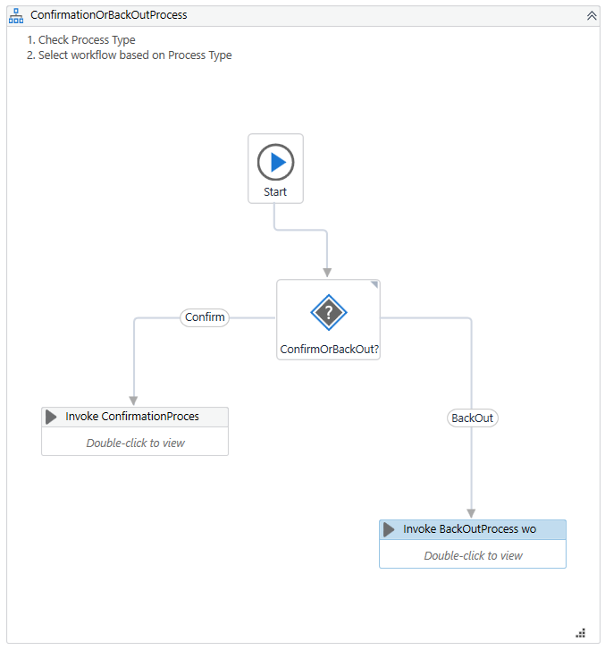

BackOutProcess Workflow – Flow chart
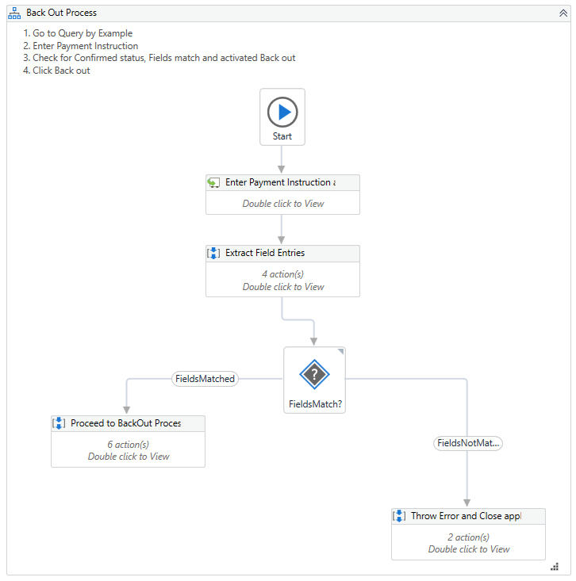

ValidatePaymentInstructions Workflow – Flow chart
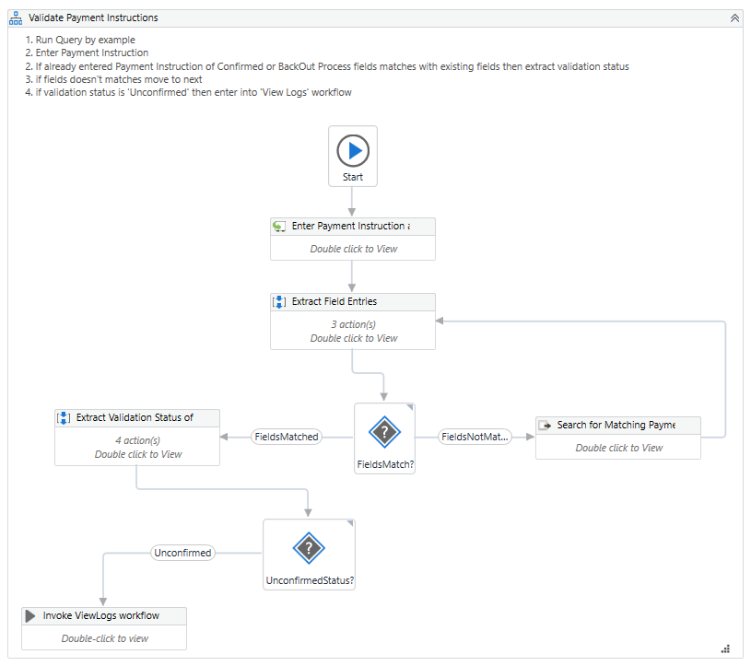

*Add more rows to the table to include all the workflow file names. No fields should be left empty. Use “n/a” for the items that don`t apply to your project.
*If the workflow is a flowchart, also include below the exported image from Studio.
**Start the list with the one that will run by default when the package is executed.

Production Orchestrator Assets
If the value contains sensitive information, leave the value column empty.
Name | Asset | Type (Integer, Bool, Text, Credential) | Value (Leave empty if sensitive)
n/a

Compliance Considerations
Item | Specific Considerations (If a section does not apply please mark the field as “n/a”. No empty fields.)
n/a | n/a

Future Improvements
Improvement | Benefit/Reason
TBD

Debugging Tips
Scenario/Error | Tip
TBD

Post UAT Specifications
Item | Specification
Average duration per transaction: (varies depending on the Test environment) | TBD
Recommended number of robots for the specified volumes | TBD
Schedule (when will this run) | Attended Automation – User will manually trigger the process from UiPath Assistant

Approvals
Date | Role | Name | Signature
07/02/2022 | Author | Hariharan Gouri, Rajesh Sudileti
 | Solution Architect | Sunil Melam
 | Process Owner | Anand Ravulapalli, Srinivas Dasari
 | RPA Program Manager | Sunil Melam

Glossary
Master project - the overall output of the development, containing one or multiple projects that together cover the scope of the robotic process automation.
Project - a UiPath Studio project containing one or multiple workflow files. A project can be converted to a package and run independently, covering a particular scope within the master project. The project is used when defining the development and support phase of the automation.
Package - the output of compiling a project. A package can be deployed on the robot machine and be executed by the robot service. Only one package can be executed at a given time by a robot. The package is used when defining the running phase of the automation
Workflow - a component of the package, the workflow encapsulates a part of the project logic. The workflow can be of type: sequence, flowchart or state machine. a workflow is saved as an .xaml file inside the project folder. A workflow file can be invoked from another workflow and by default there is an initial workflow file that will run when executing the package.
Activity - an action that the robot executes.
Sequence - a workflow where activities are executed one after another, in a sequential order
Flowchart - a workflow where activities are connected by arrows and the logic of the workflow can be easily followed in a visual manner. The flowchart can also be exported as an image from UiPath studio
State machine - a more advanced way of organizing a workflow, similar to a flowchart.
Orchestrator – Enterprise architecture server platform supporting: release management, centralized logging, reporting, auditing and monitoring tools, remote control, centralized scheduling, queue/robot workload management, assets management.

