User & Installation Manual

VR Moon Landing Experience

Version 1.0

October 2018

|  |  |
| --- | --- |
|  | C:\Users\xrosi\AppData\Local\Microsoft\Windows\INetCache\Content.Word\Logov6.png |

# Table Of Contents

Table Of Contents 2

Change Log 3

Publication Information 4

GPL (GNU Public License) Licensing 5

Document Purpose 6

Document Conventions 6

Glossary 7

Technical Specifications 9

Hardware Specifications 9

System Requirements (Recommended by Steam) 9

System 1 9

System 2 9

Software Specifications (From System 1) 9

Final Statistics 10

10

Obtaining the Product (Hamish - GitHub download) 11

Installation Instructions 12

Deployment/Creating a Build (Hamish) 12

Usage Guides 13

References 14

# 

# Change Log

|  |  |  |  |
| --- | --- | --- | --- |
| **Revision Date** | **Editor** | **Comment** | **Version No.** |
| 28-10-281 | Anthony Chapman | Final review and publication | 1.0 |
| 28-10-18 | Josh Power | Updates Section: Added more information to the usage guides and added a references section | 0.07 |
| 25-10-2018 | Anthony Chapman | Updated Section: Glossary  and Document Conventions | 0.06 |
| 23-10-2018 | Jack Marshall | Updated Section: Purpose of Document | 0.05 |
| 22-10-2018 | Josh Power | Updated Section: Usage guides | 0.04 |
| 22-10-2018 | Xana Rosini | Updated Section: Technical Specifications  Modified: Document Presentation | 0.03 |
| 20-10-2018 | Hamish Buckmaster | Updated Section: Obtaining the Product and Deployment Guide  Modified: Document Structure | 0.02 |
| 06-08-2018 | Josh Power | Initial Document Draft | 0.01 |

# 

## 

# Publication Information

**Authors**

Anthony Chapman, Hamish Buckmaster, Jack Marshall, Josh Power, Xana Rosini

**Developers**

Anthony Chapman, Hamish Buckmaster, Jack Marshall, Josh Power, Xana Rosini

**Publication Date**

28/10/2018

**Institute**

Federation University, Mt Helen, 3350

# GPL (GNU Public License) Licensing

Project-VR-Moon-Experience is licensed under the GNU General Public License v3.0

Permissions of this strong copyleft license are conditioned on make available complete source code of licensed works and modifications, which include large works using a licensed work, under the same license. Copyright and license notices must be preserved. Contributor provide an express grant of patent rights.

**License Permissions**

* Commercial use
* Modification
* Distribution
* Patent use
* Private use

**License Limitations**

* Liability
* Warranty

**Conditions**

* License and copyright notice
* State changes
* Disclose source
* Same license

## 

# Document Purpose

The purpose of this document is to provide users with assistance for our Virtual Reality Moon experience. In this document we have included the necessary information to install and run our experience from scratch. Some sections that are contained to help aid you are:

* Technical specifications
* Packaging format and contents
* Installation instructions
* Configuration requirements and options
* Instruction guides for usage

With all this information provided we intend for any users who read our manual can then attain a copy of our project, which they can then install and run by themselves.

## Document Conventions

**Headings**

Main headings consist of heading type 1 (Arial, 20):

Example

Sub heading consist of heading type 2 (Arial, 16):

Example

**Ordering**

Items with a sequential order are represented via a numerical system, with alphabetical subsystem when required. E.g.

**1**.Go to “File > Build Settings”, Once the build settings window has been opened

**a.** Make sure the “MainSceneMoon” and “MainSceneMenu” are included in the “scenes in build”.

**Examples**

Are shown with the prefix of E.g. <Statement>

# Glossary

|  |  |
| --- | --- |
| **Term** | **Definition** |
| **Assets** | An asset is representation of any item that can be used in a game or project. |
| **C#** | High Level Object-Oriented programming language |
| **Discord** | Voice and text chat client |
| **FOST** | Faculty of Science & Technology |
| **FPS** | Frames Per Second |
| **Google Docs** | Free, web-based software office suite offered by Google within its Google Drive service |
| **Graphics** | Graphical processing unit for the computing device |
| **HMD** | Head Mounted Device such as a HTC Vive, Oculus Rift, Samsung Gear etc. |
| **IDE** | Integrated Development Environment for writing and testing code. |
| **Lunar Lander** | The spacecraft that landed on the moon |
| **Memory** | Random Access memory of the computing device |
| **Oculus Rift** | A type of VR Headset |
| **OS** | Operating System which the application runs on, Windows/MacOS/Linux |
| **PC** | Personal Computer |
| **Processor** | Central processing unit for the computing device |
| **SteamVR** | SteamVR is a Virtual Reality Platform developed by Valve as an extension of Steam. SteamVR offers 360 degrees, full room VR experience. It was officially announced on March 1, 2015 during the Mobile World Congress. |
| **STEM** | Science, Technology, Engineering & Mathematics |
| **Trello** | Web-based project management application |
| **Unity** | Game development software |
| **Unityscript** | Similar language to JavaScript but Unity specific. It is an event-based programming language. As of 2017 it has been officially deprecated. |
| **Valve** | Valve Corporation is an American video game developer and digital distribution company headquartered in Bellevue, Washington. The company is known for its software distribution platform Steam. |
| **Vive** | HTC Vive©, a type of VR Headset |
| **VR** | Virtual Reality |
| **VRTK** | Virtual Reality Tool Kit used in Unity© |
| **VS** | Visual Studio© - IDE for C# programming |

## 

# Technical Specifications

## Hardware Specifications

### System Requirements (Recommended by Steam)

OS: Windows 7 SP1, Windows 8.1, or Windows 10

Processor: IntelⓇ i5-4590 / AMD FX 8350 equivalent or higher

Memory: 4GB RAM

Graphics: NVIDIA GeForceⓇ GTX 970 / AMD Radeon™ R9 290 equivalent or higher

Throughout the project we used 2 different systems for testing and benchmarking the application with a HTC VIVE™. The below specifications are from the 2 systems and due to the applications’ need to run on a wide variety of hardware, the application was primarily tested on the lower-end hardware.

### System 1

OS: Windows 10

Processor: IntelⓇ i5-4460

Memory: 16GB

Graphics: NVIDIA GeForce GTX 1060

### System 2

OS: Windows 10

Processor: AMD Ryzen 6 1600X

Memory: 32GB

Graphics: NVIDIA GeForce GTX 1080

## Software Specifications (From System 1)

Git Repository: Major 1.0 (Applications Final Release)

Unity: 2018.2.11f1

Graphics Driver: Version 416.34

Windows: Fully Updated as of 28/10/2018

As of the 28/10/2018 Windows 10 and all drivers are up to date as specified above.

Unity can build the application on different OS but for our application we have limited our testing to Windows 10.

## Final Statistics

**System 1:**

2018-10-25 13:48:13 - VRMoonExperience

Frames: 10701 - Time: 120000ms - Avg: 89.175 - Min: 80 - Max: 91

**System 2:**

2018-10-25 14:39:52 - VRMoonExperience

Frames: 10576 - Time: 120000ms - Avg 87.577 - Min: 78 - Max: 91

## 

# Obtaining the Product (Hamish - GitHub download)

Obtaining the “VR Moon Experience” final product can be downloaded from the GitHub releases page;

1. Open the “Project-VR-Moon-Experience” GitHub page
2. Navigate to the releases button *Inset picture*
3. This page contains all the releases that this project has pre-released/released, Navigate to the latest release
4. You’ll have options to download the source code to load into unity and create your own build or you can download the VR Moon Experiences latest build that is playable like normal. 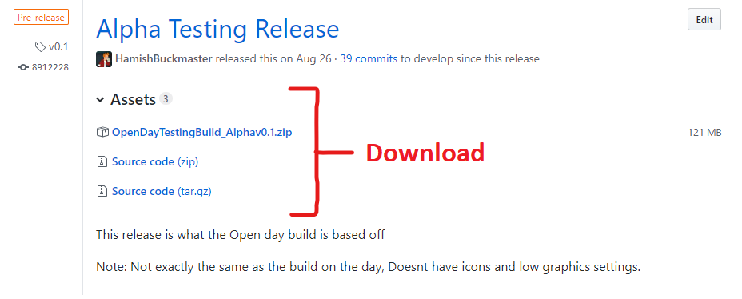
5. Unzip the latest released build to a directory. Then click the “*.exe” file to run it. To set up the VR experience go to the guide called “Configuration and Requirements and options.

## 

# Installation Instructions

## Deployment/Creating a Build (Hamish)

In Unity you can create your own builds to build to other devices if needed, I will summarize what we would need to create a build for this product, but a more detailed guide can be found on Unity’s Documentation Site: <https://docs.unity3d.com/Manual/PublishingBuilds.html>

1. Go to “File > Build Settings”, Once the build settings window has been opened
   1. Make sure the “MainSceneMoon” and “MainSceneMenu” are included in the “scenes in build”.
2. Select the platform you wish to build for, for this product since it’s VR you’ll be only building to Windows Architecture
   1. Copy the settings below and make sure all checkboxes are *UNTICKED*. 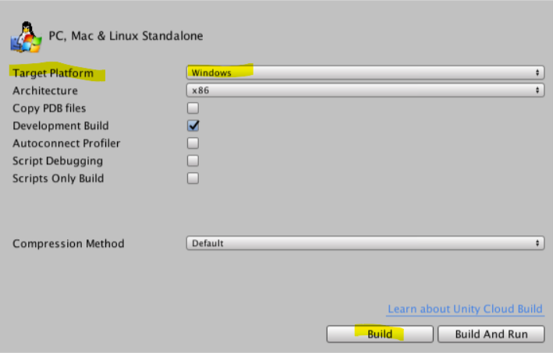
3. Once the settings have been chosen, click the build button and follow the popup dialog to choose a location to have the build built too.
4. Once built and in the desired chosen folder location, Click the “*.exe” to run the “VR Moon Experience”.

## 

# Usage Guides

The application is designed to be an informative and educational experience for the user. The user will be able to interact and experience near to real life experiences that actually occurred on the moon.

The general age requirements for the application are as follows:

* High School aged - 12 to 18 are the most likely to use the application
* Most adults should be able to use the application with some guidance
* Children under the age of 12 are generally not recommended due to the hardware requirements (The headset will not fit a young person) and that long-term usage of VR could have a detrimental effect on their stereo-acuity (their ability to detect differences in distances). (McKie, 2017)

Any users with a physical impairment are not recommended to use the application, as are users who are under the effects of alcohol or drugs, prescribed or otherwise.

For full terms and conditions for the use of the HTC Vive© can go to the following site - <https://www.htc.com/au/terms/vive/vive-eula/>

The following diagram explains the various usage of the buttons on the Vive controller.

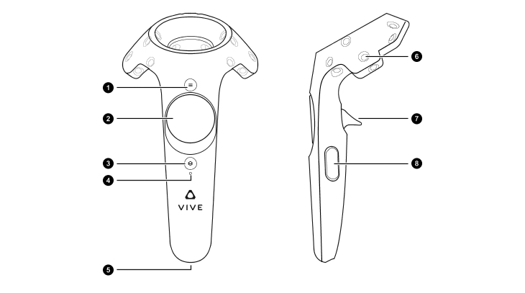

1. SteamVR Home Menu
2. Teleport (Click and hold to enable)
3. Power button
4. Power light
5. Micro USB plug
6. Tracking
7. Interaction Trigger
8. Grip (not used)

# References

McKie, R. (2017, October 28). *Virtual reality headsets could put children’s health at risk*. From The Guardian: https://www.theguardian.com/technology/2017/oct/28/virtual-reality-headset-children-cognitive-problems