
KOMOREBI PIZZA
Online Ordering Website
User & Installation Manual

Team Yatri — Federation University Australia
Nabraj Gyawali (NG) — Scrum Master / Front-End Developer
Ankit Kunwar (AK) — Full Stack Developer / Version Control Lead
Shree B. Thapa (ST) — Full Stack Developer / Database Architect
Sulav Gurung (SG1) — Tester / Technical Writer / Business Analyst
Sushanka Gurung (SG2) — UI/UX Designer / Business Analyst
Client: Mike Vu | Aug 2025 – May 2026 | Version 2.0

Table of Contents
Contents
Glossary 6
1. System Overview 8
1.1 System Specifications 8
1.2 Sprint Overview 8
1.3 User Roles 9
1.4 How to Use This Manual 9
1.5 Revision History 9
2. Installation Guide 10
2.1 Pre-requisites 10
2.2 Windows Installation Guide 10
Step 1 — Install Node.js on Windows 10
Step 2 — Install PostgreSQL on Windows 10
Step 3 — Install Git on Windows 11
Step 4 — Clone the Repository on Windows 11
Step 5 — Install Project Dependencies on Windows 11
Step 6 — Configure Environment Variables (.env) on Windows 12
Step 7 — Create Database and Import Schema on Windows 12
Step 8 — Build and Start the Application on Windows 13
Step 9 — (Optional) Run with PM2 Process Manager on Windows 13
2.3 Linux Installation Guide (Ubuntu 22.04) 14
Step 1 — Install Node.js on Ubuntu 14
Step 2 — Install PostgreSQL on Ubuntu 14
Step 3 — Install Git on Ubuntu 14
Step 4 — Clone the Repository on Ubuntu 14
Step 5 — Install Project Dependencies on Ubuntu 15
Step 6 — Configure Environment Variables (.env) on Ubuntu 15
Step 7 — Create Database and Import Schema on Ubuntu 15
Step 8 — Build and Start the Application on Ubuntu 16
Step 9 — (Optional) Run with PM2 on Ubuntu 16
Step 10 — (Optional) Enable HTTPS with Certbot on Ubuntu 16
A1 — Admin Login (PROJECT-3) 18
How to Log In as Administrator 18
A2 — Admin Logout 22
How to Log Out as Administrator 22
A3 — Create New User Account (PROJECT-5) 23
How to Create a New User Account 23
A4 — Deactivate / Block a User (PROJECT-6) 25
How to Deactivate a User Account 25
A5 — Admin Reset User Password 26
How to Reset a User's Password as Admin 26
A6 — Update User Details 27
How to Update a User's Details 27
A7 — Delete a User Account 28
How to Permanently Delete a User Account 28
A8 — Add a New Product (PROJECT-11) 29
How to Add a New Pizza / Product 29
A9 — Update / Edit a Product (PROJECT-12) 32
How to Edit an Existing Product 32
A10 — Delete / Remove a Product (PROJECT-13) 34
How to Remove a Product 34
A11 — Manage Product Categories (PROJECT-15) 35
How to Add a New Category 35
How to Edit or Delete a Category 36
A12 — Admin View All Orders 38
How to View and Monitor All Customer Orders 38
A13 — Create Promo Codes (PROJECT-43) 40
How to Create a New Promo Code 40
A14 — Send Promotional Emails (PROJECT-44) 42
How to Send a Bulk Promotional Email to Customers 42
A15 — Sales Analytics Dashboard (PROJECT-55) 44
How to Use the Sales Analytics Dashboard 44
A16 — Product Analytics (PROJECT-56) 47
How to View Product Performance Analytics 47
A17 — Manage Homepage Banners (PROJECT-58) 50
How to Add a New Homepage Banner 50
How to Reorder or Remove Banners 51
A18 — Search, Filter & Sort Users (PROJECT-59, 60, 61) 52
How to Search for a Specific User 52
How to Filter Users by Role or Status 53
How to Sort the User List 53
B1 — Customer Registration (PROJECT-1) 55
How to Register a New Customer Account 55
B2 — Customer Login (PROJECT-2) 58
How to Log In as a Customer 58
B3 — Forgot Password / Reset Password (PROJECT-7) 60
How to Reset Your Password 60
B4 — Update Personal Details (PROJECT-9) 62
How to Update Your Profile 62
B5 — Update Delivery Address (PROJECT-10) 63
How to Update Your Delivery Address 63
B6 — Browse Products / View Menu (PROJECT-16) 66
How to Browse the Pizza Menu 66
B7 — View Product Details (PROJECT-17) 68
How to View Full Product Details 68
B8 — Search Products (PROJECT-18) 69
How to Search for a Product 69
B9 — Add Items to Cart (PROJECT-27) 71
How to Add a Product to Your Cart 71
B10 — View & Modify Cart (PROJECT-28 & PROJECT-29) 72
How to View Your Cart 72
How to Modify Your Cart 73
B11 — Place an Order (PROJECT-30 & PROJECT-31) 74
How to Place an Order 74
B12 — Cancel Order (PROJECT-32) 77
How to Cancel an Order 77
B13 — Pay Online via Stripe or PayPal (PROJECT-40) 80
How to Pay Using Stripe (Credit/Debit Card) 80
How to Pay Using PayPal 81
B14 — Order Confirmation Notification (PROJECT-42) 82
How Order Confirmation Works 82
B15 — Apply Promo / Discount Code (PROJECT-46 & PROJECT-47) 83
How to Apply a Promo Code at Checkout 83
B16 — Unsubscribe from Promotional Emails (PROJECT-52) 84
How to Unsubscribe from Promotional Emails 84
C1 — Staff Login (PROJECT-4) 86
How to Log In as a Staff Member 86
C2 — Staff Password Reset (PROJECT-8) 88
How to Reset Your Staff Password 88
C3 — Staff View All Products (PROJECT-14) 90
How to View All Products as Staff 90
C4 — View All Orders (PROJECT-33) 92
How to View Incoming Customer Orders 92
C5 — Accept / Confirm an Order (PROJECT-34) 94
How to Accept a Customer Order 94
C6 — Staff Cancel Order (PROJECT-35) 95
How to Cancel an Order as Staff 95
C7 — Staff Email Notifications for New Orders (PROJECT-41) 97
How Staff Email Notifications Work 97
C8 — Update Order Status (PROJECT-51) 98
How to Update the Status of an Order 98
C9 — Auto-Progress Order Status (PROJECT-53) 101
Understanding Auto-Progress Order Status 101
C10 — Export Order Details as PDF (PROJECT-57) 102
How to Export an Order as a PDF 102
About Us & Contact Information 105

Glossary
Term | Definition
Admin | The highest-level user role with full access to all website management features.
Customer / Shopper | A registered user who browses products, places orders, and makes payments.
Staff / Picker | A restaurant employee who manages and fulfils customer orders.
Jira | Project management tool used by Team Yatri to track user stories and sprints.
User Story | An agile requirement written as: 'As a [role], I want [feature] so that [benefit].'
Sprint | A fixed 2–4 week development cycle in which a set of user stories is completed.
Epic | A high-level grouping of related user stories (e.g. USER REGISTRATION, ORDER PLACEMENT).
Story Points | A relative measure of effort or complexity assigned to each user story.
PBI | Product Backlog Item — any user story or task in the project backlog.
React | A JavaScript library (v19) used to build the Komorebi front-end user interface.
Node.js | JavaScript runtime environment used to run the Komorebi back-end server.
Express | Web framework for Node.js used to define the Komorebi REST API routes.
PostgreSQL | Relational database system used to store all Komorebi application data.
pgAdmin 4 | GUI tool for managing PostgreSQL databases (Windows & Linux).
npm | Node Package Manager — used to install and manage JavaScript project dependencies.
Git | Version control system used to track code changes and collaborate across the team.
JWT | JSON Web Token — used for secure user authentication and session management.
Stripe | Third-party payment gateway for processing credit/debit card payments.
PayPal | Third-party payment gateway for processing PayPal account payments.
Nodemailer | Node.js library used to send transactional emails via Gmail SMTP.
Chart.js | JavaScript charting library used to render the Admin Analytics Dashboard.
PDFKit | Node.js library used to generate PDF exports of order records.
.env File | Configuration file containing sensitive environment variables (never shared publicly).
PM2 | Node.js process manager used to keep the server running in production.
Certbot | Tool used to issue free HTTPS/SSL certificates via Let's Encrypt (Linux).
HTTPS | Secure HTTP protocol — encrypts data between the browser and the server.
Scrum | Agile framework using sprints, daily stand-ups, and retrospectives for project delivery.

1. System Overview
The Komorebi Pizza Ordering Website is a full-stack web application developed by Team Yatri at Federation University Australia for client Mike Vu. The platform enables customers to browse the pizza menu, place and pay for orders online, and track deliveries in real time. Staff manage and fulfil orders. Administrators control all aspects of the platform including products, users, promotions, and analytics.

1.1 System Specifications
Component | Technology / Detail
Front-End | React 19, HTML5, CSS3, JavaScript ES6+
Back-End | Node.js, Express.js (REST API)
Database | PostgreSQL 14+
Authentication | JWT (JSON Web Tokens)
Payment Processing | Stripe API, PayPal REST API
Email Service | Nodemailer + Gmail SMTP
Analytics / Charts | Chart.js
PDF Generation | PDFKit
Version Control | Git + GitHub
Project Management | Jira (Project2_Pizza_Website)
Client | Mike Vu
Team | Team Yatri (5 members)
Project Duration | August 2025 – May 2026
Total Sprints | 5 Sprints
Total User Stories | 62 User Stories

1.2 Sprint Overview
Sprint | Name | Focus | Dates | Stories | Points
Sprint 1 | Account Management | Registration, Login, Password, Profiles | Aug – Sep 2025 | 10 | 32
Sprint 2 | Product Management | Add/Edit/Delete Products, Browse, Search | 22 Sep – 12 Oct 2025 | 8 | 28
Sprint 3 | Order Management | Cart, Checkout, Order Placement, Cancel | 25 Mar – 2 Apr 2026 | 9 | 34
Sprint 4 | Payments & Notifications | Stripe, PayPal, Promo Codes, Email Alerts | 20 Apr – 2 May 2026 | 10 | 40
Sprint 5 | Analytics & Polishing | Dashboard, Analytics, PDF Export, Banners | 14–30 May 2026 | 8 | 31

1.3 User Roles
The system has three distinct user roles, each with different levels of access:

Role | Also Known As | Access Level
Admin | Administrator | Full access: users, products, orders, analytics, promotions, banners, email campaigns
Staff | Picker / Kitchen Staff | Order management: view orders, accept, cancel, update status, export PDF
Customer | Shopper | Browse menu, cart management, place orders, payments, promo codes, profile settings

1.4 How to Use This Manual
This manual is divided into three parts. Use the Table of Contents to jump to the section relevant to your role:
Part | Role | Coverage
Part A | Admin | Login, User Management, Products, Categories, Orders, Promotions, Analytics, Banners (Sprints 1–5)
Part B | Customer | Registration, Login, Browse Menu, Cart, Orders, Payment, Promo Codes (Sprints 1–4)
Part C | Staff | Login, View Products, Order Management, Notifications, Status Updates, PDF Export (Sprints 1–5)

1.5 Revision History
Version | Date | Author | Description
1.0 | Sep 2025 | Team Yatri | Initial installation guide and Sprint 1 user guide
1.5 | Feb 2026 | Team Yatri | Added Sprints 2 & 3 — product and order management
2.0 | May 2026 | Team Yatri | Full manual — all 5 sprints, all 3 roles, Windows & Linux

2. Installation Guide
This section provides step-by-step installation instructions for deploying the Komorebi Pizza Ordering Website on both Windows and Linux (Ubuntu 22.04) operating systems.

2.1 Pre-requisites
Before installing the Komorebi application, ensure the following software is available on your system:

Required Software: Node.js v18+, npm v9+, PostgreSQL 14+, Git 2.x, A modern web browser (Chrome, Firefox, Edge)

2.2 Windows Installation Guide
Windows Installation — Step by Step

Step 1 — Install Node.js on Windows
1 | Open your web browser and go to https://nodejs.org
2 | Download the LTS version (v18 or later) — click the 'LTS Recommended' button.
3 | Run the downloaded installer (e.g. node-v18.x.x-x64.msi).
4 | Accept the licence agreement and click 'Next' through all installation steps.
5 | Tick the checkbox to automatically install necessary tools (including npm).
6 | Click 'Install'. You may be prompted for Administrator permission — click 'Yes'.
7 | After installation completes, click 'Finish'.
8 | Verify the installation: open Command Prompt (Win+R → type cmd → Enter) and run: node --version
9 | Expected output: v18.x.x (or higher). Also run: npm --version — expected output: 9.x.x or higher.

Step 2 — Install PostgreSQL on Windows
1 | Go to https://www.postgresql.org/download/windows/ and download the latest PostgreSQL 14+ installer.
2 | Run the downloaded installer (e.g. postgresql-14.x-windows-x64.exe).
3 | Click 'Next' through the setup wizard. Leave default installation directory.
4 | On the 'Select Components' screen, ensure PostgreSQL Server, pgAdmin 4, and Command Line Tools are all ticked.
5 | Set the data directory (default is fine). Click 'Next'.
6 | Enter a password for the default 'postgres' superuser. Write this password down — you will need it later.
7 | Leave the default port as 5432. Click 'Next'.
8 | Leave locale as default. Click 'Next', then 'Finish' to begin installation.
9 | After installation, open pgAdmin 4 from the Start Menu to verify PostgreSQL is running.
10 | In pgAdmin, connect to the local server using the password you set in step 6.

Step 3 — Install Git on Windows
1 | Go to https://git-scm.com/download/win and download the Git installer.
2 | Run the installer and click 'Next' through all steps, accepting defaults.
3 | Ensure 'Git Bash Here' and 'Git GUI Here' context menu options are selected.
4 | Click 'Install', then 'Finish'.
5 | Verify: open Command Prompt or Git Bash and run: git --version
6 | Expected output: git version 2.x.x

Step 4 — Clone the Repository on Windows
1 | Open Command Prompt (cmd) or Git Bash.
2 | Navigate to the folder where you want to install the project, e.g.: cd C:\Projects
3 | Run the clone command: git clone https://github.com/YourTeam/komorebi-pizza.git
4 | Press Enter. Git downloads all project files to the folder: C:\Projects\komorebi-pizza
5 | Navigate into the project folder: cd komorebi-pizza
6 | Run: dir to confirm the project files are present (you should see: client, server, package.json, README.md).

Step 5 — Install Project Dependencies on Windows
1 | In Command Prompt, inside the komorebi-pizza folder, run: npm install
2 | Wait for npm to install all root-level dependencies. This may take 1–3 minutes.
3 | Navigate to the server folder: cd server
4 | Run: npm install to install back-end dependencies.
5 | Navigate back and then to the client folder: cd ..\client
6 | Run: npm install to install front-end (React) dependencies.
7 | Return to the root: cd ..
8 | All dependencies are now installed. No errors should appear in red.

Step 6 — Configure Environment Variables (.env) on Windows
1 | In the root project folder, look for a file named .env.example
2 | Open Notepad (or VS Code): right-click → Open with Notepad.
3 | Create a new file named .env (no extension) in the server folder.
4 | Copy the contents of .env.example into .env
5 | Fill in the following values:
6 | DB_HOST=localhost
7 | DB_PORT=5432
8 | DB_USER=postgres
9 | DB_PASSWORD=your_postgres_password
10 | DB_NAME=komorebi_db
11 | JWT_SECRET=your_secret_key_here
12 | EMAIL_USER=your_gmail@gmail.com
13 | EMAIL_PASS=your_gmail_app_password
14 | STRIPE_SECRET_KEY=sk_test_xxxxxxxxxxxx
15 | PAYPAL_CLIENT_ID=your_paypal_client_id
16 | PAYPAL_CLIENT_SECRET=your_paypal_secret
17 | Save the .env file. Do NOT commit this file to Git.
Important: Never share your .env file or commit it to GitHub. Add .env to your .gitignore file.

Step 7 — Create Database and Import Schema on Windows
1 | Open pgAdmin 4 from the Start Menu.
2 | In the left panel, expand Servers → PostgreSQL → right-click on Databases → Create → Database.
3 | Enter Database Name: komorebi_db and click Save.
4 | In Command Prompt, navigate to the server folder: cd server
5 | Run the schema import command: psql -U postgres -d komorebi_db -f database/schema.sql
6 | Enter your postgres password when prompted.
7 | Run the seed data command (if provided): psql -U postgres -d komorebi_db -f database/seed.sql
8 | Open pgAdmin and refresh the komorebi_db database to confirm tables were created (users, products, orders, categories, etc.).

Step 8 — Build and Start the Application on Windows
1 | In Command Prompt, from the root project folder, build the React front-end: npm run build
2 | Wait for the build to complete (1–3 minutes). A 'build' folder is created inside the client directory.
3 | Start the server: npm start
4 | The terminal should display: 'Server running on port 5000' (or the configured port).
5 | Open your browser and go to: http://localhost:5000
6 | The Komorebi Pizza website loads. Log in with the admin credentials from the seed data.
7 | To run in development mode (with hot reload): npm run dev

Step 9 — (Optional) Run with PM2 Process Manager on Windows
1 | Install PM2 globally: npm install -g pm2
2 | Start the server with PM2: pm2 start server/index.js --name komorebi
3 | View running processes: pm2 list
4 | To restart: pm2 restart komorebi
5 | To stop: pm2 stop komorebi
6 | PM2 keeps the server running even if you close the terminal window.

2.3 Linux Installation Guide (Ubuntu 22.04)
Linux (Ubuntu 22.04) Installation — Step by Step

All commands below are run in the Terminal. Open a Terminal window with: Ctrl + Alt + T

Step 1 — Install Node.js on Ubuntu
1 | Open Terminal (Ctrl + Alt + T).
2 | Update your package list: sudo apt update
3 | Install curl if not already installed: sudo apt install -y curl
4 | Add the NodeSource repository for Node.js 18 LTS: curl -fsSL https://deb.nodesource.com/setup_18.x | sudo -E bash -
5 | Install Node.js: sudo apt install -y nodejs
6 | Verify: node --version — expected output: v18.x.x
7 | Verify npm: npm --version — expected output: 9.x.x

Step 2 — Install PostgreSQL on Ubuntu
1 | In Terminal, run: sudo apt install -y postgresql postgresql-contrib
2 | Start the PostgreSQL service: sudo systemctl start postgresql
3 | Enable PostgreSQL to start on boot: sudo systemctl enable postgresql
4 | Switch to the postgres user: sudo -i -u postgres
5 | Open the PostgreSQL prompt: psql
6 | Set a password for the postgres user: ALTER USER postgres WITH PASSWORD 'your_password';
7 | Exit the psql prompt: \q
8 | Exit the postgres user session: exit
9 | Verify PostgreSQL is running: sudo systemctl status postgresql — look for 'active (running)'.

Step 3 — Install Git on Ubuntu
1 | Run: sudo apt install -y git
2 | Verify: git --version — expected: git version 2.x.x

Step 4 — Clone the Repository on Ubuntu
1 | Navigate to your desired installation directory: cd ~/projects (create it first with mkdir ~/projects if needed)
2 | Clone the repository: git clone https://github.com/YourTeam/komorebi-pizza.git
3 | Enter the project folder: cd komorebi-pizza
4 | List files to confirm: ls — you should see: client server package.json README.md

Step 5 — Install Project Dependencies on Ubuntu
1 | From the project root, install root dependencies: npm install
2 | Install server dependencies: cd server && npm install
3 | Install client dependencies: cd ../client && npm install
4 | Return to root: cd ..

Step 6 — Configure Environment Variables (.env) on Ubuntu
1 | In the server folder, create the .env file using nano: nano server/.env
2 | Type or paste the following configuration (replace values as required):
3 | DB_HOST=localhost
4 | DB_PORT=5432
5 | DB_USER=postgres
6 | DB_PASSWORD=your_postgres_password
7 | DB_NAME=komorebi_db
8 | JWT_SECRET=your_secret_key_here
9 | EMAIL_USER=your_gmail@gmail.com
10 | EMAIL_PASS=your_gmail_app_password
11 | STRIPE_SECRET_KEY=sk_test_xxxxxxxxxxxx
12 | PAYPAL_CLIENT_ID=your_paypal_client_id
13 | PAYPAL_CLIENT_SECRET=your_paypal_secret
14 | Save and exit nano: press Ctrl+O then Enter to save, then Ctrl+X to exit.
15 | Verify the file: cat server/.env
Security: Run: chmod 600 server/.env to restrict the file to the current user only.

Step 7 — Create Database and Import Schema on Ubuntu
1 | Switch to the postgres user: sudo -i -u postgres
2 | Create the database: createdb komorebi_db
3 | Exit postgres user: exit
4 | Import the schema from the project root: psql -U postgres -d komorebi_db -f server/database/schema.sql
5 | Enter your postgres password when prompted.
6 | Import seed data: psql -U postgres -d komorebi_db -f server/database/seed.sql
7 | Verify tables: psql -U postgres -d komorebi_db -c '\dt'
8 | You should see a list of tables: users, products, orders, categories, promo_codes, banners.

Step 8 — Build and Start the Application on Ubuntu
1 | From the project root, build the React front-end: npm run build
2 | Start the server: npm start
3 | You should see: 'Server running on port 5000'
4 | Open a browser and navigate to: http://localhost:5000
5 | The Komorebi Pizza website loads. Log in with admin credentials from the seed file.
6 | For development mode with hot reload: npm run dev

Step 9 — (Optional) Run with PM2 on Ubuntu
1 | Install PM2: sudo npm install -g pm2
2 | Start with PM2: pm2 start server/index.js --name komorebi
3 | Save PM2 process list: pm2 save
4 | Set PM2 to start on boot: pm2 startup — run the command it outputs with sudo.
5 | Check status: pm2 status

Step 10 — (Optional) Enable HTTPS with Certbot on Ubuntu
1 | This step requires a domain name and public server (e.g. AWS, DigitalOcean, VPS).
2 | Install Certbot: sudo apt install -y certbot python3-certbot-nginx
3 | Install Nginx: sudo apt install -y nginx
4 | Configure Nginx to proxy port 5000 to port 80/443.
5 | Run Certbot: sudo certbot --nginx -d yourdomain.com -d www.yourdomain.com
6 | Follow the prompts to issue an SSL certificate (free via Let's Encrypt).
7 | Certbot automatically configures Nginx for HTTPS.
8 | Test HTTPS: open https://yourdomain.com in your browser.

PART A — ADMINISTRATOR USER GUIDE

This section covers all features available to the Administrator of the Komorebi Pizza website. The Admin has the highest level of access and can manage users, products, categories, orders, promotions, email campaigns, analytics, and homepage content.

Sprint 1 | Admin Features — Login & User Management  Sprint 1 | Aug – Sep 2025

ID | User Story | Epic | Pts | Assignee
PROJECT-3 | Log in securely to manage the website | USER REGISTRATION | 4 | ST
PROJECT-5 | Create new user accounts | USER ACCOUNT MGMT | 5 | NG
PROJECT-6 | Deactivate users so they cannot log in | USER ACCOUNT MGMT | 3 | SG
PROJECT-19 | Reset any user's password | USER ACCOUNT MGMT | 3 | SG
PROJECT-20 | Update any user's details | USER ACCOUNT MGMT | 3 | ST
PROJECT-21 | Delete a user account permanently | USER ACCOUNT MGMT | 2 | ST

A1 — Admin Login (PROJECT-3)
PROJECT-3 Epic: USER REGISTRATION | 4 pts | Assignee: Shree Thapa (ST)
As an admin, I want to log in securely so that I can manage the website.

How to Log In as Administrator
The Admin account is the master account for the Komorebi website. Admin credentials are set up during initial deployment. Keep your admin password strictly confidential.
1 | Open your web browser (Chrome, Firefox, Edge, or Safari) and navigate to the Komorebi website URL.
2 | Click the 'Login' button in the top-right navigation bar.
3 | Enter the Admin Email Address (set during database setup, e.g. admin@komorebi.com).
4 | Enter the Admin Password in the password field.
5 | Click 'Login' or 'Sign In'.
6 | If credentials are correct, you are redirected to the Admin Dashboard.
7 | The Admin Dashboard shows navigation links for: Users, Products, Categories, Orders, Promotions, Analytics, and Settings.
8 | Your name and role ('Admin') will be shown in the top-right navigation bar.
9 | If credentials fail, an error message displays: 'Invalid email or password. Please try again.'
10 | For security, do not share admin credentials. Change the default admin password immediately after first login.

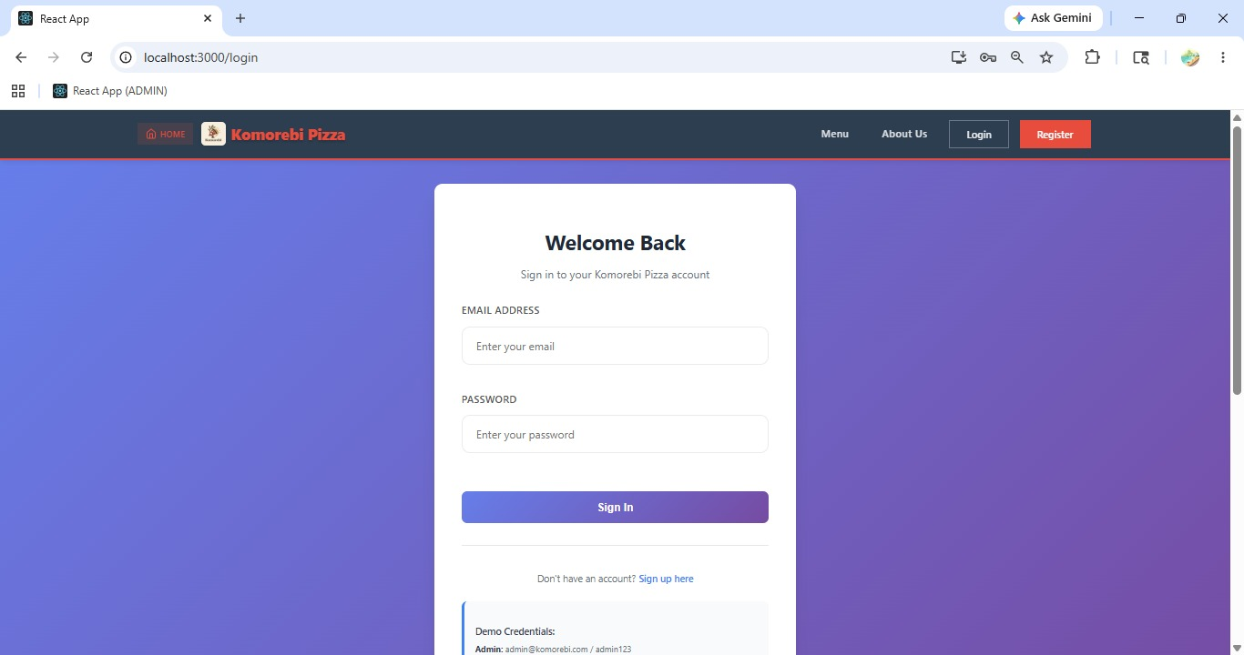
[ Figure: Fig-A1-1: Admin Login Page ]

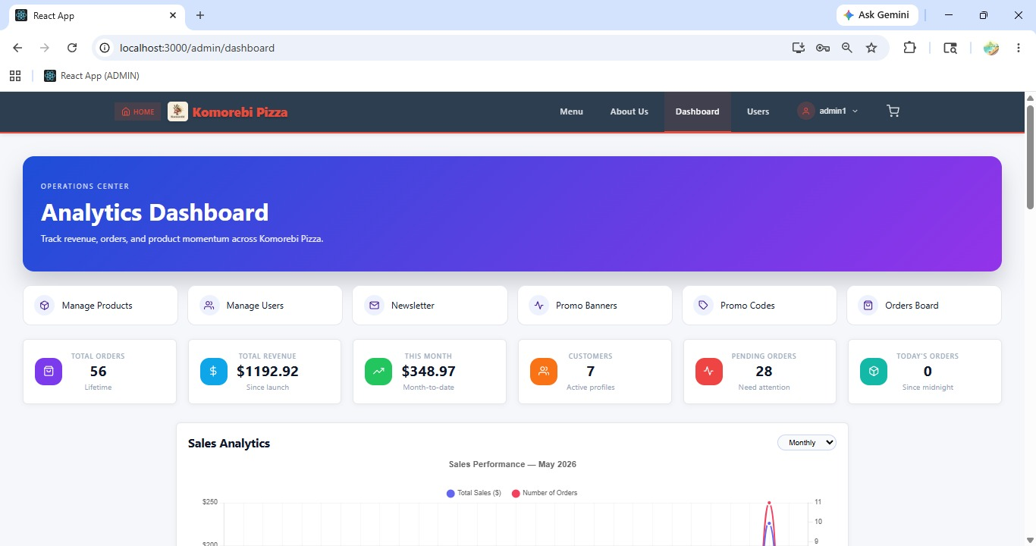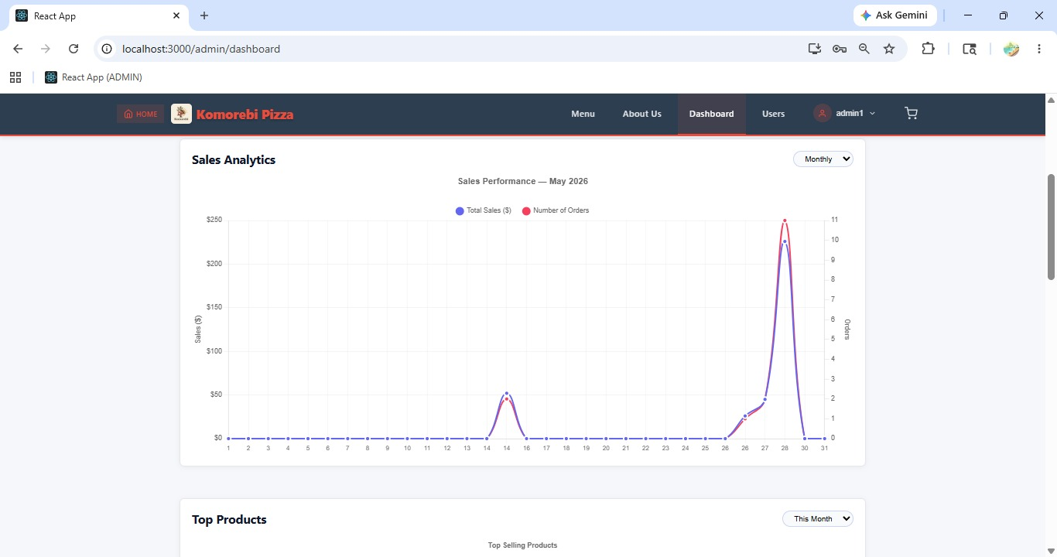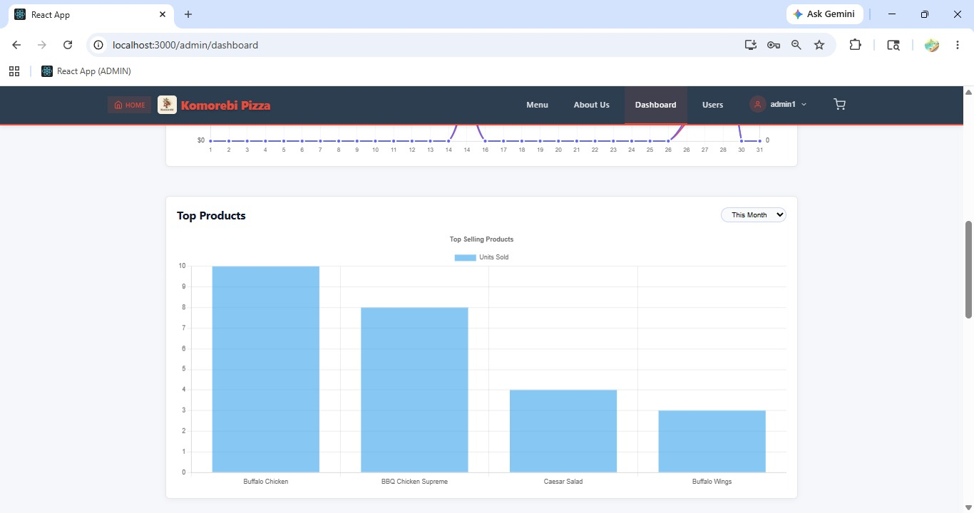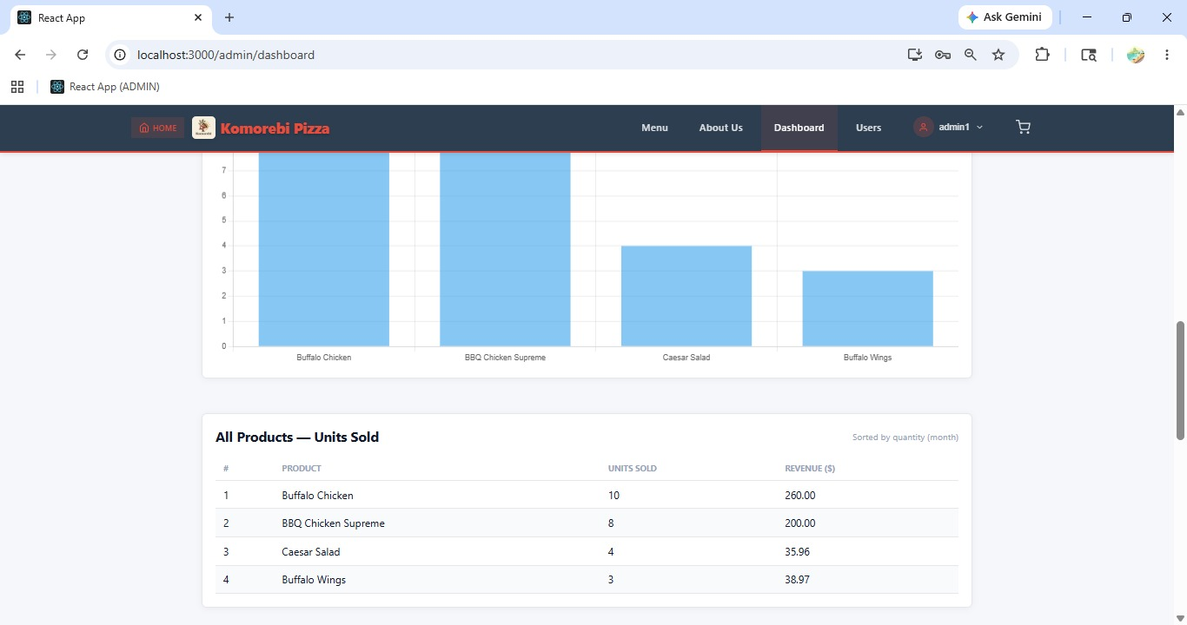
[ Figure: Fig-A1-2: Admin Dashboard Overview ]
Acceptance Criteria
- Admin login uses a unique email and password with elevated permissions.
- Successful login redirects to the full Admin Dashboard.
- Admin role provides access to all management features not available to staff or customers.
- Change default password on first login for security.

A2 — Admin Logout

How to Log Out as Administrator
1 | Click your name or the profile icon in the top-right corner of any page.
2 | Select 'Logout' or 'Sign Out' from the dropdown menu.
3 | You are redirected to the homepage or login page and your session is ended.
4 | Always log out when leaving the computer unattended to protect the admin account.
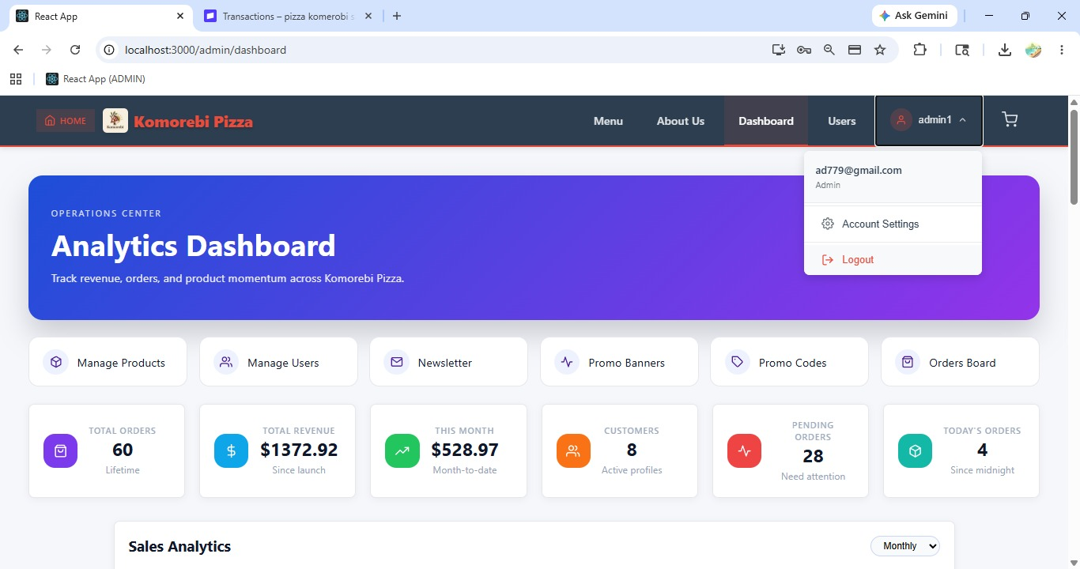 [ Figure: Fig-A2-1: Logout Dropdown Menu ]

A3 — Create New User Account (PROJECT-5)
PROJECT-5 Epic: USER ACCOUNT MGMT | 5 pts | Assignee: Nabraj Gyawali (NG)
As an admin, I want to create new user accounts so that they can use the website.

How to Create a New User Account
1 | Log in to the Admin Dashboard.
2 | Click 'Users' in the left navigation sidebar.
3 | The User Management page opens, listing all registered users.
4 | Click the '+ Create User' or '+ Add New User' button at the top-right.
5 | The Create User form opens. Enter the user's Full Name.
6 | Enter the user's Email Address — this must be unique in the system.
7 | Enter a temporary Password for the new user (they should change this on first login).
8 | Select the user Role from the dropdown: Customer, Staff, or Admin.
9 | Enter the user's Phone Number (optional).
10 | Click 'Create User' or 'Save' to submit.
11 | A success message appears: 'User created successfully.'
12 | The new user now appears in the User Management list.
13 | Communicate the login credentials (email and temporary password) to the user securely.

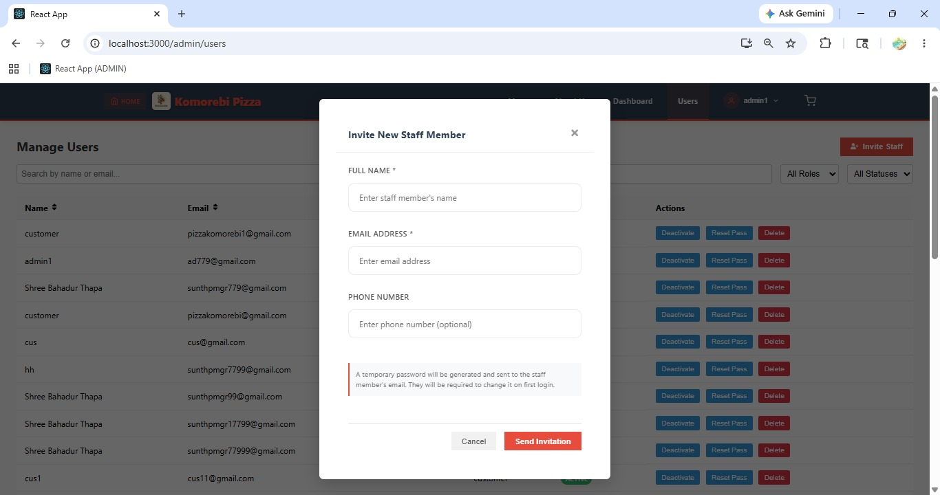
[ Figure: Fig-A3-1: Create User Form ]
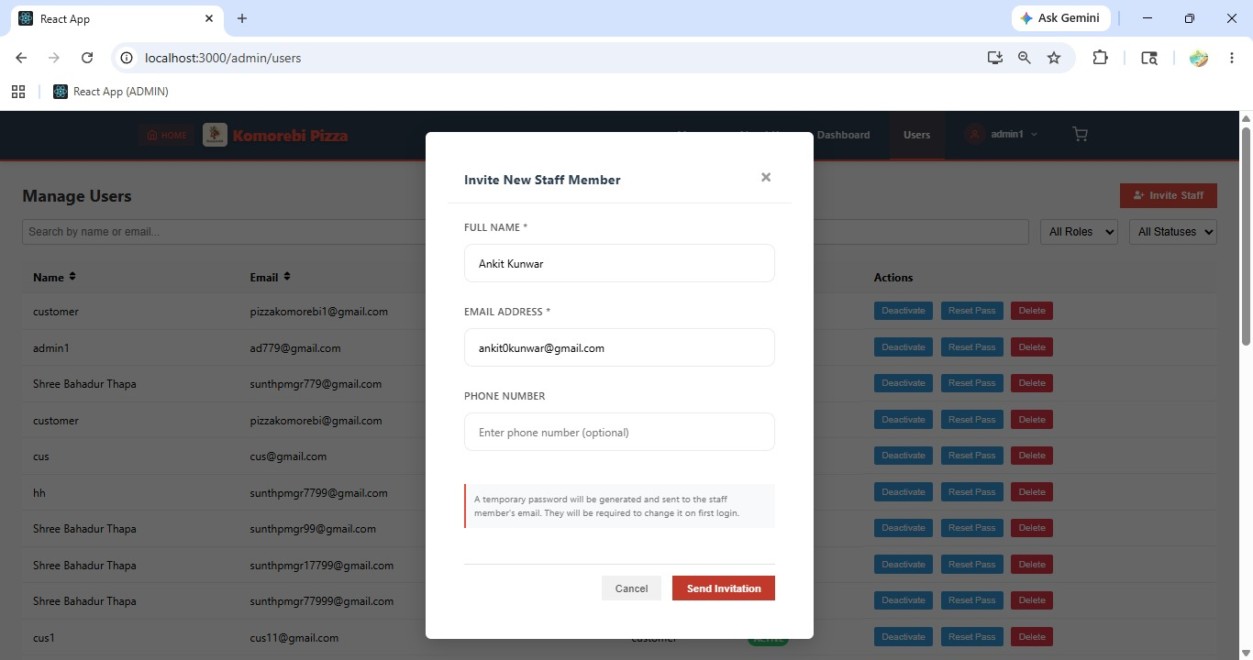[ Figure: Fig-A3-2: Filled Create User Form ]

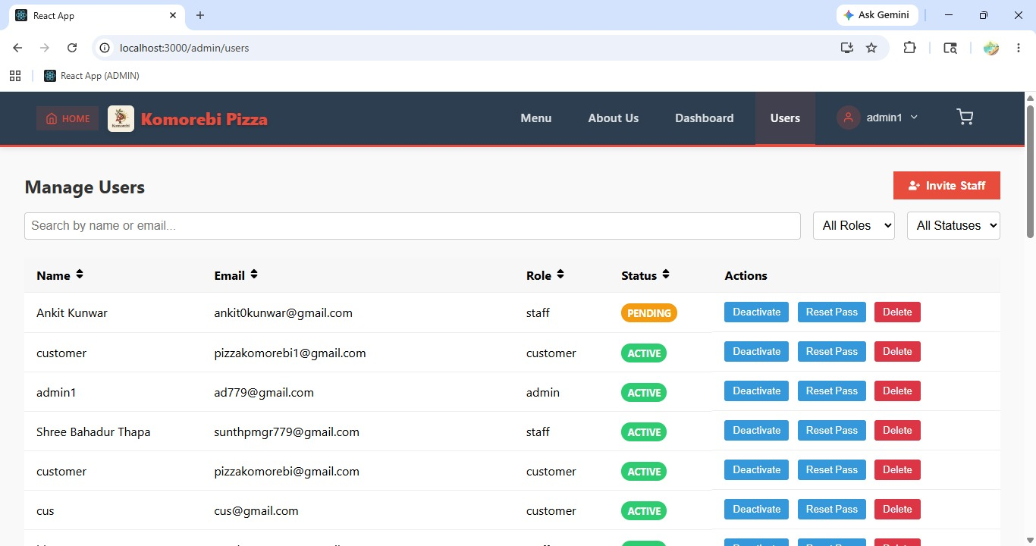[ Figure: Fig-A3-2: New User in User Management List ]
Acceptance Criteria
- Admin can create accounts for any role: Customer, Staff, or Admin.
- Email must be unique — duplicate emails are rejected.
- A temporary password is set by Admin; user should change it on first login.
- New user appears immediately in the User Management list.

A4 — Deactivate / Block a User (PROJECT-6)
PROJECT-6 Epic: USER ACCOUNT MGMT | 3 pts | Assignee: Sulav Gurung (SG)
As an admin, I want to deactivate users so that they cannot log in.

How to Deactivate a User Account
1 | Log in to the Admin Dashboard and click 'Users' in the sidebar.
2 | Browse or search for the user you want to deactivate.
3 | Click on the user's name or the 'Edit' (pencil) icon to open their account details.
4 | Locate the 'Account Status' field or toggle (Active / Inactive).
5 | Click the toggle or select 'Inactive' / 'Deactivated' from the dropdown.
6 | Click 'Save Changes' or 'Update User'.
7 | A confirmation message appears: 'User has been deactivated successfully.'
8 | The user's status changes to 'Inactive' in the User Management list.
9 | The user will no longer be able to log in. They will see: 'Your account has been deactivated. Please contact support.'
10 | To reactivate the user, repeat the process and toggle the status back to 'Active'.

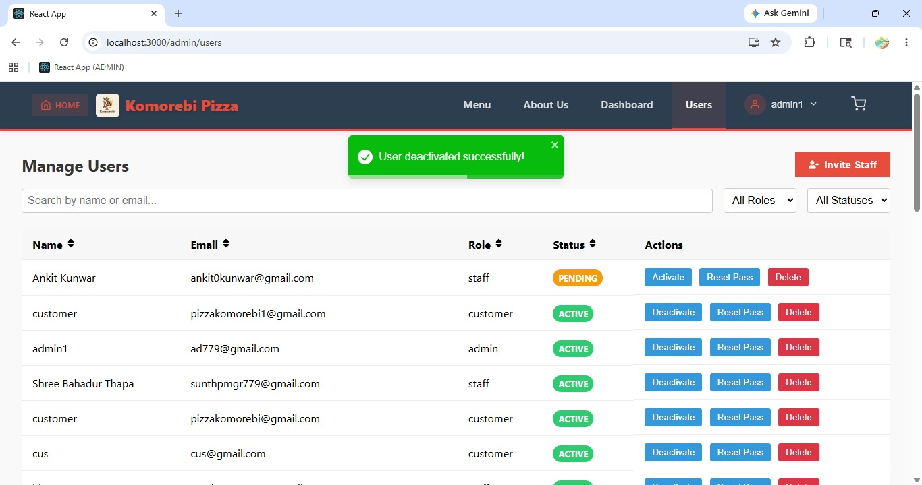[ Figure: Fig-A4-1: User Account Status Toggle & User Shown as Inactive in List ]

Acceptance Criteria
- Deactivated users cannot log in to the website.
- Account data is preserved — deactivation is reversible.
- Deactivated users see a clear message explaining their account status.
- Admin can reactivate an account at any time.

A5 — Admin Reset User Password

How to Reset a User's Password as Admin
1 | Log in to the Admin Dashboard and click 'Users' in the sidebar.
2 | Find the user whose password needs resetting. Click their name or 'Edit' icon.
3 | On the user's account page, locate the 'Reset Password' button.
4 | Click 'Reset Password'.
5 | Enter a new temporary password for the user in the field provided.
6 | Click 'Save' or 'Confirm Reset'.
7 | A success message appears: 'Password reset successfully.'
8 | Notify the user of their new temporary password via a secure channel.
9 | Advise the user to log in and change their password immediately.

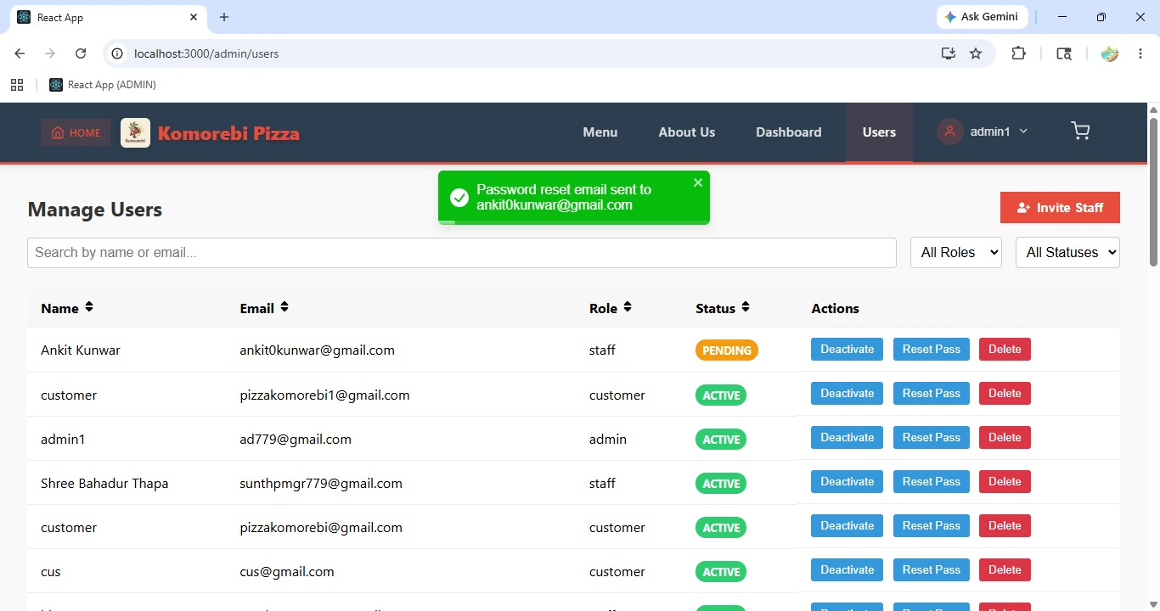 [ Figure: Fig-A5-1: Admin Reset Password for User ]

Acceptance Criteria
- Admin can reset any user's password from the User Management section.
- A temporary password is assigned — the user should change it immediately.
- Password change is recorded in the system.

A6 — Update User Details

How to Update a User's Details
1 | Log in to Admin Dashboard and click 'Users'.
2 | Find the user to edit and click their name or 'Edit' icon.
3 | Update any of the following fields: Full Name, Email Address, Phone Number, Role.
4 | Click 'Save Changes' to confirm.
5 | A success message confirms the update.

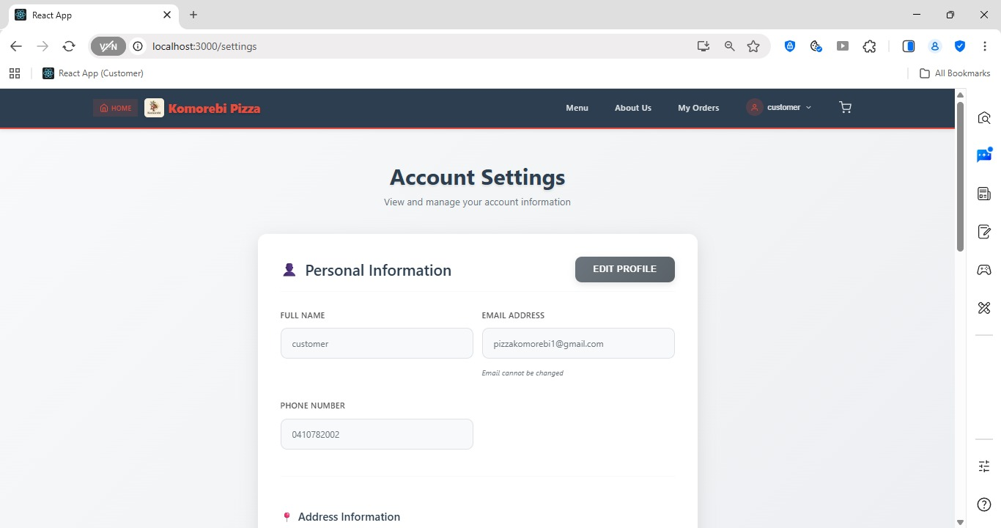[ Figure: Fig-A6-1: Edit User Details Form ]

A7 — Delete a User Account

How to Permanently Delete a User Account
1 | Log in to Admin Dashboard and click 'Users'.
2 | Find the user to delete. Click the 'Delete' or trash icon next to their name.
3 | A confirmation popup appears: 'Are you sure you want to permanently delete this user? This cannot be undone.'
4 | Click 'Yes, Delete' to confirm.
5 | The user account and all associated data are permanently removed from the system.
6 | The user is removed from the User Management list immediately.
7 | Note: Consider deactivating rather than deleting to preserve order history.

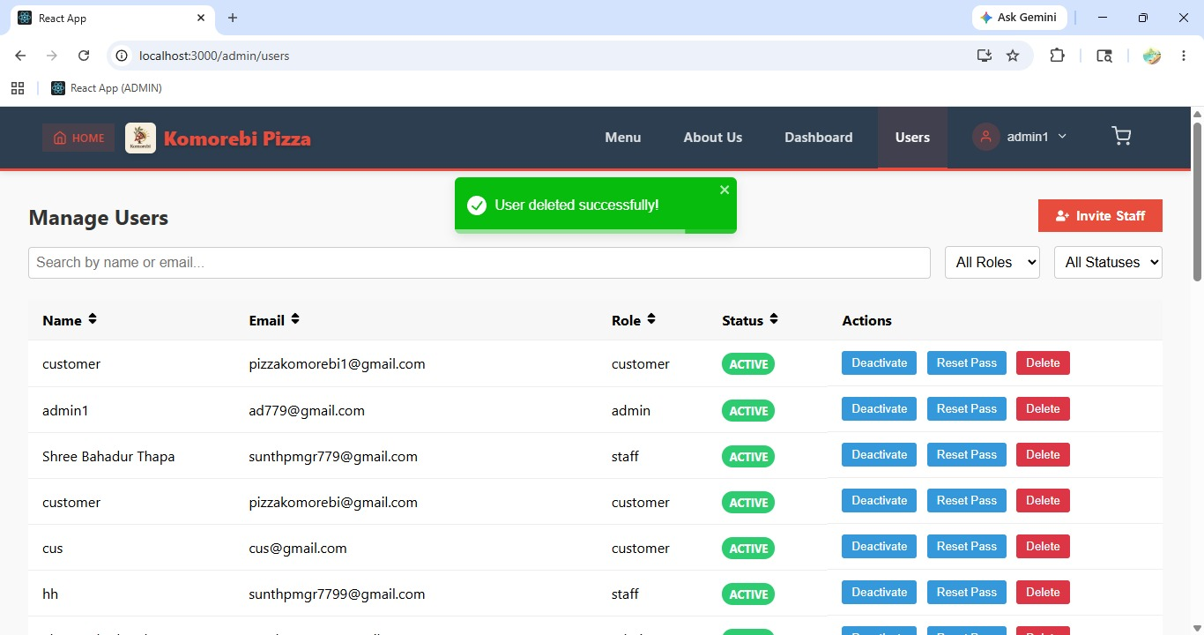[ Figure: Fig-A7-1: Delete User Confirmation Popup ]
Acceptance Criteria
- Deletion is permanent and irreversible.
- All user data is removed from the system.
- Consider deactivation instead of deletion to preserve order records.

Sprint 2 | Admin Features — Product Management  Sprint 2 | 22 Sep – 12 Oct 2025

ID | User Story | Epic | Pts | Assignee
PROJECT-11 | Add products so customers can see and order them | PRODUCT CRUD (ADMIN) | 4 | NG
PROJECT-12 | Edit product details so info stays accurate | PRODUCT CRUD (ADMIN) | 4 | NG
PROJECT-13 | Remove products so unavailable items are hidden | PRODUCT CRUD (ADMIN) | 3 | ST
PROJECT-15 | Categorise products so customers can filter | PRODUCT CRUD (ADMIN) | 4 | AK

A8 — Add a New Product (PROJECT-11)
PROJECT-11 Epic: PRODUCT CRUD (ADMIN) | 4 pts | Assignee: Nabraj Gyawali (NG)
As an admin, I want to add products so that customers can view and order them.

How to Add a New Pizza / Product
1 | Log in to the Admin Dashboard and click 'Products' in the left sidebar.
2 | The Product Management page opens, listing all current products.
3 | Click '+ Add Product' or '+ New Product' at the top-right.
4 | The Add Product form opens. Enter the Product Name (e.g. 'Hawaiian Delight').
5 | Enter a detailed Product Description (e.g. ingredients, toppings, flavour notes).
6 | Set the Price in the price field (e.g. 18.99).
7 | Select the Category from the dropdown (e.g. Classic, Vegetarian, Premium, Specials).
8 | Upload a Product Image by clicking 'Choose File' or dragging an image into the upload area. Recommended size: 800×600px, JPG or PNG.
9 | Set the product status to 'Active' to make it visible to customers immediately.
10 | Click 'Save Product' or 'Add Product' to submit.
11 | A success message appears: 'Product added successfully.'
12 | The new product appears in the Product Management list and is now visible on the Menu for customers.
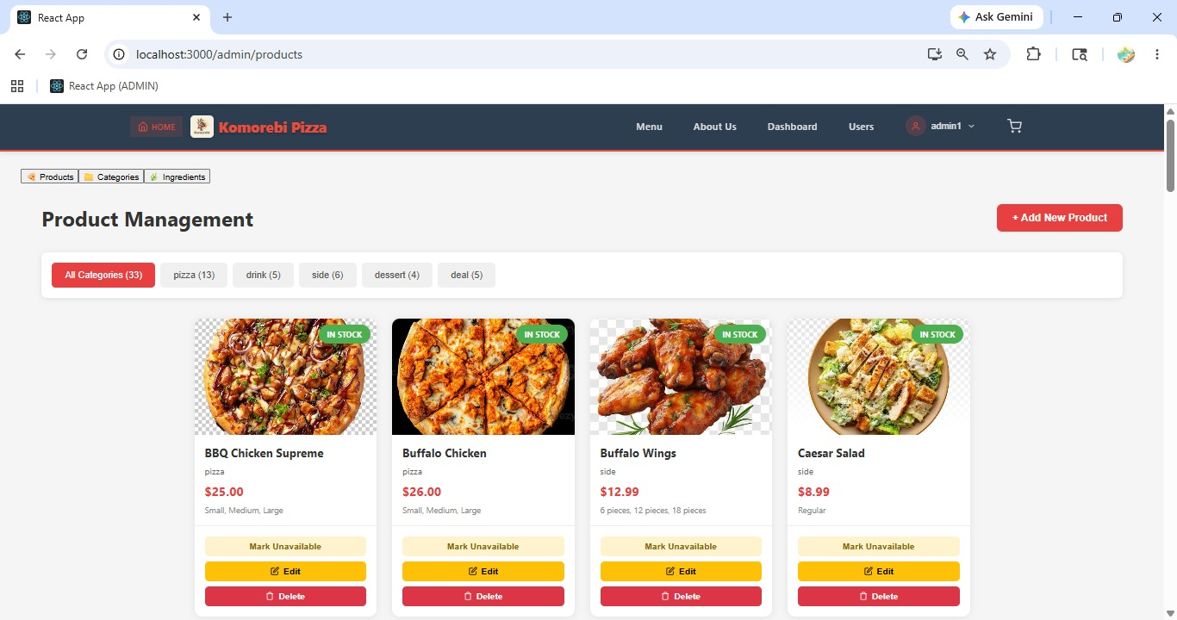
[ Figure: Fig-A8-1: Admin Product Management Dashboard]

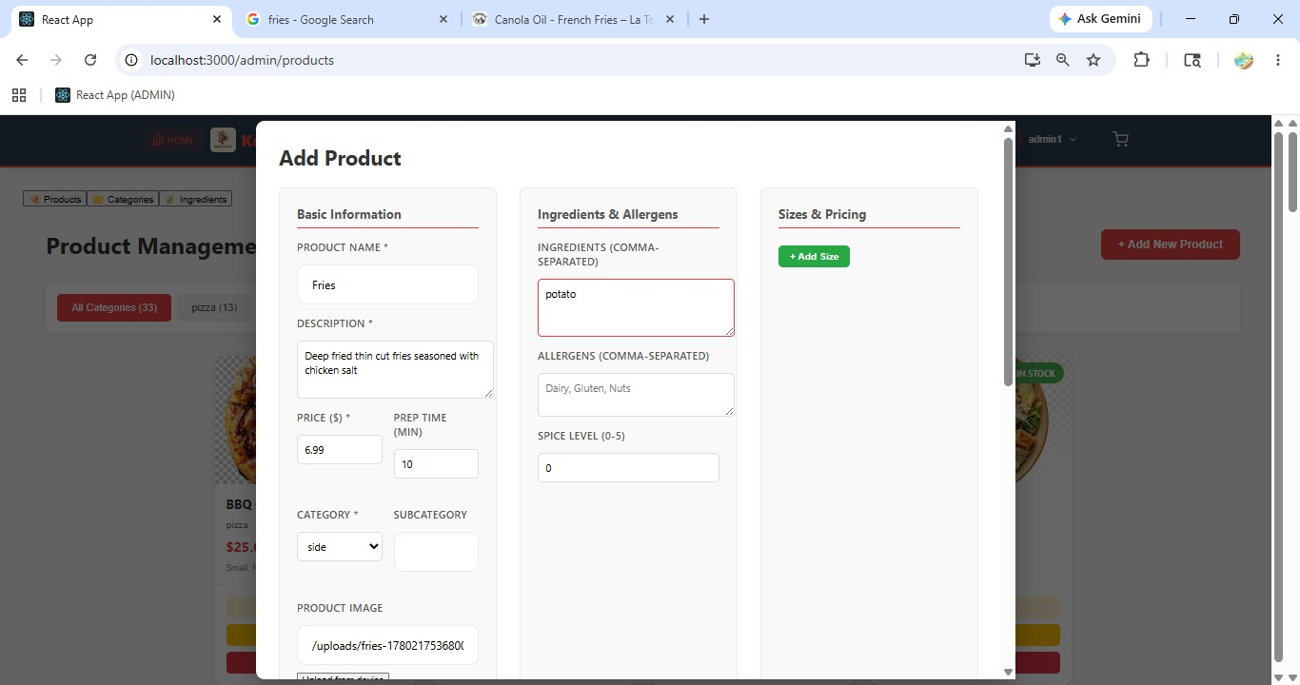[ Figure: Fig-A8-2: Add Product Form ]
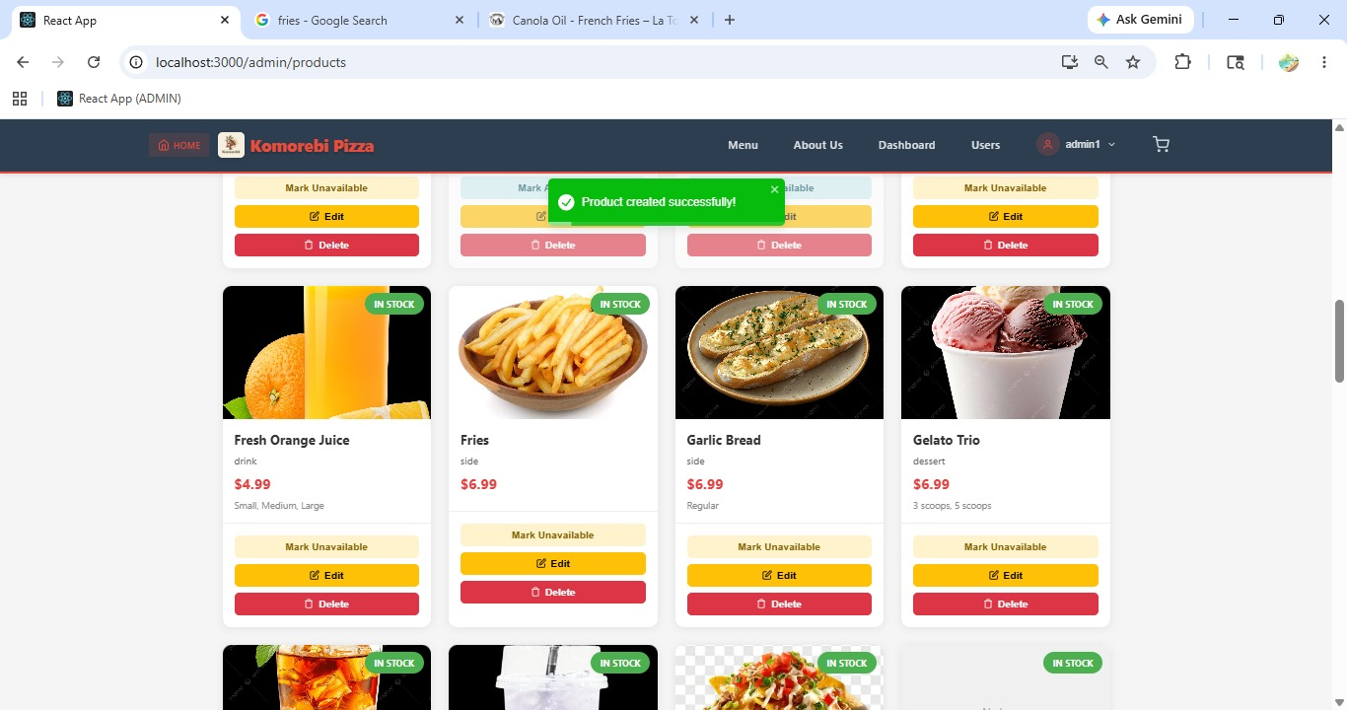
[ Figure: Fig-A8-3: Updated Admin Product Management Dashboard]

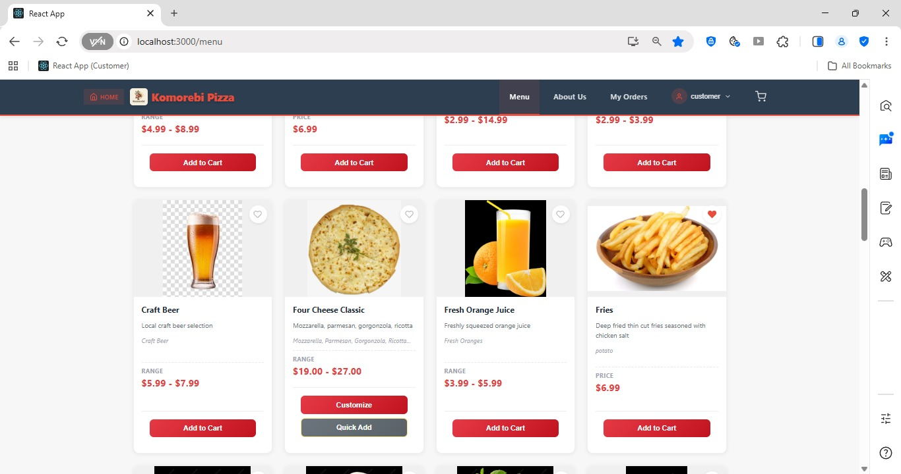[ Figure: Fig-A8-3: New Product Visible on Customer Menu ]
Acceptance Criteria
- All required fields (name, description, price, category) must be filled.
- A product image should be uploaded for best customer experience.
- Active products are immediately visible to customers on the Menu page.
- Inactive products are hidden from customers but preserved in the system.

A9 — Update / Edit a Product (PROJECT-12)
PROJECT-12 Epic: PRODUCT CRUD (ADMIN) | 4 pts | Assignee: Nabraj Gyawali (NG)
As an admin, I want to edit product details so that the information stays accurate.

How to Edit an Existing Product
1 | Log in to Admin Dashboard and click 'Products'.
2 | Find the product you want to update. Click the 'Edit' (pencil) icon next to the product name.
3 | The Edit Product form opens, pre-filled with the current product details.
4 | Update any of the following fields as required: Product Name, Description, Price, Category, Image, Status (Active/Inactive).
5 | To replace the product image, click 'Upload New Image' and select a new file.
6 | Click 'Save Changes' or 'Update Product' to confirm.
7 | A success message appears: 'Product updated successfully.'
8 | The changes are immediately reflected on the customer-facing Menu page.

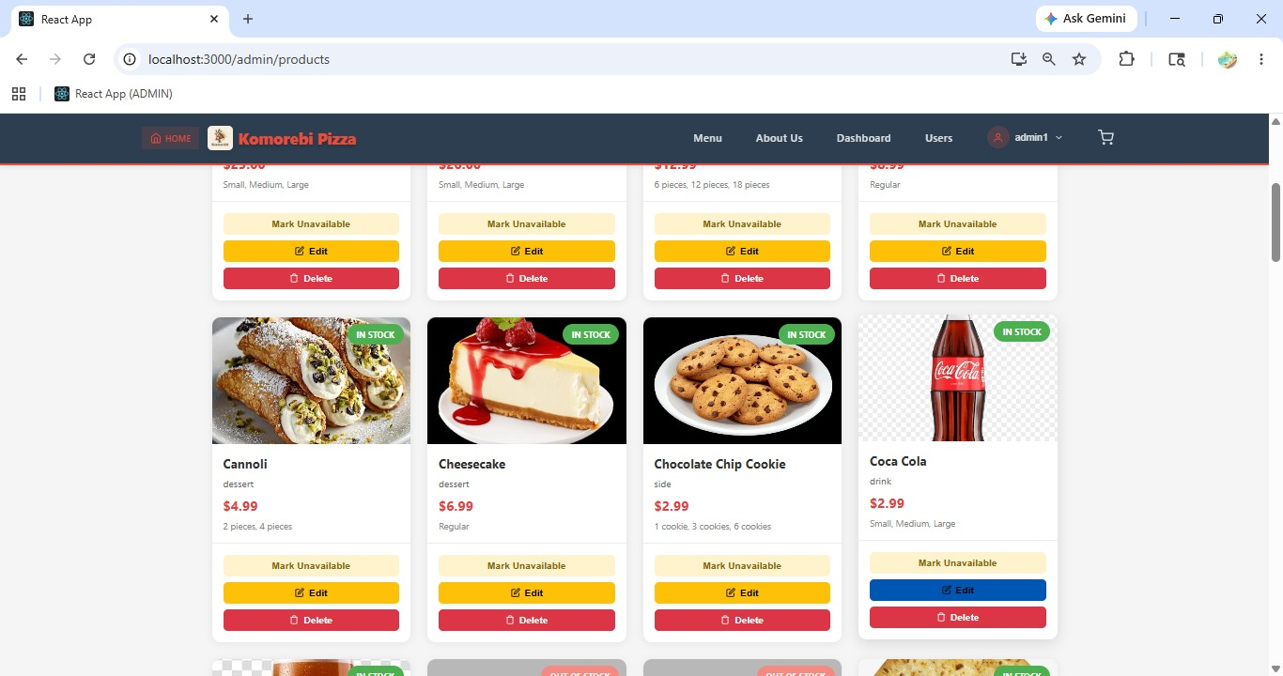[ Figure: Fig-A9-1:Admin Product Management Dashboard (before)]
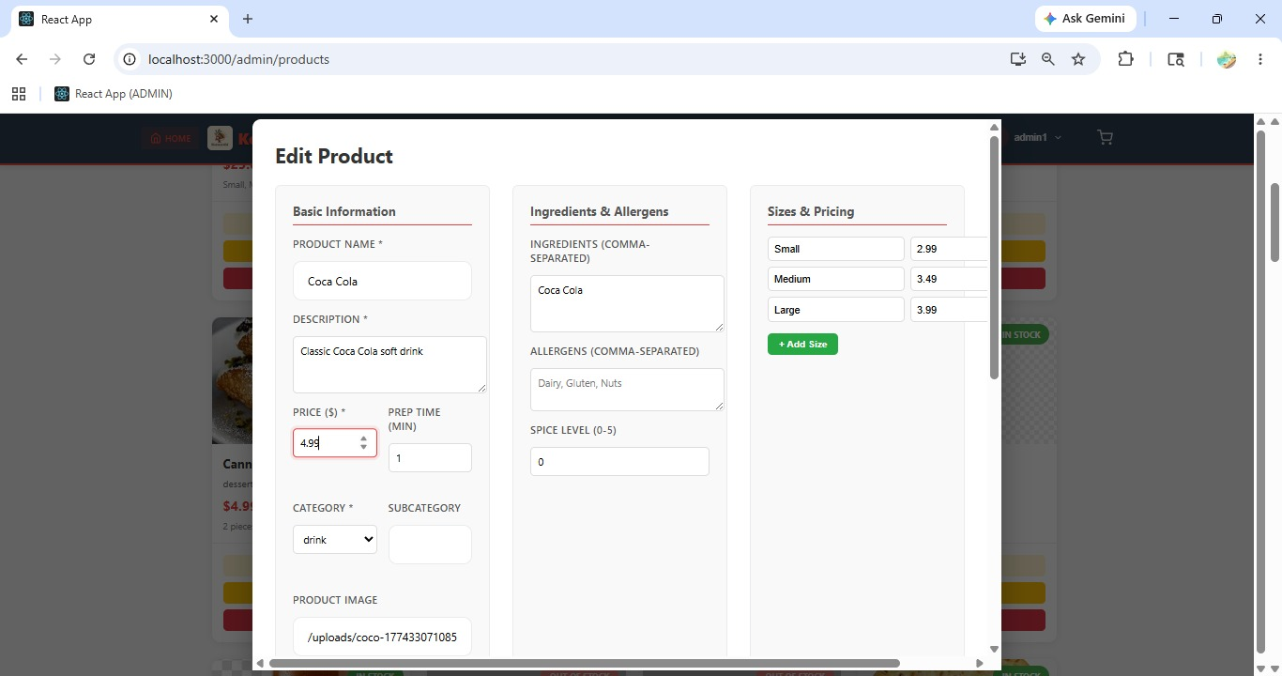
[ Figure: Fig-A9-2: Edit Product Form with Updated Fields ]

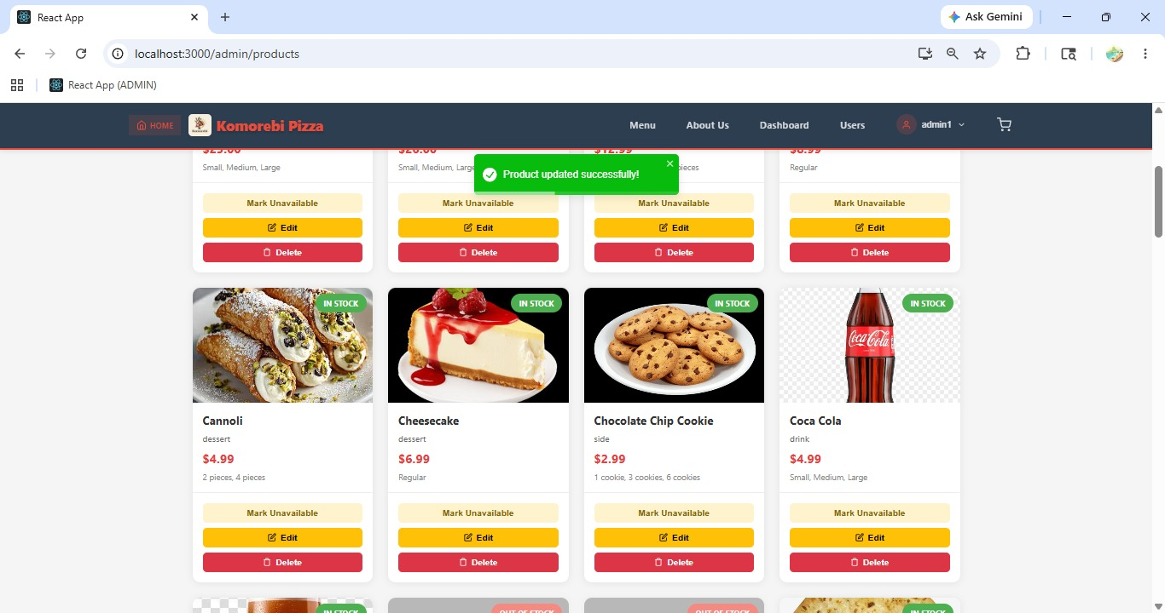
[ Figure: Fig-A9-3:Admin Product Management Dashboard (after)]

Acceptance Criteria
- All product fields can be edited at any time.
- Updated information is reflected immediately on the live menu.
- Image can be replaced by uploading a new file.

A10 — Delete / Remove a Product (PROJECT-13)
PROJECT-13 Epic: PRODUCT CRUD (ADMIN) | 3 pts | Assignee: Shree Thapa (ST)
As an admin, I want to remove products so that unavailable items are not shown.

How to Remove a Product
1 | Log in to Admin Dashboard and click 'Products'.
2 | Find the product you want to remove from the menu.
3 | Option A — Soft Delete (Recommended): Click the 'Edit' icon and set the product Status to 'Inactive'. Click 'Save'. The product is hidden from customers but preserved in the system.
4 | Option B — Hard Delete: Click the 'Delete' (trash) icon next to the product.
5 | A confirmation popup appears: 'Are you sure you want to delete this product? This cannot be undone.'
6 | Click 'Yes, Delete' to permanently remove the product.
7 | A success message appears: 'Product deleted successfully.'
8 | The product is removed from the Menu page and the Product Management list.

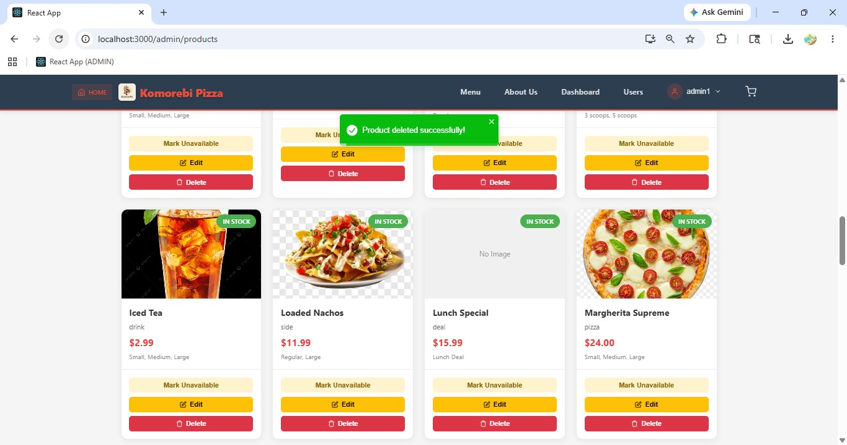 [ Figure: Fig-A10-1: Delete Product Confirmation ]
Acceptance Criteria
- Setting a product to Inactive hides it from customers without deleting data.
- Permanent deletion removes the product and all associated data.
- Consider using Inactive status for seasonal items instead of deletion.

A11 — Manage Product Categories (PROJECT-15)
PROJECT-15 Epic: PRODUCT CRUD (ADMIN) | 4 pts | Assignee: Ankit Kunwar (AK)
As an admin, I want to categorise products into groups so that customers can browse more easily.

How to Add a New Category
1 | Log in to Admin Dashboard and click 'Categories' in the sidebar (or find it under the Products section).
2 | The Category Management page lists all existing categories.
3 | Click '+ Add Category' button.
4 | Enter the Category Name (e.g. 'Vegetarian', 'Premium', 'Specials').
5 | Optionally enter a Category Description.
6 | Click 'Save Category'.
7 | The new category is immediately available in the Product form's category dropdown.

How to Edit or Delete a Category
1 | On the Category Management page, find the category to change.
2 | Click 'Edit' to rename or update the description. Click 'Save'.
3 | Click 'Delete' to remove a category. Note: Products in this category must be reassigned to another category first.
4 | A confirmation prompt appears before deletion. Click 'Confirm'.

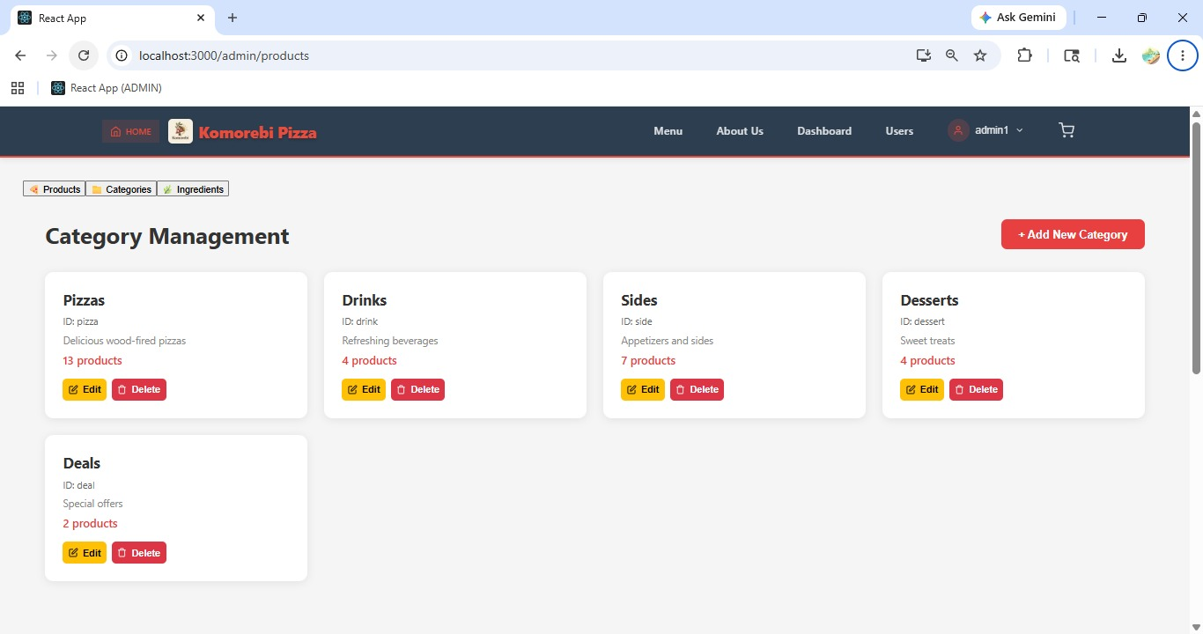 [ Figure: Fig-A11-1: Admin Category Management Page ]

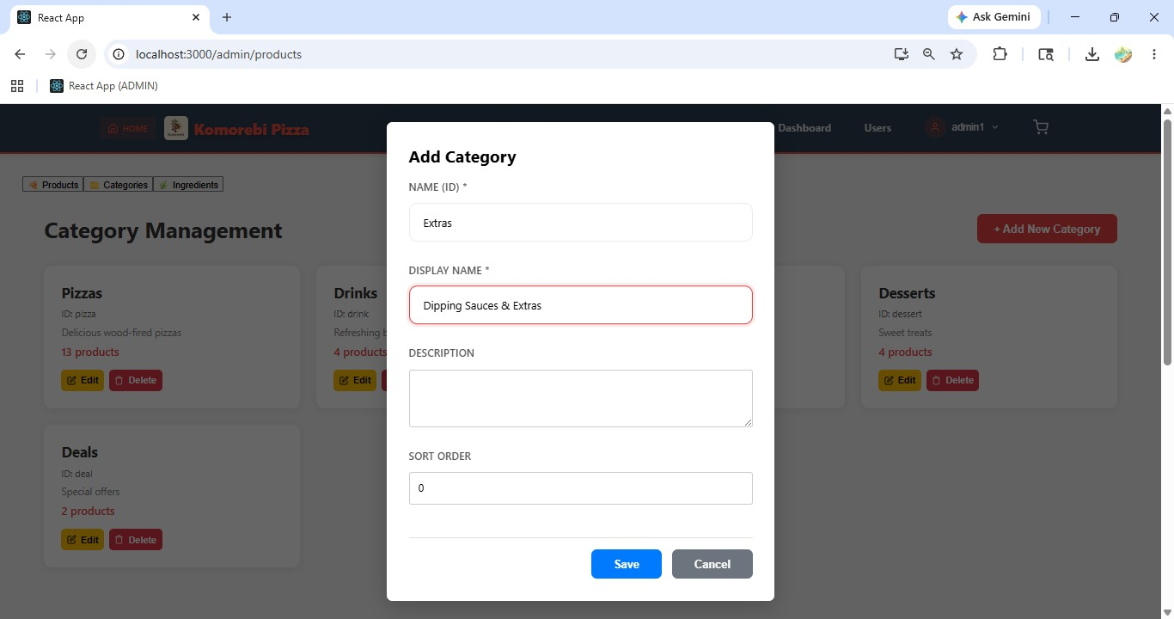[ Figure: Fig-A11-2: Add Category Form ]

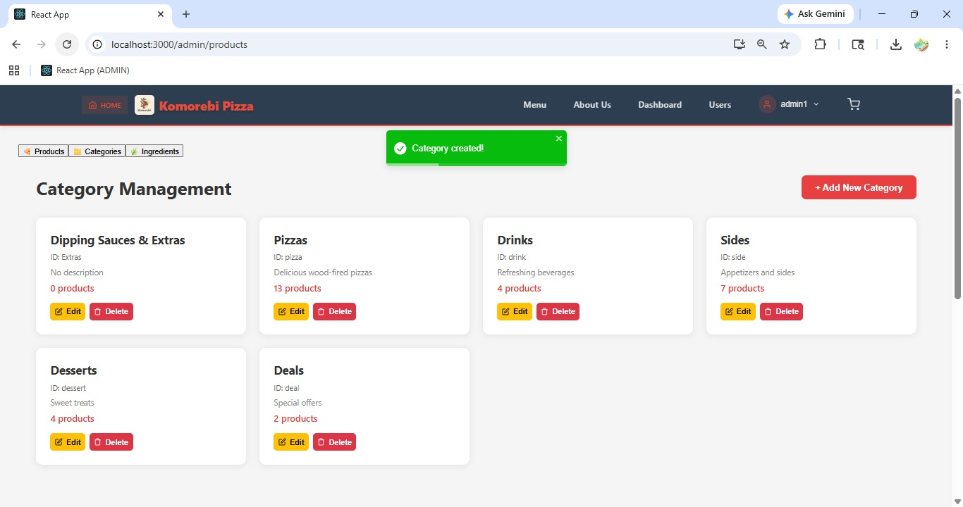
[ Figure: Fig-A11-3: Updated Admin Category Management Page]

Acceptance Criteria
- Categories can be added, edited, or deleted from the Category Management page.
- Products must be reassigned before a category can be deleted.
- Categories appear as filter options on the customer-facing Menu page.

Sprint 3 | Admin Features — View All Orders  Sprint 3 | 25 Mar – 2 Apr 2026

ID | User Story | Epic | Pts | Assignee
PROJECT-36 | View all customer orders to monitor operations | ADMIN ORDER VIEW | 4 | ST

A12 — Admin View All Orders

How to View and Monitor All Customer Orders
1 | Log in to Admin Dashboard and click 'Orders' in the left sidebar.
2 | The Orders Management page lists all customer orders across all statuses.
3 | Each row shows: Order ID, Customer Name, Date & Time, Items, Total Amount, Payment Method, and Status.
4 | Use the Status filter dropdown to view specific categories: All, Pending, Accepted, In Preparation, Ready, Delivered, Cancelled.
5 | Use the Date Range filter to view orders from a specific period (e.g. Today, Last 7 Days, Custom Range).
6 | Use the Search bar to find orders by Order ID or Customer Name.
7 | Click any Order ID to open the full Order Detail view.
8 | The Order Detail shows: customer details, full item list with quantities, delivery address, order notes, payment info, and complete status history with timestamps.
9 | Admin can also update order status from this view if staff have not acted on an order.

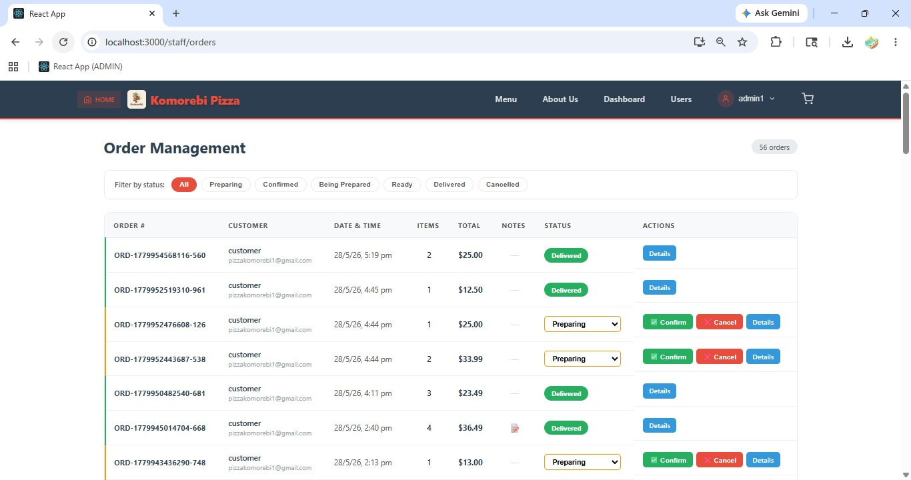[ Figure: Fig-A12-1: Admin Orders Management Page ]

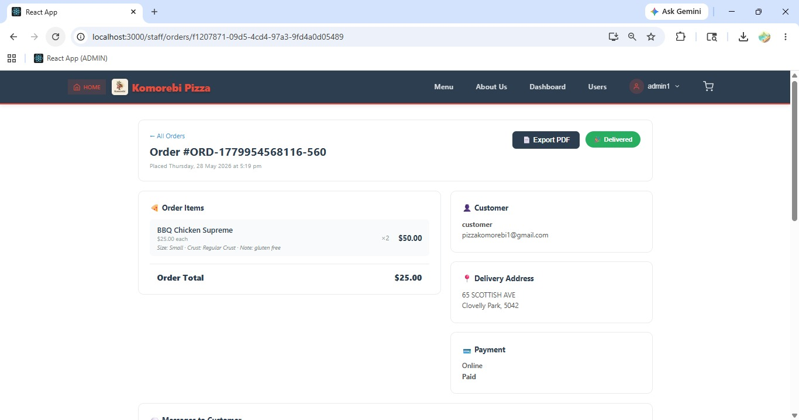[ Figure: Fig-A12-2: Order Detail View — Admin Perspective ]
Acceptance Criteria
- Admin can view all orders from all customers.
- Filters by status, date range, and search by ID/name are available.
- Full order details including payment and status history are accessible.
- Admin can update order status if required.

Sprint 4 | Admin Features — Promotions & Email Campaigns  Sprint 4 | 20 Apr – 2 May 2026

ID | User Story | Epic | Pts | Assignee
PROJECT-43 | Create and generate promo codes for discounts | DISCOUNT & PROMO | 5 | —
PROJECT-44 | Send promotional emails to customers | NOTIFICATIONS & COMM | 3 | AK

A13 — Create Promo Codes (PROJECT-43)
PROJECT-43 Epic: DISCOUNT & PROMO | 5 pts | Assignee: —
As an admin, I want to create and generate promo codes so that I can offer discounts.

How to Create a New Promo Code
1 | Log in to Admin Dashboard and click 'Promotions' or 'Promo Codes' in the sidebar.
2 | The Promo Code Management page lists all existing promo codes with their status.
3 | Click '+ Create Promo Code' or '+ Add Code' button.
4 | Enter the Promo Code string (e.g. PIZZA20, SUMMER10). Codes are case-insensitive for customers.
5 | Set the Discount Type: Percentage (e.g. 20% off) or Fixed Amount (e.g. $5.00 off).
6 | Enter the Discount Value (e.g. 20 for 20%, or 5 for $5.00).
7 | Set the Minimum Order Amount required to use the code (e.g. $30.00 minimum order).
8 | Set the Expiry Date using the date picker — after this date the code will no longer work.
9 | Set the Maximum Uses limit (e.g. 100 uses total, or leave blank for unlimited).
10 | Toggle the code Status to 'Active' to make it available for customer use.
11 | Click 'Save Promo Code' or 'Create'.
12 | The new code appears in the Promo Code list with its status and usage count.
13 | Share the code with customers via email campaigns, social media, or the homepage.

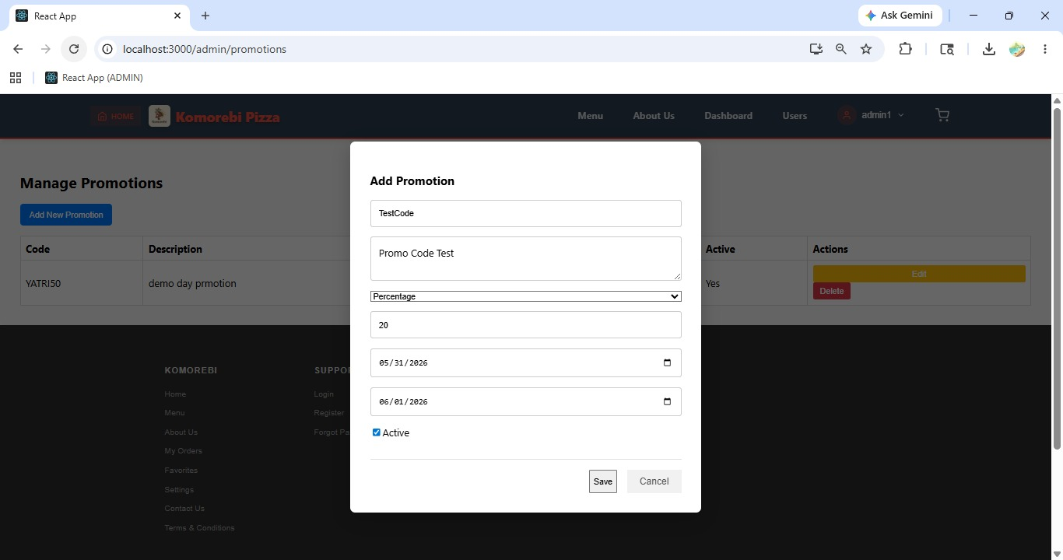[ Figure: Fig-A13-1: Create Promo Code Form ]

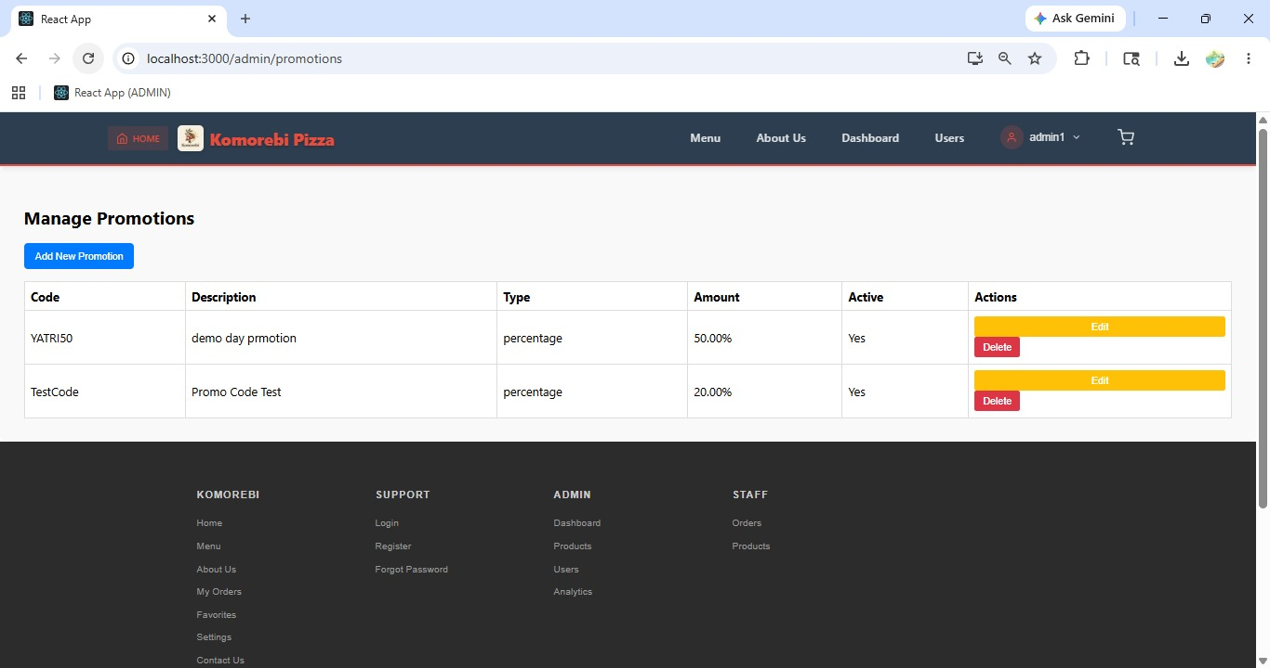[ Figure: Fig-A13-2: Promo Code Management List ]
Acceptance Criteria
- Promo codes can be percentage-based or fixed-amount discounts.
- Expiry date, minimum order amount, and usage limits can all be configured.
- Only Active codes can be used by customers.
- Usage count is tracked automatically.

A14 — Send Promotional Emails (PROJECT-44)
PROJECT-44 Epic: NOTIFICATIONS & COMM | 3 pts | Assignee: Ankit Kunwar (AK)
As an admin, I want to send promotional emails to customers so that I can drive more orders.

How to Send a Bulk Promotional Email to Customers
1 | Log in to Admin Dashboard and click 'Email Campaigns' or 'Promotions' in the sidebar.
2 | Click 'Send Promotional Email' or 'New Campaign'.
3 | The email composer opens. Enter the Email Subject line (e.g. 'Exclusive Weekend Offer — 20% Off All Pizzas!').
4 | Type or paste the email body in the message area. Include: the offer details, promo code if applicable, any images or links, and terms and conditions.
5 | Select the Target Audience: All Customers, or filter by specific criteria if available.
6 | Note: Customers who have unsubscribed from promotional emails will be automatically excluded from the send list.
7 | Review the email preview to check formatting and content.
8 | Click 'Send Now' to dispatch the email immediately, or 'Schedule' to set a future send time.
9 | A confirmation message appears: 'Promotional email sent to X subscribers successfully.'
10 | The campaign is recorded in the Email Campaigns history log.

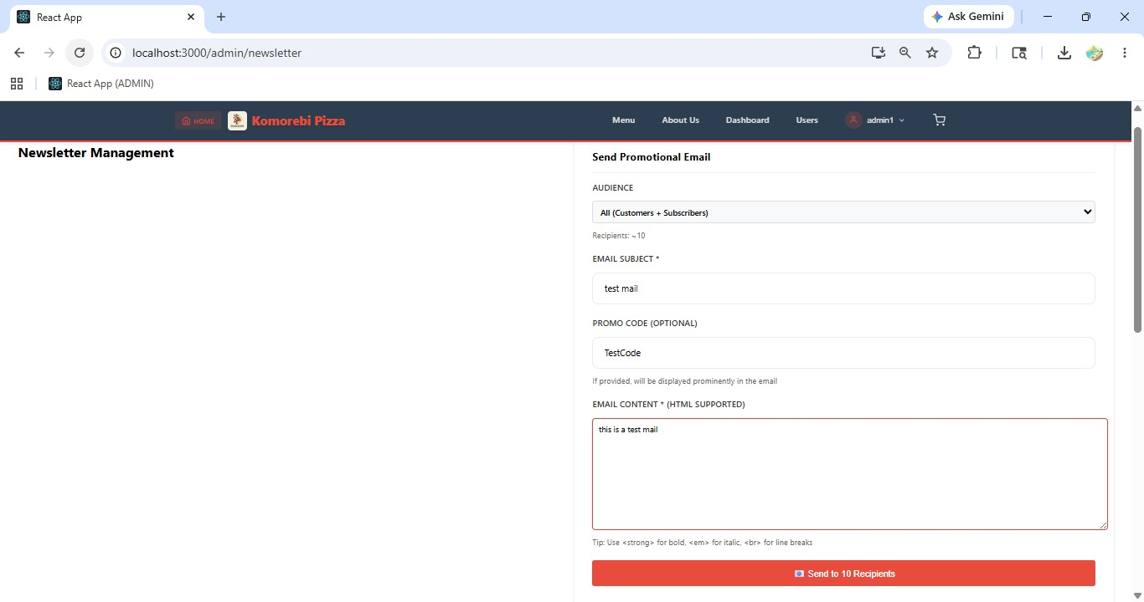[ Figure: Fig-A14-1: Email Campaign Composer ]

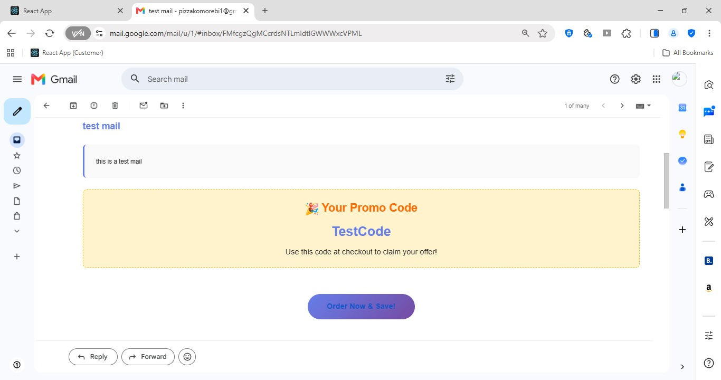[ Figure: Fig-A14-2: Campaign Sent Confirmation ]
Acceptance Criteria
- Promotional emails are sent to all subscribed customers.
- Unsubscribed customers are automatically excluded from all bulk sends.
- Email subject and body are fully customisable.
- Sent campaigns are logged in the campaign history.

Sprint 5 | Admin Features — Analytics, Banners & User Management Tools  Sprint 5 | 14–30 May 2026

ID | User Story | Epic | Pts | Assignee
PROJECT-55 | Sales dashboard to track website performance | ANALYTICS & REPORTING | 8 | ST
PROJECT-56 | Product analytics to know top-selling pizzas | ANALYTICS & REPORTING | 5 | AK
PROJECT-58 | Update homepage banners for fresh promotions | WEBSITE CONTENT MGMT | 3 | ST
PROJECT-59 | Search for users to find them easily | USER MANAGEMENT | 3 | AK
PROJECT-60 | Filter users to manage accounts better | USER MANAGEMENT | 2 | SG
PROJECT-61 | Sort users to view them in order | USER MANAGEMENT | 2 | SG
PROJECT-62 | Training documentation to train staff | TRAINING & DOCUME... | 3 | NG

A15 — Sales Analytics Dashboard (PROJECT-55)
PROJECT-55 Epic: ANALYTICS & REPORTING | 8 pts | Assignee: Shree Thapa (ST)
As an admin, I want a sales dashboard so that I can track website performance.

How to Use the Sales Analytics Dashboard
1 | Log in to Admin Dashboard and click 'Analytics' or 'Sales Dashboard' in the sidebar.
2 | The Sales Dashboard page loads with visual charts and key performance metrics.
3 | Review the Summary Cards at the top of the page: Total Revenue, Total Orders, Average Order Value, and New Customers.
4 | The Daily Sales Trend chart shows revenue and order volume plotted over time (built with Chart.js). Hover over data points to see exact values.
5 | The Revenue Breakdown by Payment Method chart shows the split between Stripe and PayPal payments.
6 | Use the Date Range filter at the top to view data for: Today, Last 7 Days, Last 30 Days, or a Custom Range.
7 | The Orders by Status summary shows how many orders are in each status (Pending, Accepted, Delivered, Cancelled).
8 | Review the Top Customers section showing your highest-value customers by total spend.
9 | Use this data to make business decisions such as running promotions on slow days or rewarding top customers.
10 | Scroll down for additional metrics such as cancellation rate and average delivery time if available.


[ Figure: Fig-A15-1: Sales Analytics Dashboard Overview ]

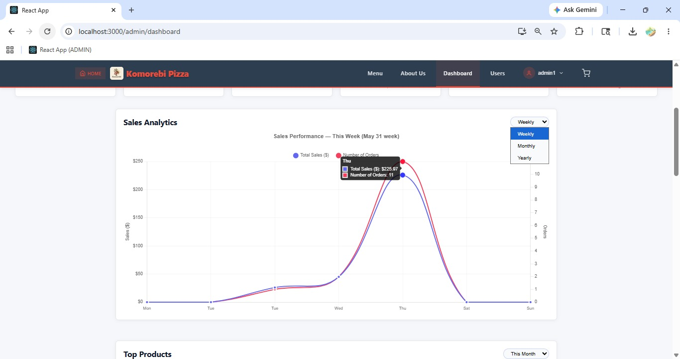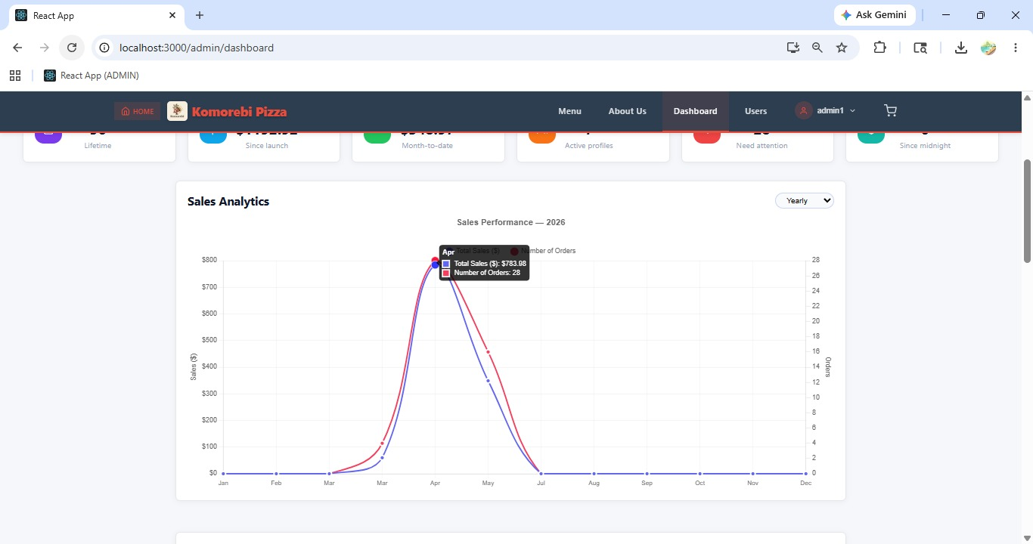
[ Figure: Fig-A15-2,A15-3,A15-4: Daily, Monthly & Yearly Sales Trend Chart ]

Acceptance Criteria
- Dashboard shows Total Revenue, Orders, Average Order Value, and New Customers.
- Charts are interactive — hover for data point details.
- Date range filter allows comparison across different periods.
- Data updates in real-time as new orders come in.

A16 — Product Analytics (PROJECT-56)
PROJECT-56 Epic: ANALYTICS & REPORTING | 5 pts | Assignee: Ankit Kunwar (AK)
As an admin, I want product analytics so that I know which are the top-selling pizzas.

How to View Product Performance Analytics
1 | Log in to Admin Dashboard and click 'Analytics' then select 'Product Analytics' or find it as a tab on the Analytics page.
2 | The Product Analytics page loads showing performance data for all products.
3 | Review the Top Selling Products chart — a bar chart (Chart.js) showing the most ordered products by quantity sold.
4 | Review the Revenue by Product chart — shows which products generate the most revenue.
5 | The Products Table below the charts lists every product with: Total Orders, Total Quantity Sold, Total Revenue Generated, and Average Rating (if available).
6 | Use the Date Range filter to see performance for a specific period.
7 | Sort the table by any column (Orders, Quantity, Revenue) to rank products.
8 | Identify underperforming products that may need promotion, price adjustments, or removal.
9 | Use top-seller data to inform menu planning, ingredient stocking, and promotional campaigns.

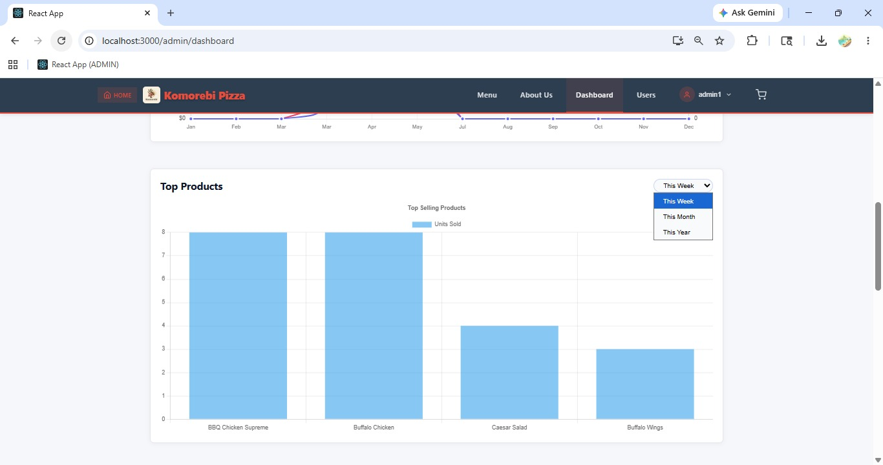
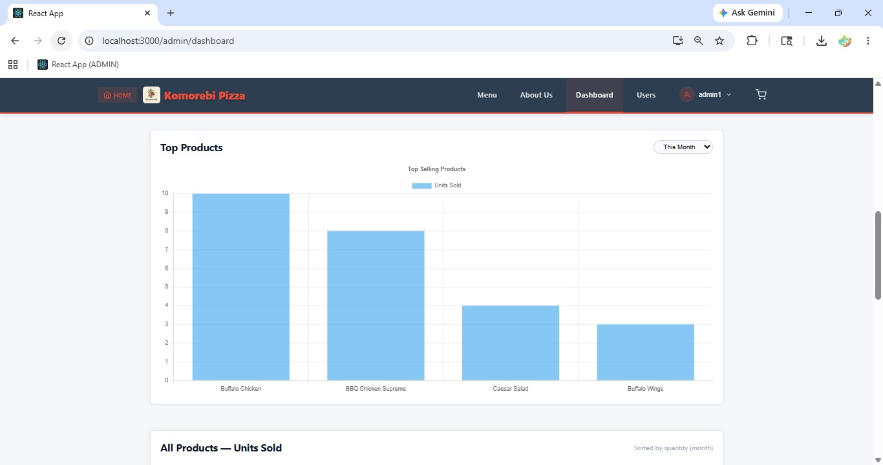
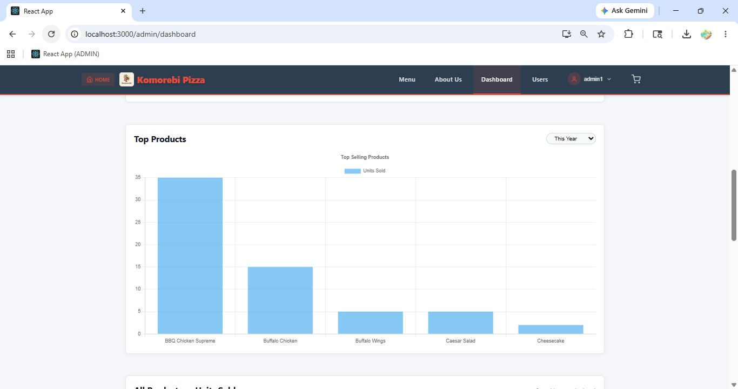 [ Figure: Fig- A16-1, A16-2, A16-3: Weekly, Monthly & Yearly Product Analytics Page ]
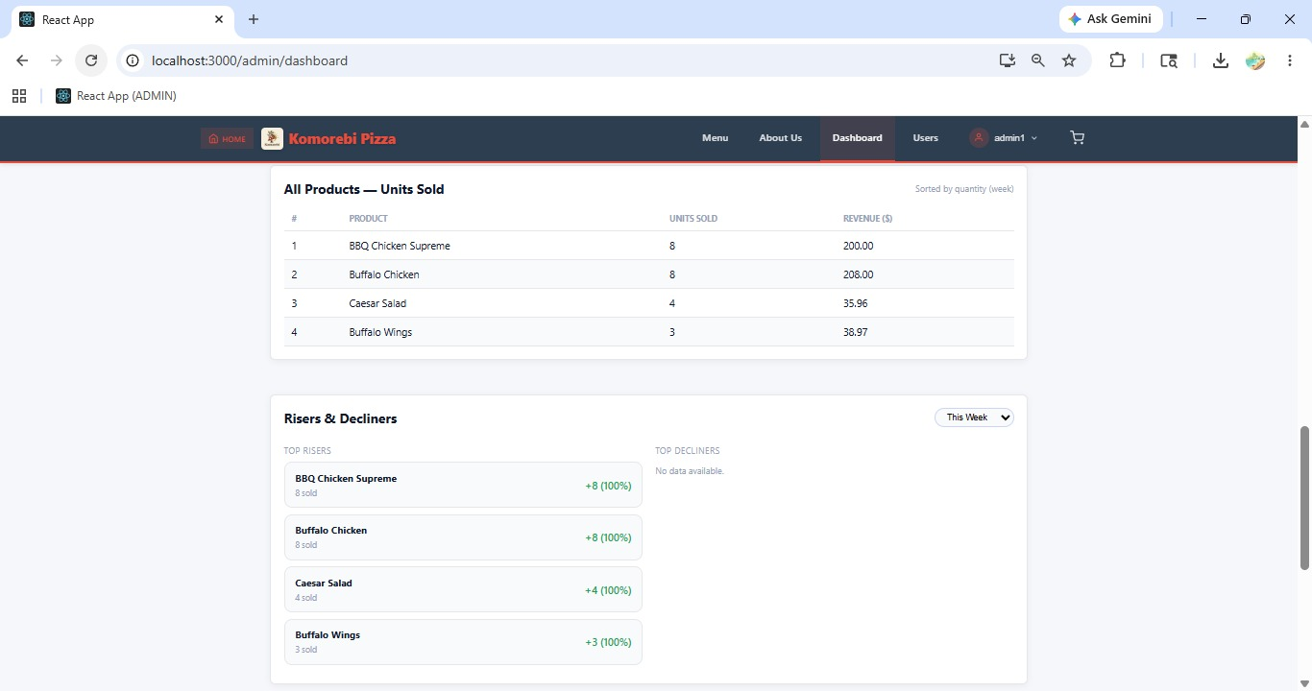 [ Figure: Fig-A16-2: Top Selling Products Chart ]
Acceptance Criteria
- Product analytics shows orders, quantity sold, and revenue per product.
- Charts and tables are sortable to easily identify top and bottom performers.
- Date range filter allows trend analysis over different periods.
- Use this data to inform menu and stock decisions.

A17 — Manage Homepage Banners (PROJECT-58)
PROJECT-58 Epic: WEBSITE CONTENT MGMT | 3 pts | Assignee: Shree Thapa (ST)
As an admin, I want to update homepage banners so that promotions stay fresh.

How to Add a New Homepage Banner
1 | Log in to Admin Dashboard and click 'Banners' or 'Homepage Content' in the sidebar.
2 | The Banner Management page shows all current banners with a preview image, title, and status.
3 | Click '+ Add Banner' to upload a new promotional banner.
4 | Enter the Banner Title (e.g. 'Weekend Special — Free Delivery').
5 | Click 'Upload Image' and select the banner image from your computer. Recommended size: 1200×400px (wide landscape), JPG or PNG.
6 | Optionally enter a Link URL if the banner should link to a specific product or promo page.
7 | Set the banner Status to 'Active' to display it on the homepage.
8 | Click 'Save Banner'.
9 | The banner appears immediately in the homepage carousel/slider.

How to Reorder or Remove Banners
1 | On the Banner Management page, drag and drop banners using the handle icon to reorder them.
2 | To remove a banner: click the 'Delete' icon next to it and confirm.
3 | To temporarily hide a banner without deleting it: click 'Edit' and set the status to 'Inactive'.

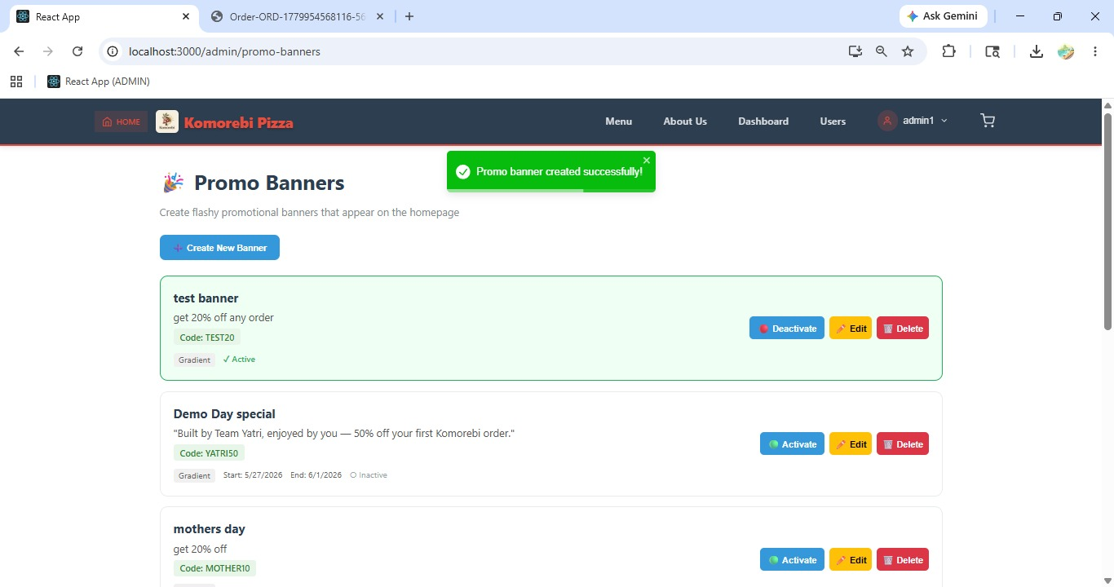[ Figure: Fig-A17-1: Banner Management Page ]

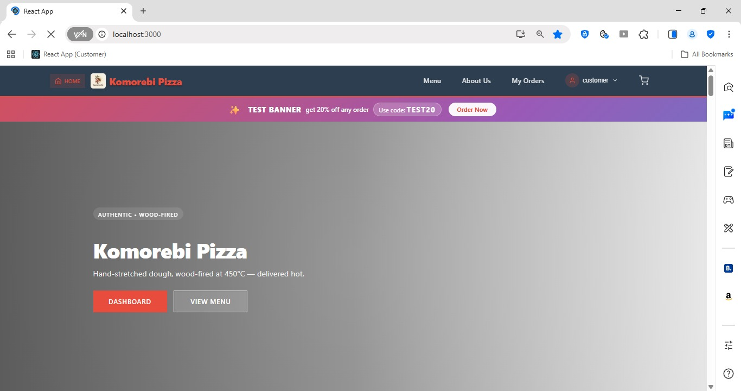[ Figure: Fig-A17-2: New Banner Live on Homepage ]

Acceptance Criteria
- Banners can be added, reordered, hidden, or deleted from the Banner Management page.
- Active banners display immediately on the homepage.
- Recommended image size: 1200×400px for best display.
- Inactive banners are hidden from customers but preserved for future use.

A18 — Search, Filter & Sort Users (PROJECT-59, 60, 61)
PROJECT-59 Epic: USER MANAGEMENT | 3 pts | Assignee: Ankit Kunwar (AK)
As an admin, I want to search for users so that I can find them easily.

PROJECT-60 Epic: USER MANAGEMENT | 2 pts | Assignee: Sulav Gurung (SG)
As an admin, I want to filter users so that I can manage accounts better.

PROJECT-61 Epic: USER MANAGEMENT | 2 pts | Assignee: Sulav Gurung (SG)
As an admin, I want to sort users so that I can view them in order.

How to Search for a Specific User
1 | Log in to Admin Dashboard and click 'Users' in the sidebar.
2 | The User Management page shows all registered users.
3 | Locate the Search bar at the top of the user table.
4 | Type the user's Name or Email Address into the search bar.
5 | Results update as you type, showing only matching users.
6 | Click on the user's name to open their full account details.

How to Filter Users by Role or Status
1 | On the User Management page, locate the Filter options above the user table.
2 | Click the 'Role' filter dropdown and select: All, Customer, Staff, or Admin.
3 | Click the 'Status' filter dropdown and select: All, Active, or Inactive.
4 | The user list updates immediately to show only users matching the selected filters.
5 | To clear filters, click 'Reset Filters' or select 'All' in each dropdown.

How to Sort the User List
1 | On the User Management page, click on any column header to sort by that field.
2 | Click 'Name' to sort users alphabetically A–Z. Click again for Z–A.
3 | Click 'Date Registered' to sort by newest or oldest registration.
4 | Click 'Role' to group users by role.
5 | A sort arrow indicator (↑ or ↓) appears on the active sort column.

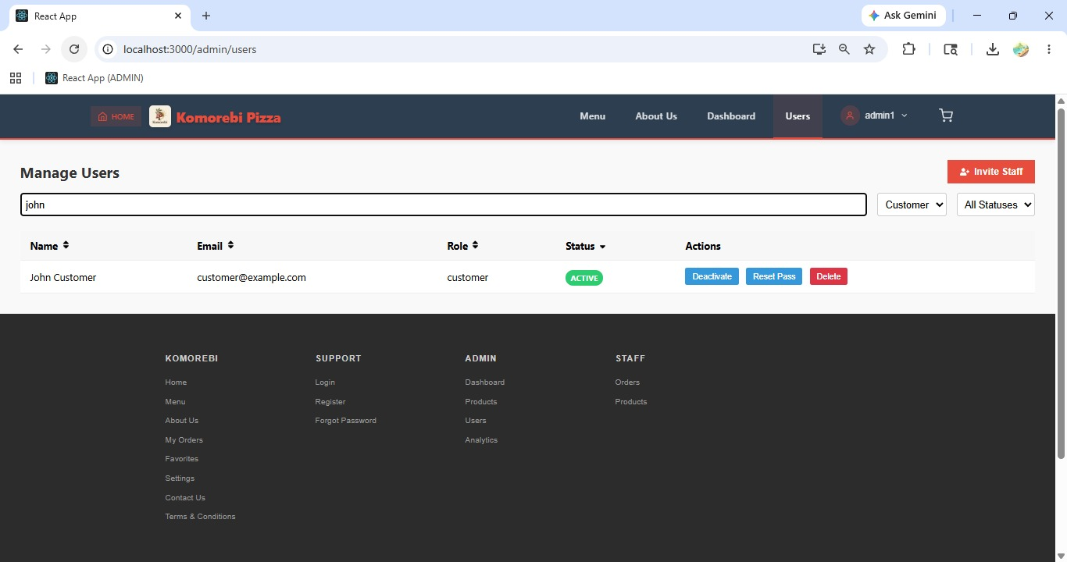[ Figure: Fig-A18-1: User Search Bar in Action ]

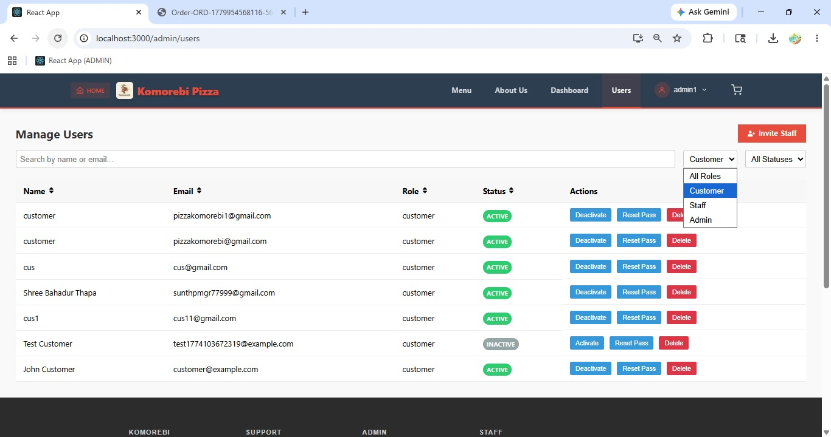[ Figure: Fig-A18-2: Role and Status Filter Dropdowns ]

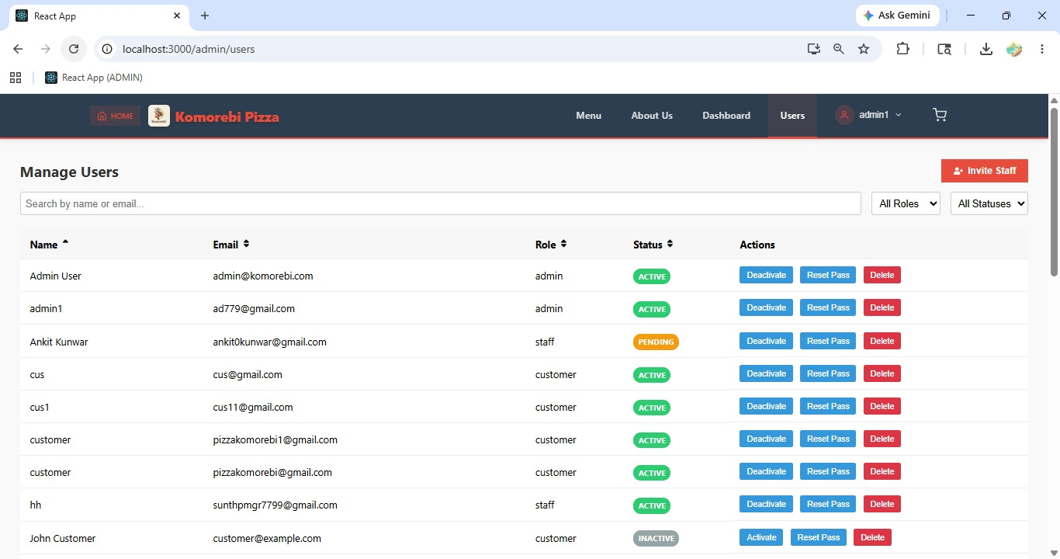[ Figure: Fig-A18-3: User List Sorted by Name ]
Acceptance Criteria
- Search works on user name and email fields.
- Role filter narrows users to: Customer, Staff, or Admin.
- Status filter shows only Active or Inactive accounts.
- Column headers are clickable to sort the list ascending or descending.
- All three tools (search, filter, sort) can be used simultaneously.

PART B — CUSTOMER USER GUIDE

This section covers all features available to registered customers of the Komorebi Pizza website. Customers can register, log in, browse products, manage their cart, place orders, pay online, apply promo codes, and track their orders.

Sprint 1 | Customer Features — Account & Registration  Sprint 1 | Aug – Sep 2025

ID | User Story | Epic | Pts | Assignee
PROJECT-1 | Register on the website to place orders | USER REGISTRATION | 3 | SG
PROJECT-2 | Log in to access my account | USER REGISTRATION | 3 | AK
PROJECT-7 | Reset my password to regain access | PASSWORD & RECOVERY | 3 | SG
PROJECT-9 | Update personal details | USER ACCOUNT MGMT | 3 | ST
PROJECT-10 | Update delivery address | USER ACCOUNT MGMT | 3 | ST

B1 — Customer Registration (PROJECT-1)
PROJECT-1 Epic: USER REGISTRATION | 3 pts | Assignee: Sulav Gurung (SG)
As a customer, I want to register on the website so that I can place orders.

How to Register a New Customer Account
Open your web browser (Chrome, Firefox, Edge, or Safari) and navigate to the Komorebi Pizza website homepage.
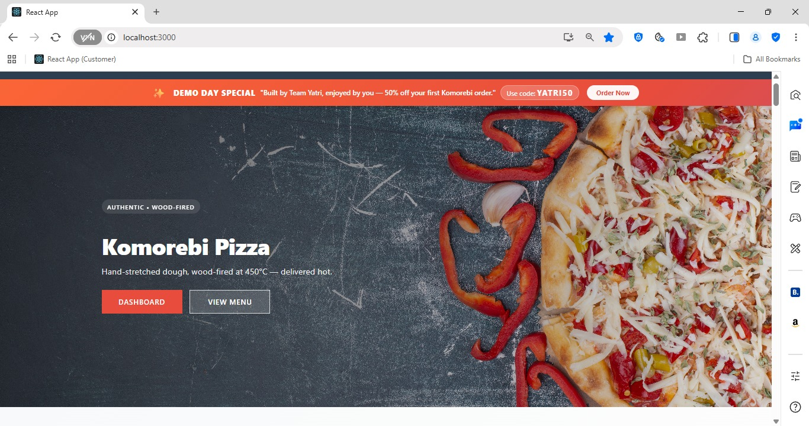[ Figure: Fig-B1-1: Komorebi Homepage ]
1 | Open your web browser and go to the Komorebi Pizza website URL (e.g. http://localhost:3000 for local, or the live domain provided).
2 | On the homepage, click the 'Sign Up' or 'Register' button located in the top-right navigation bar.
3 | The Registration page will open. Enter your Full Name in the first text field (e.g. John Smith).
4 | Enter a valid Email Address in the email field. This will be used as your login username (e.g. john@email.com).
5 | Enter a strong Password in the password field. Must be at least 8 characters, including one uppercase letter and one number.
6 | Re-enter the same password in the Confirm Password field to verify it matches.
7 | Enter your Phone Number (optional but recommended for order notifications).
8 | Click the 'Register' or 'Create Account' button to submit the form.
9 | A success message will appear: 'Account created successfully! Please check your email to verify your account.'
10 | Open your email inbox and click the verification link sent by Komorebi (via Gmail/Nodemailer).
11 | You are now redirected to the login page. Your account is active and ready to use.

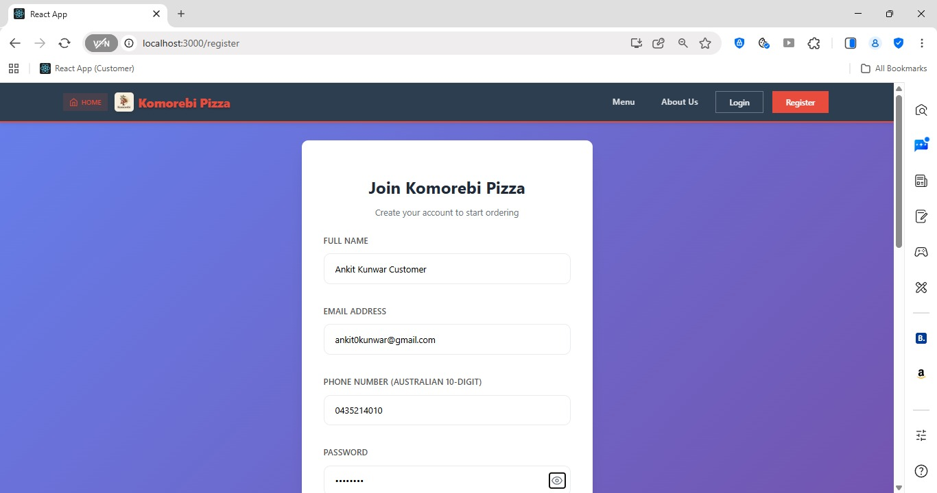[ Figure: Fig-B1-2: Registration Form filled in ]

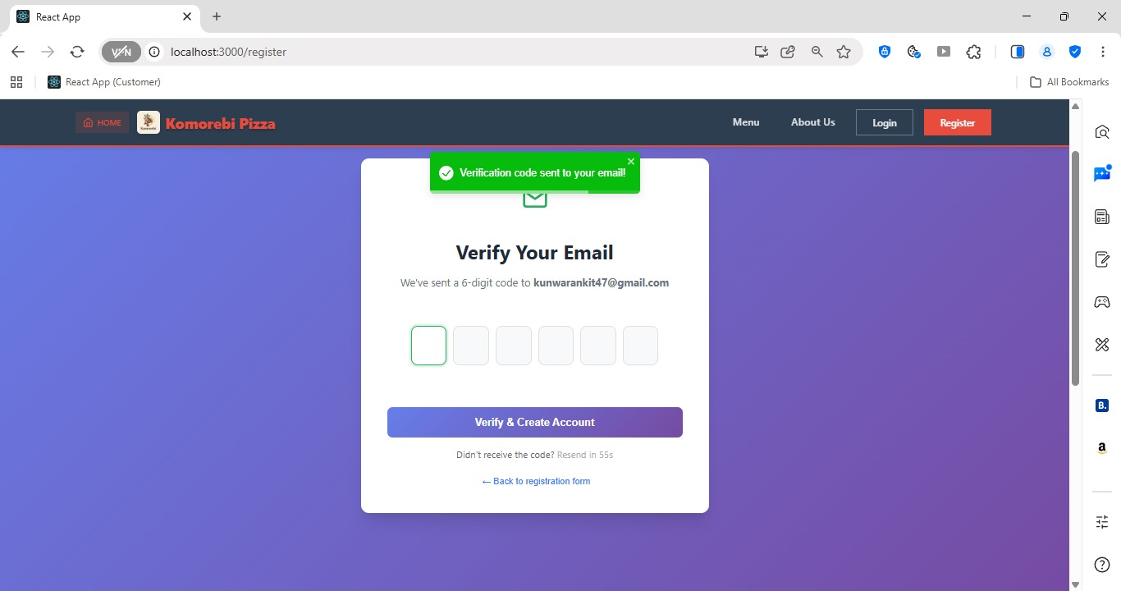
[ Figure: Fig-B1-4: Registration Verification ]

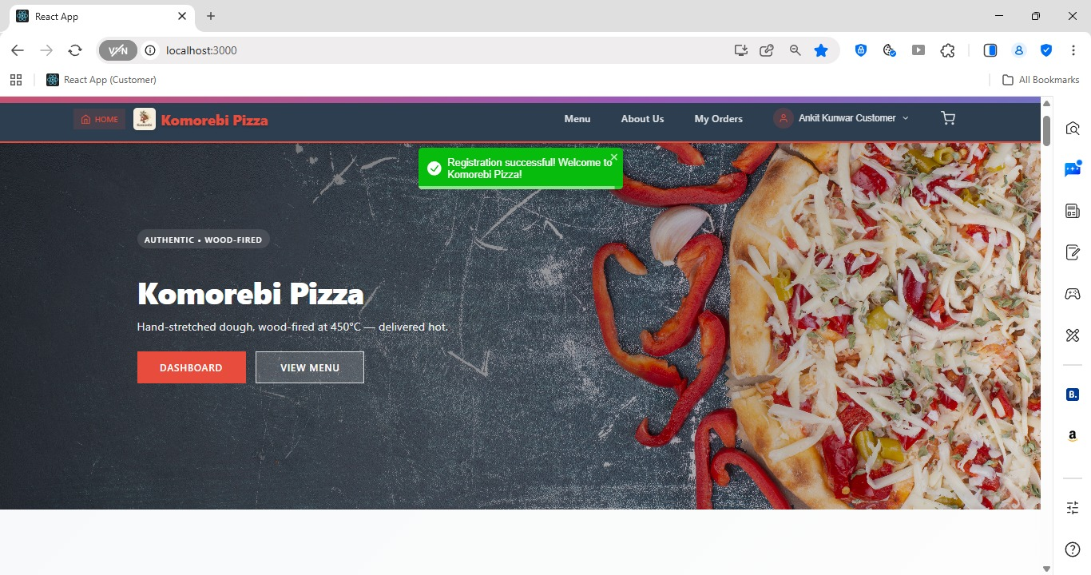 [ Figure: Fig-B1-4: Registration Success Message ]
Acceptance Criteria
- Registration form accepts: Full Name, Email, Password, Confirm Password, Phone Number.
- Email must be unique — duplicate emails are rejected with an error message.
- Password must be at least 8 characters with at least one uppercase letter and one number.
- A verification email is sent upon successful registration.
- User cannot log in until email is verified.

B2 — Customer Login (PROJECT-2)
PROJECT-2 Epic: USER REGISTRATION | 3 pts | Assignee: Ankit Kunwar (AK)
As a customer, I want to log in so that I can access my account.

How to Log In as a Customer
1 | Navigate to the Komorebi website homepage in your browser.
2 | Click the 'Login' button in the top-right corner of the navigation bar.
3 | The Login page opens. Enter your registered Email Address in the email field.
4 | Enter your Password in the password field.
5 | Click the 'Login' or 'Sign In' button.
6 | If credentials are correct, you are redirected to the Customer Dashboard / Homepage.
7 | Your name will appear in the top-right navigation bar confirming you are logged in.
8 | If your email or password is incorrect, an error message displays: 'Invalid email or password. Please try again.'
9 | If you have forgotten your password, click the 'Forgot Password?' link below the login form.

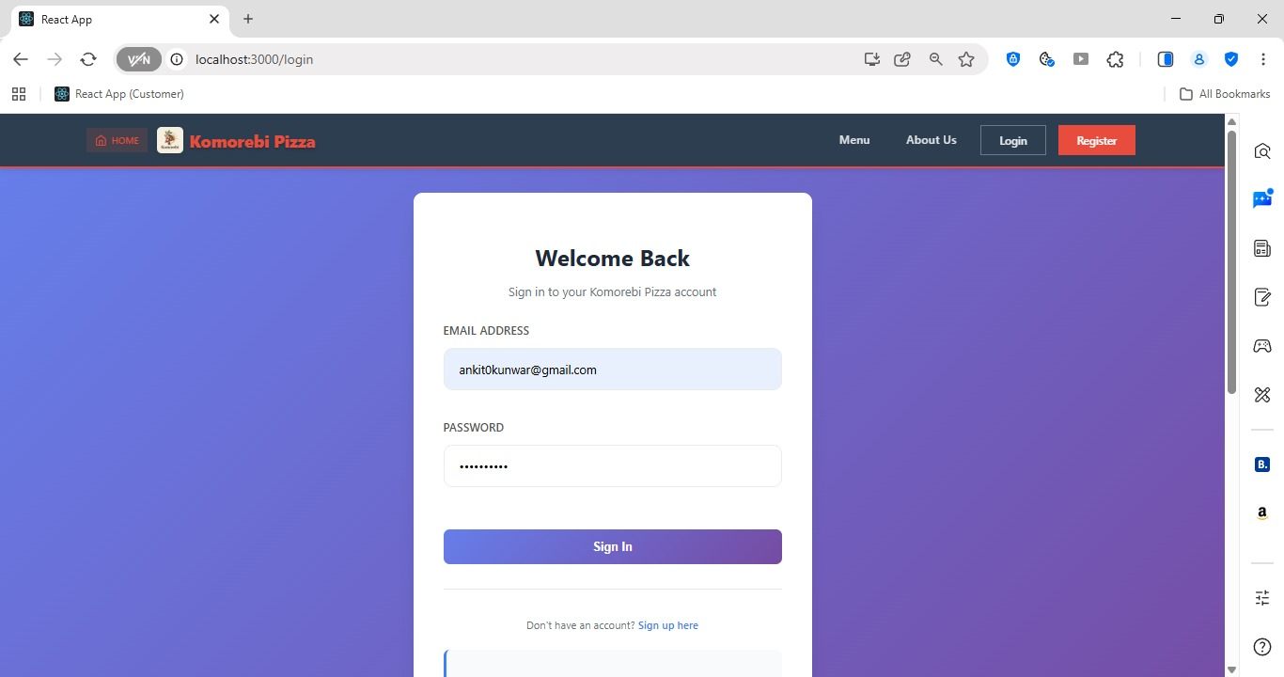[ Figure: Fig-B2-1: Customer Login Page ]

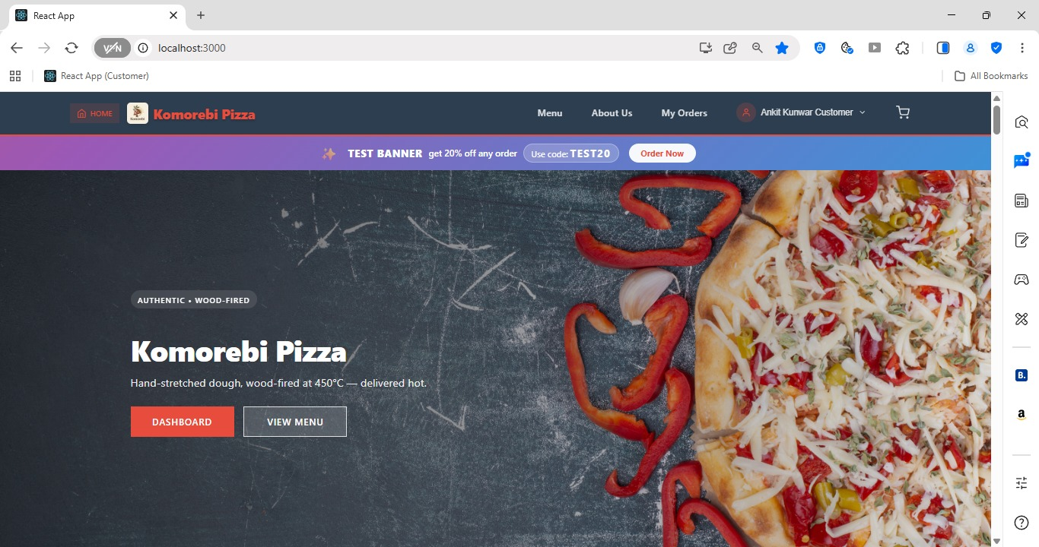[ Figure: Fig-B2-2: Customer Homepage After Login ]

Acceptance Criteria
- Login accepts registered email and password combination.
- Incorrect credentials show a clear error message without revealing which field is wrong.
- Successful login redirects to the customer homepage with the user's name visible.
- Session is maintained until the user logs out or the session expires.

B3 — Forgot Password / Reset Password (PROJECT-7)
PROJECT-7 Epic: PASSWORD & RECOVERY | 3 pts | Assignee: Sulav Gurung (SG)
As a customer, I want to reset my password so that I can regain access.

How to Reset Your Password
1 | On the Login page, click the 'Forgot Password?' link below the login form.
2 | The Forgot Password page opens. Enter your registered Email Address.
3 | Click 'Send Reset Link' or 'Submit'.
4 | A message appears: 'If an account exists with this email, a password reset link has been sent.'
5 | Open your email inbox and locate the password reset email from Komorebi.
6 | Click the 'Reset Password' link inside the email. Note: this link expires after 1 hour.
7 | A new page opens. Enter your New Password in the first field.
8 | Re-enter the same password in the Confirm New Password field.
9 | Click 'Save New Password' or 'Reset Password'.
10 | A success message appears: 'Your password has been reset. Please log in with your new password.'
11 | You are redirected to the Login page. Log in using your new password.

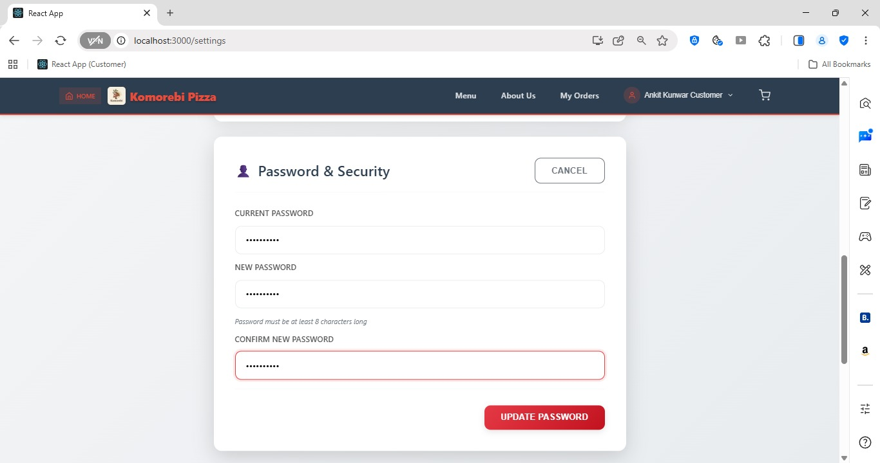[ Figure: Fig-B3-1: Forgot Password Page ]

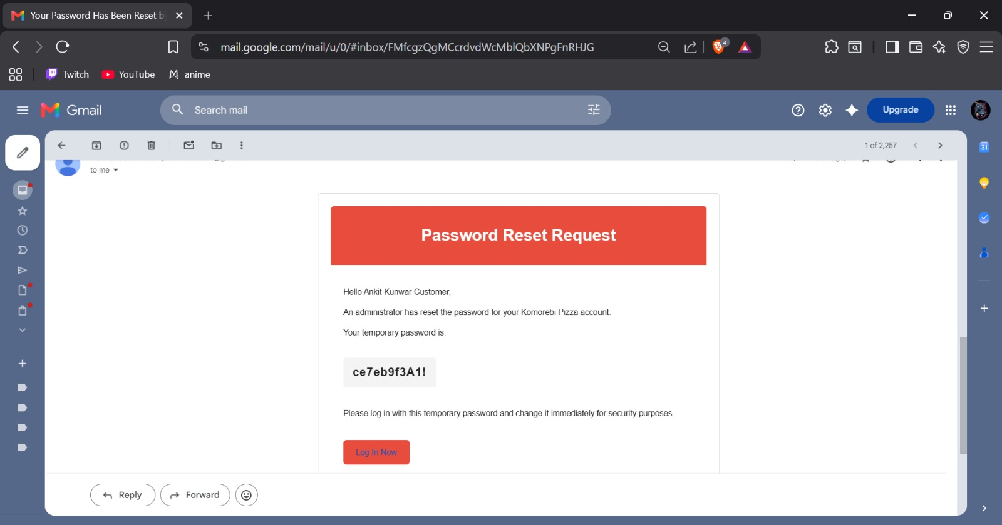[ Figure: Fig-B3-2: Password Reset Email ]
Acceptance Criteria
- A password reset email is sent only to registered email addresses.
- Reset link expires after 1 hour for security.
- New password must meet the same strength requirements as registration.
- Old password is invalidated after successful reset.

B4 — Update Personal Details (PROJECT-9)
PROJECT-9 Epic: USER ACCOUNT MGMT | 3 pts | Assignee: Shree Thapa (ST)
As a customer, I want to update my personal details (name, phone, email) so that my profile stays current.

How to Update Your Profile
1 | Log in to your customer account.
2 | Click on your name or the profile icon in the top-right navigation bar.
3 | Select 'My Profile' or 'Account Settings' from the dropdown menu.
4 | The Profile page opens showing your current details: Name, Email, Phone Number.
5 | Click the 'Edit' button or click directly into the field you wish to change.
6 | Update your Full Name if required.
7 | Update your Phone Number if required.
8 | To change your Email Address, enter the new email — note: a verification email may be sent to the new address.
9 | Click 'Save Changes' or 'Update Profile' to confirm your edits.
10 | A success message appears: 'Profile updated successfully.'
11 | Your new details are now reflected in the navigation bar and account page.

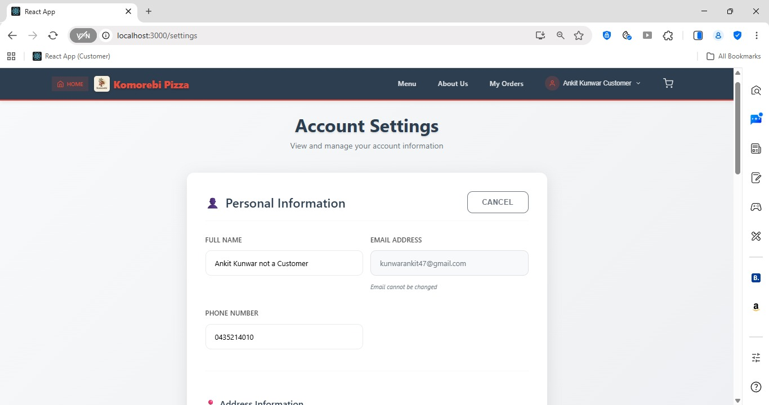[ Figure: Fig-B4-1: My Profile Page ]

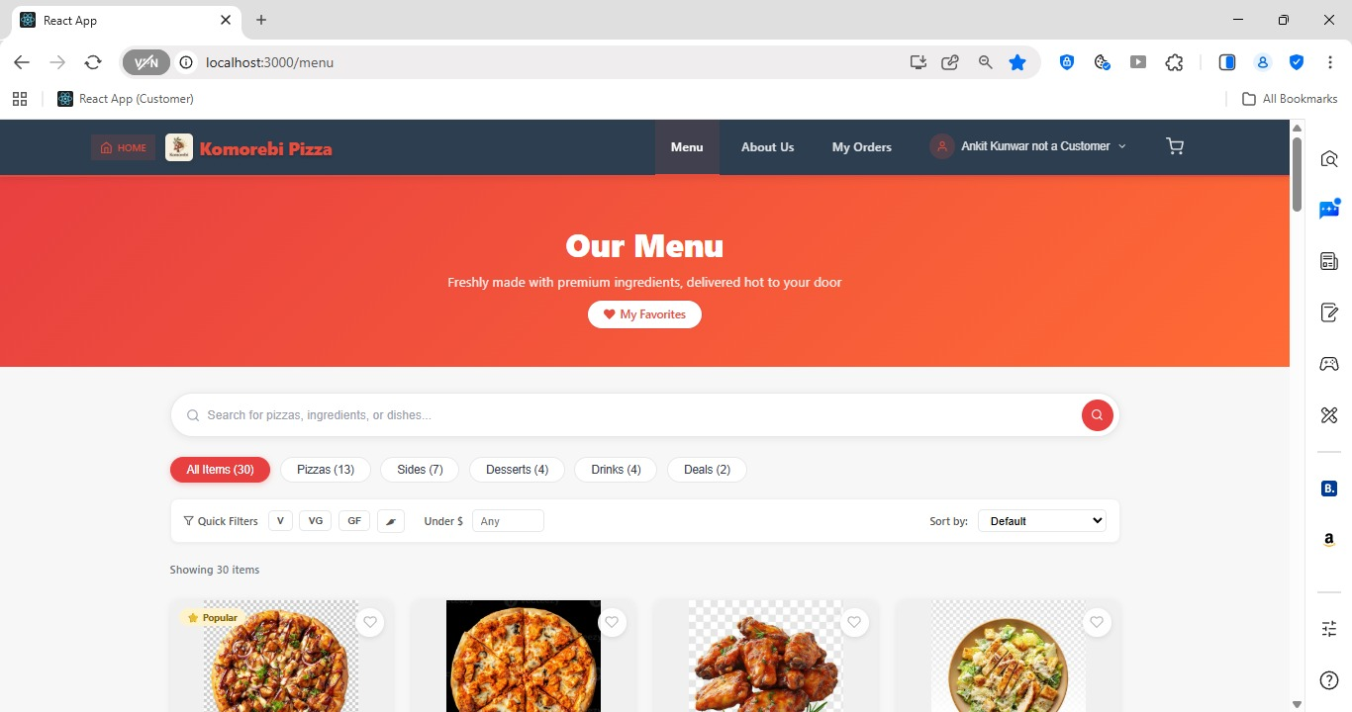[ Figure: Fig-B4-2: Profile Updated Successfully ]
Acceptance Criteria
- Customer can update Name, Email, and Phone Number from their profile page.
- Changes are saved immediately upon clicking Save.
- Email change may trigger re-verification depending on system settings.
- Success confirmation message is shown after any update.

B5 — Update Delivery Address (PROJECT-10)
PROJECT-10 Epic: USER ACCOUNT MGMT | 3 pts | Assignee: Shree Thapa (ST)
As a customer, I want to update my delivery address so that orders go to the right place.

How to Update Your Delivery Address
1 | Log in to your customer account.
2 | Click your name or profile icon in the top-right navigation bar.
3 | Select 'My Addresses' or 'Delivery Addresses' from the dropdown.
4 | The Address Management page displays your saved addresses.
5 | To edit an existing address: click the 'Edit' (pencil) icon next to the address.
6 | Update the Street Address, Suburb, State, and Postcode fields as needed.
7 | To add a new address: click the '+ Add New Address' button.
8 | Fill in all required fields: Street Address, Suburb, State, Postcode.
9 | Optionally tick 'Set as Default Address' to use this address for future orders automatically.
10 | Click 'Save Address' to confirm.
11 | The address list refreshes and your updated/new address appears.

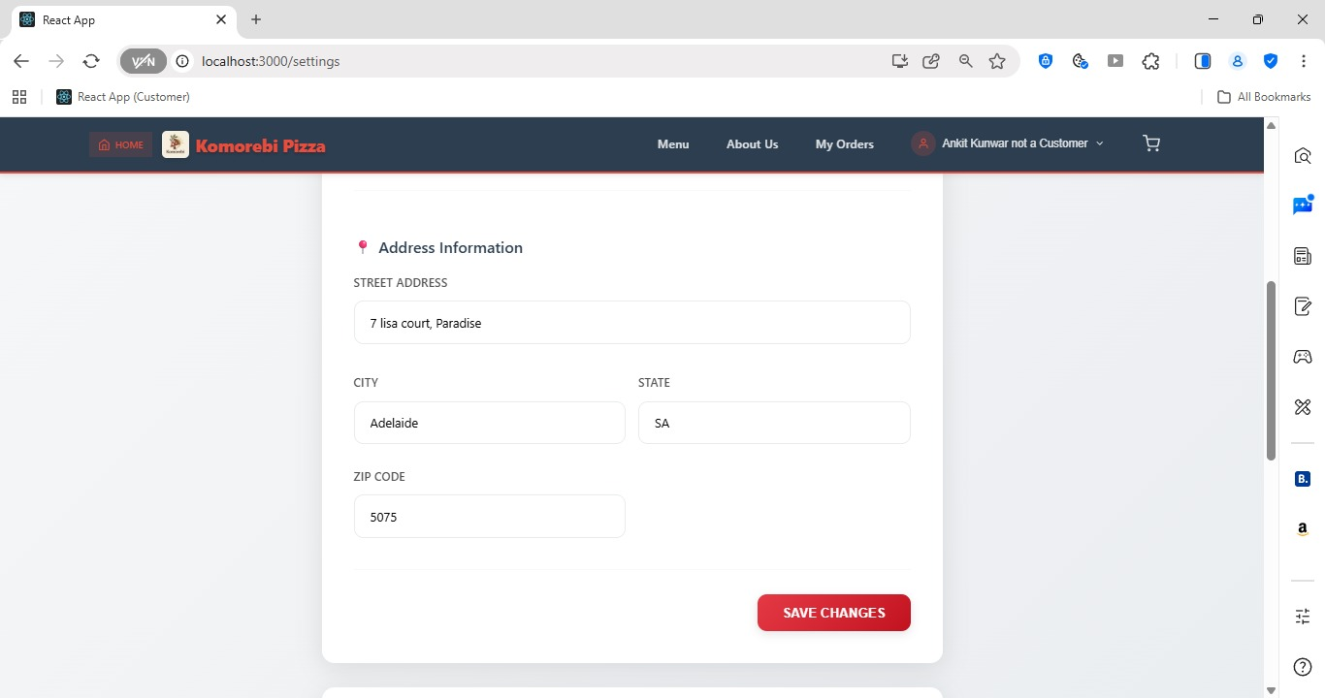[ Figure: Fig-B5-1: Add / Edit Address Form]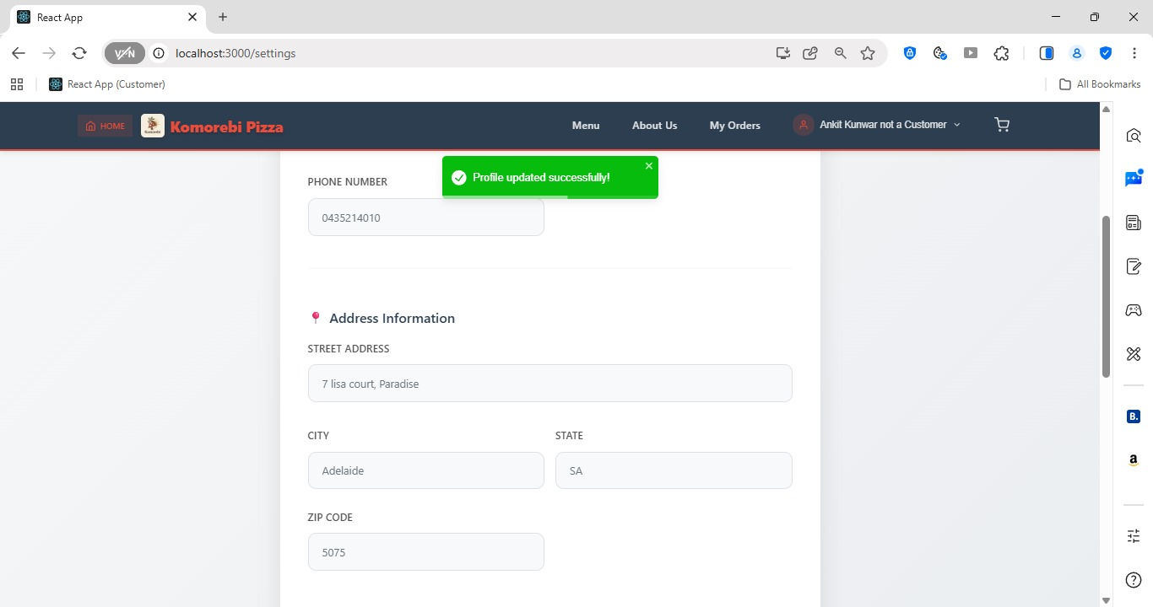
[ Figure: Fig-B5-2: Updated Address Information]

Acceptance Criteria
- Customer can add, edit, or delete delivery addresses.
- One address can be set as the default for checkout.
- All address fields (street, suburb, state, postcode) are required.
- Default address is automatically pre-selected at checkout.

Sprint 2 | Customer Features — Browse & Search Products  Sprint 2 | 22 Sep – 12 Oct 2025

ID | User Story | Epic | Pts | Assignee
PROJECT-16 | View all products / menu to choose pizzas | CUSTOMER PRODUCT BROWSING | 3 | SG
PROJECT-17 | View product details to make informed choices | CUSTOMER PRODUCT BROWSING | 3 | AK
PROJECT-18 | Search for products to find them quickly | PRODUCT SEARCH & FILTER | 4 | SG

B6 — Browse Products / View Menu (PROJECT-16)
PROJECT-16 Epic: CUSTOMER PRODUCT BROWSING | 3 pts | Assignee: Sulav Gurung (SG)
As a customer, I want to view all products so that I can choose what to order.

How to Browse the Pizza Menu
1 | Log in to your customer account and go to the homepage.
2 | Click 'Menu' in the top navigation bar, or scroll down to the product listing section on the homepage.
3 | The Menu / Products page loads, displaying all available pizzas with thumbnail images, names, and prices.
4 | Use the Category filter on the left sidebar (or top filter bar) to narrow results by category (e.g. Classic, Vegetarian, Premium).
5 | Scroll through the product grid to browse all items.
6 | Each product card shows: product image, name, short description, and price.
7 | Click on any product card to open the full product detail page.
8 | To return to the full menu, click 'Back' or the 'Menu' link in the navigation bar.

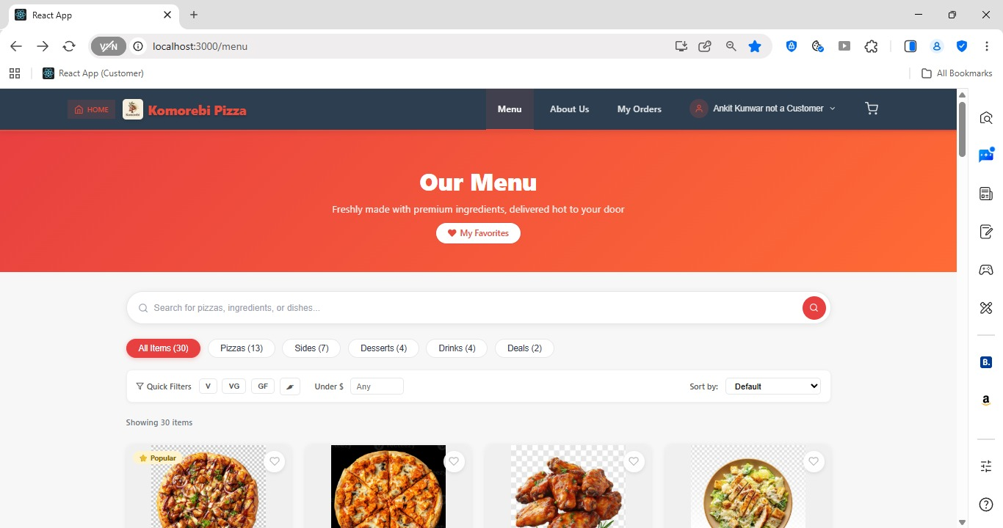[ Figure: Fig-B6-1: Menu / Products Page ]

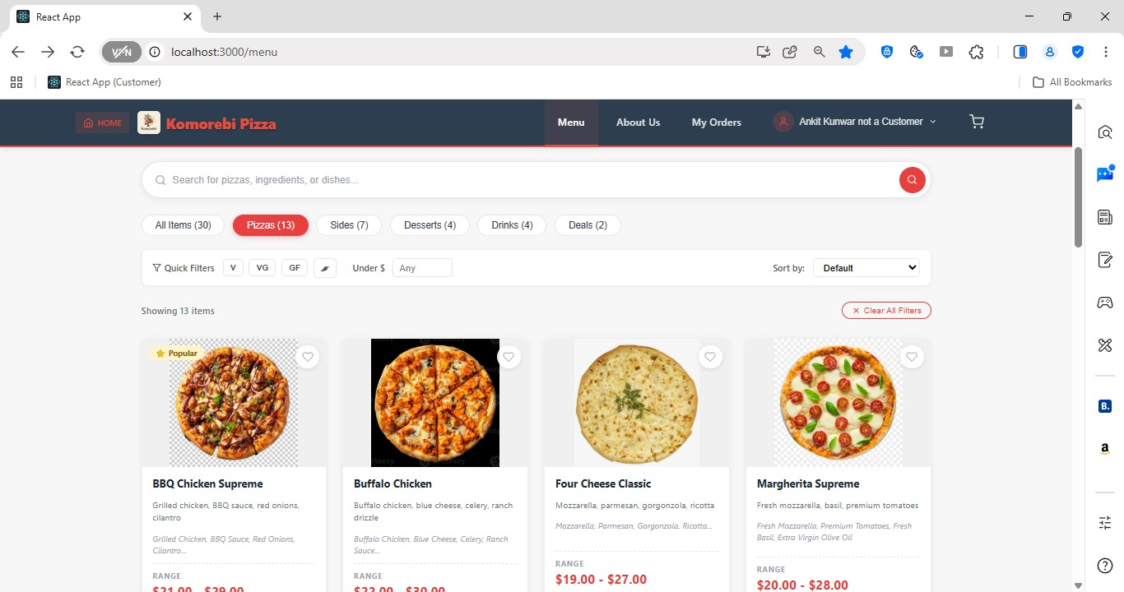[ Figure: Fig-B6-2: Product Category Filter ]
Acceptance Criteria
- All active products are visible to logged-in customers on the Menu page.
- Products are displayed with image, name, description, and price.
- Category filters allow customers to narrow down products.
- Out-of-stock or deactivated products are not shown.

B7 — View Product Details (PROJECT-17)
PROJECT-17 Epic: CUSTOMER PRODUCT BROWSING | 3 pts | Assignee: Ankit Kunwar (AK)
As a customer, I want to view product details so that I can make an informed choice.

How to View Full Product Details
1 | From the Menu page, click on any pizza product card.
2 | The Product Detail page opens for that specific item.
3 | Review the full product name, high-quality image, detailed description, ingredients, and price.
4 | If the product has size or customisation options, select your preference from the available buttons (e.g. Small / Medium / Large).
5 | Check the allergen or dietary information if displayed (e.g. Vegetarian, Contains Gluten).
6 | Review the price which may update based on your selected size.
7 | Click 'Add to Cart' to add this item to your shopping cart, or click 'Back' to return to the menu.

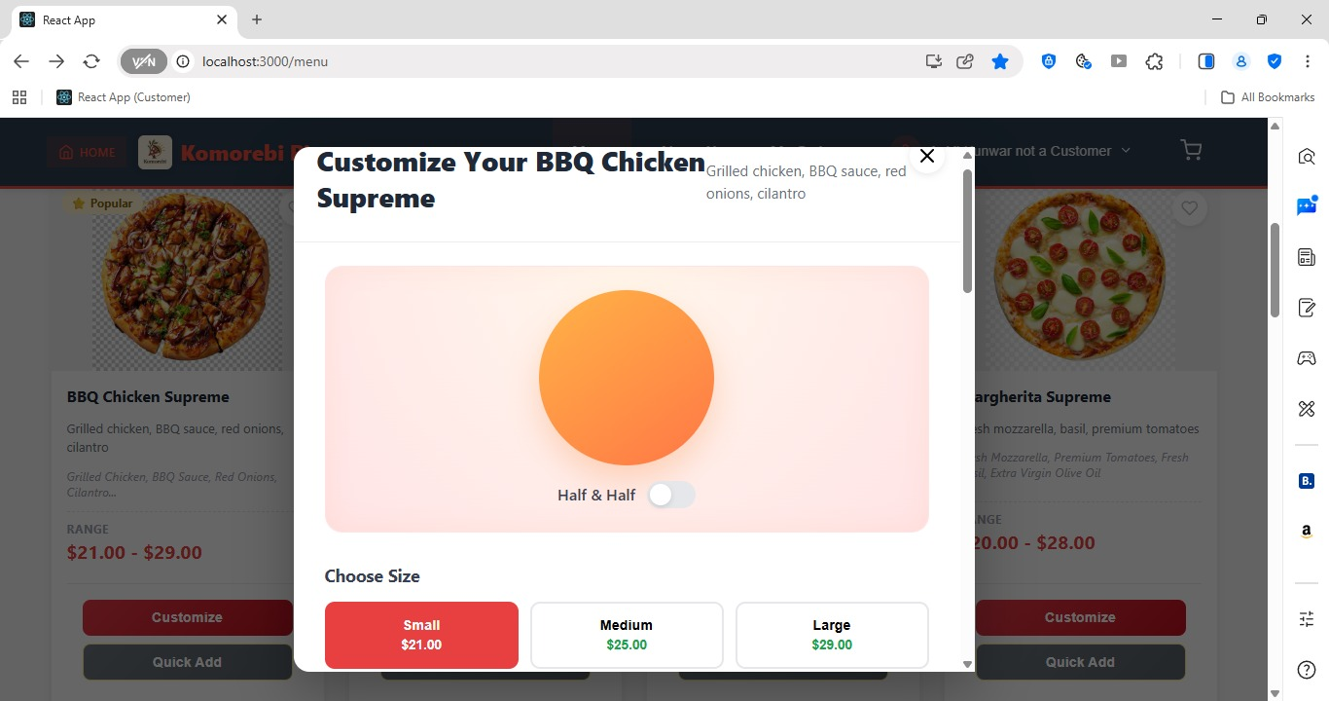[ Figure: Fig-B7-1: Product Detail Page & Size Selection Options]
Acceptance Criteria
- Product detail page shows full image, name, description, ingredients, and price.
- Size or variant options update the price dynamically.
- Add to Cart button is accessible from the product detail page.

B8 — Search Products (PROJECT-18)
PROJECT-18 Epic: PRODUCT SEARCH & FILTER | 4 pts | Assignee: Sulav Gurung (SG)
As a customer, I want to search for products so that I can find specific items quickly.

How to Search for a Product
1 | From any page on the website, locate the Search bar at the top of the page (usually in the navigation bar).
2 | Click inside the search bar so the cursor appears.
3 | Type a keyword for the pizza or item you are looking for (e.g. 'Margherita', 'BBQ Chicken', 'Vegetarian').
4 | Press Enter on your keyboard or click the search icon (magnifying glass).
5 | The search results page loads, showing all products that match your keyword.
6 | If no results are found, a message appears: 'No products found matching your search.'
7 | Click on any result to open the Product Detail page, or click 'Add to Cart' directly from the results.
8 | To clear the search and return to the full menu, clear the search field and press Enter, or click 'Menu' in the navigation.

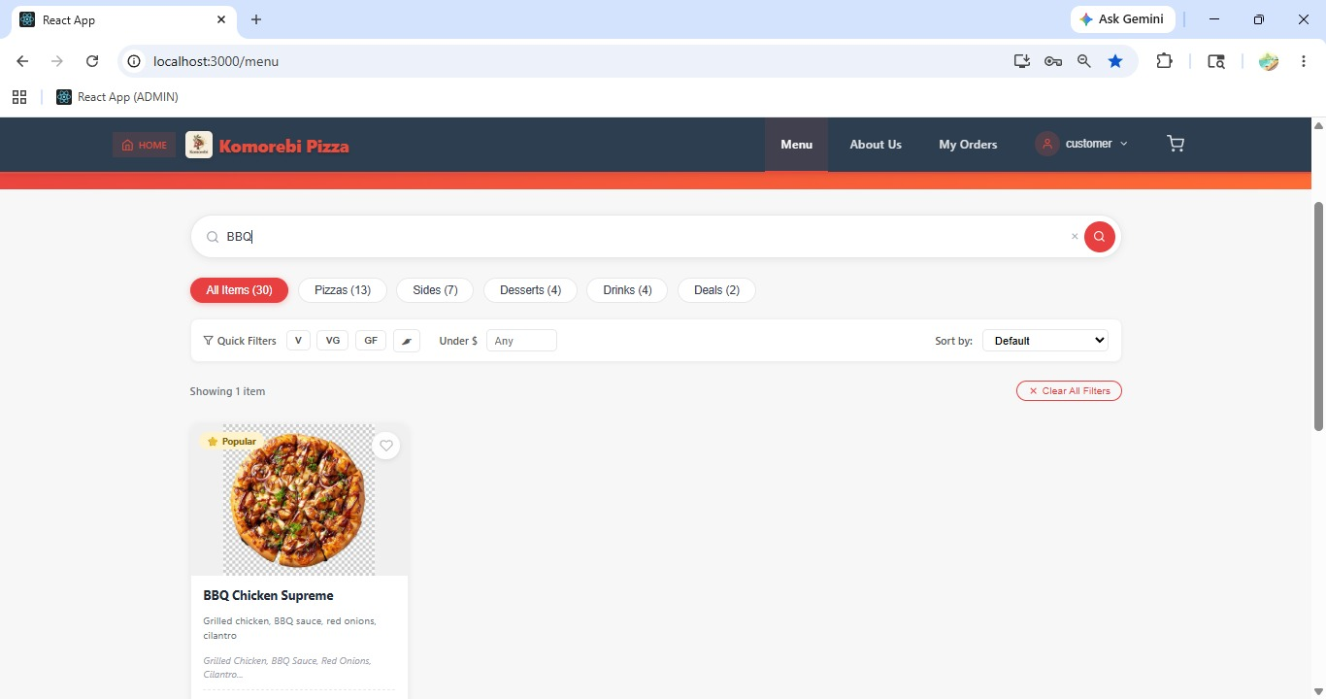[ Figure: Fig-B8-1: Search Bar with Keyword & Results Page]

Acceptance Criteria
- Search works across product names and descriptions.
- Results appear instantly or on pressing Enter.
- Empty results show a clear 'no results' message.
- Search is case-insensitive.

Sprint 3 | Customer Features — Cart & Order Management  Sprint 3 | 25 Mar – 2 Apr 2026

ID | User Story | Epic | Pts | Assignee
PROJECT-27 | Add items to cart to buy later | CART MANAGEMENT | 5 | NG
PROJECT-28 | View cart to know what I'm ordering | CART MANAGEMENT | 2 | NG
PROJECT-29 | Modify cart so my order is correct | CART MANAGEMENT | 3 | ST
PROJECT-30 | Place an order online to buy pizzas | ORDER PLACEMENT | 8 | AK
PROJECT-31 | Send a note to restaurant when placing order | CUSTOMER SIDE ORDER | 3 | AK
PROJECT-32 | Cancel my order before it's prepared | STAFF SIDE ORDER P... | 3 | ST

B9 — Add Items to Cart (PROJECT-27)
PROJECT-27 Epic: CART MANAGEMENT | 5 pts | Assignee: Nabraj Gyawali (NG)
As a customer, I want to add items to my cart so that I can buy them later.

How to Add a Product to Your Cart
1 | Log in to your customer account and navigate to the Menu page.
2 | Browse or search for the pizza you want to order.
3 | Click on the product card to open the Product Detail page.
4 | Select your preferred size or variant (e.g. Small, Medium, Large) if options are available.
5 | Set the quantity using the + and – buttons (default quantity is 1).
6 | Click the 'Add to Cart' button.
7 | A confirmation message appears (e.g. 'Margherita Pizza added to cart!').
8 | The shopping cart icon in the top navigation bar updates to show the number of items in your cart (e.g. a red badge showing '1').
9 | Continue browsing to add more items, or click the cart icon to proceed.
10 | To add the same item again, return to the product page and repeat steps 5–6, or increase quantity from the cart.

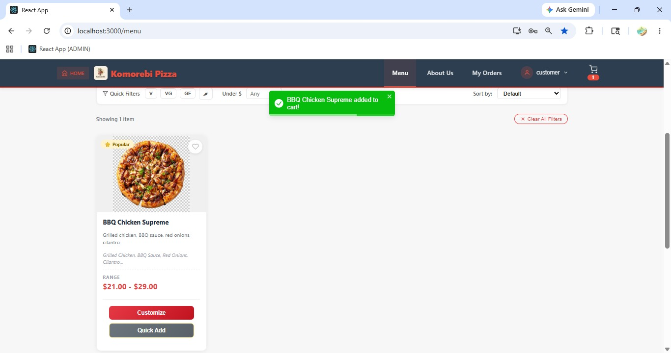[ Figure: Fig-B9-1: Add to Cart Button on Product Page & Cart Icon Updated with Item Count ]

Acceptance Criteria
- Any active product can be added to the cart from the product detail page.
- Cart icon in navigation updates the item count immediately.
- Multiple quantities of the same item can be added.
- Cart contents persist while the customer is logged in.

B10 — View & Modify Cart (PROJECT-28 & PROJECT-29)
PROJECT-28 Epic: CART MANAGEMENT | 2 pts | Assignee: Nabraj Gyawali (NG)
As a customer, I want to view my cart so that I know what I'm ordering.

PROJECT-29 Epic: CART MANAGEMENT | 3 pts | Assignee: Shree Thapa (ST)
As a customer, I want to modify my cart so that my order is correct.

How to View Your Cart
1 | Click the Cart icon (shopping basket/bag) in the top-right navigation bar.
2 | The Cart page opens, listing all items currently in your cart.
3 | Each row shows: product image, product name, selected size, unit price, quantity, and line total.
4 | The cart summary at the bottom shows: Subtotal, any applicable discounts, and Total Amount.

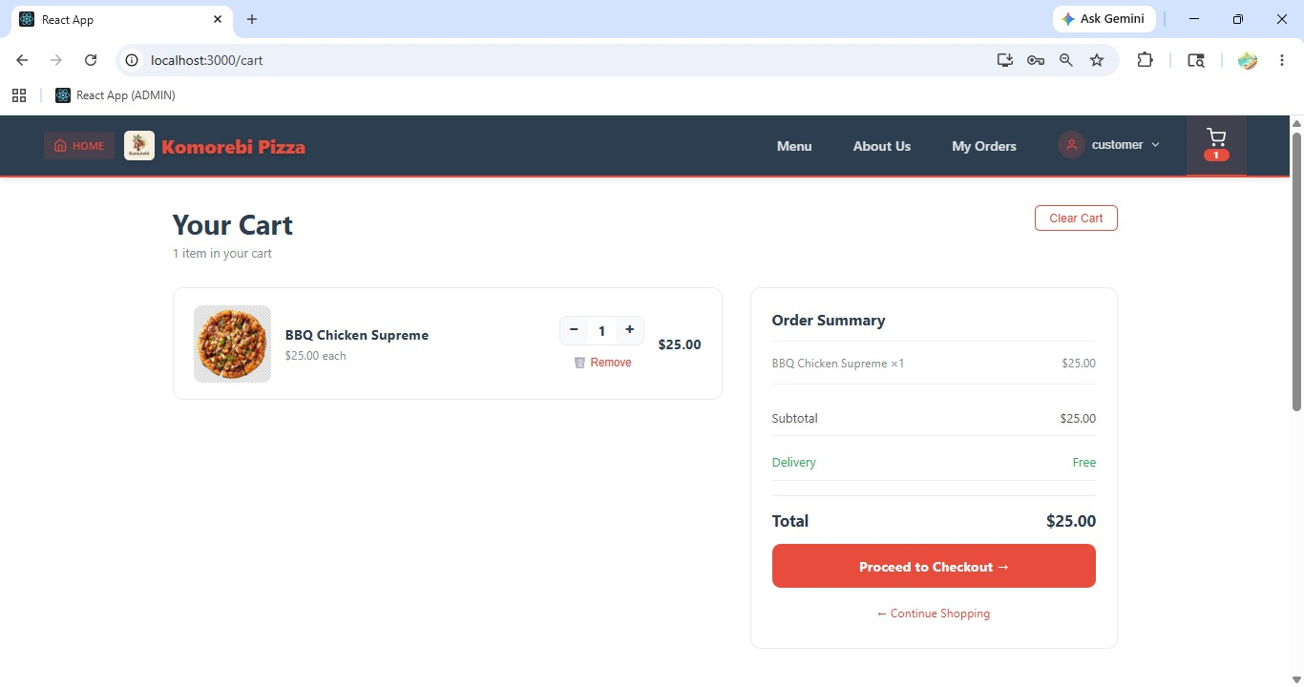[ Figure: Fig-B10-1: Cart Page with Items Listed ]

How to Modify Your Cart
1 | On the Cart page, find the item you wish to change.
2 | To increase quantity: click the '+' button next to the item. The quantity and total update automatically.
3 | To decrease quantity: click the '–' button. If quantity reaches 0, the item is removed from the cart.
4 | To remove an item entirely: click the 'Remove' or trash icon (🗑) next to the product.
5 | A confirmation prompt may appear: 'Remove this item from cart?' — click 'Yes' to confirm.
6 | The cart updates immediately, recalculating the total.
7 | If the cart is empty, a message appears: 'Your cart is empty. Start shopping!'
8 | Click 'Continue Shopping' to return to the Menu, or 'Proceed to Checkout' when ready.

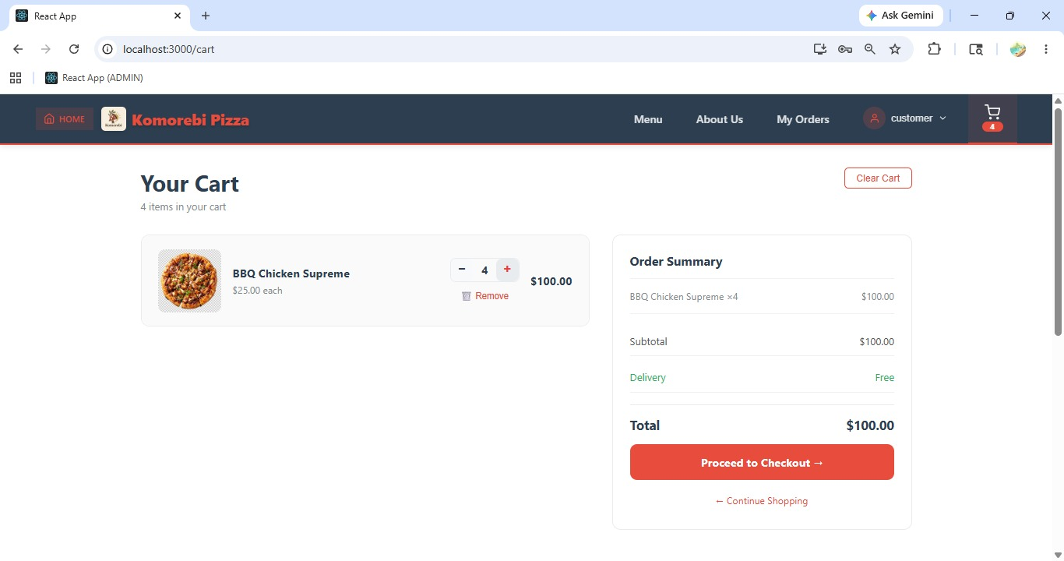[ Figure: Fig-B10-2: Modifying Cart Quantities ]
Acceptance Criteria
- Cart displays all added items with quantities, prices, and totals.
- Quantity can be increased or decreased using +/– controls.
- Items can be individually removed from the cart.
- Cart total recalculates dynamically on any change.

B11 — Place an Order (PROJECT-30 & PROJECT-31)
PROJECT-30 Epic: ORDER PLACEMENT | 8 pts | Assignee: Ankit Kunwar (AK)
As a customer, I want to place an order online so that I can buy pizzas.

PROJECT-31 Epic: CUSTOMER SIDE ORDER | 3 pts | Assignee: Ankit Kunwar (AK)
As a customer, I want to send a note to the restaurant when I place my order.

How to Place an Order
1 | After adding all desired items to your cart, click the Cart icon and then click 'Proceed to Checkout'.
2 | The Checkout page opens. Review your order summary on the right side of the screen.
3 | Select or confirm your Delivery Address from the saved addresses, or enter a new address.
4 | In the 'Order Notes' or 'Special Instructions' field, type any specific requests for the kitchen (e.g. 'Extra cheese please', 'No onions', 'Ring the doorbell').
5 | Select your preferred Delivery Time if the option is available (e.g. ASAP or a scheduled time).
6 | Review the order total including subtotal, delivery fee, and any applied discounts.
7 | Click 'Continue to Payment' or 'Place Order' to proceed to the payment step.
8 | Select your payment method (Stripe credit/debit card or PayPal) — see Section B13 for full payment steps.
9 | After payment is confirmed, an Order Confirmation page appears with your Order ID and summary.
10 | A confirmation email is automatically sent to your registered email address.

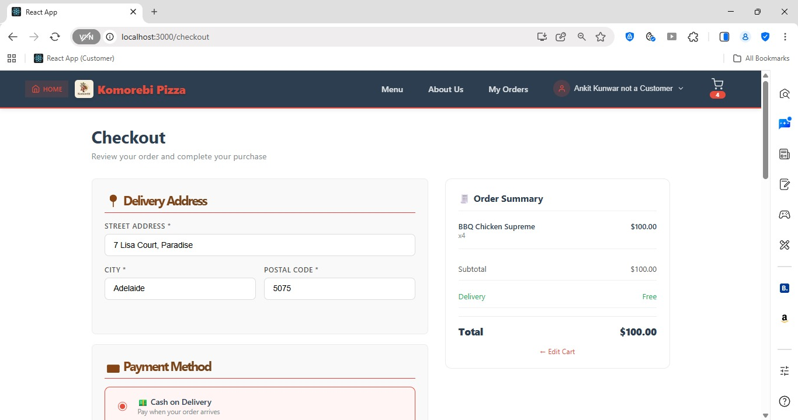[ Figure: Fig-B11-1: Checkout Page with Address and Notes ]

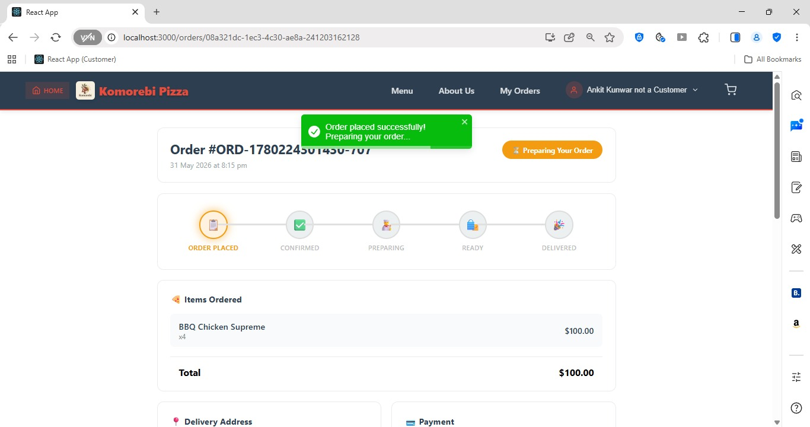[ Figure: Fig-B11-2: Order Confirmation Screen ]

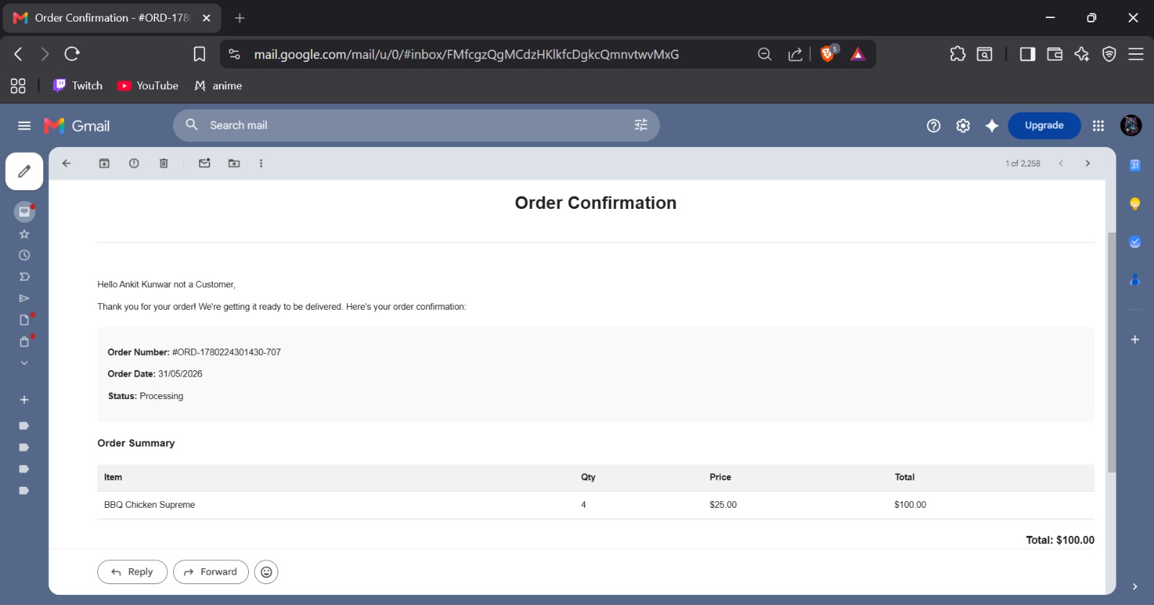[ Figure: Fig-B11-3: Order Confirmation Email ]
Acceptance Criteria
- Checkout requires a valid delivery address to be selected.
- Order notes / special instructions field accepts free text up to 500 characters.
- Order is only confirmed after successful payment.
- Order confirmation email is sent automatically via Nodemailer/Gmail.
- A unique Order ID is assigned to every successful order.

B12 — Cancel Order (PROJECT-32)
PROJECT-32 Epic: STAFF SIDE ORDER P... | 3 pts | Assignee: Shree Thapa (ST)
As a customer, I want to cancel my order before it is prepared so that I am not charged for unwanted food.

How to Cancel an Order
1 | Log in to your customer account and click your name or profile icon in the navigation bar.
2 | Select 'My Orders' or 'Order History' from the dropdown menu.
3 | The Order History page lists all your past and current orders.
4 | Locate the order you wish to cancel. Orders that are still cancellable will show a 'Cancel Order' button.
5 | Click the 'Cancel Order' button next to the relevant order.
6 | A confirmation popup appears: 'Are you sure you want to cancel this order? This action cannot be undone.'
7 | Click 'Yes, Cancel Order' to confirm.
8 | The order status changes to 'Cancelled'.
9 | A cancellation confirmation email is sent to your registered email address.
10 | Note: Orders can only be cancelled while they are in 'Pending' or 'Accepted' status. Once the order is 'In Preparation' or later, cancellation is not available.

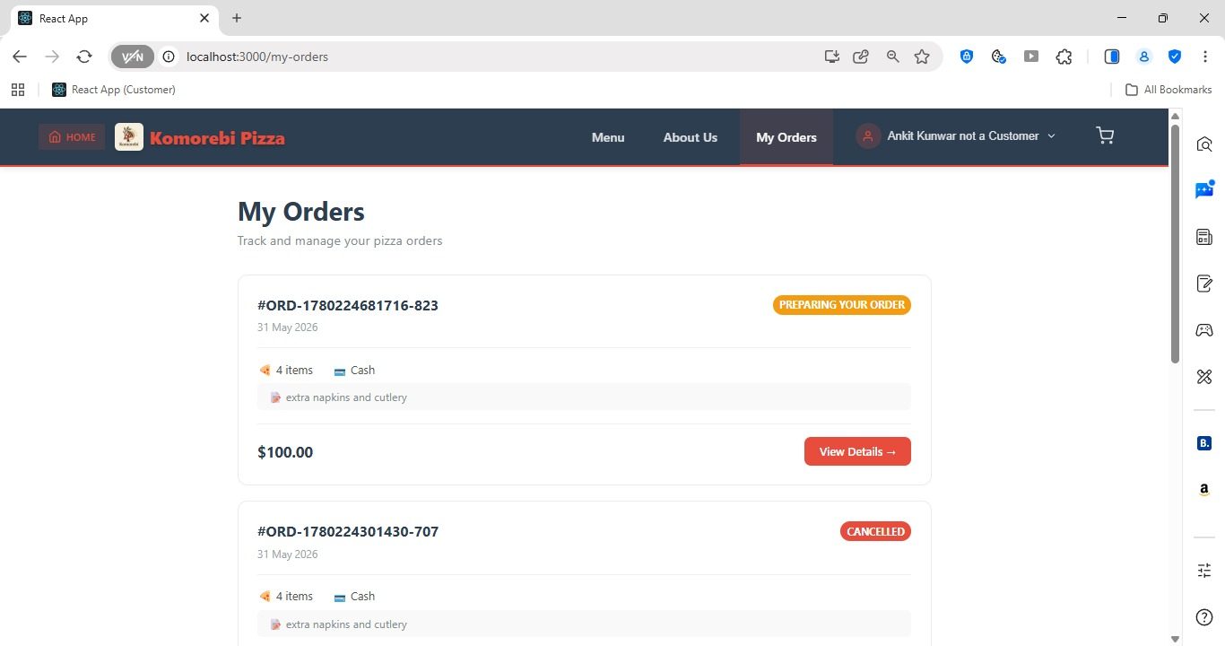[ Figure: Fig-B12-1: Order History Page ]

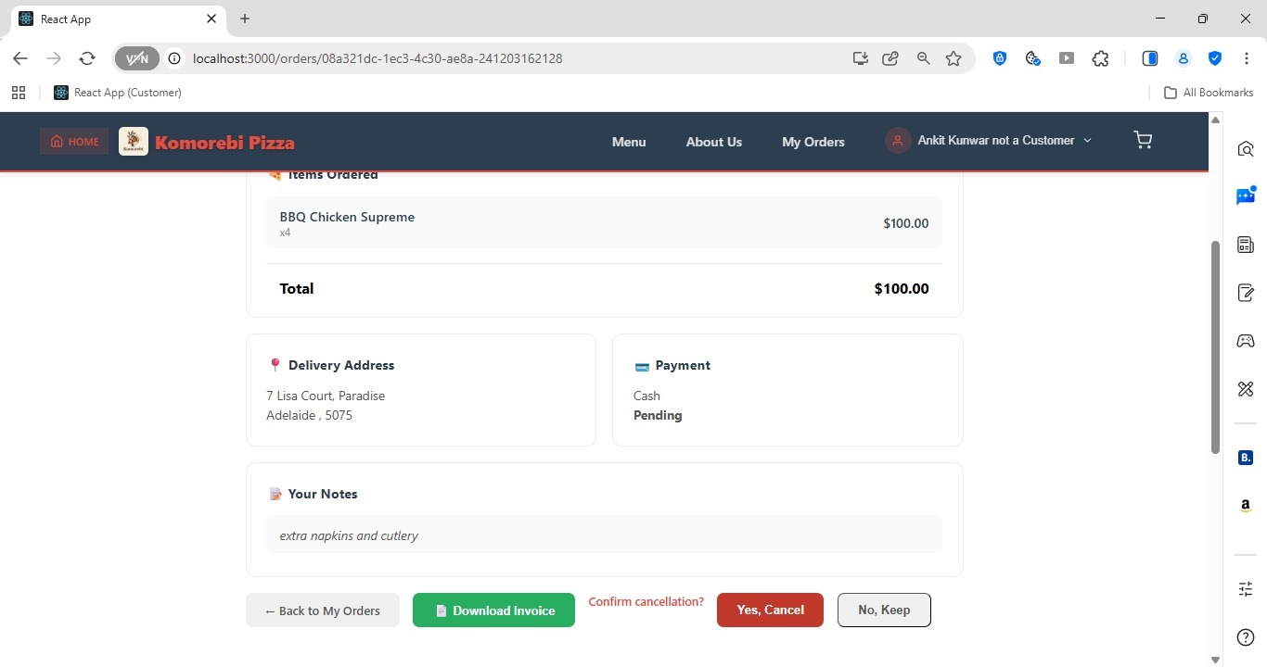
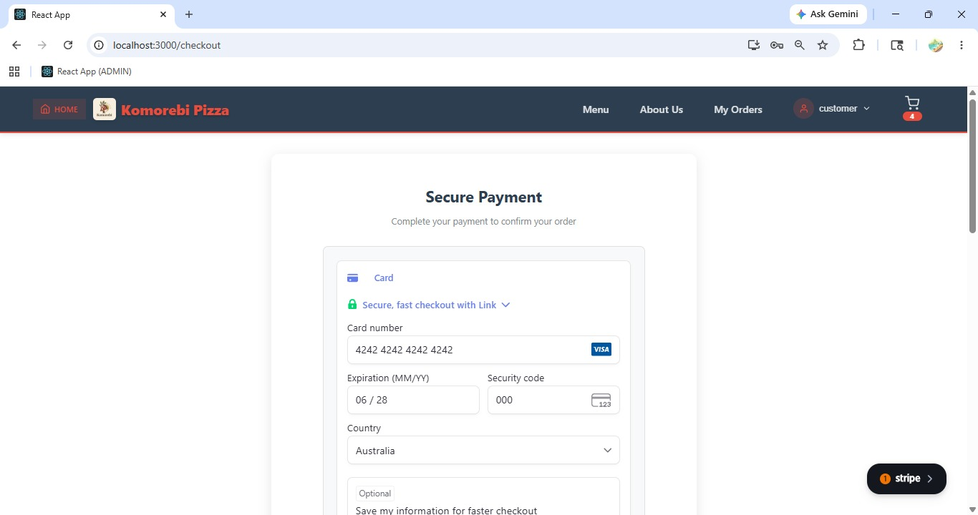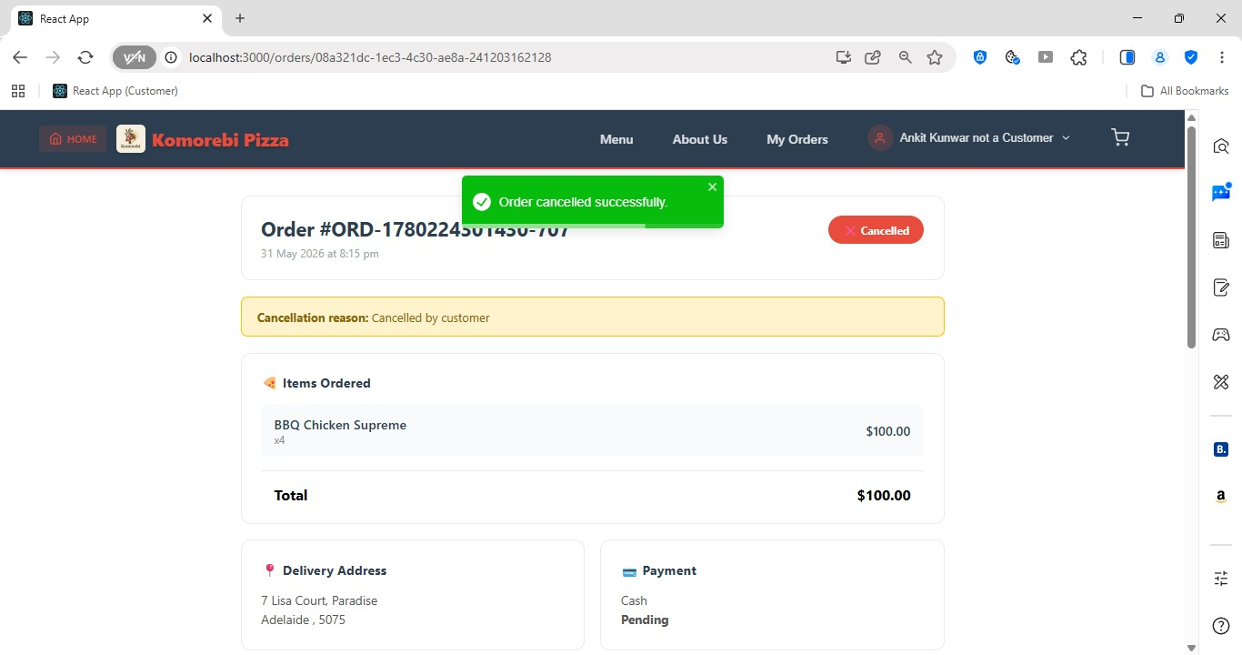 [ Figure: Fig-B12-2, 12-3: Cancel Order Confirmation Popup ]
Acceptance Criteria
- Orders can only be cancelled before preparation begins (status: Pending or Accepted).
- A confirmation prompt prevents accidental cancellations.
- Cancelled order status is updated immediately in Order History.
- Cancellation confirmation email is sent to the customer.

Sprint 4 | Customer Features — Payment, Promo Codes & Order Tracking  Sprint 4 | 20 Apr – 2 May 2026

ID | User Story | Epic | Pts | Assignee
PROJECT-40 | Pay online so my order is processed | PAYMENT PROCESSING | 7 | —
PROJECT-42 | Get order confirmation so I know it was received | NOTIFICATIONS & COMM | 2 | —
PROJECT-46 | Enter a discount code field at checkout | DISCOUNT & PROMO | 3 | AK
PROJECT-47 | Promo discount applies to my total | DISCOUNT & PROMO | 4 | AK
PROJECT-52 | Unsubscribe from promotional emails | DISCOUNT & PROMO | 3 | NG

B13 — Pay Online via Stripe or PayPal (PROJECT-40)
PROJECT-40 Epic: PAYMENT PROCESSING | 7 pts | Assignee: —
As a customer, I want to pay online so that my order is processed and paid.

How to Pay Using Stripe (Credit/Debit Card)
1 | Complete the checkout process up to the Payment step (see Section B11).
2 | On the Payment page, select 'Credit / Debit Card' or the Stripe payment option.
3 | The Stripe payment form appears. Enter your Card Number (16 digits).
4 | Enter the card Expiry Date (MM/YY format).
5 | Enter the CVV / CVC security code (3 digits on the back of the card).
6 | Enter the Cardholder Name as it appears on the card.
7 | Click 'Pay Now' or 'Confirm Payment'.
8 | Stripe processes the payment. A loading spinner appears while processing.
9 | On success, you are redirected to the Order Confirmation page with a message: 'Payment successful! Your order has been placed.'
10 | On failure, an error message displays (e.g. 'Card declined. Please check your details or try another card.').

How to Pay Using PayPal
1 | On the Payment page, select the 'PayPal' option.
2 | Click the PayPal button. You are redirected to the PayPal login page in a new window or modal.
3 | Log in to your PayPal account with your PayPal email and password.
4 | Review the payment amount and details on the PayPal screen.
5 | Click 'Pay Now' within the PayPal interface.
6 | You are redirected back to the Komorebi website with a success confirmation.
7 | Your order is now confirmed and you will receive a confirmation email.

 [ Figure: Fig-B13-2: PayPal Payment Page ]
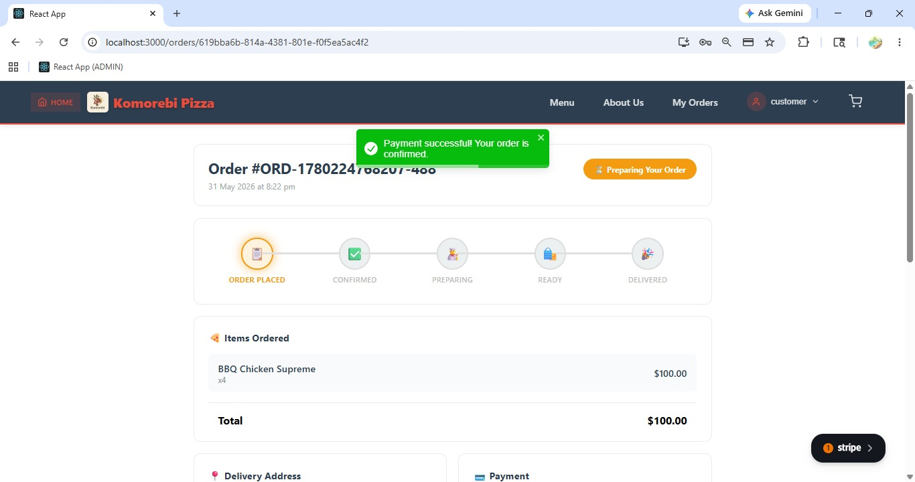 [ Figure: Fig-B13-3: Payment Success Confirmation ]
Acceptance Criteria
- Stripe accepts all major credit and debit cards (Visa, Mastercard, Amex).
- PayPal is available as an alternative payment method.
- Payments are processed securely — card details are not stored by Komorebi.
- A payment success/failure message is clearly shown.
- Order is only confirmed after successful payment.

B14 — Order Confirmation Notification (PROJECT-42)
PROJECT-42 Epic: NOTIFICATIONS & COMM | 2 pts | Assignee: —
As a customer, I want to get an order confirmation so that I know my order was received.

How Order Confirmation Works
1 | After a successful payment, the system automatically sends an order confirmation email.
2 | Check your registered email inbox for an email from Komorebi Pizza.
3 | The email subject will be something like: 'Order Confirmed — Order #KP-00123'.
4 | The email contains: your Order ID, the list of ordered items with quantities and prices, delivery address, estimated delivery time, and total amount paid.
5 | If you do not receive the email within 5 minutes, check your Spam or Junk folder.
6 | You can also view your order confirmation directly on the website by going to 'My Orders' from your profile menu.
 [ Figure: Fig-B14-1: Order Confirmation Email ]
Acceptance Criteria
- Confirmation email is sent automatically upon successful payment.
- Email contains full order details: items, address, total, and order ID.
- Order is also visible in the customer's My Orders page.

B15 — Apply Promo / Discount Code (PROJECT-46 & PROJECT-47)
PROJECT-46 Epic: DISCOUNT & PROMO | 3 pts | Assignee: Ankit Kunwar (AK)
As a customer, I want a field to enter a discount code so that I can redeem promotions.

PROJECT-47 Epic: DISCOUNT & PROMO | 4 pts | Assignee: Ankit Kunwar (AK)
As a customer, I want the promo discount to apply to my total automatically.

How to Apply a Promo Code at Checkout
1 | Add items to your cart and proceed to the Checkout page.
2 | On the Checkout page, locate the 'Promo Code' or 'Discount Code' field (usually below the order summary).
3 | Type or paste your promo code exactly as provided (codes are case-sensitive, e.g. PIZZA20).
4 | Click 'Apply' or press Enter.
5 | If the code is valid, a success message appears: 'Promo code applied! You saved $X.XX.'
6 | The discount amount is shown in the order summary (e.g. Discount: –$5.00).
7 | The total amount updates automatically to reflect the discount.
8 | If the code is invalid or expired, an error message appears: 'Invalid or expired promo code. Please check and try again.'
9 | Only one promo code can be applied per order.
10 | To remove the promo code, click the 'Remove' or 'X' button next to the applied code.

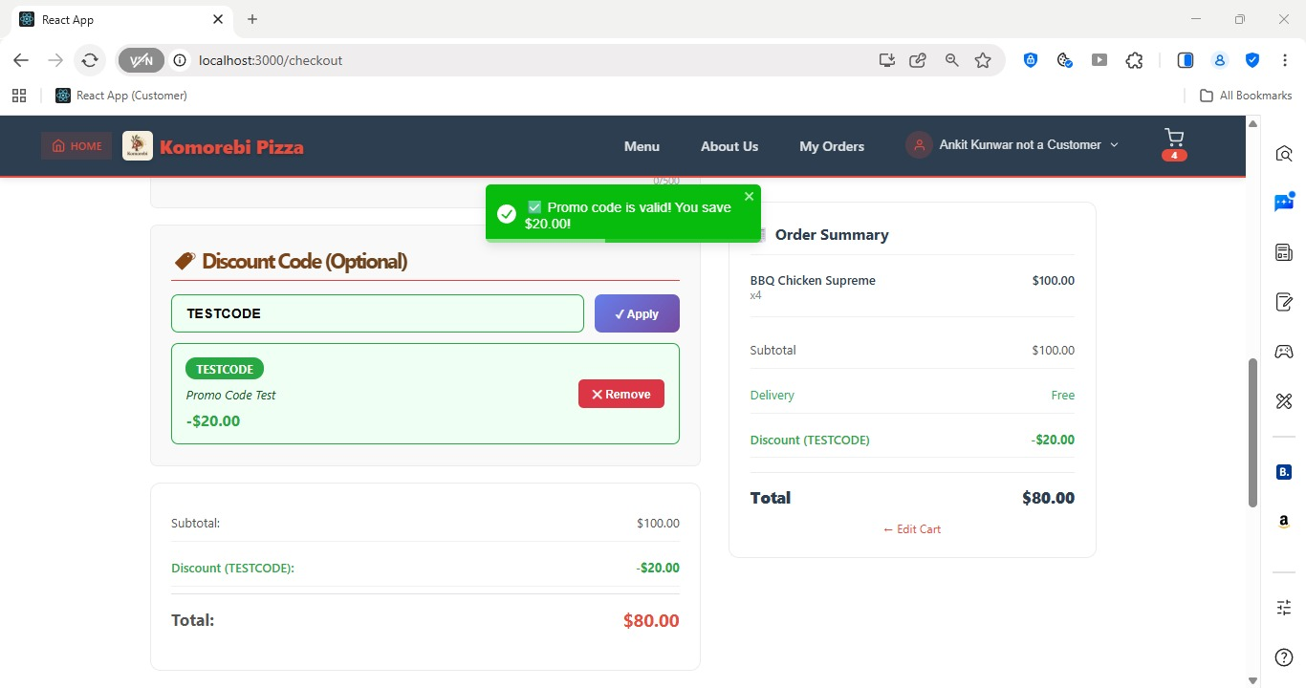[ Figure: Fig-B15-1: Promo Code Field at Checkout & Discount Applied to Order Total ]

Acceptance Criteria
- Promo code field is visible on the Checkout page.
- Valid codes apply a discount to the order total immediately.
- Invalid or expired codes show a clear error message.
- Only one promo code can be used per order.
- Discounted total is shown before payment is confirmed.

B16 — Unsubscribe from Promotional Emails (PROJECT-52)
PROJECT-52 Epic: DISCOUNT & PROMO | 3 pts | Assignee: Nabraj Gyawali (NG)
As a customer, I want to unsubscribe from promotional emails so that I do not receive unwanted marketing.

How to Unsubscribe from Promotional Emails
1 | Open any promotional email you have received from Komorebi Pizza.
2 | Scroll to the bottom of the email.
3 | Click the 'Unsubscribe' link at the bottom of the email.
4 | You are directed to a confirmation page: 'You have been unsubscribed from promotional emails. You will no longer receive marketing communications from Komorebi.'
5 | Alternatively, log in to your account and go to 'Account Settings' or 'Email Preferences'.
6 | Toggle the 'Receive promotional emails' setting to Off.
7 | Click 'Save Preferences'.
8 | You will no longer receive promotional emails from the admin's bulk email campaigns.
9 | Note: You will still receive transactional emails such as order confirmations and password resets.

Acceptance Criteria
- Unsubscribe link is present in the footer of all promotional emails.
- Customer can also manage email preferences from their account settings.
- Unsubscribing only stops promotional emails — order and account emails still arrive.
- Unsubscribe action takes immediate effect.

PART C — STAFF USER GUIDE

This section covers all features available to Staff (Pickers) of the Komorebi Pizza website. Staff can log in, view the product menu, manage incoming orders, update order statuses, receive email notifications, and export order records as PDF.

Sprint 1 | Staff Features — Login & Account Access  Sprint 1 | Aug – Sep 2025

ID | User Story | Epic | Pts | Assignee
PROJECT-4 | Log in to manage orders | USER REGISTRATION | 3 | AK
PROJECT-8 | Reset my password to regain access | PASSWORD & RECOVERY | 3 | SG

C1 — Staff Login (PROJECT-4)
PROJECT-4 Epic: USER REGISTRATION | 3 pts | Assignee: Ankit Kunwar (AK)
As staff, I want to log in so that I can manage orders.

How to Log In as a Staff Member
Staff accounts are created by an Administrator. You will receive your login credentials (email and temporary password) from your Admin before first use.
1 | Open your web browser (Chrome, Firefox, Edge, or Safari) and navigate to the Komorebi Pizza website URL.
2 | Click the 'Login' button in the top-right navigation bar.
3 | The Login page opens. Enter your staff Email Address provided by your Admin.
4 | Enter your Password in the password field.
5 | Click 'Login' or 'Sign In'.
6 | If credentials are correct, you are redirected to the Staff Dashboard.
7 | The Staff Dashboard shows: incoming orders, order queue, and navigation links for staff functions.
8 | Your name and role ('Staff') will be shown in the top-right navigation bar.
9 | If your credentials are incorrect, an error message displays: 'Invalid email or password.'
10 | Contact your Admin if you cannot log in or if your account has been deactivated.

[ Figure: Fig-C1-1: Login Page ]
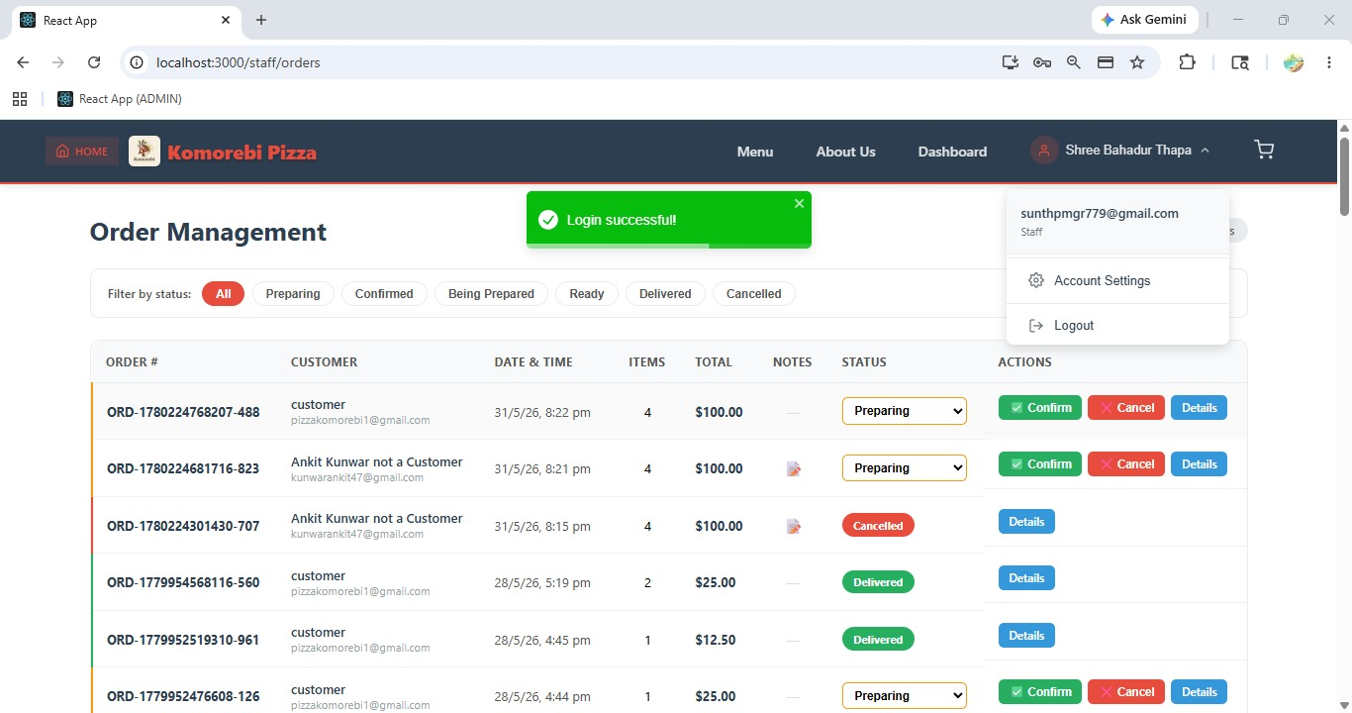
[ Figure: Fig-C1-2: Staff Dashboard after Login ]
Acceptance Criteria
- Staff login uses email and password credentials set up by Admin.
- Successful login redirects to the Staff Dashboard.
- Deactivated accounts cannot log in — contact Admin.
- Staff can only access staff-specific features, not admin functions.

C2 — Staff Password Reset (PROJECT-8)
PROJECT-8 Epic: PASSWORD & RECOVERY | 3 pts | Assignee: Sulav Gurung (SG)
As staff, I want to reset my password so that I can regain access.

How to Reset Your Staff Password
1 | On the Login page, click 'Forgot Password?' below the login form.
2 | The Forgot Password page opens. Enter your registered staff email address.
3 | Click 'Send Reset Link'.
4 | A message appears: 'If an account exists with this email, a password reset link has been sent.'
5 | Open your email inbox and locate the password reset email from Komorebi.
6 | Click the 'Reset Password' link. Note: this link expires after 1 hour.
7 | A new page opens. Enter your New Password.
8 | Re-enter the password in the Confirm New Password field.
9 | Click 'Save New Password'.
10 | You are redirected to the Login page. Log in using your new password.
11 | If you do not receive the reset email, check your Spam folder or contact your Admin.

[ Figure: Fig-C2-1: Forgot Password Page ]

[ Figure: Fig-C2-2: Password Reset Email ]
Acceptance Criteria
- Reset link is sent to the registered staff email.
- Link expires after 1 hour for security.
- New password must meet minimum strength requirements.
- Contact Admin if email is not accessible.

Sprint 2 | Staff Features — View Product Menu  Sprint 2 | 22 Sep – 12 Oct 2025

ID | User Story | Epic | Pts | Assignee
PROJECT-14 | View all products to answer customer queries | STAFF PRODUCT ACCESS | 3 | ST

C3 — Staff View All Products (PROJECT-14)
PROJECT-14 Epic: STAFF PRODUCT ACCESS | 3 pts | Assignee: Shree Thapa (ST)
As staff, I want to view all products so that I can answer customer queries.

How to View All Products as Staff
1 | Log in to your staff account. You are on the Staff Dashboard.
2 | Click 'Products' or 'Menu' in the staff navigation sidebar or top menu.
3 | The Products page loads, showing all active products available on the menu.
4 | Each product row shows: product image thumbnail, product name, category, description, and price.
5 | Use the Category filter or search bar to find a specific product if needed.
6 | Click on a product name or row to view the full product details (name, description, ingredients, price, category).
7 | Staff can view product details but cannot edit, add, or delete products — only Admin has that access.
8 | Use this information to assist customers with menu queries (ingredients, allergens, pricing).

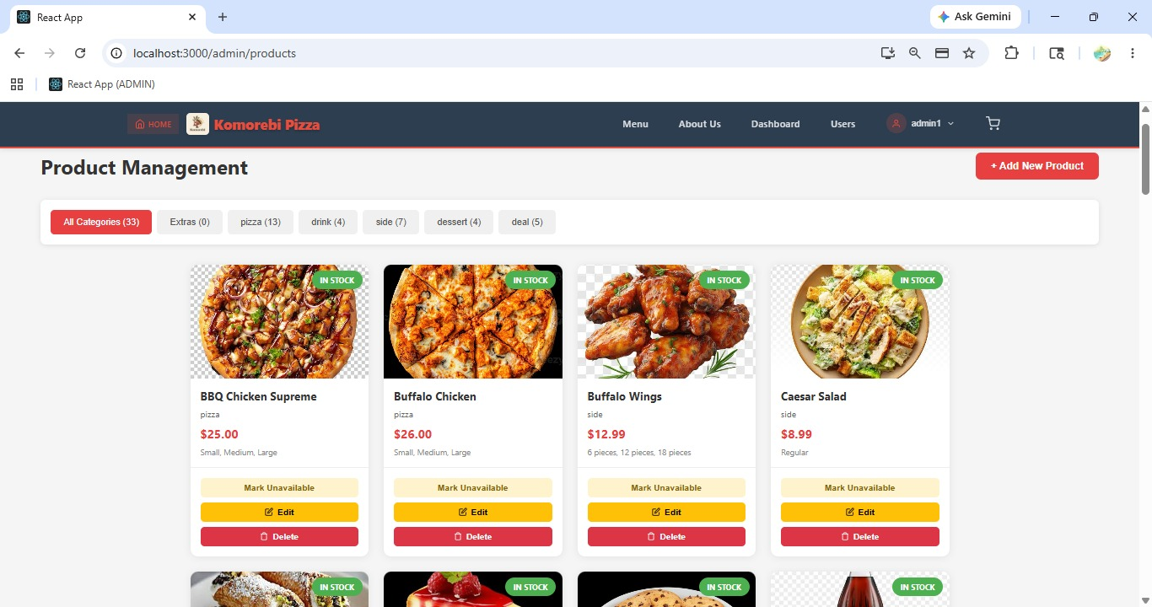[ Figure: Fig-C3-1: Staff Product View Page ]

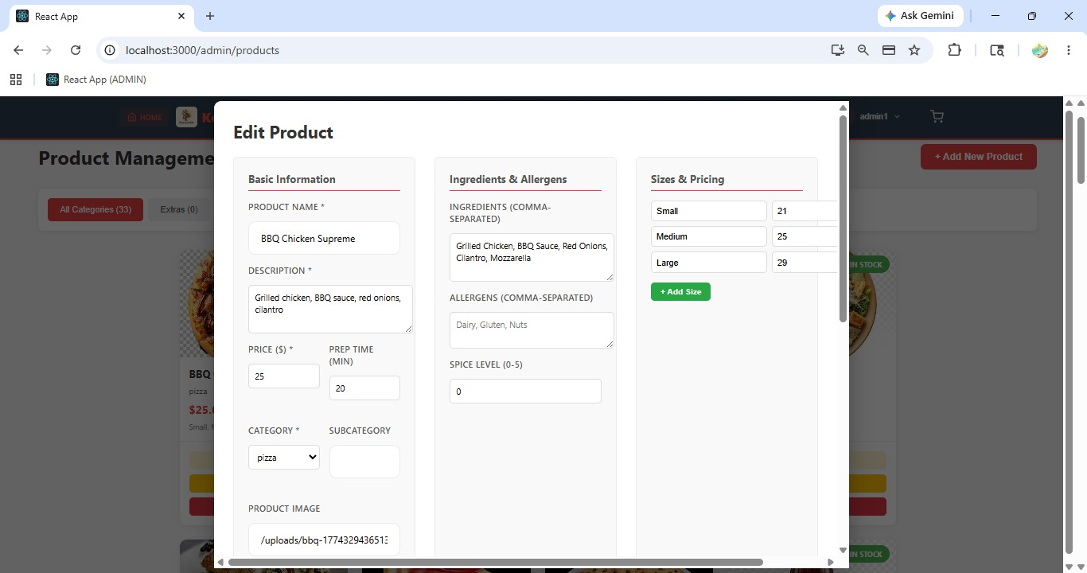[ Figure: Fig-C3-2: Product Detail View for Staff ]
Acceptance Criteria
- Staff can view all active products including name, description, price, and category.
- Staff cannot add, edit, or delete products (read-only access).
- Search and filter is available to quickly find specific products.

Sprint 3 | Staff Features — Order Management  Sprint 3 | 25 Mar – 2 Apr 2026

ID | User Story | Epic | Pts | Assignee
PROJECT-33 | View all orders on the website to prepare them | STAFF SIDE ORDER P... | 3 | NG
PROJECT-34 | Confirm orders so customers know they are accepted | STAFF SIDE ORDER P... | 5 | ST
PROJECT-35 | Cancel orders so unavailable items are not processed | ORDER PLACEMENT | 2 | SG

C4 — View All Orders (PROJECT-33)
PROJECT-33 Epic: STAFF SIDE ORDER P... | 3 pts | Assignee: Nabraj Gyawali (NG)
As staff, I want to view all orders on the website so that I can prepare them.

How to View Incoming Customer Orders
1 | Log in to your staff account and go to the Staff Dashboard.
2 | Click 'Orders' or 'Order Management' in the staff navigation menu.
3 | The Orders page loads, listing all customer orders with the most recent at the top.
4 | Each order row shows: Order ID, Customer Name, Order Date & Time, Items Ordered, Total Price, and Current Status.
5 | Use the Status filter to view orders by stage: All, Pending, Accepted, In Preparation, Ready for Delivery, Delivered, Cancelled.
6 | Click on any Order ID or row to open the full Order Detail view.
7 | The Order Detail page shows: customer name and delivery address, all items ordered with quantities, special instructions/notes from the customer, payment method and total, and current order status.
8 | Use this view to know exactly what to prepare for each order.

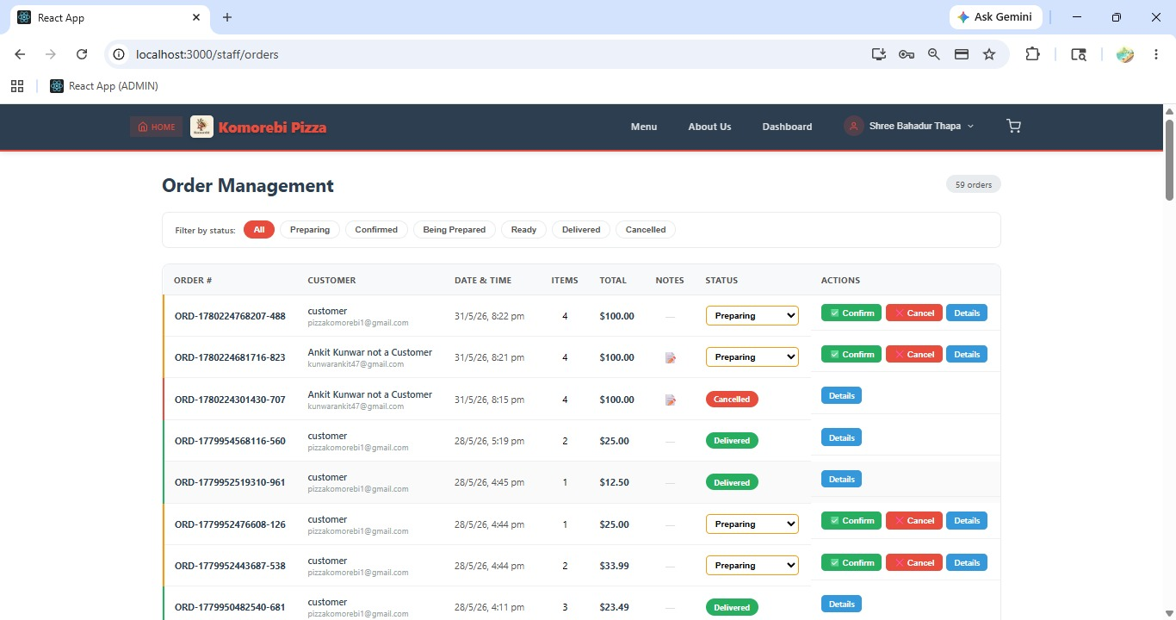[ Figure: Fig-C4-1: Orders List Page — Staff View ]
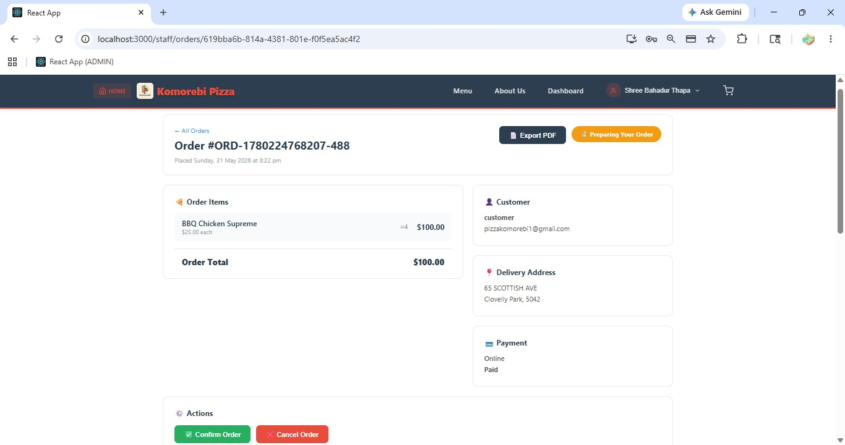
[ Figure: Fig-C4-2: Order Detail Page — Staff View ]
Acceptance Criteria
- All customer orders are visible to staff from the Orders page.
- Orders are sorted by most recent first.
- Filters allow staff to view orders by status.
- Full order details including customer notes are accessible.

C5 — Accept / Confirm an Order (PROJECT-34)
PROJECT-34 Epic: STAFF SIDE ORDER P... | 5 pts | Assignee: Shree Thapa (ST)
As staff, I want to confirm orders so that customers know their order is accepted.

How to Accept a Customer Order
1 | Go to the Orders page from the Staff Dashboard.
2 | Find an order with the status 'Pending' — these are new orders awaiting staff action.
3 | Click on the Order ID to open the Order Detail page.
4 | Review all items, quantities, customer notes, and the delivery address.
5 | Click the 'Accept Order' or 'Confirm Order' button on the Order Detail page.
6 | A confirmation prompt appears: 'Accept this order? The customer will be notified.'
7 | Click 'Yes, Accept' to confirm.
8 | The order status changes from 'Pending' to 'Accepted'.
9 | The customer automatically receives an email notification: 'Your order #KP-00123 has been accepted and is being prepared!'
10 | The order now appears in the Accepted/In Progress orders list for the staff to prepare.

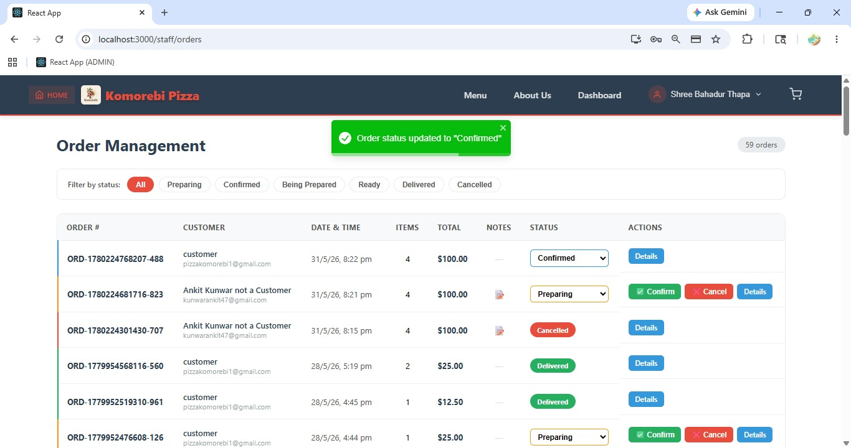[ Figure: Fig-C5-1: Confirm Order Button on Order Detail Page & Order Status Changed to Accepted]

Acceptance Criteria
- Only Pending orders can be Accepted.
- Accepting an order triggers an automatic email notification to the customer.
- Order status updates to Accepted immediately.
- Staff confirmation ensures the customer is kept informed.

C6 — Staff Cancel Order (PROJECT-35)
PROJECT-35 Epic: ORDER PLACEMENT | 2 pts | Assignee: Sulav Gurung (SG)
As staff, I want to cancel orders so that unavailable items are not processed.

How to Cancel an Order as Staff
1 | Go to the Orders page from the Staff Dashboard.
2 | Find the order you need to cancel (e.g. an order containing an out-of-stock item).
3 | Click the Order ID to open the Order Detail page.
4 | Review the order and confirm the reason for cancellation (e.g. item unavailable, customer request via phone).
5 | Click the 'Cancel Order' button on the Order Detail page.
6 | A cancellation reason field appears. Enter a brief reason (e.g. 'Pepperoni out of stock').
7 | Click 'Confirm Cancellation'.
8 | The order status changes to 'Cancelled'.
9 | The customer receives an automatic email notification: 'Your order #KP-00123 has been cancelled. We apologise for the inconvenience.'
10 | The cancelled order remains in the order history with the Cancelled status for records.

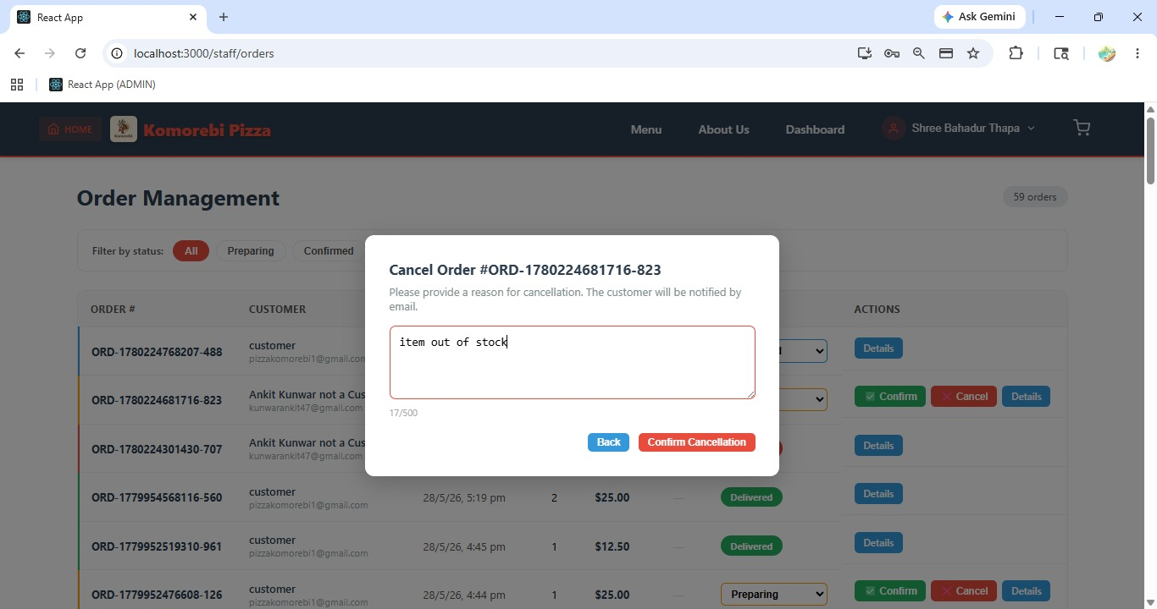[ Figure: Fig-C6-1: Cancellation Confirmation and Reason Field]

Acceptance Criteria
- Staff can cancel Pending or Accepted orders.
- A cancellation reason must be entered before confirming.
- Customer is automatically notified via email upon cancellation.
- Cancelled orders remain in order history for audit purposes.

Sprint 4 | Staff Features — Notifications & Order Status Updates  Sprint 4 | 20 Apr – 2 May 2026

ID | User Story | Epic | Pts | Assignee
PROJECT-41 | Get email notifications for new orders | NOTIFICATIONS & COMM | 3 | —
PROJECT-51 | Update order status to track progress | ORDER MANAGEMENT | 4 | AK
PROJECT-53 | Orders auto-progress through stages | ORDER MANAGEMENT | 6 | NG

C7 — Staff Email Notifications for New Orders (PROJECT-41)
PROJECT-41 Epic: NOTIFICATIONS & COMM | 3 pts | Assignee: —
As staff, I want to get email notifications for new orders so that I can act quickly.

How Staff Email Notifications Work
Email notifications are automatically triggered by the system — no manual action is required by staff. This section explains what to expect.
1 | When a customer successfully places and pays for a new order, the Komorebi system automatically sends an email notification to all active staff accounts.
2 | Check your staff email inbox for an email from Komorebi with subject: 'New Order Received — Order #KP-00123'.
3 | The email contains: Order ID, customer name, items ordered with quantities, delivery address, order total, and time of order.
4 | Log in to the Staff Dashboard and go to the Orders page to view and act on the new order.
5 | If you are not receiving notifications, check your Spam/Junk folder.
6 | Contact your Admin to verify your staff email address is correctly registered in the system.
7 | Notifications are also sent when: an order is updated by admin, an order is cancelled, or a customer updates their order note.
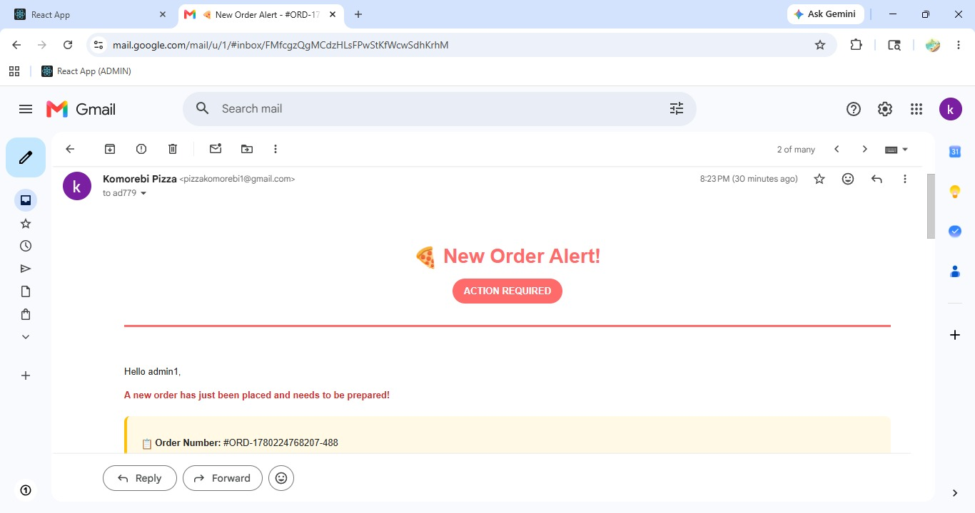[ Figure: Fig-C7-1: New Order Email Notification Received by Staff ]
Acceptance Criteria
- Email notifications are sent automatically for every new customer order.
- Notification email includes full order details.
- Staff must log in to the dashboard to Accept or update the order.
- Contact Admin if notifications are not being received.

C8 — Update Order Status (PROJECT-51)
PROJECT-51 Epic: ORDER MANAGEMENT | 4 pts | Assignee: Ankit Kunwar (AK)
As staff, I want to update order status only for my assigned orders so that tracking is accurate.

How to Update the Status of an Order
1 | Log in to your staff account and go to the Orders page.
2 | Find the order you need to update. Click the Order ID to open the Order Detail page.
3 | Review the current order status displayed at the top of the order detail.
4 | Click the 'Update Status' button or the status dropdown selector.
5 | Select the next appropriate status from the list:
6 | → 'In Preparation' — Kitchen is actively making the order.
7 | → 'Ready for Delivery' — Order is packed and ready to be picked up or dispatched.
8 | → 'Out for Delivery' — Order has been handed to the delivery driver.
9 | → 'Delivered' — Order has been successfully delivered to the customer.
10 | Click 'Save' or 'Update' to confirm the status change.
11 | The order status is updated immediately in the system.
12 | The customer's Order Tracking page (if applicable) reflects the new status.
13 | Each status change is timestamped and recorded in the order history.

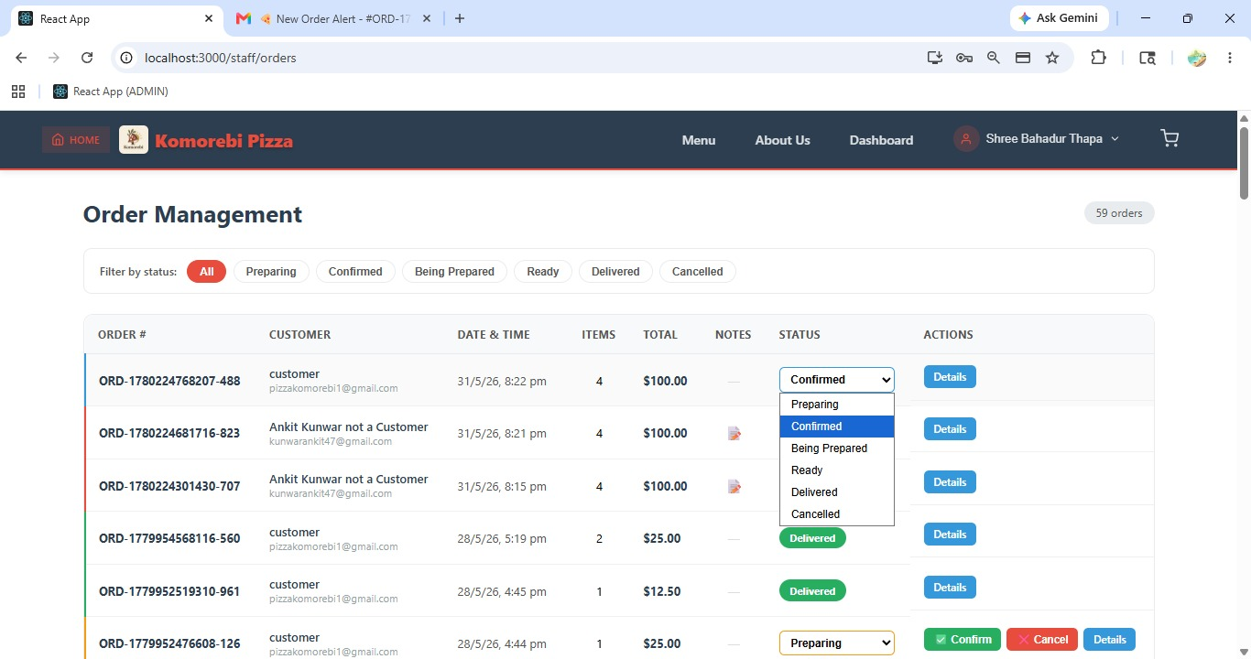[ Figure: Fig-C8-1: Update Order Status Dropdown ]

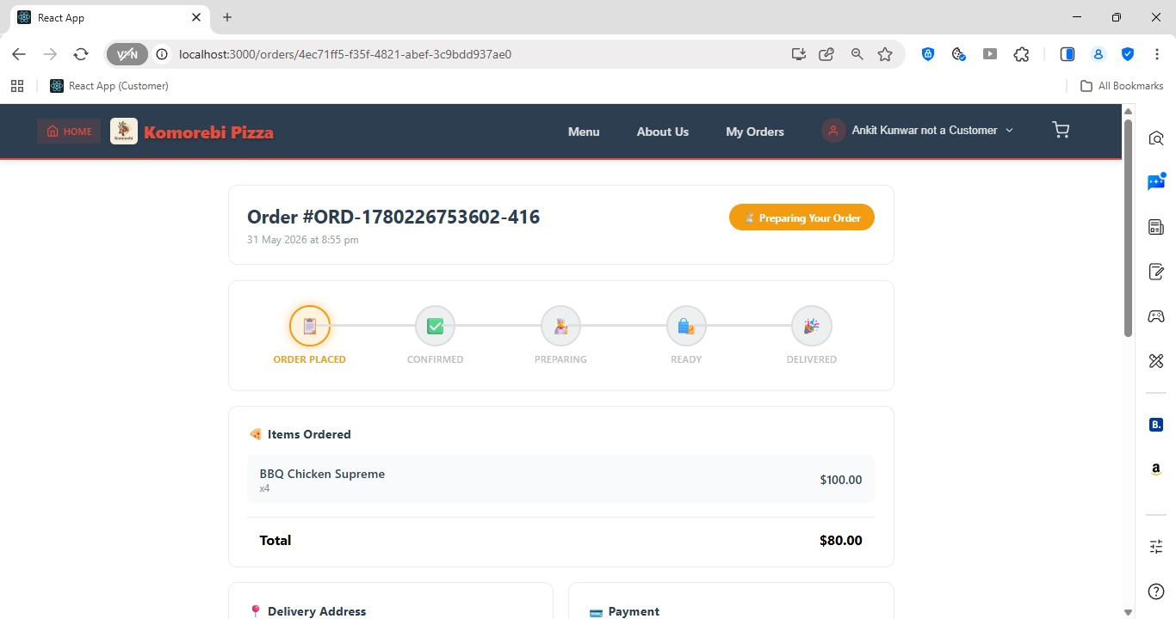
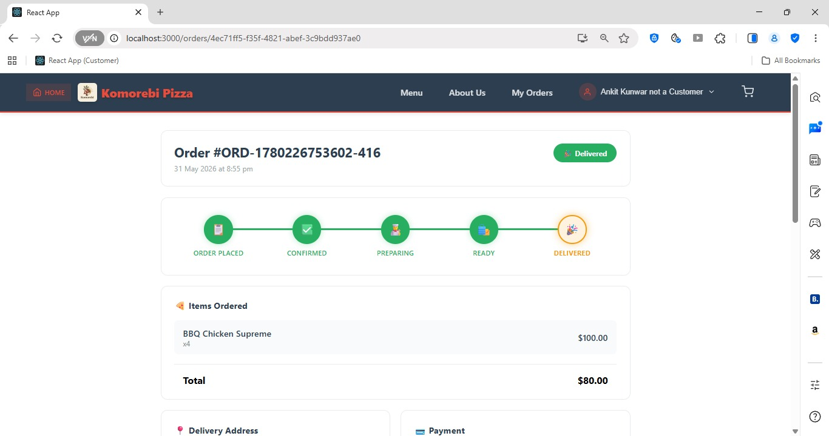[ Figure: Fig-C8-2, 8-3: Order Status History Timeline ]
Acceptance Criteria
- Order status can be updated step by step: Pending → Accepted → In Preparation → Ready → Delivered.
- Each update is timestamped and logged.
- Status changes are visible to customers in their Order History.
- Staff cannot skip statuses — updates must follow the correct sequence.

C9 — Auto-Progress Order Status (PROJECT-53)
PROJECT-53 Epic: ORDER MANAGEMENT | 6 pts | Assignee: Nabraj Gyawali (NG)
As staff, I want orders to automatically progress through stages so that I save time on manual updates.

Understanding Auto-Progress Order Status
The auto-progress feature reduces manual work for staff by automatically advancing order statuses after set time intervals or triggered events.
1 | When a customer places an order, it starts as 'Pending' — this requires manual staff acceptance.
2 | After a staff member clicks 'Accept Order', the status moves to 'Accepted' and a timer begins.
3 | After the configured preparation time (e.g. 20 minutes), the system may automatically advance the status to 'In Preparation' — no staff action needed.
4 | Staff can still manually update the status at any time to override the auto-progress.
5 | When the order is ready, staff must manually set it to 'Ready for Delivery' to confirm physical readiness.
6 | The 'Delivered' status must always be confirmed manually by staff to ensure accuracy.
7 | To check auto-progress settings, go to the Orders section on the dashboard — a timer/countdown may be visible next to each order.
8 | If auto-progress is advancing orders incorrectly, contact your Admin to review the timer settings.

Acceptance Criteria
- Auto-progress advances order status automatically after configured time intervals.
- Manual overrides by staff are always possible.
- Delivered status requires manual staff confirmation.
- Auto-progress settings are configured by Admin.

Sprint 5 | Staff Features — Export Orders as PDF  Sprint 5 | 14–30 May 2026

ID | User Story | Epic | Pts | Assignee
PROJECT-57 | Export order details as PDF for offline records | ANALYTICS & REPORTING | 5 | NG

C10 — Export Order Details as PDF (PROJECT-57)
PROJECT-57 Epic: ANALYTICS & REPORTING | 5 pts | Assignee: Nabraj Gyawali (NG)
As staff, I want to export order details as PDF so that I can keep offline records.

How to Export an Order as a PDF
1 | Log in to your staff account and go to the Orders page.
2 | Locate the order you want to export. Click on the Order ID to open the Order Detail page.
3 | On the Order Detail page, look for the 'Export PDF' or 'Download PDF' button (usually at the top-right of the order detail).
4 | Click the 'Export PDF' button.
5 | The system generates a professionally formatted PDF file for that order using PDFKit.
6 | Your browser will either download the PDF automatically to your Downloads folder, or a Save dialog will appear asking where to save the file.
7 | Open the downloaded PDF file using any PDF reader (Adobe Acrobat, Chrome built-in viewer, Preview on Mac).
8 | The PDF contains: Order ID, date and time, customer name and delivery address, itemised list of products with quantities and prices, special instructions, payment method, and order total.
9 | Save or print the PDF for your records.
10 | To export multiple orders, repeat the process for each order individually.

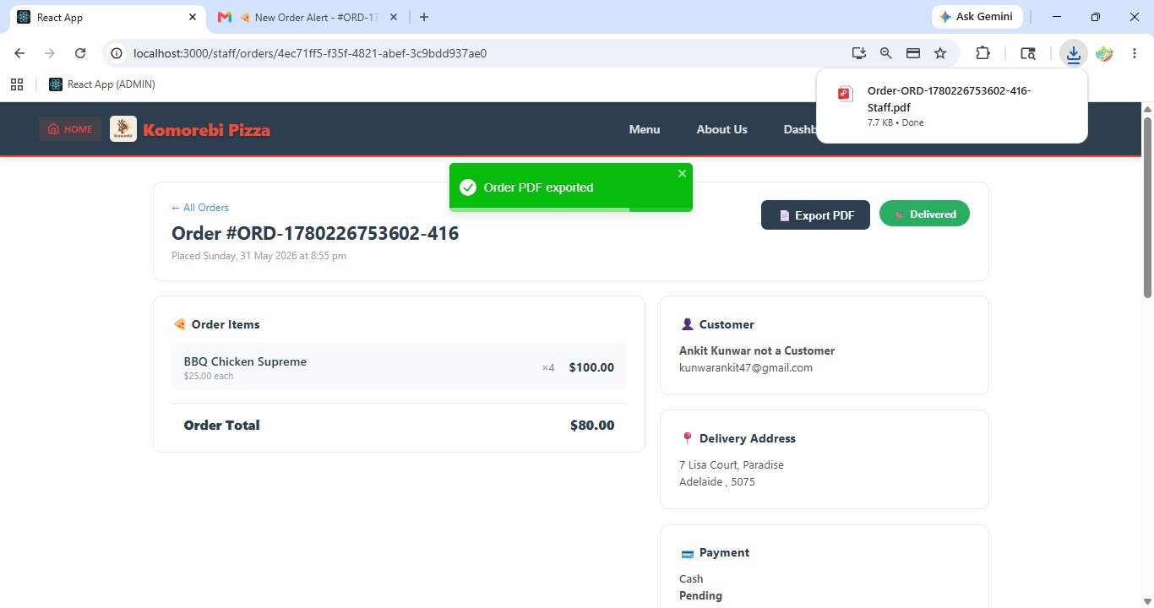[ Figure: Fig-C10-1: Export PDF Button on Order Detail Page ]

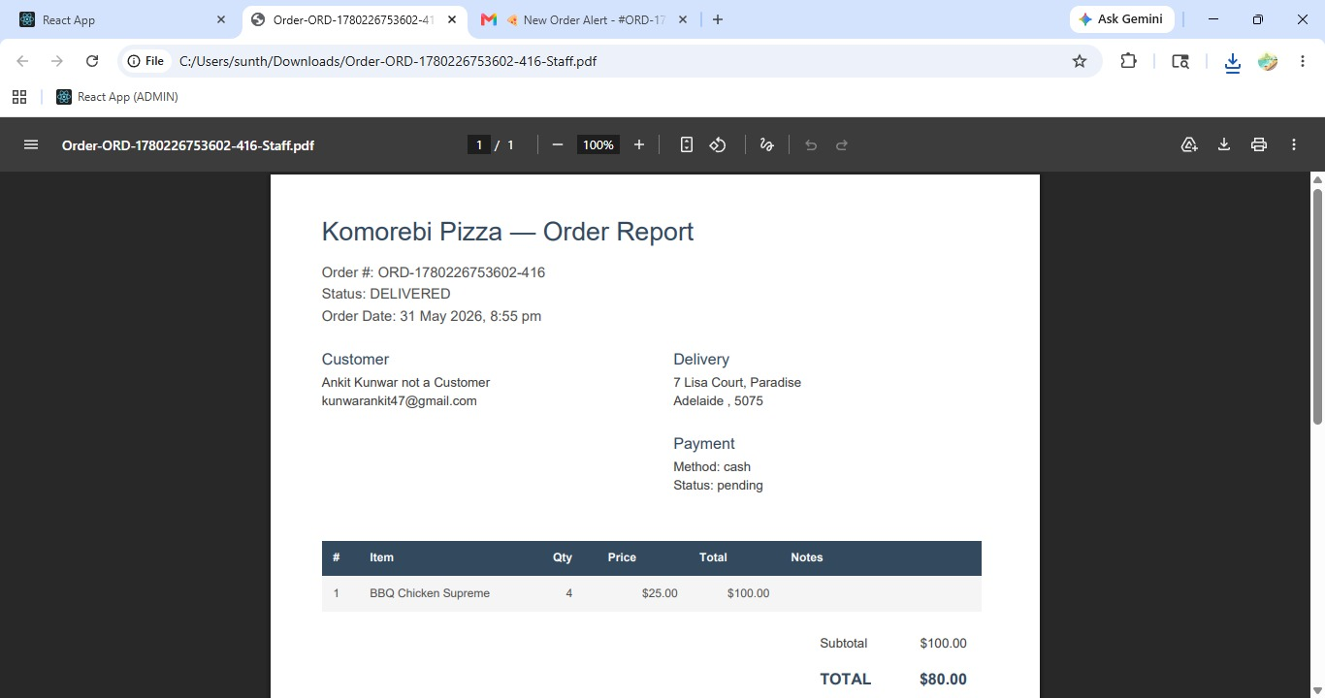[ Figure: Fig-C10-2: Downloaded PDF Order Record ]
Acceptance Criteria
- PDF export is available for any order from the Order Detail page.
- The PDF is generated using PDFKit and formatted professionally.
- PDF includes all order details: items, customer info, totals, notes.
- PDF downloads immediately to the browser's default Downloads folder.
- No internet is required to open the saved PDF after download.

About Us & Contact Information
Team Yatri is a student software development team from Federation University Australia. This project was developed as part of the ITECH 3002 unit under the supervision of academic staff, and delivered to client Mike Vu.

Name | Role | Email | Phone
Nabraj Gyawali | Scrum Master / Front-End | ngyawali100@gmail.com | 0406 934 464
Ankit Kunwar | Full Stack Dev | Kunwarankit47@gmail.com | 0435 214 010
Shree B. Thapa | Full Stack Dev | Sunthpmgr7799@gmail.com | 0410 782 002
Sulav Gurung | Tester / Tech Writer | sulavgurung40@gmail.com | 0491 697 747
Sushanka Gurung | UI/UX Designer | sushankagurung@gmail.com | 0492 952 536

For technical support or system issues, please contact the Scrum Master: Nabraj Gyawali at the phone or email above.

