**PFE notes:**

# Web sites:

[https://www.cisa.gov](https://www.cisa.gov/?fbclid=IwAR2cwFk2Nv6iSKULyilMcg5jilQnswpjVbd5N7MKeYjSlp1Kptp7z4rza6A)

<https://www.cyber.gov.au/acsc/report>

<https://www.cyber.gc.ca/en>

<https://www.ncsc.gov.uk>

<https://complaint.ic3.gov>

# Screenshots:

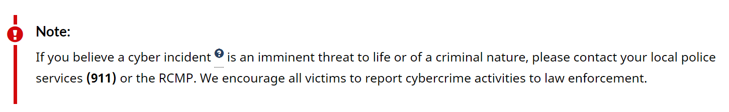

layout

[https://reportapp.cyber.gov.au/?_gl=1*n8t6it*_ga*MTkwMTAyNjU3OC4xNjgxMTkyOTgy*_ga_SBP29688KC*MTY4MTM4MDE4Mi4xMy4xLjE2ODEzODEyNDIuMC4wLjA.&_ga=2.95962708.918647901.1681192982-1901026578.1681192982#/](https://reportapp.cyber.gov.au/?_gl=1*n8t6it*_ga*MTkwMTAyNjU3OC4xNjgxMTkyOTgy*_ga_SBP29688KC*MTY4MTM4MDE4Mi4xMy4xLjE2ODEzODEyNDIuMC4wLjA.&_ga=2.95962708.918647901.1681192982-1901026578.1681192982#/)

form

<https://www.ic.gc.ca/eic/site/cb-bc.nsf/frm-eng/GHÉT-7TDNA5>

