Hayden Feddock

ECE 1395 – Dr. Dallal

Assignment 2

1/29/2023

Python modules used: numpy, warnings, pandas, matplotlib

**Question 1: Cost Function**

Output from the cost function test case 1: 12.6875

Output from the cost function test case 2: 3.75

**Question 2: Gradient Descent**

Theta estimate using gradient descent: [[0.80206587 0.40108766]

Cost after 15 iterations: [10.39773979]

**Question 3: Normal Equation**

Theta estimate using normal equation: [[1.], [2.]]

The difference in the estimates between the result of gradient descent and the result of the normal equation can be explained by the alpha value. Since the alpha value is small, and the number of iterations is low, the gradient descent method is not getting us as accurate of an estimate. If we increase the alpha value or the number of iterations we will get a result closer to that of normal equation.

**Question 4: Linear Regression with One Variable**

Part b:

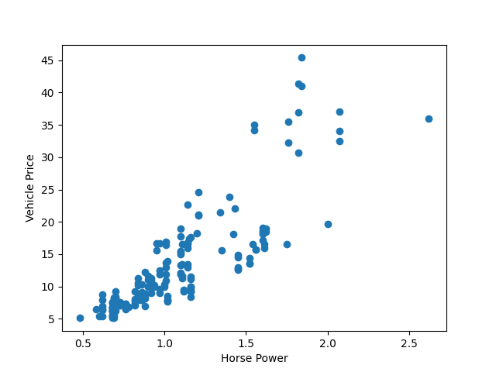

Ps2-4-b.png

Part c:

Size of X feature matrix: (179, 2)

Size of Y label vector: (179, 1)

Part e:

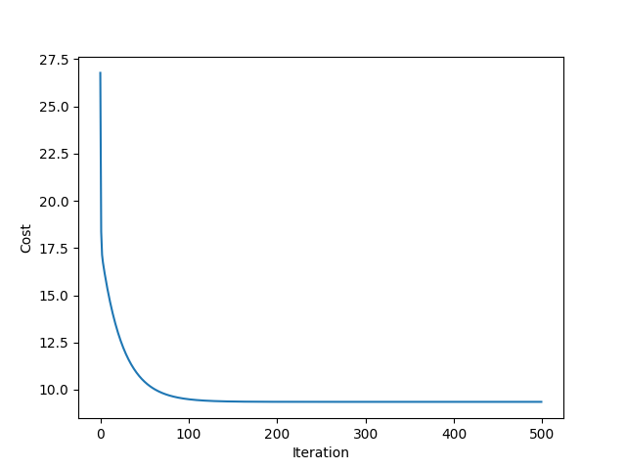

Ps2-4-e-1.png

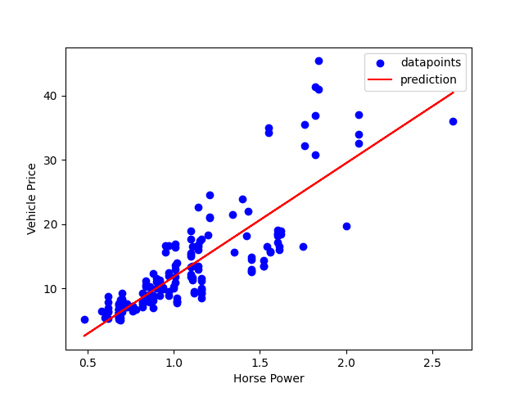

Ps2-4-e-2.png

Output model parameters theta: [-5.88949745 17.87768195]

Part f:

Mean squared error from gradient descent hypothesis: 53.83703598091144

Part g:

Mean squared error from normal equation hypothesis: 53.83808675471343

These error values are very similar

Part h:

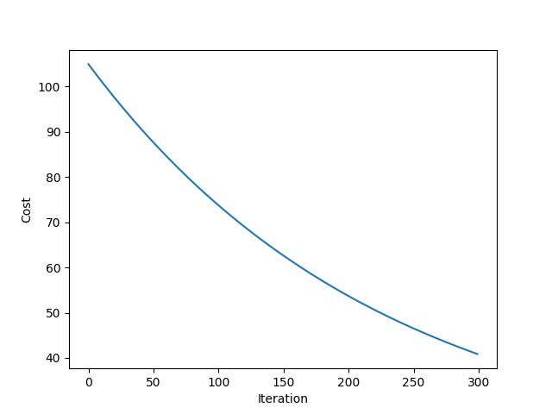

Ps2-4-h-1.png

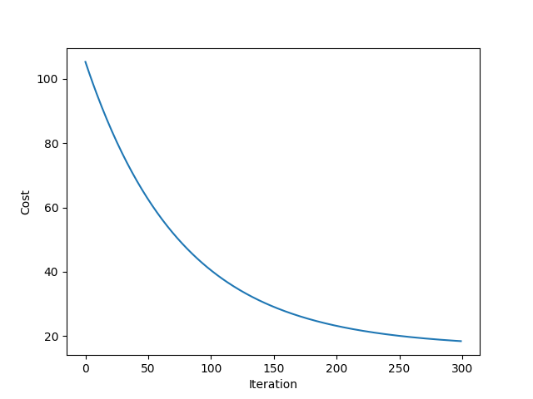

Ps2-4-h-2.png

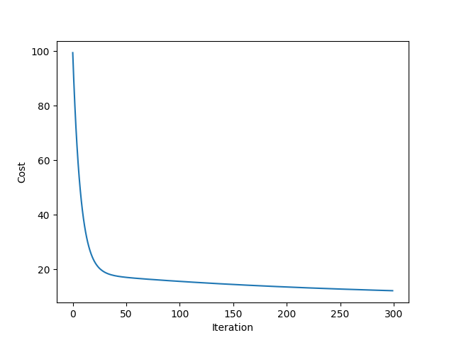

Ps2-4-h-3.png

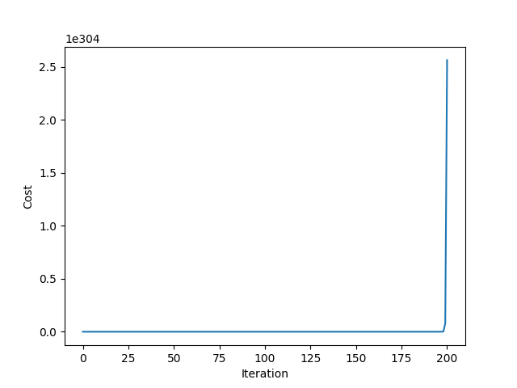

Ps2-4-h-4.png

As the value of alpha increases the cost drops faster over and requires less iterations

Question 5: Linear Regression with Multiple Variables

Part a:

The mean size of a house is 2000.6808510638298 (square feet), and the stdev is 786.2026187430467

The number of bedrooms in a house is 3.1702127659574466, and the stdev is 0.7528428090618781

The mean price of a house is 340412.6595744681, and the stdev is 123702.5360061474

The size of feature matrix X is: (47, 3)

The size of feature matrix y is: (47, 1)

Part b:

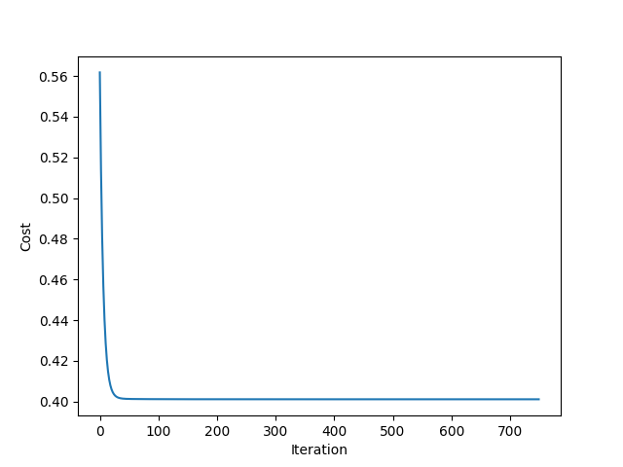

Ps2-5-b.png

The computed value for theta is: [0.79840354 0.29230107 0.44123713]

Part c:

The predicted price of a 1080 sqft house with 2 bedrooms is: 221105.42965746054