Hayden Feddock

ECE 1395 – Dr. Dallal

Assignment 3

2/5/2023

**Question 1: Logistic Regression**

**Part a:**

* Text output:
  + The size of feature matrix X is: (100, 3)
  + The size of feature label vector is: (100, 1)

**Part b:**

* Output:

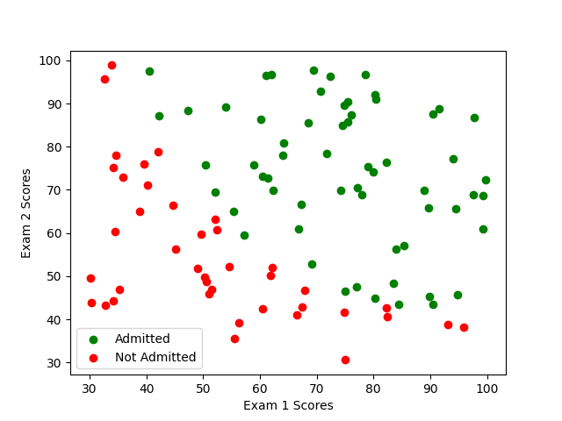

(ps3-1-b.png)

**Part d:**

* Output:

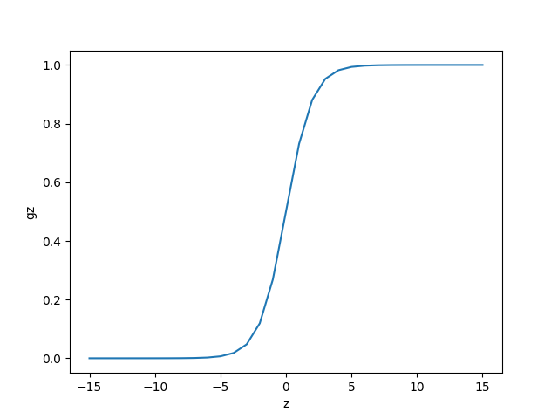

(ps3-1-c.png)

* Text response:
  + Figure ps3-1-c reaches an output of 0.9 with an input of about 2.5

**Part e:**

* Text output:
  + The value of the cost J for the toy dataset is: [[0.69314718]]

**Part f:**

* Text output:
  + The optimal parameters for theta are: [-24.69021561 0.20094076 0.19706876]
  + The cost at the optimized theta values is: 0.2066785856270287

**Part g:**

* Output:

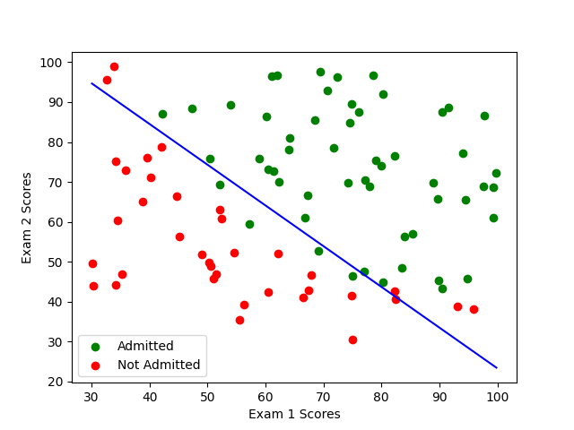

(ps3-1-f.png)

**Part i:**

* Text output:
  + The admission probability is: 0.7752999076910132
  + The admission decision should be: Admitted

**Question 2: Non-Linear Fitting**

**Part a:**

* Text output:
  + The learned model parameters for theta are: [[ 2.19256629e+05], [-7.75886157e+02], [ 1.06170508e+01]]

**Part b:**

* Output:

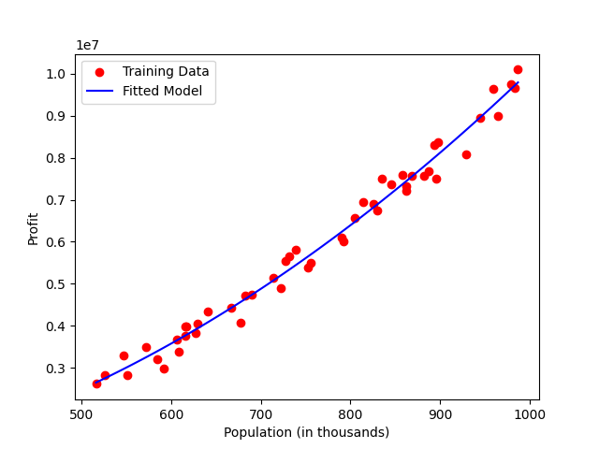

(ps3-2-b.png)